Govt. College for Women, Faridabad
NSS ACTIVITY SESSION
(July-June)
2021-2022

Title of the Activities & date | Organizing unit/ agency/ collaborating agency | Number of teachers co-ordinate such activities | Number of students participated in such activities | Achievements/  Remarks
1) Tree plantation drive 22nd July, 2021 | NSS Unit | 2 teachers  Dr. Rachna  Dr. Raman Kumar | Students were not present due to COVID 19 | NSS unit of GCW Faridabad organized a tree plantation drive under social outreach programme in the college premises and in nearby areas.  The drive was inaugurated by principal Dr. Sunidhi. She shared that trees are natural oxygen producers that sustain all life on earth. She said that we should become aware about our environment and plant more and more tree so that we can save our surroundings and nature. Ms. Ritika Gupta, senior faculty said that tree plantation drive tackles many environmental issues like deforestation, erosion of soil, desertification in semi-arid areas, global warming etc. she also added that considering the manifold benefits of trees, including that they release oxygen into the air, absorb harmful gases such as carbon dioxide, carbon monoxide and Sulphur dioxide from the air and purify it NSS PO Dr. Rachna Saini shared that tree plantation should be the priority of nations and humanity if they want to survive and thrive. NSS unit of GCW planted around 100 trees inside and outside the campus. NSS volunteer planted trees in near by areas and also in adopted village  Mirtzapur. Dr. Raman kumar of NSS unit planted trees in adopted village Mirtzapur.

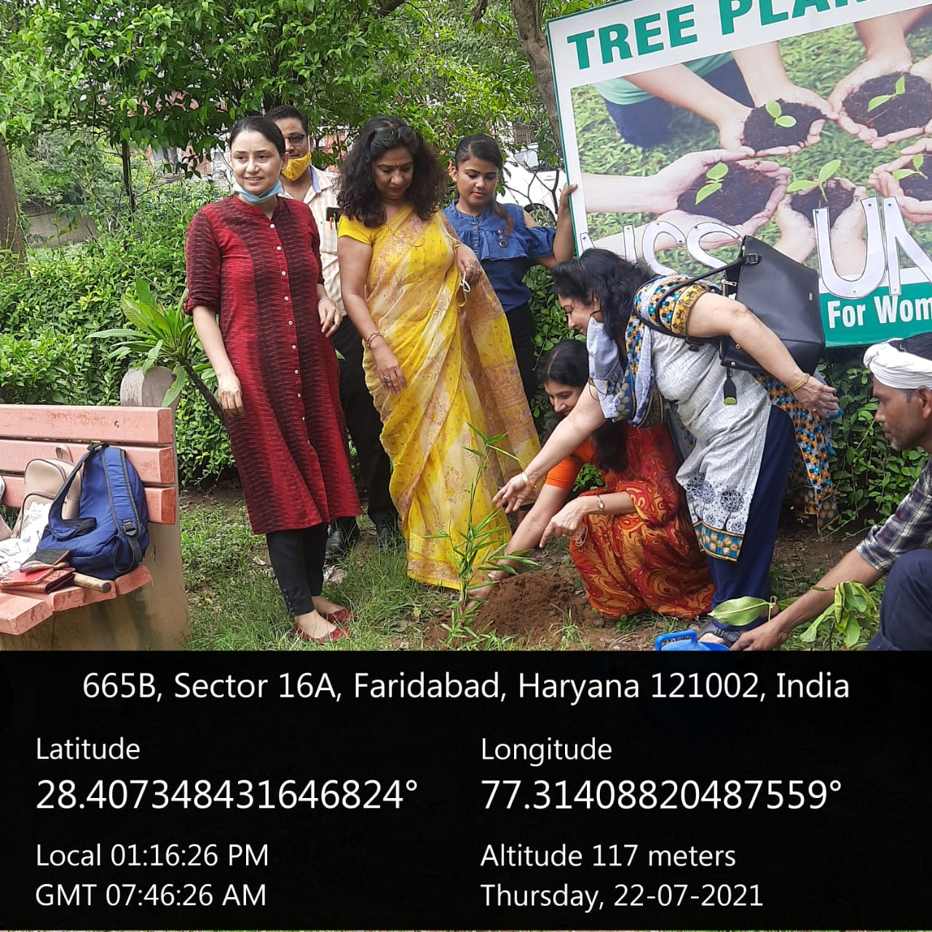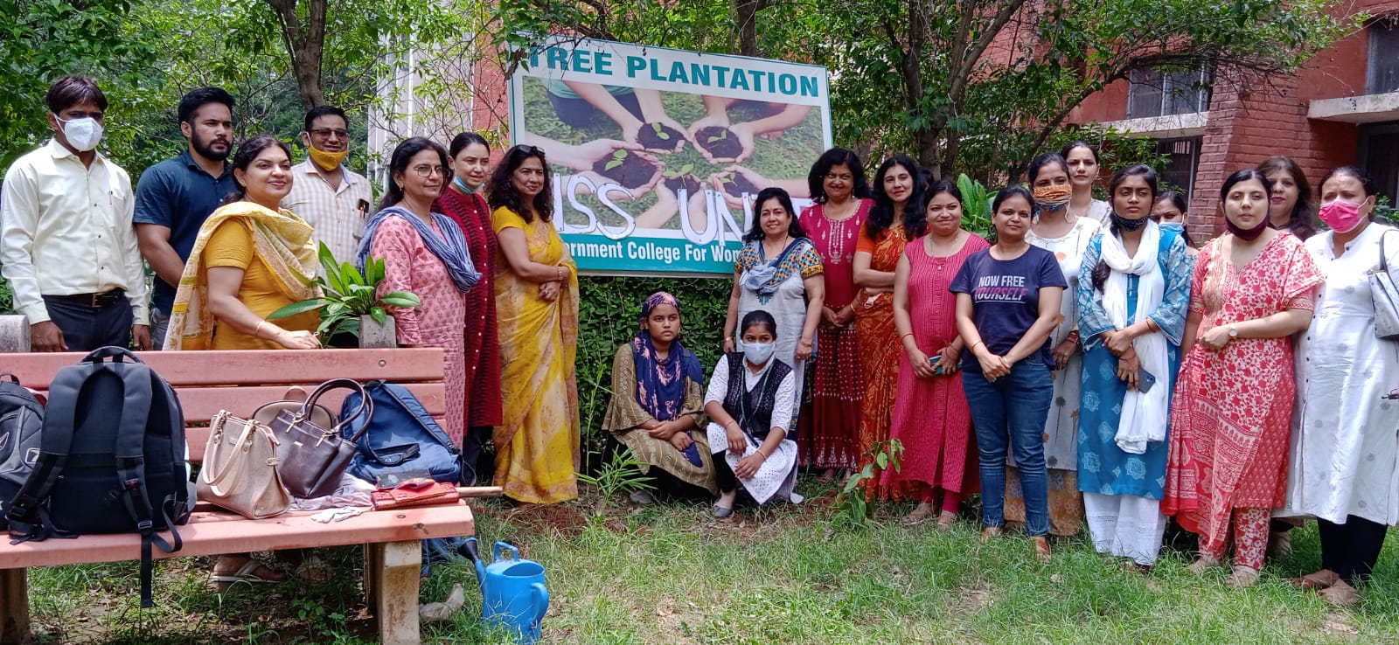

Title of the Activities & date | Organising unit/ agency/ collaborating agency | Number of teachers co-ordinated such activities | Number of students participated in such activities | Achievements/  Remarks
2) Independence day celebration 15th August, 2021 | NSS Unit and Music Department | All staff Members | 100 students | Government College for Women Faridabad and Government Girls College Nachouli celebrated Independence Day with great enthusiasm. Corona warrior Associate Professor Balbir Singh Dahiya hoisted the flag. Principal Dr Sunidhi wishes everyone on the occasion. NSS volunteer Rishu Jha presented a self composed poem. Senior Professors Dr. Dinesh Joon, Ms Archana Verma, Dr. Sushil Verma ,Dr. Raman Kumar were present.
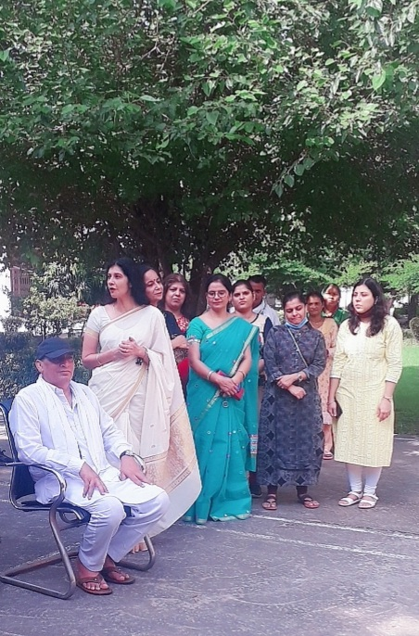

Title of the Activities & date | Organising unit/ agency/ collaborating agency | Number of teachers co-ordinated such activities | Number of students participated in such activities | Achievements/  Remarks
3) Corona vaccine drive for students, staff members of the college and other stakeholders from the community,25TH August 2021 | NSS Unit | Dr. Rachna Saini  Dr. Raman Kumar  Dr. Varsha  Ms. Poonam Rani  Ms. Priya Saini  Ms. Neha Vij  Ms. Savita Nagar | 337 students | The NSS unit of government college for women, sector 16a, Faridabad organised corona vaccine drive for students, staff members of the college and other stakeholders from the community. Covishield vaccine was administered to around 500 people where 450 recipients got their first dose while around 50 recipients got 2nd dose of vaccine. The vaccination drive was led by a team of doctors from esi hospital, sector 8, faridabad. Physician dr. Shalini from the esi vaccination team tried to dispel the misconception regarding corona vaccine and declared it absolutely safe. Corona vaccine works as an immunity booster; therefore, everyone should get the vaccine as soon as possible without any fear -she retorted. Gcw: making community safe  Principal, dr. Sunidhi shared that according to who, 3rd wave of the pandemic is anticipated soon, therefore the need of the hour is to vaccinate the population in large numbers. This camp was mainly organized for staff members and students who were yet to receive 1st dose of vaccine therefore bringing into fold a large number of people into vaccination.  Nss program officer of the college dr. Rachna saini told that 337 students, 24 staff members and around 139 people from the community have been administered the 1st and 2nd doses of vaccine in this camp. The certificates will also be issued to everyone by the team of doctors. She told that the camp was successfully organised with the help and guidance of the principal of the college besides the staff and nss volunteers.
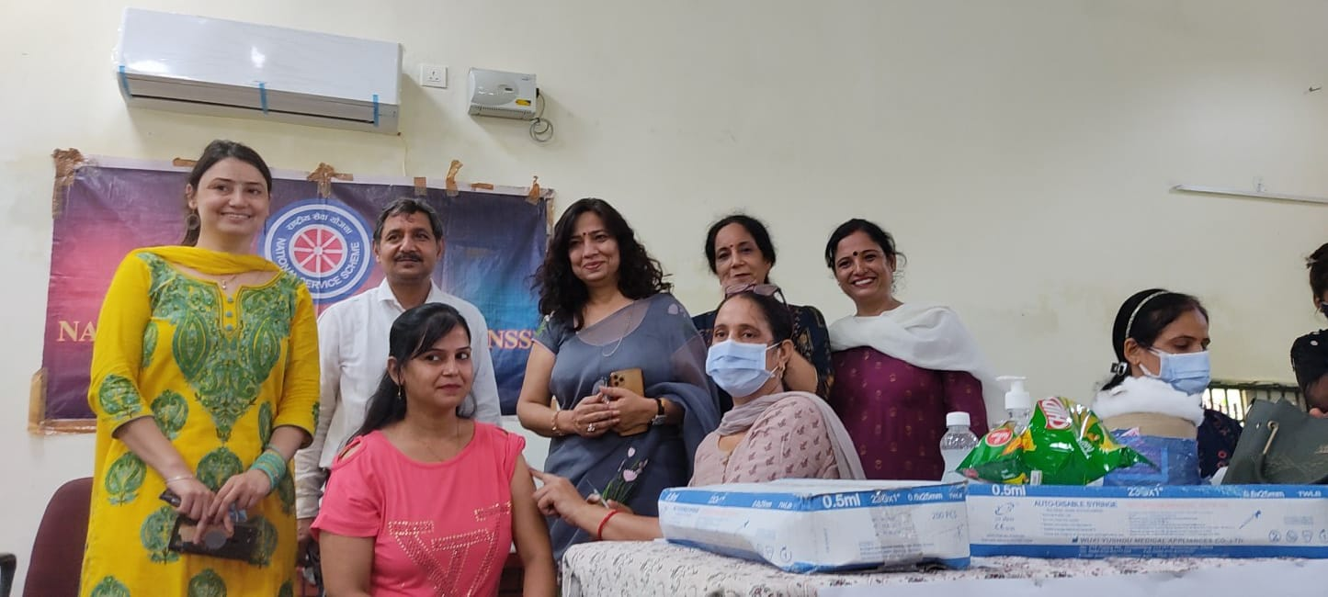

Title of the Activities & date | Organising unit/ agency/ collaborating agency | Number of teachers co-ordinated such activities | Number of students participated in such activities | Achievements/  Remarks
4) Certificate of Appreciation for "Beat covid Campaign” initiative of Mahatma Gandhi National Council of Rural Education (MGNCRE), 27th August 2021 | NSS Unit | Dr. Rachna Saini  Dr. Raman Kumar  Dr. Varsha  Ms. Poonam Rani  Ms. Priya Saini  Ms. Neha Vij  Ms. Savita Nagar |  | NSS unit of GCW,Faridabad received certificate of Appreciation for "Beat covid Campaign” initiative of Mahatma Gandhi National Council of Rural Education (MGNCRE). This certificate was awarded for the efforts in making the campaign successful by coordinating formation of 5 -student volunteer team in areas of Hospital Management, Non Hospital Management ,Support to covid affected families, medical supplies. The team worked under the able leadership of Principal Dr. Sunidhi . She also congratulated and appreciated the effort of entire NSS team including NSS PO Dr Rachna Saini, Dr. Raman Kumar, Dr. Varsha Sharma, Ms. Poonam Sharma, Ms. Savita Nagar, Ms. Priya Saini, Dr. Neha Vij and all NSS volunteers.
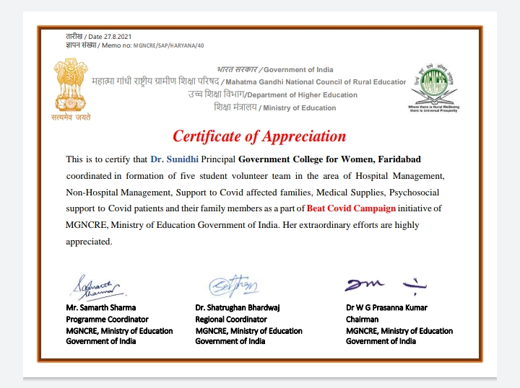
Title of the Activities & date | Organising unit/ agency/ collaborating agency | Number of teachers co-ordinated such activities | Number of students participated in such activities | Achievements/  Remarks
5) NSS Day Celebration 24th September, 2021 | NSS Unit | Dr. Rachna Saini  Dr. Raman Kumar | 50 students | NSS Foundation Day celebrations by NSS unit  24 September 2021  52nd Foundation Day of NSS (National Service Scheme) was celebrated at Government Women's College, Faridabad where a special plantation and cleanliness drive was organised under the Azadi ka Amrit Mahotsav . NSS volunteers enthusiastically planted dozens of saplings in and around the campus. The volunteers also took an oath to make the society tobacco free.  Inaugurating the campaign by planting Neem and Bada saplings, she stressed on the role of youth in the task of nation building. She told that that to fulfil this dream of the Father of the Nation, on 24 September 1969, first Vice-president of India and the Chairman of the University Grants Commission Dr. Radhakrishnan talked about celebrating 24th September as National Service Scheme Day in all colleges and universities. Since then, every year this day is celebrated as NSS Day. Speaking on this occasion, the Principal congratulated NSS PO Dr. Rachna Saini for being chosen as the Best NSS Program Officer at the university level and Kajal Singh, the student of the college, for being chosen as the best volunteer. NSS In-charge Dr. Rachna Saini told that the main objective of self-service scheme is social welfare, for which various types of awareness programs are run by the college from time to time. On this occasion Mrs. Ritika Gupta, Mr. Balbir Singh Dahiya, Mrs. Neelam Rani, Mrs. Shalini Khurana, Dr. Raman Kumar, Dr. Varsha Sharma, Mrs. Priya Saini, Mrs. Poonam Sharma, Mrs. Chanchal Sharma, Mrs. Savita Nagar etc. were present.
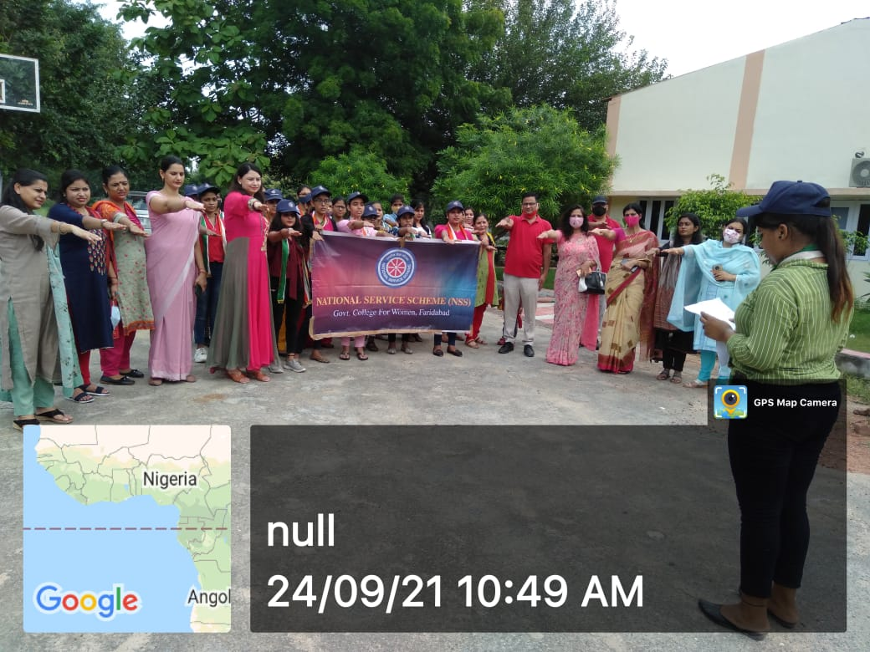
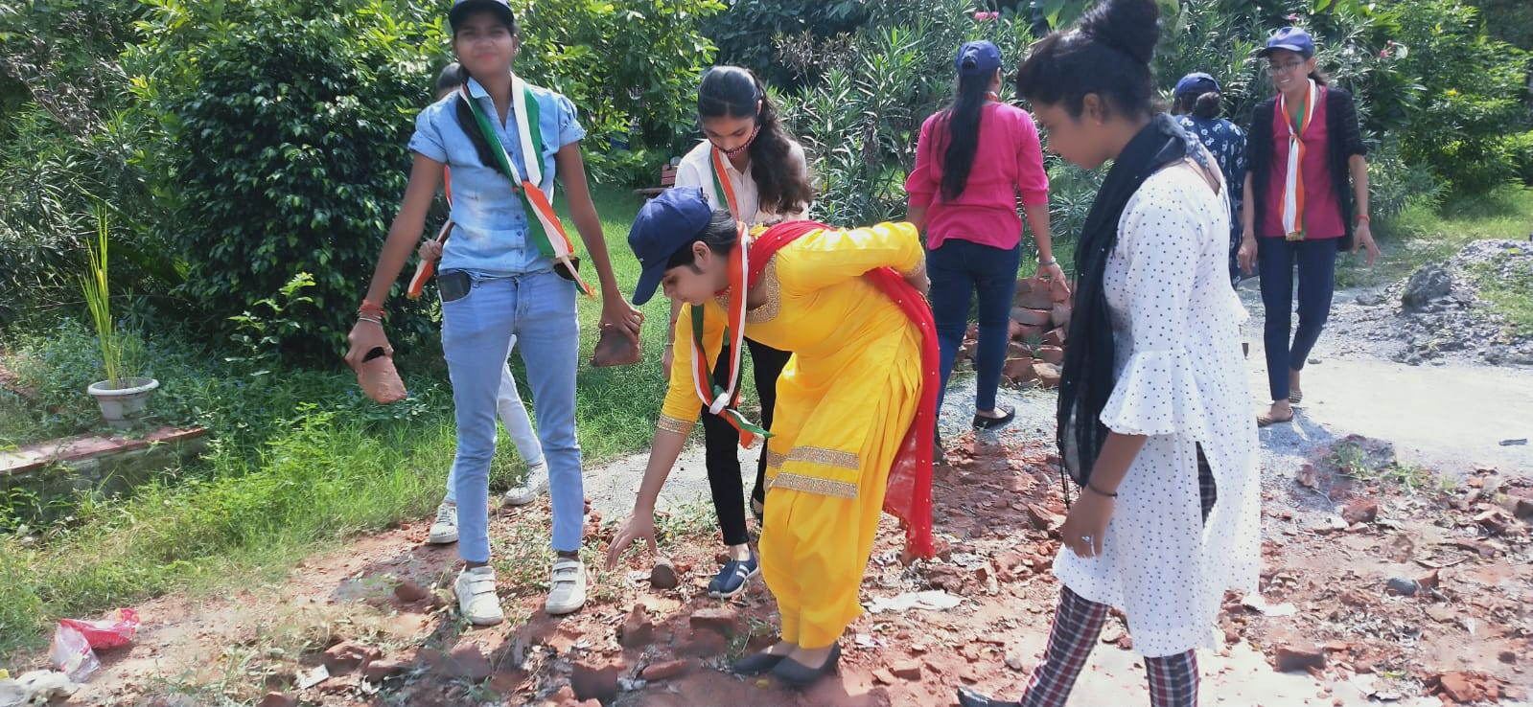
Title of the Activities & date | Organising unit/ agency/ collaborating agency | Number of teachers co-ordinated such activities | Number of students participated in such activities | Achievements/  Remarks
6) Felicitation of NSS Program Officer Dr. Rachna Saini and NSS Volunteer Kajal Singh,5th September,2021 | MDU Rohtak | Dr. Rachna Saini | One student | NSS Program Officer Dr. Rachna Saini and NSS Volunteer Kajal Singh participated in Teacher’s Day celebration held at MDU, Rohtak were felicitated by the Hon’ble Governor Haryana along with entire MDU’s NSS team. Respected Principal Dr. Sunidhi congratulated NSS PO and NSS Volunteer on their felicitation.
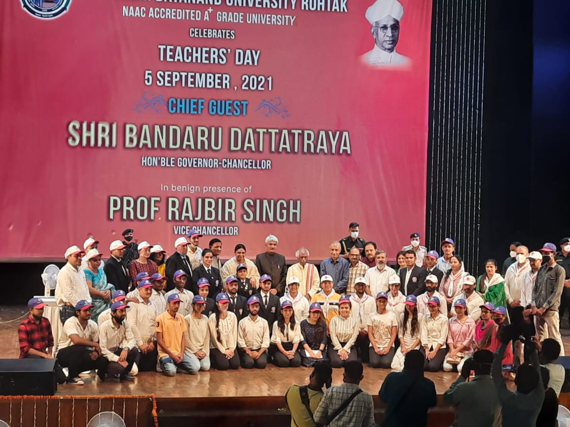
Title of the Activities & date | Organising unit/ agency/ collaborating agency | Number of teachers co-ordinated such activities | Number of students participated in such activities | Achievements/  Remarks
7) NSS State Level Camp from 19th to 25th october 2021 | Chaudhary Ranbir Singh University, Jind | Dr. Rachna Saini | 2 students | NSS. State Level Camp was organized in chaudhary Ranbir Singh University, Jind from 19th to 25th october 2021. NSS volunteers of GCW  Shivangi Tiwari from BJMC 1st year and Bindu, from B. A 3rd year participated enthusiastically in the camp. They participated in various activities held during camp i.e. yoga, cleanliness drive, awareness rallies and other sports and cultural activities.  OurWorthy Principal Dr. Sunidhi Congratulated students for their active participation in state level camp.NSSincharge Dr. Rachna Saini said that these activities provides platform for the students which helps them to tackle their fears, facilitates in self growth and discipline in life.

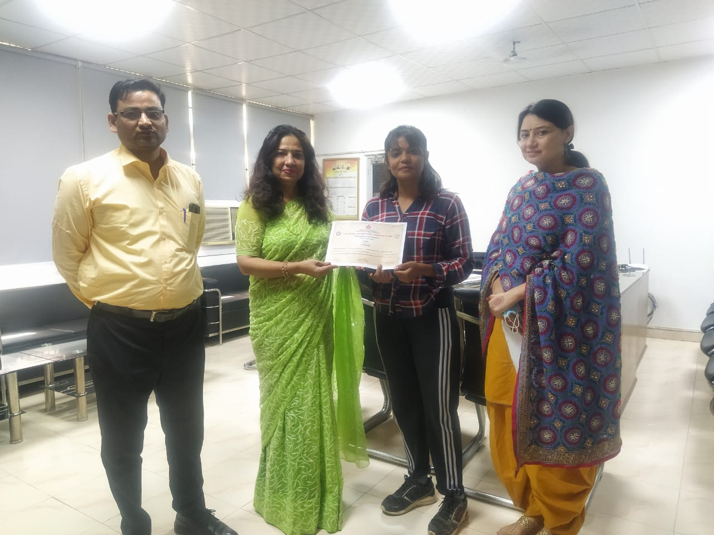
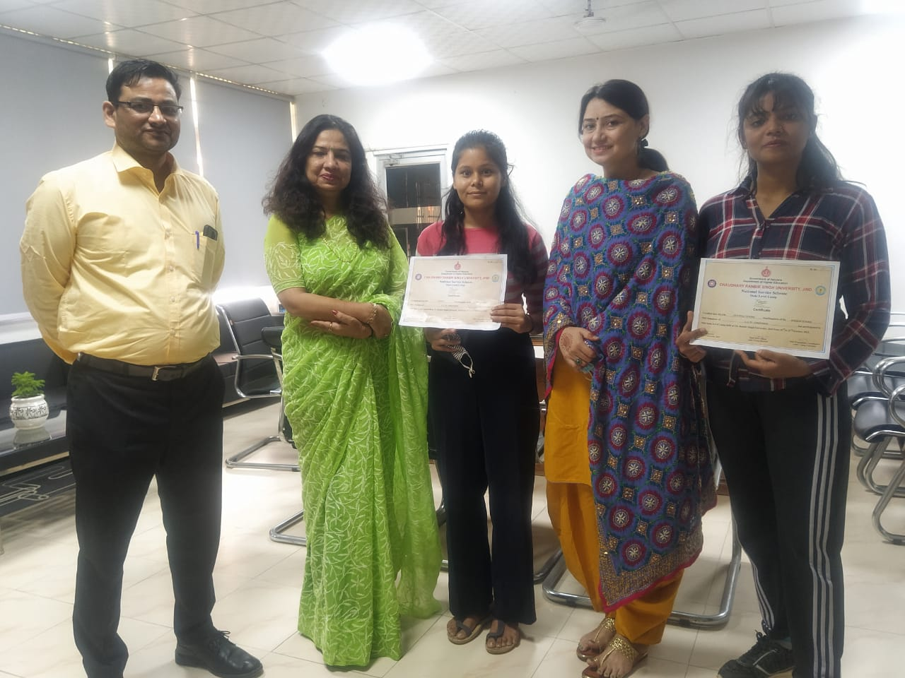

Title of the Activities & date | Organising unit/ agency/ collaborating agency | Number of teachers co-ordinated such activities | Number of students participated in such activities | Achievements/  Remarks
8) University Level Camp at CRA Sonipat, 25th Oct to 31st October 2021 | MDU Rohtak | Dr. Rachna Saini | 6 | University level camp was organised by Maharshi Dayanand University Rohtak from 25th October 2021 to 31st October2021 at CRA Sonipat .  six volunteers from our college actively participated in this camp. Maina(BAJMC-2nd year) Deepika (BBA -2nd year)  Kirti( BAJMC-2nd year)  Preeti Sharma (BAJMC-1st year)  Ruby(BA-3rd year) and  Tanu kanth (BAJMC-1st year)  Various activities like yoga, cleanliness drive, awareness rallies etc work being organised in the camp.Our student enthusiastically participated in the activities and learnt a lot.  Our Worthy Principal Dr. Sunidhi Congratulated student for her active participation in University level camp. NSS incharge Dr. Rachna Saini said that this Camp provides a platform to the volunteers to groom their personality helps them in becoming good leader.

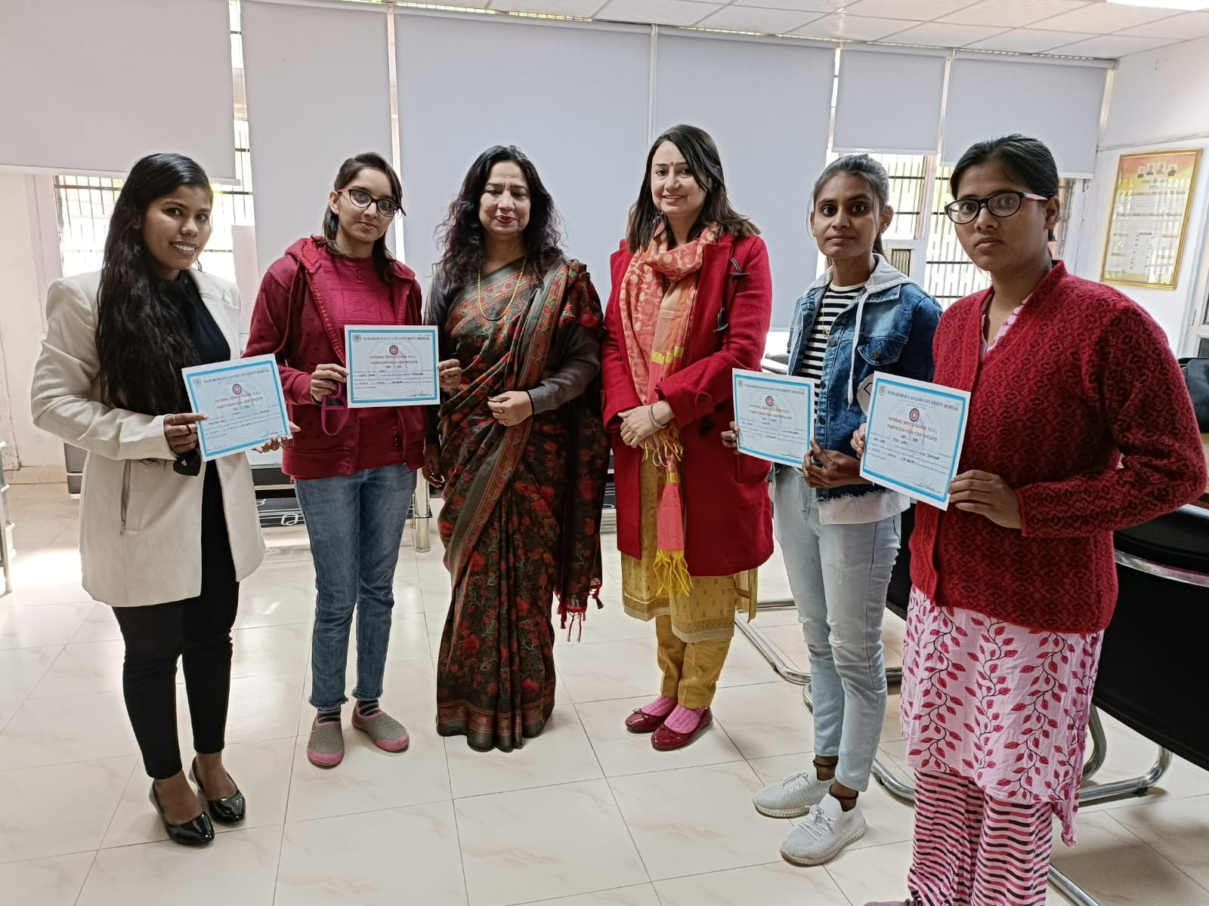

Title of the Activities & date | Organising unit/ agency/ collaborating agency | Number of teachers co-ordinated such activities | Number of students participated in such activities | Achievements/  Remarks
9) One day cleaning camp, 27th Oct 2021 | NSS Unit | Dr. Rachna Saini  Dr. Raman Kumar, Dr. Varsha Sharma, Ms. Priya Saini, Ms. Chanchal Sharma, Ms. Poonam Sharma, Dr. Neha Vij and Ms. Savita Nagar | 50 students | Under the joint aegis of National Service Scheme Unit of Government Women's College, Faridabad and NSS Regional Directorate of Ministry of Youth Affairs and Sports, Delhi, a one-day cleanliness campaign programme was organized under Azadi Ka Amrit Mahotsav.  The volunteers of National Service Scheme of GCW, Faridabad, Pandit Jawaharlal Nehru Post Graduate College, Faridabad and J.C Bose University Faridabad participated in special cleaning drive outside Old Railway Station, Faridabad with successful disposal of 500 kg polythene and other waste.  Inaugurating the campaign, Mr. Harish, representative of NSS unit of MDU and also a recipient of Indira Gandhi Award, and Shri Manoj Kumar, representative of Regional Directorate of Ministry of Youth Affairs and Sports, Delhi called upon the students to make people aware about cleanliness. It was shared that the cleanliness campaign was launched by Hon'ble Prime Minister Narendra Modi in the year 2014 on the occasion of Gandhi Jayanti. The representatives shared that that the country is celebrating the 75th year of independence as the nectar festival of independence. Its main objective is to make the country clean and healthy.  On this occasion, Officiating Principal, Ms. Ritika Gupta encouraged the volunteers towards cleanliness and appreciated the work done by them. On this occasion, the NSS Program Officer of the college Dr. Rachna Saini talked about the benefits of keeping our houses and environs clean. Dr. Raman Kumar, Dr. Varsha Sharma, Ms. Priya Saini, Ms. Chanchal Sharma, Ms. Poonam Sharma, Dr. Neha Vij and Ms. Savita Nagar were also present on this occasion.
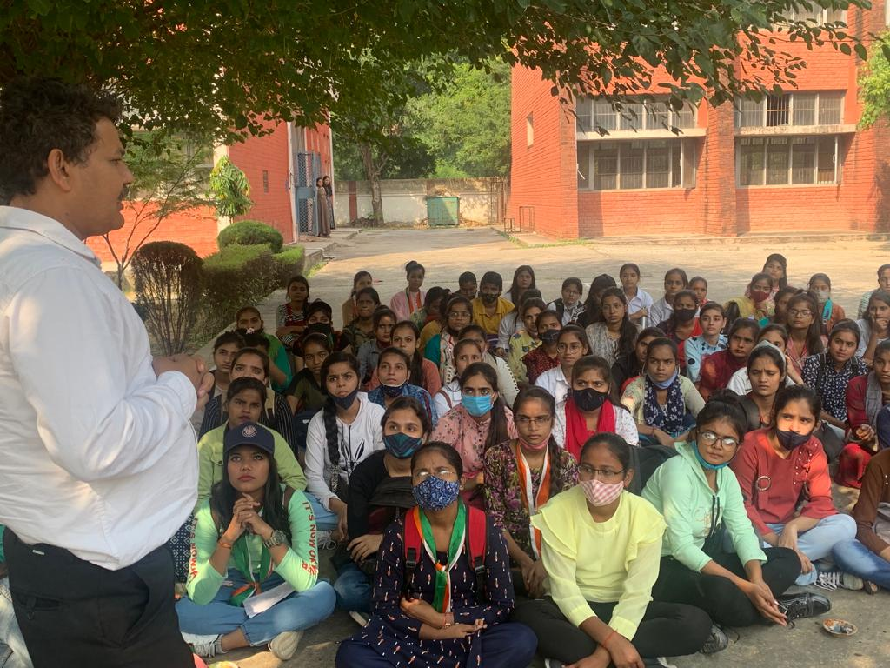

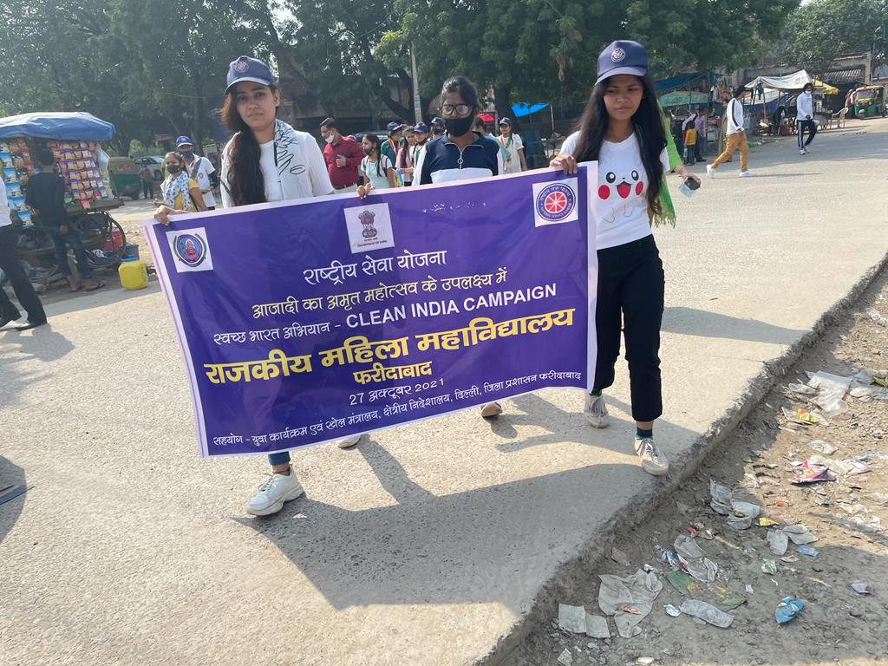
Title of the Activities & date | Organising unit/ agency/ collaborating agency | Number of teachers co-ordinated such activities | Number of students participated in such activities | Achievements/  Remarks
10) NSS Youth leadership training Camp from 2nd to 10th Nov 2021.) | Maharishi Dayanand University, Rohtak at Manali | Dr. Rachna Saini | 2 students | NSS Youth leadership training Camp was organized by Maharishi Dayanand University, Rohtak at Manali from 2nd to 10th nov 2021. NSS volunteer Deepika from BA2nd year and Maina from BAJMC 2nd year participated enthusiastically in the camp. They participated in various activities held during camp.  Our Worthy Principal Dr. Sunidhi Congratulated student for their active participation in University level YLTC camp. NSS incharge Dr. Rachna Saini said that this Camp provides a platform to the volunteers to groom their personality helps them in becoming good leader.
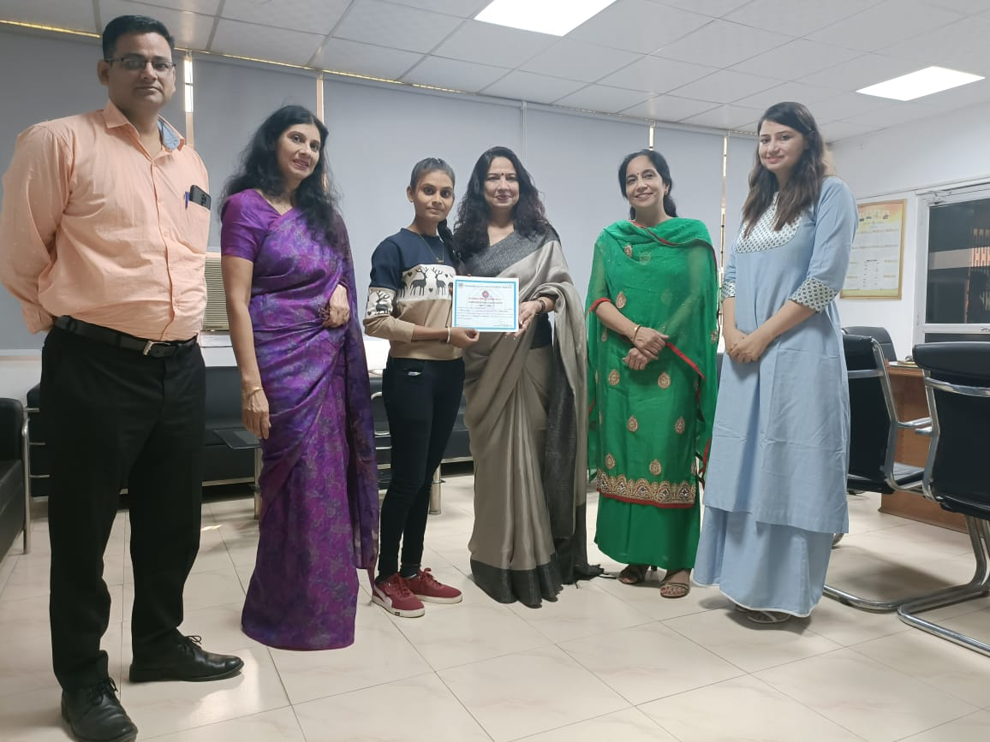
Title of the Activities & date | Organising unit/ agency/ collaborating agency | Number of teachers co-ordinated such activities | Number of students participated in such activities | Achievements/  Remarks
11) National Intergration Camp 19th Nov to 25th Nov 2021 | MDU Rohtak | Dr. Rachna Saini | 1 | National Integration camp was organised at Maharishi Dayanand University Rohtak from 19th November 2021 to 25th November 2021. Bindu bist student of B.A final year participated in this camp and was cultural head. Total 100 volunteers, of which 50 girls and 50 boys participated from different states of India such as Telangana ,Andhra Pradesh, Chandigarh ,Punjab ,Delhi, Jammu and Kashmir , North East state, Gujarat , UP, Uttrakhand and Rajasthan. Respected Principal Dr. Sunidhi congratulated volunteer for the achievement. Dr. Rachna saini, NSS PO also shared that NIC camp provide exposure to the volunteers.

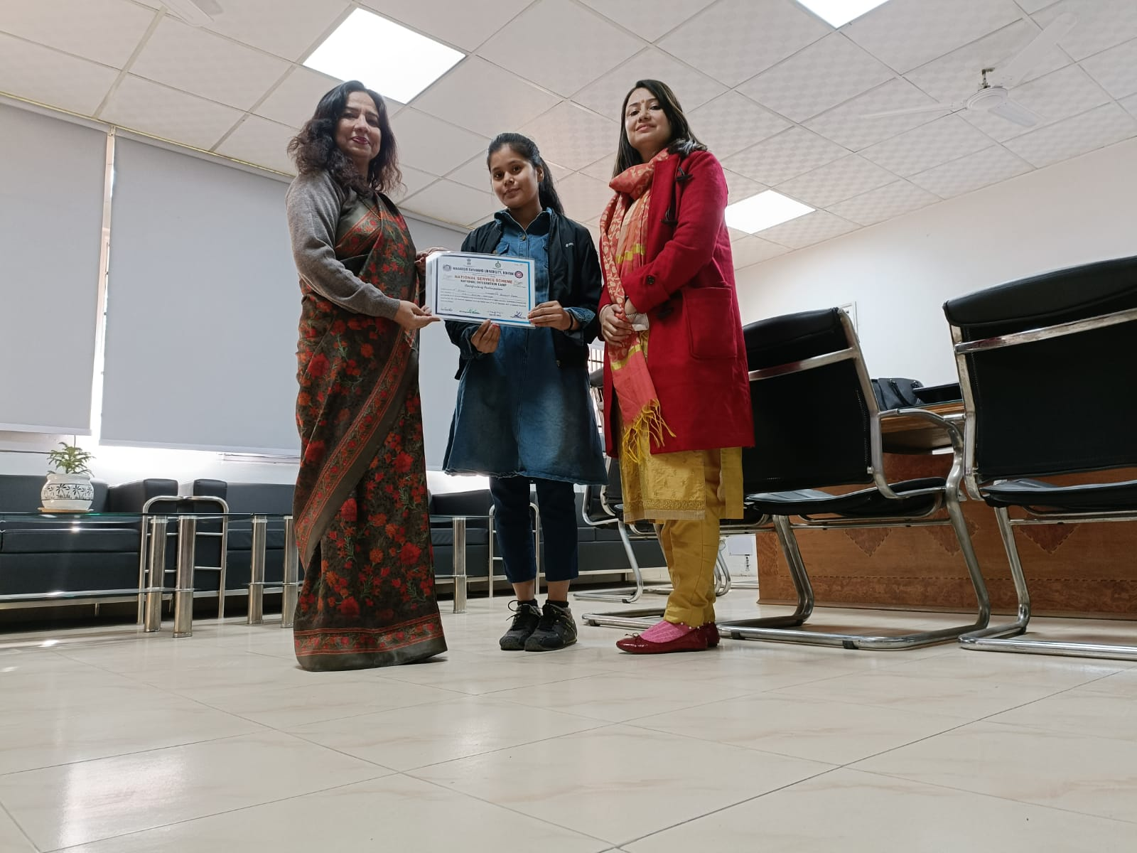
Title of the Activities & date | Organising unit/ agency/ collaborating agency | Number of teachers co-ordinated such activities | Number of students participated in such activities | Achievements/  Remarks
12) Corona Vaccine Drive on 11th December, 2021 | NSS Unit | Rachna Saini  Dr. Raman Kumar, Ms. Priya Saini, Ms Savita Nagar, Mr. Suresh, Mr. Keshav Kumar, Mr. Anuj, | 307 students | Corona Vaccine Drive was organized for the students and staff members of the college by the NSS unit of Government Women's College, Sector 16A, Faridabad.In which 61 people were given the first dose and 360 people were given the second dose. The vaccine was administered by Ms. Manjeet and Ms Kamlesh under the guidance of Dr. Shalini, who came from ESI Sector-8 Faridabad. Inaugurating the vaccine drive, Principal Dr. Sunidhi said that the state government has set a target to vaccinate all people above 18 years of age by December 31, so that people can be saved from the third possible wave of corona. That's why the second corona vaccine camp has been organized in the college.Earlier, a camp was organized in the college on August 25, 2021, in which 488 people were given first and second doses.  NSS in-charge Dr. Rachna Saini said that in this camp, 307 girl students, 18 staff members and 96 others were given the first and second doses of the vaccine. E-certificates were also issued to all by the team of doctors. On this occasion Prof. Archana Verma, Dr. Raman Kumar, Ms. Priya Saini, Ms Savita Nagar, Mr. Suresh, Mr. Keshav Kumar, Mr. Anuj, and NSS volunteers were present.

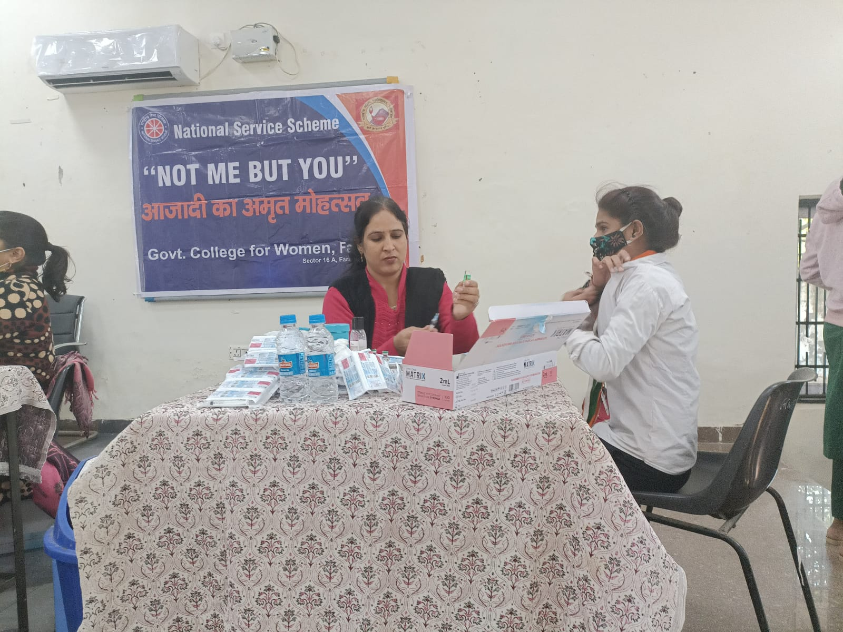

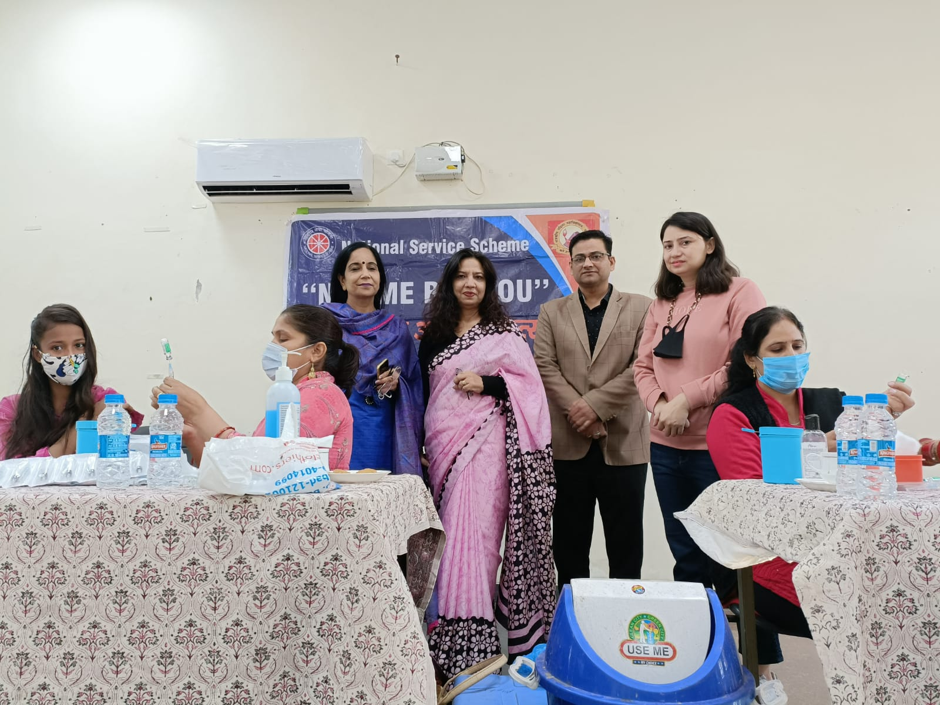

Title of the Activities & date | Organising unit/ agency/ collaborating agency | Number of teachers co-ordinated such activities | Number of students participated in such activities | Achievements/  Remarks
13) National Intergration Camp, 14th Dec to 23th Dec 2021 | Orissa | Dr. Rachna Saini | 1 | NSS volunteers Shivangi of BAJMC-1st year participated in the National Integration camp being organised at Orissa from 14 December2021 to 23rd December, 2021.She got a chance to meet honorable governor of Orissa Shri Ganesh Lal ji. She was overwhelmed to meet the Governor and she also shared her experiences as volunteer of this camp along with other NSS volunteers of our college.  Our Worthy Principal Dr. Sunidhi Congratulated student for her active participation in University level camp. NSS incharge Dr. Rachna Saini said that this Camp provides a platform to the volunteers to groom their personality helps them in becoming good leader.

Title of the Activities & date | Organising unit/ agency/ collaborating agency | Number of teachers co-ordinated such activities | Number of students participated in such activities | Achievements/  Remarks
14) Youth leadership training camp, Manali, 24th Dec to 3rd Jan 2021 | Manali | Dr. Rachna Saini | 2 | Youth leadership training camp was organised at Manali from 24th December 2021 to 3rd January 2022 . Program coordinator Mr. Ranbir Singh Gulia motivated the students and conducted the programme in very disciplined way. Two students of our college Antima and kirti ( BAJMC-2nd year) participated in this camp. Various activities like yoga awareness program, survey of the village, benefit of exercise and its importance, lecture on various current issues were discussed in this camp.  Our Worthy Principal Dr. Sunidhi Congratulated student for her active participation in University level camp. NSS incharge Dr. Rachna Saini said that this Camp provides a platform to the volunteers to groom their personality helps them in becoming good leader.

Title of the Activities & date | Organising unit/ agency/ collaborating agency | Number of teachers co-ordinated such activities | Number of students participated in such activities | Achievements/  Remarks
15)

