Govt. College for Women, Faridabad
(July-June)
2021-2022
Title of the Activities & date | Organising unit/ agency/ collaborating agency | Number of teachers co-ordinated such activities | Number of students participated in such activities | Achievements/  Remarks
1) One day webinar on 3rd July 2021 under Abhivyakti series on ‘Photo-Journalism | Department of Journalism and Mass Communication of Government College for Women, Faridabad in collaboration with Government P.G. College, Panchkula | 4 teachers  Ms. Shalini Khurana  Ms. Rachna Saini  Ms. Savita  Mr. Suresh | 90 students | Department of Journalism and Mass Communication of Government College for Women, Faridabad in collaboration with Government P.G. College, Panchkula organised a one day webinar on 3rd July 2021 under Abhivyakti series on ‘Photo-Journalism by Ms. Prerna Sodhi, Freelance Photojournalist. She has worked as journalist with The Times of India, India Today and Wall Street Journal(India). In a decade long career, she had dabbled in novel editing, teaching and documentary, photography and videography. She shared her rich experiences with students. She said that for being a good photojournalist, you should follow your intuition and always prepare your mind. She informed students about various camera skills and how to create connections of the photographs with the story. She told students that you can’t instruct your subject while taking picture and also you cannot edit your picture in photo journalism. You only can change brightness and exposure. As it was an interactive session, students asked various questions. She answered all the questions very lucidly and cleared all the doubts. Officiating Principal Ms Ritika Gupta congratulated both the colleges for their collaboration and also highlighted the importance of photographs in Journalism, and how photographs create impact on readers mind. Around 90 students attended the session. Faculty members Ms. Shalini Khurana, Dr Rachna Saini, Mr. Suresh Kumar and Ms Savita Nagar from GCW Faridabad and Mr. Advitya Khurana, Dr Chitra, Mr Naveen Kumar, Mr Anil Pandey, and Ms Shreyasi from Government P.G. College Panchkula were present.
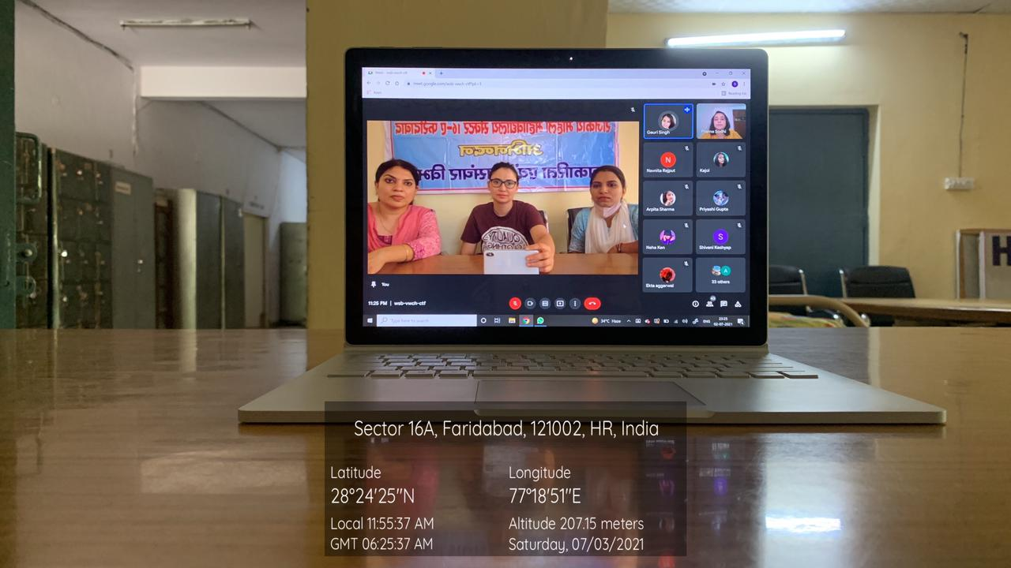

Title of the Activities & date | Organising unit/ agency/ collaborating agency | Number of teachers co-ordinated such activities | Number of students participated in such activities | Achievements/  Remarks
2) Tree plantation drive 22nd July, 2021 | NSS Unit | 2 teachers  Dr. Rachna  Dr. Raman Kumar | Students were not present due to COVID 19 | NSS unit of GCW Faridabad organized a tree plantation drive under social outreach programme in the college premises and in nearby areas.  The drive was inaugurated by principal Dr. Sunidhi. She shared that trees are natural oxygen producers that sustain all life on earth. She said that we should become aware about our environment and plant more and more tree so that we can save our surroundings and nature. Ms. Ritika Gupta, senior faculty said that tree plantation drive tackles many environmental issues like deforestation, erosion of soil, desertification in semi-arid areas, global warming etc. she also added that considering the manifold benefits of trees, including that they release oxygen into the air, absorb harmful gases such as carbon dioxide, carbon monoxide and Sulphur dioxide from the air and purify it NSS PO Dr. Rachna Saini shared that tree plantation should be the priority of nations and humanity if they want to survive and thrive. NSS unit of GCW planted around 100 trees inside and outside the campus. NSS volunteer planted trees in near by areas and also in adopted village  Mirtzapur. Dr. Raman kumar of NSS unit planted trees in adopted village Mirtzapur.
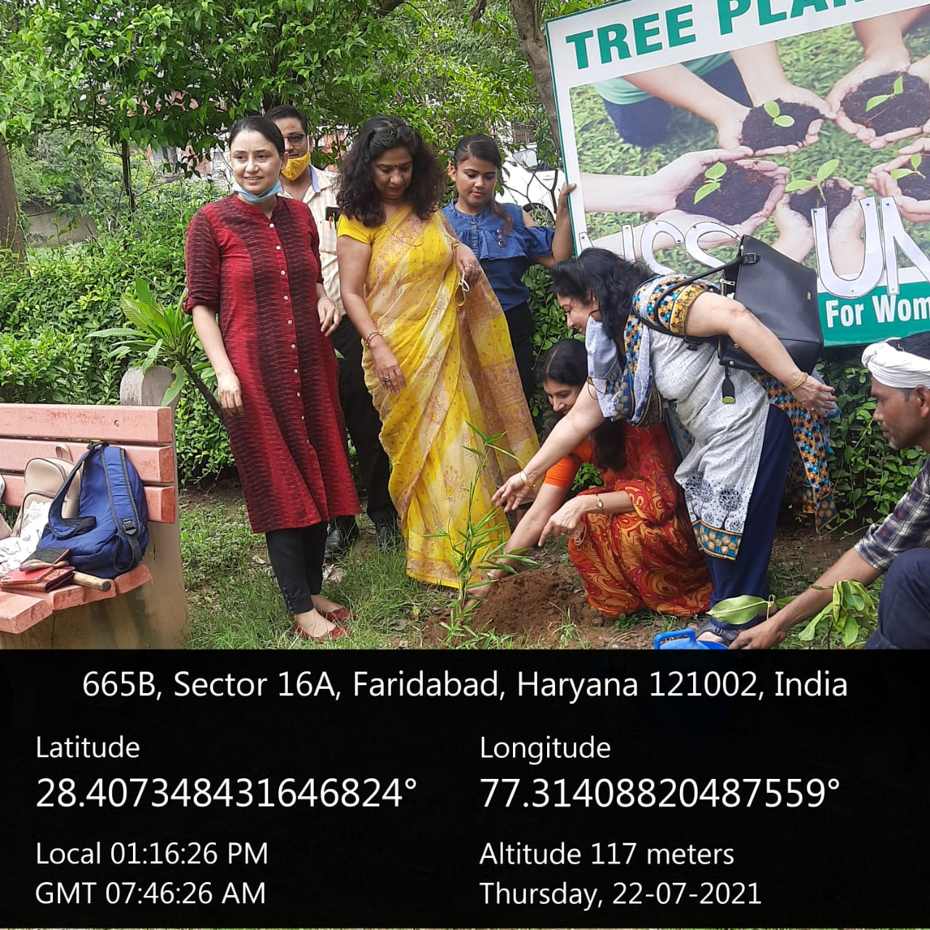
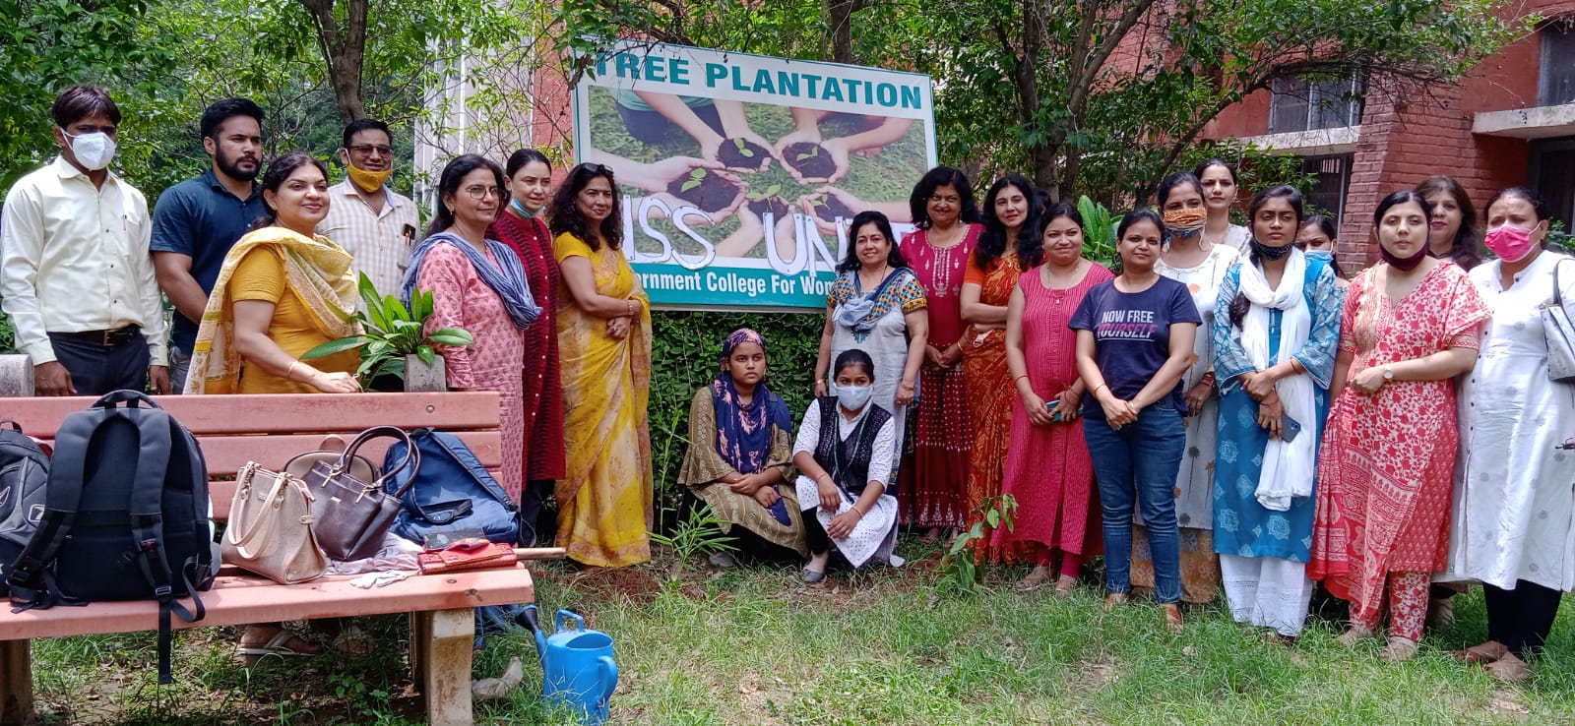

Title of the Activities & date | Organising unit/ agency/ collaborating agency | Number of teachers co-ordinated such activities | Number of students participated in such activities | Achievements/  Remarks
3) library day celebration
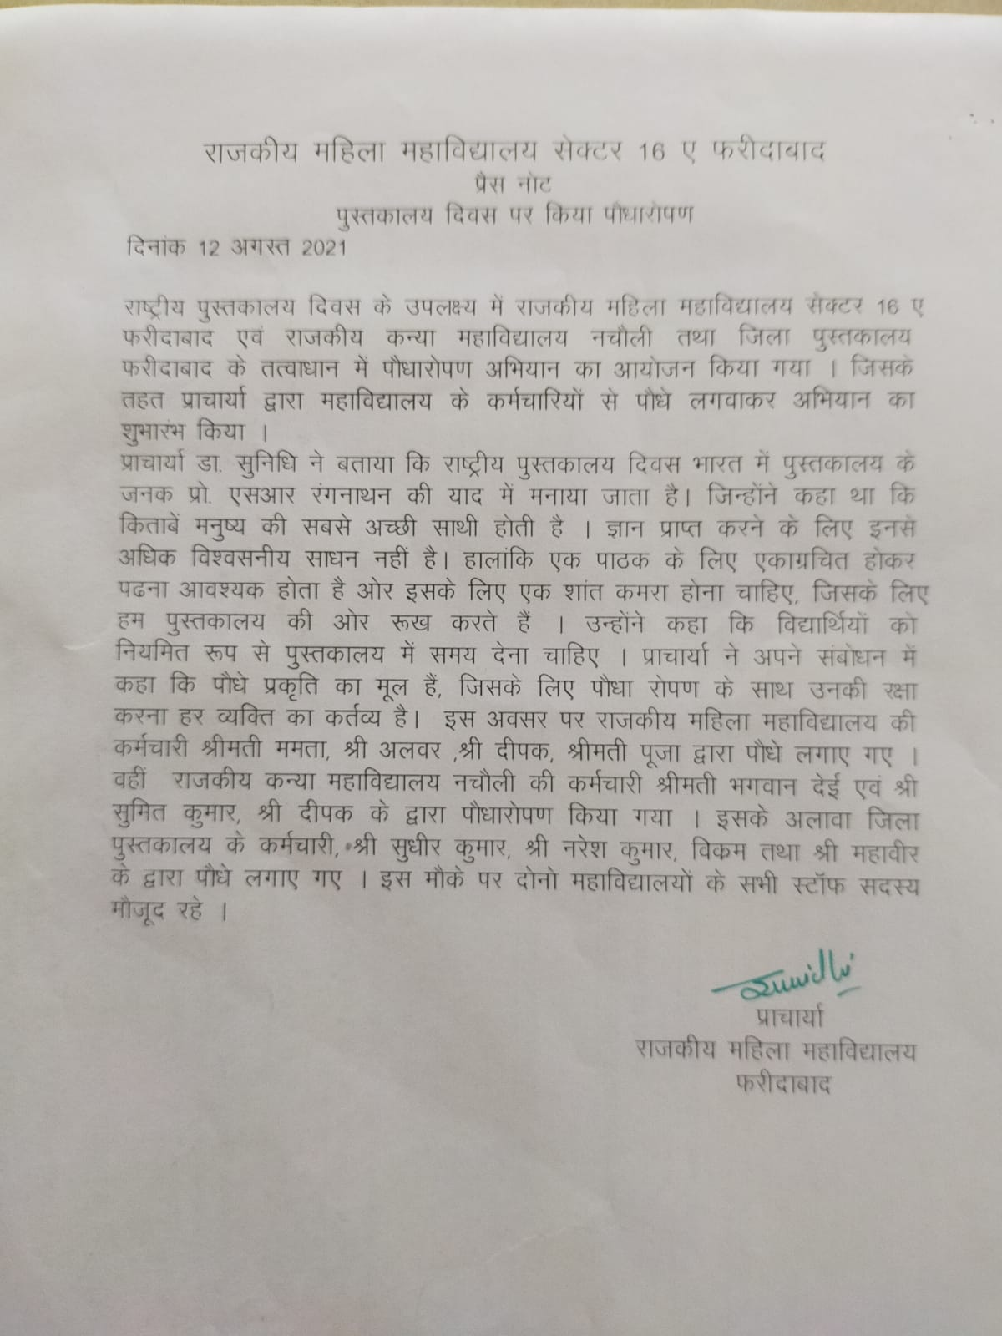

Title of the Activities & date | Organising unit/ agency/ collaborating agency | Number of teachers co-ordinated such activities | Number of students participated in such activities | Achievements/  Remarks
4) Independence day celebration 15th August, 2021 | NSS Unit and Music Department | All staff Members | 100 students
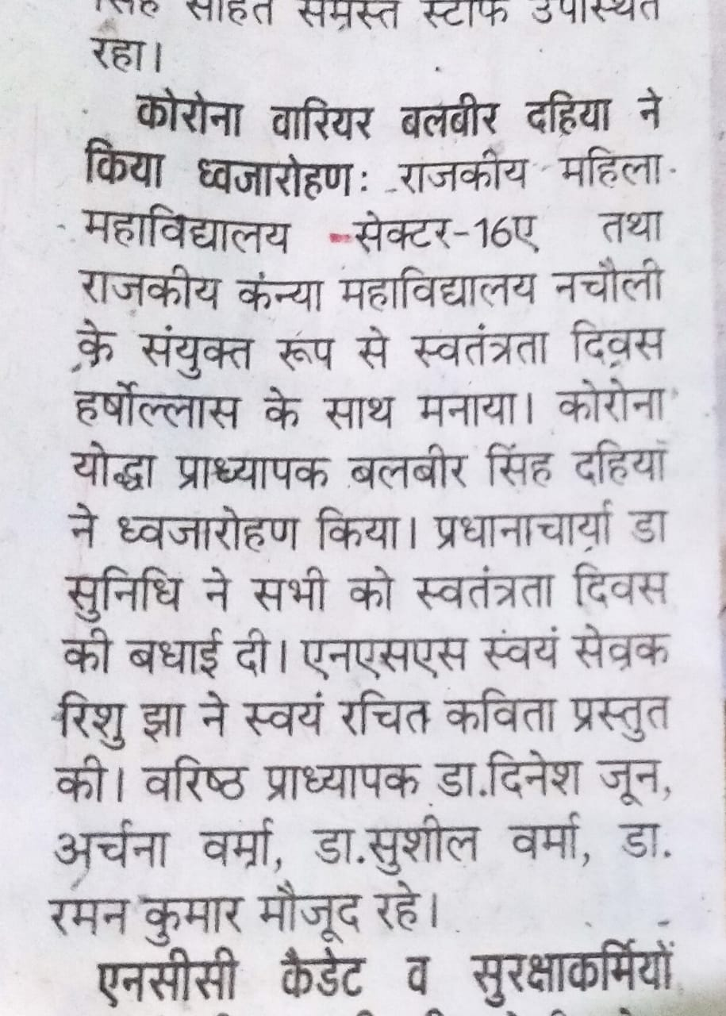

Title of the Activities & date | Organising unit/ agency/ collaborating agency | Number of teachers co-ordinated such activities | Number of students participated in such activities | Achievements/  Remarks
5) Tree plantation on Teacher’s day celebration on 5th September, 2021 | Eco club and Women Cell | Ms. Meenal Sabharwal  Ms. Parul Rana  Ms. Neelam Rani  Ms. Neha Aggarwal | Students were not present due to Covid-19. | To commemorate Teachers' Day, a tree plantation drive was held under the auspices of Lions Club Daffodils in Government College for Women, Faridabad . Dr.Sunidhi, Principal presided over the function. Eco Club and Women Cell which initiated the celebration of 'Poshan Mah' in the month of September, joined hands to organize the function. Around 50 plants that included trees like neem, amla, guava and ornamental plants like Aerocaria, Duffin Spodium, Peepal, Eucalyptus, Palm etc were planted. Besides Staff Council others present were Meenal Sabharwal , Parul Rana, Neha Aggarwal , Neelam Rani . Lions Governor Anil Arora, President Rajan Mehta were also present on the occasion. Students were not present due to pandemic.
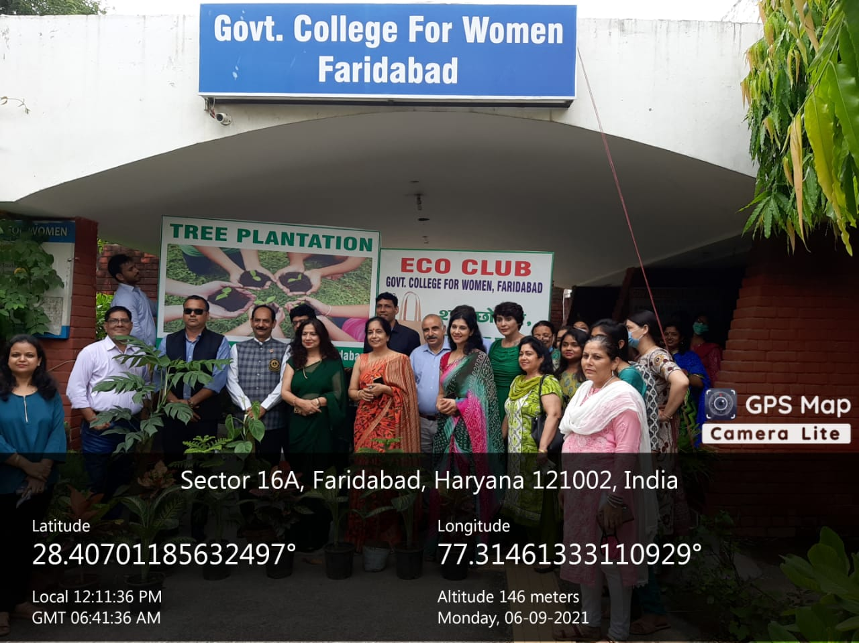
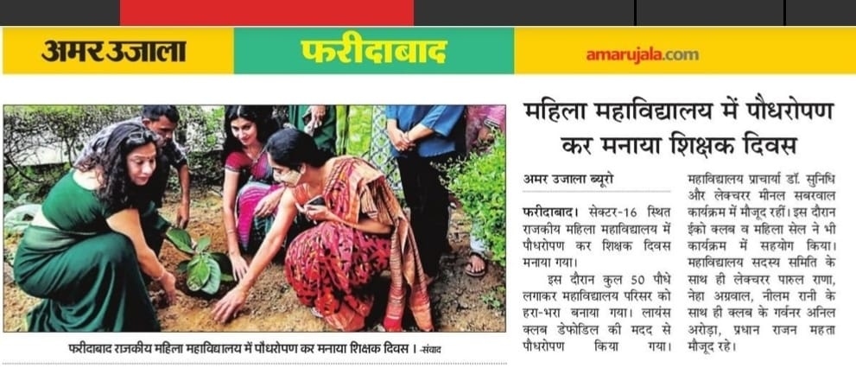

Title of the Activities & date | Organising unit/ agency/ collaborating agency | Number of teachers co-ordinated such activities | Number of students participated in such activities | Achievements/  Remarks
6) Award to Dr. Sunidhi, Principal GCW, Faridabad |  |  |  | Dr. Sunidhi, Principal GCW, Faridabad was conferred upon Dr. Sarvapalli Radhakrishnan Samman -2021 by Radio Maharani in association with Satyug Kala Kendra for her immense contribution in education field. On this occasion, a special interview with Dr Sunidhi was broadcast on Radio Maharani- an internet based radio station- to serve the cause of education. She thanked the organizers for recognizing women’s contribution and efforts in education during the felicitation and award ceremony.
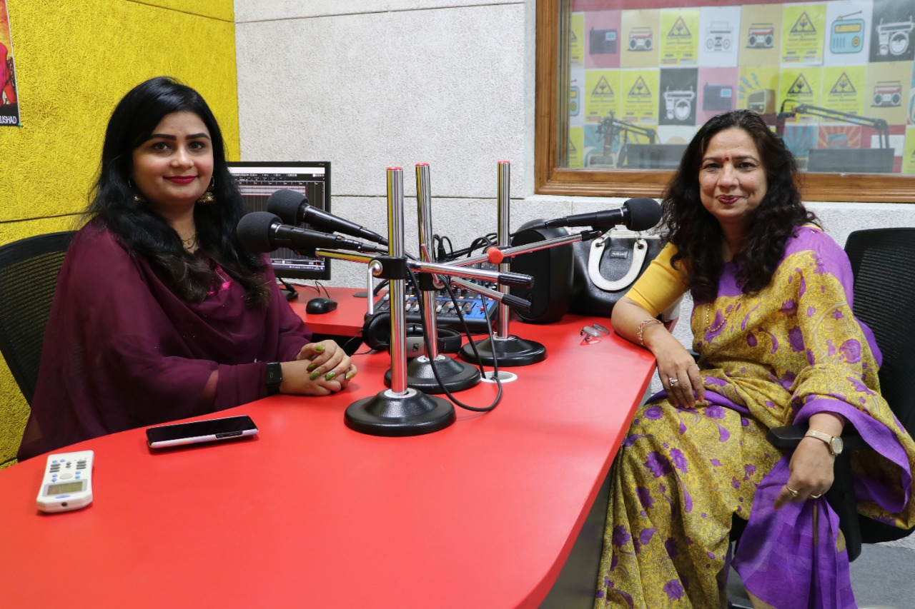

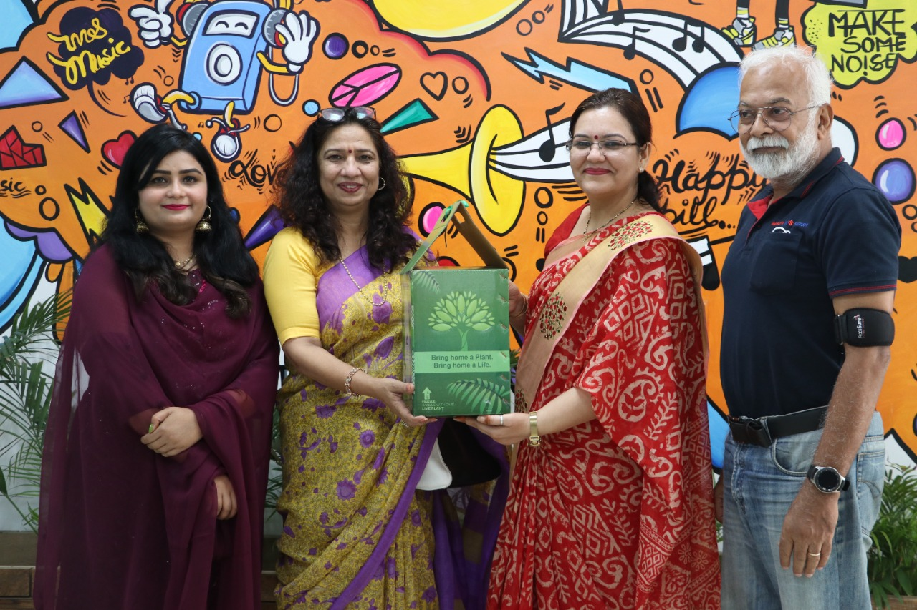

Title of the Activities & date | Organising unit/ agency/ collaborating agency | Number of teachers co-ordinated such activities | Number of students participated in such activities | Achievements/  Remarks
7) state level online kavita paath pratiyogita on 14th September, 2021 | Hindi Department of K. L. Mehta Dayanand College for Women | Ms. Neha Aggarwal | One student | Meenu chakravarti, Roll no 61 of B.Sc final year got second position in the state level online kavita paath pratiyogita organized by the Hindi Department of K. L. Mehta Dayanand College for Women, Faridabad on 14/09/2021 on the occasion of Hindi Diwas.
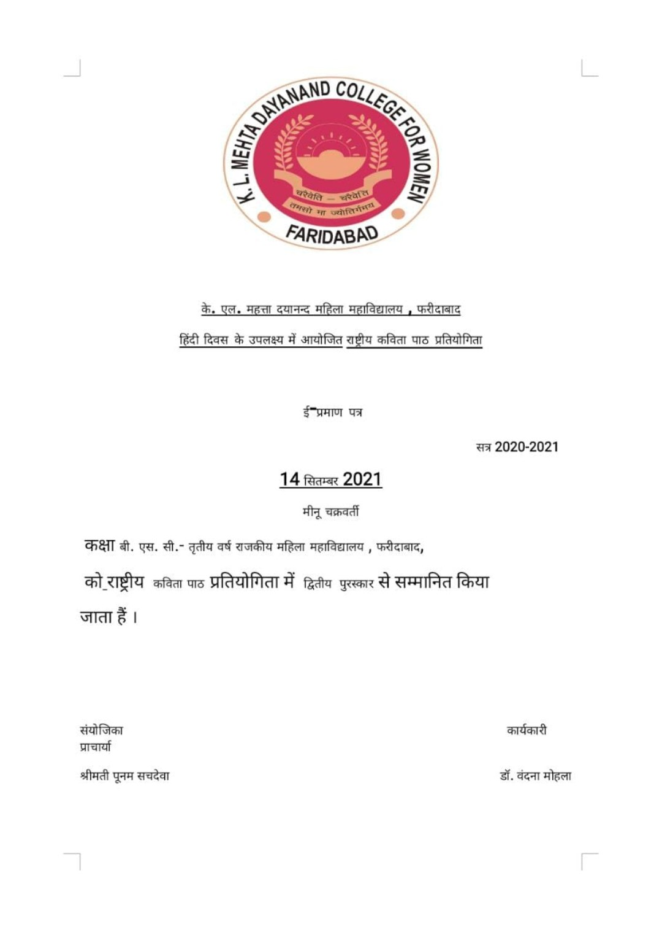

Title of the Activities & date | Organising unit/ agency/ collaborating agency | Number of teachers co-ordinated such activities | Number of students participated in such activities | Achievements/  Remarks
8) Car free day 22nd September, 2021 | Road Safety day | Ms. Sabharwal | For teachers | To commemorate International Car free Day, Worthy Deputy commissioner called on Sep 22 as car free day. The college observed it in right spirit. The parking looks deserted and everyone came either on foot or on local transport. Principal Dr.Sunidhi appreciated the incentive and propagated that every Wednesday will be considered as Car Free Day in future. Road Safety Club took the lead for the cause.
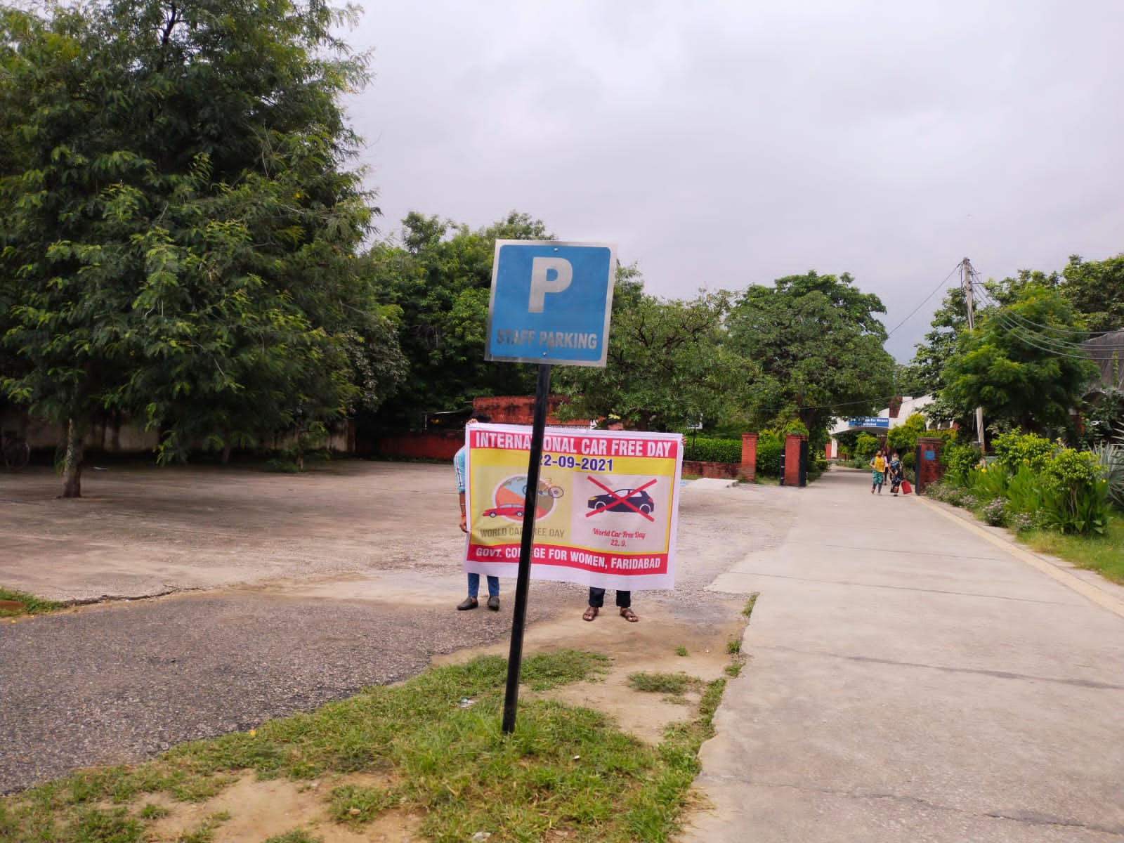
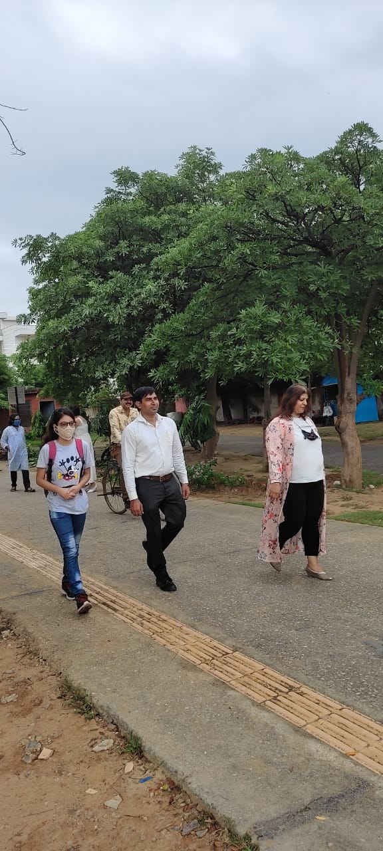

Title of the Activities & date | Organising unit/ agency/ collaborating agency | Number of teachers co-ordinated such activities | Number of students participated in such activities | Achievements/  Remarks
9) Several events under Poshan Maah on health, hygiene and nutrition on 06/09/2021, 15/09/2021 and 19/09/2021. | Women Cell, Eco Club, Department of Home science and department of Chemistery | Ms. Parul Rana  Ms. Meenal Sabharwal  Ms. Neelam Rani  Ms. Neha Aggarwal | 150 students | With reference to letter no. 29467-78 dated 31/08/2021 by Women and Child Development Department, Haryana, Women cell of Government College for Women, Faridabad organized several events on health, hygiene and nutrition on 06/09/2021, 15/09/2021 and 19/09/2021. The details of the events organized are as follows:  1. Tree plantation drive in collaboration with ECO club and Department of Home Science under the auspices of Lions Club Daffodils in our college on 06/09/2021. Dr. Sunidhi, Principal presided over the function. Around 50 plants  that included trees like neem, amla, guava and ornamental plants like Aerocaria,  Duffin Spodium, Peepal, Eucalyptus, Palm etc were planted. Besides Staff Council, others present were Ms. Meenal Sabharwal , Dr. Parul Rana, Ms. Neelam Rani, Dr. Neha Aggarwal and the entire present staff of GCW, Faridabad. Lions Governor Anil Arora, President Rajan Mehta were also present on the occasion.  2. A webinar by Dr. Monika Garg, Head of Nutrition, mhealth.ai was organized in collaboration with Home Science and Chemistry department on “Nutrition and Diet Awareness  for Pregnant Women, Children and Adolescent Girls” for the college students on 15/09/2019.  The speaker mainly emphasized on nutrition during pregnancy, how nutrition impacts health of  newborn child, which food to be included and avoided during pregnancy, importance of breast  feeding, why junk food is harmful to adolescents, importance of healthy eating, eating disorders  of children and many more. Our diet plays a major role in deciding how healthy we are and how well our body functions. She also talked about personal hygiene which basically refers to the conditions and practices that help to maintain health and prevent the spread of diseases. Total  88 students participated in this webinar.  3. State-level online Slogan Writing Competition on health and nutrition was also organized on 19/09/2021  under women cell in collaboration with Home Science and Chemistry Department to spread awareness among the college students. The first three winners were given the appreciation certificates along with the prize money of Rs. 500 (I position), Rs. 300 (II position) and Rs. 200 (III position). One special mention was also given.  Our worthy Principal Dr.Sunidhi has been the spine behind all the successful activities. She acts as a motivating force for the organization to run smooth. Our special thanks to her. I also want to thank the entire team of Women Cell and Chemistry Department.
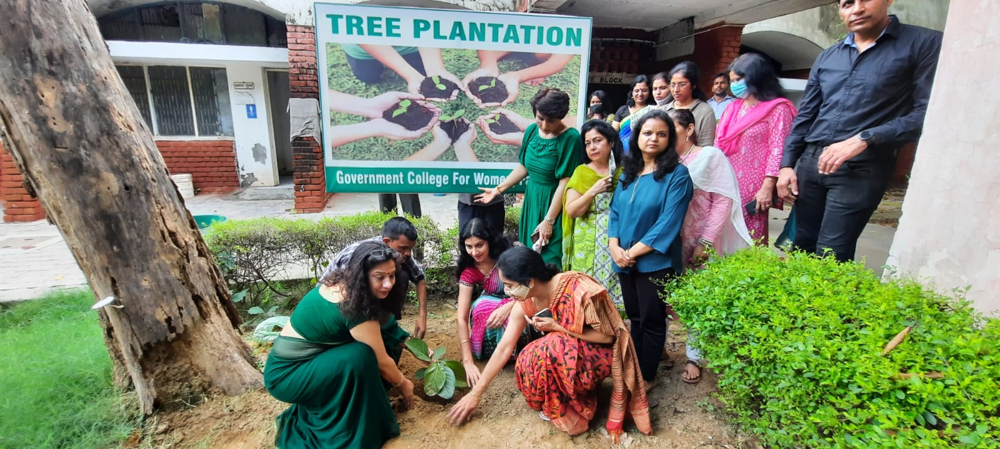
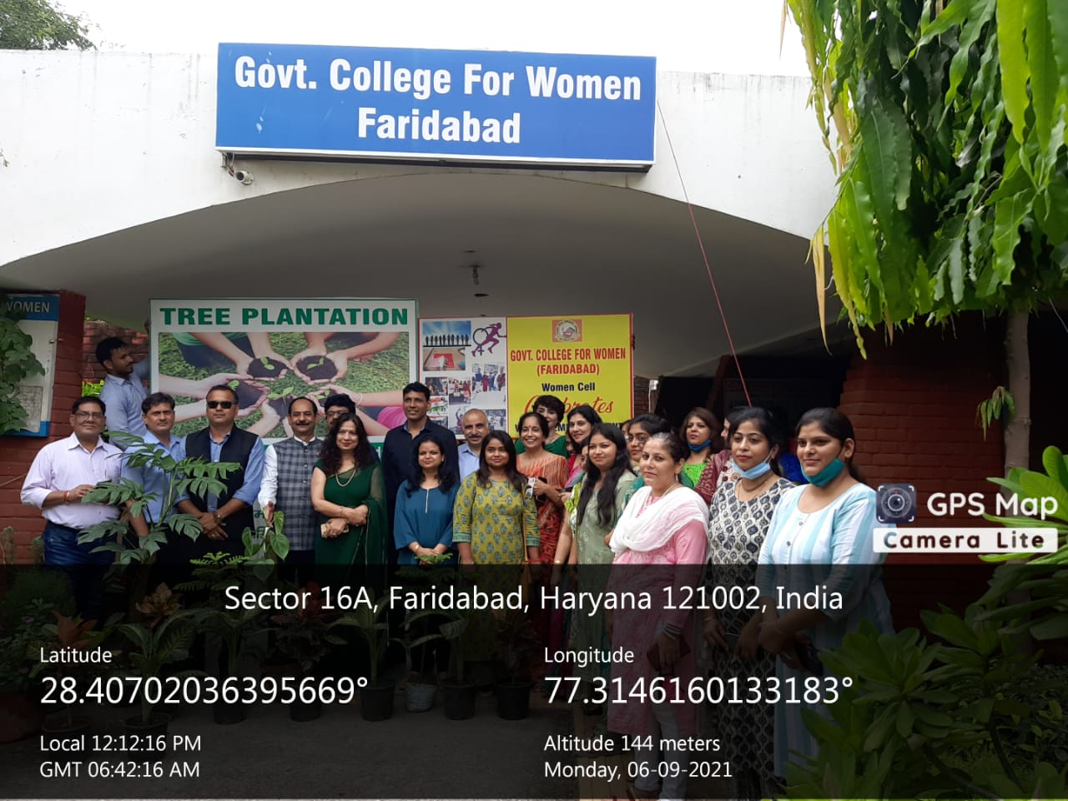
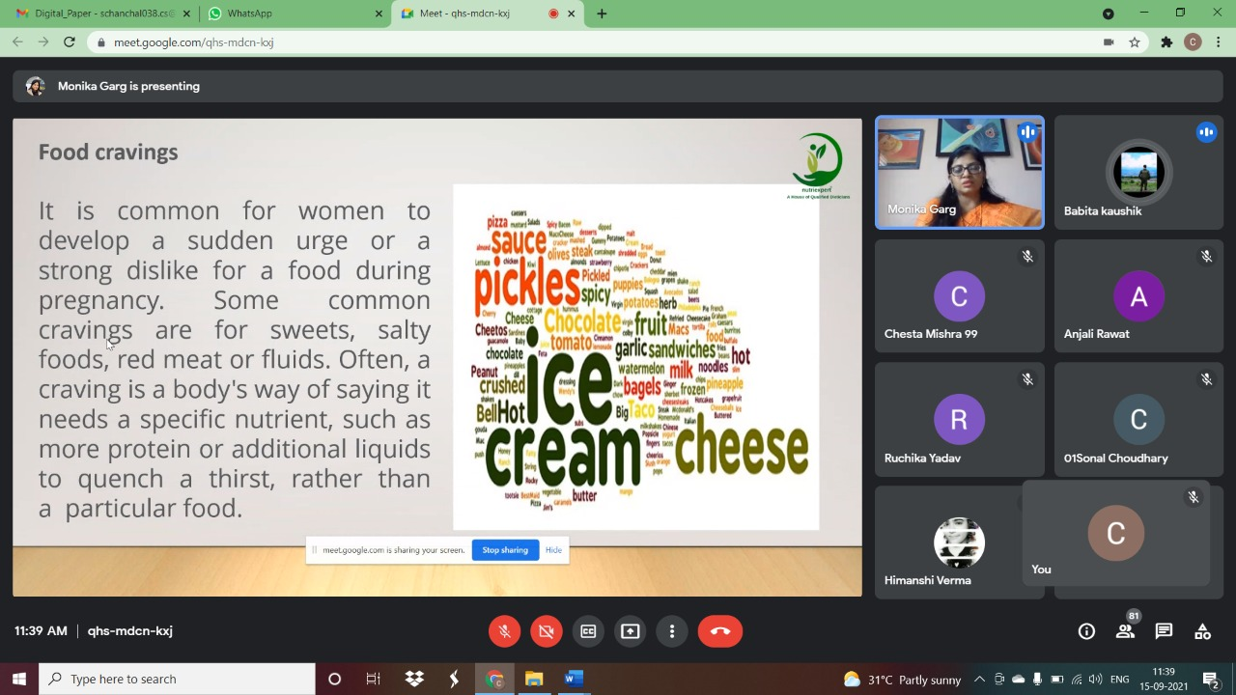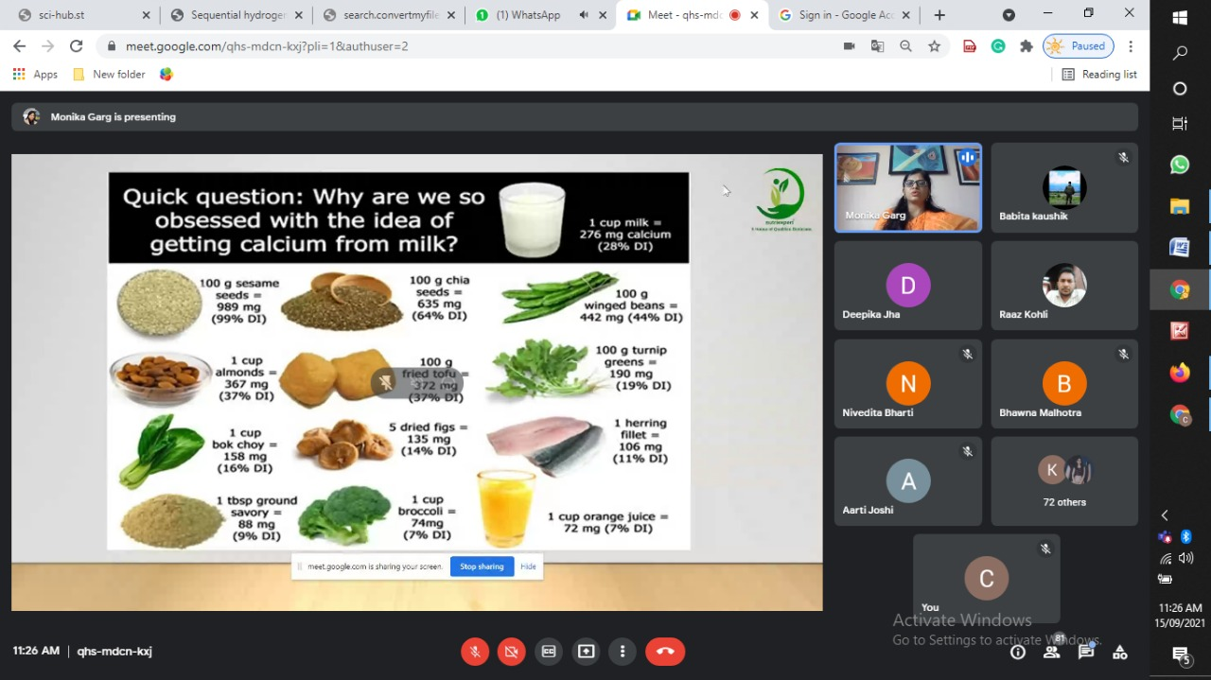

Title of the Activities & date | Organising unit/ agency/ collaborating agency | Number of teachers co-ordinated such activities | Number of students participated in such activities | Achievements/  Remarks
10) Hindi Divas celebration 14th September, 2021 | Department of Hindi | Dr. Raman Kumar |  | राजकीय महिला महाविद्यालय फरीदाबाद में हिंदी दिवस के उपलक्ष में एक निबंध लेखन प्रतियोगिता का आयोजन किया गया।। इस प्रतियोगिता में महाविद्यालय की अनेकों छात्राओं ने बढ़ चढ़कर हिस्सा लिया। B.a. प्रथम वर्ष की छात्रा आंचल ने प्रथम पुरस्कार तथा गौरी सिंह बीजेएमसी तृतीय वर्ष ने द्वितीय पुरस्कार और पुष्पा बीकॉम तृतीय वर्ष की छात्रा ने तृतीय पुरस्कार प्राप्त किया। एक अन्य प्रतियोगिता में हिंदी दिवस के उपलक्ष में आयोजित राष्ट्रीय कविता पाठ प्रतियोगिता में महाविद्यालय की बीएससी की छात्रा मीनू चक्रवर्ती ने राष्ट्रीय कविता पाठ प्रतियोगिता में द्वितीय स्थान प्राप्त किया। यह कविता केएल मेहता दयानंद महाविद्यालय फरीदाबाद ने कराई। इस खुशी के मौके पर महाविद्यालय की प्रिंसिपल डॉक्टर सुनिधि तथा कार्यक्रम के संयोजक एवं हिंदी विभाग के प्राध्यापक डॉक्टर रमन कुमार ने सभी विजेता छात्राओं को शुभकामनाएं दी
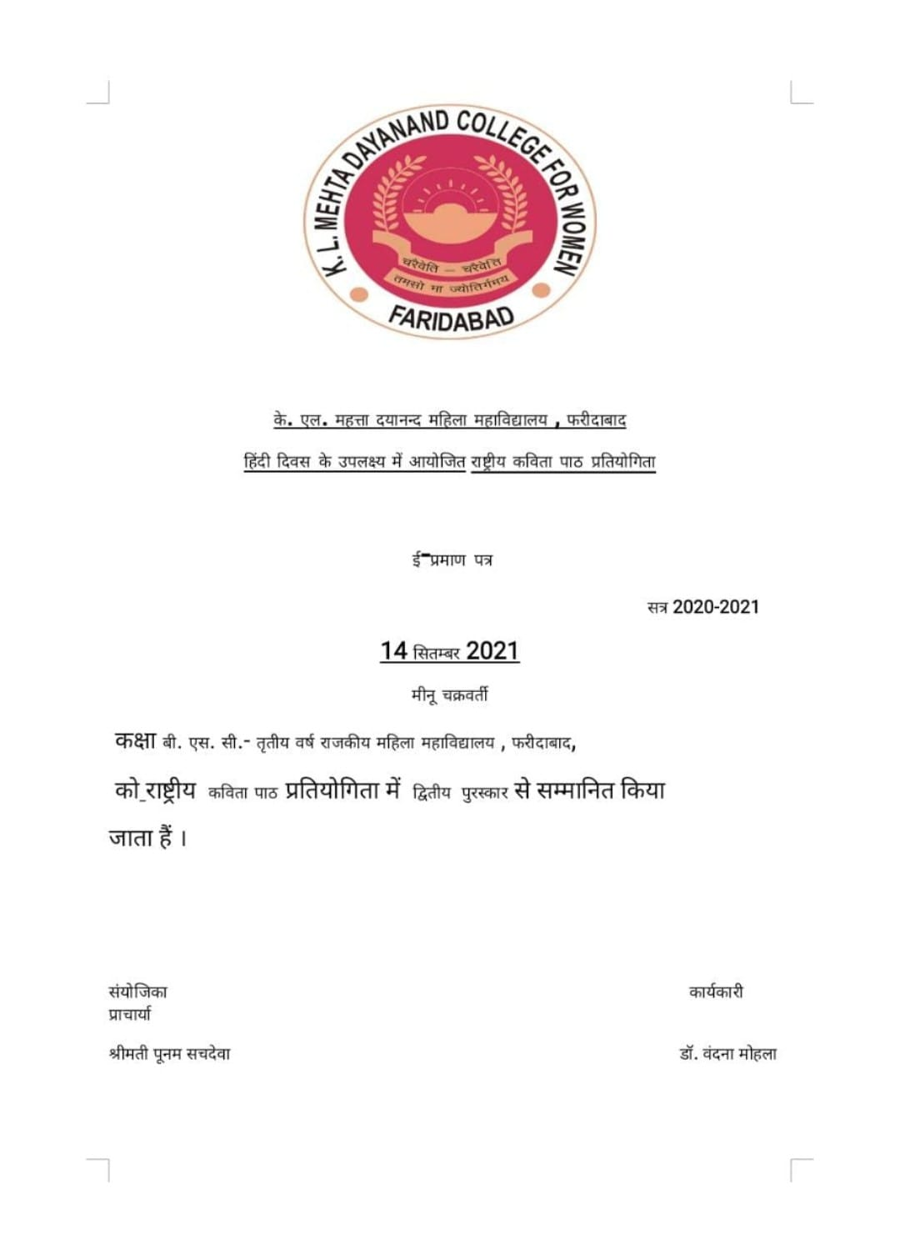

Title of the Activities & date | Organising unit/ agency/ collaborating agency | Number of teachers co-ordinated such activities | Number of students participated in such activities | Achievements/  Remarks
11) award as Best NSS volunteer on 24th September, 2021 | NSS Unit | Dr. Rachna Saini | 1 student | Our NSS volunteer Kajal Singh awarded as Best NSS volunteer at University level by Honourable Vice Chancellor prof. Rajbir Singh ji, on the occasion of NSS day celebration.

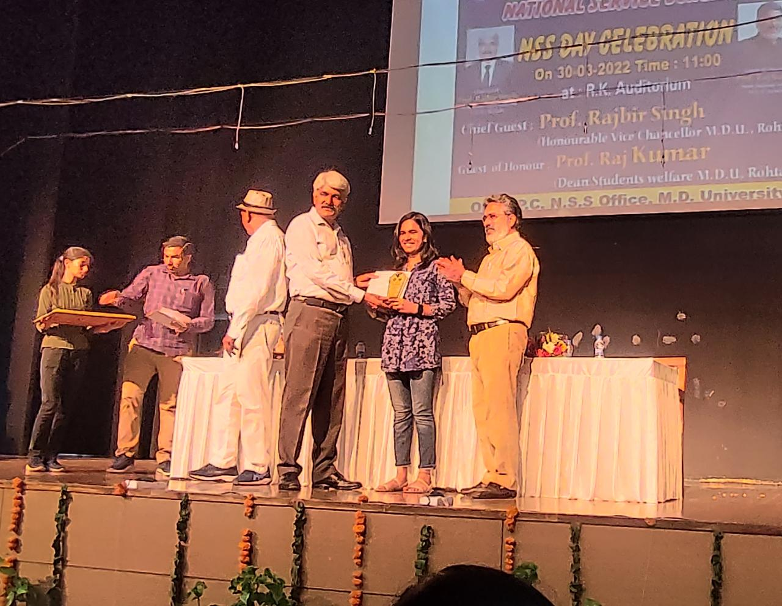

Title of the Activities & date | Organising unit/ agency/ collaborating agency | Number of teachers co-ordinated such activities | Number of students participated in such activities | Achievements/  Remarks
12) Award | NSS Unit | Dr. Rachna Saini | - | Ms. Rachna Saini, Assistant Professor of our college awarded as Best NSS program officer at University level by Honourable Vice Chancellor Prof Rajbir Singhji on the occasion of NSS day celebration.

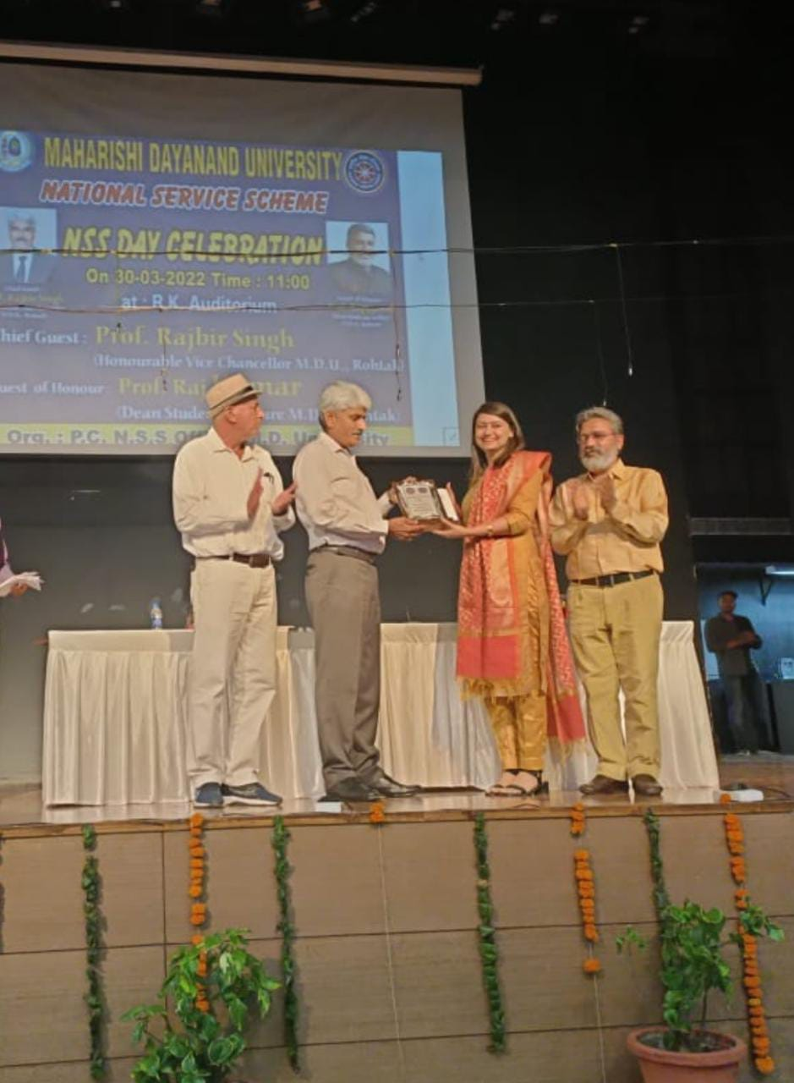

Title of the Activities & date | Organising unit/ agency/ collaborating agency | Number of teachers co-ordinated such activities | Number of students participated in such activities | Achievements/  Remarks
13) NSS Day Celebration 24th September, 2021 | NSS Unit | Dr. Rachna Saini  Dr. Raman Kumar | 50 students | NSS Foundation Day celebrations by NSS unit  24 September 2021  52nd Foundation Day of NSS (National Service Scheme) was celebrated at Government Women's College, Faridabad where a special plantation and cleanliness drive was organised under the Azadi ka Amrit Mahotsav . NSS volunteers enthusiastically planted dozens of saplings in and around the campus. The volunteers also took an oath to make the society tobacco free.  Inaugurating the campaign by planting Neem and Bada saplings, she stressed on the role of youth in the task of nation building. She told that that to fulfil this dream of the Father of the Nation, on 24 September 1969, first Vice-president of India and the Chairman of the University Grants Commission Dr. Radhakrishnan talked about celebrating 24th September as National Service Scheme Day in all colleges and universities. Since then, every year this day is celebrated as NSS Day. Speaking on this occasion, the Principal congratulated NSS PO Dr. Rachna Saini for being chosen as the Best NSS Program Officer at the university level and Kajal Singh, the student of the college, for being chosen as the best volunteer. NSS In-charge Dr. Rachna Saini told that the main objective of self-service scheme is social welfare, for which various types of awareness programs are run by the college from time to time. On this occasion Mrs. Ritika Gupta, Mr. Balbir Singh Dahiya, Mrs. Neelam Rani, Mrs. Shalini Khurana, Dr. Raman Kumar, Dr. Varsha Sharma, Mrs. Priya Saini, Mrs. Poonam Sharma, Mrs. Chanchal Sharma, Mrs. Savita Nagar etc. were present.
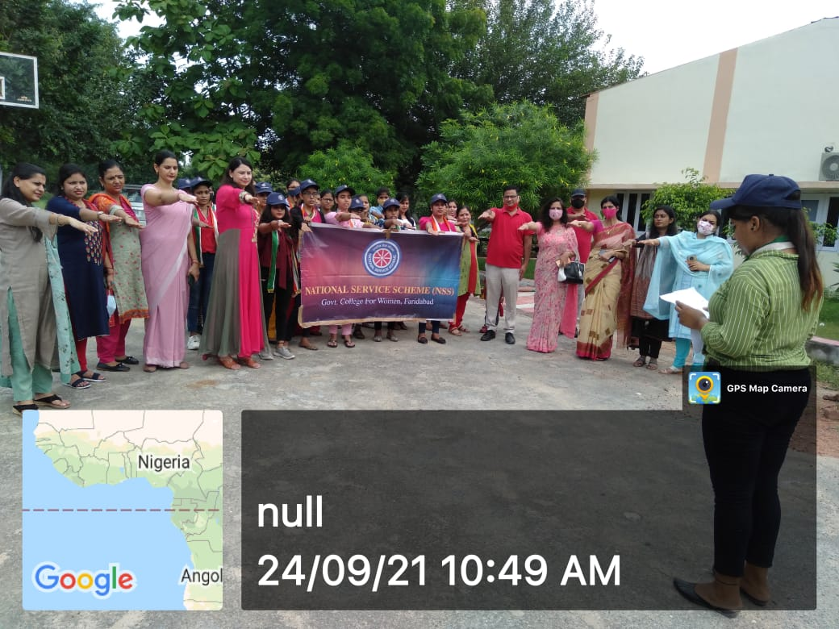
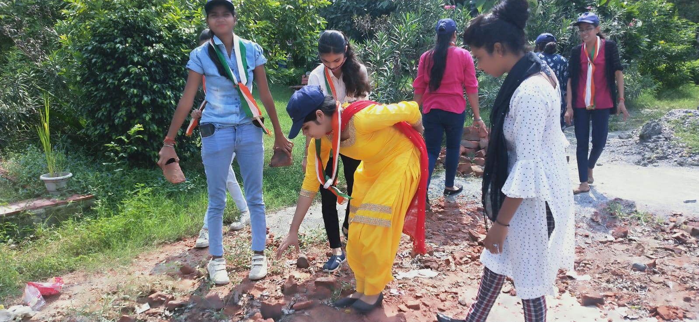
Title of the Activities & date | Organising unit/ agency/ collaborating agency | Number of teachers co-ordinated such activities | Number of students participated in such activities | Achievements/  Remarks
14) Webinar on World tourism Day 27th September, 2021 | Department of Tourism | Dr. Preeti Raina  Mr. Sandeep  Mr. Keshav | 60 students | On occasion of World Tourism day 27 September 2020.Department of Tourism Management organised a webinar on Travel Agency and Tour operations buisness. Key speaker of this occasion was Mr. Sandeep Mehta ,CEO of My Wings Travel. He informed the students about the practical aspects of this industry  and talked about the scope of BTTM course . Regarding rebuilding of Tourism he is of the opinion that Domestic Tourism will return before international tourism,as Travel companies have started receiving bookings for domestic travel, although number is less but it shows that gradually the doors to Tourism growth seems to open. As Tourism are pillar to economic growth for countries who are mostly dependant on Tourism earnings. . Our worthy  Principal Dr. Sunidhi motivated students and discussed the prospects of this course and guided the students to give more attention to improve their personality and communication skills,which would be useful for them to work in this industry.Ms PreetiRaina,Mr.Sandeep and Mr.keshav from department of tourism along with other faculty members were present in this program.About 60 students of BTTM attended this event.
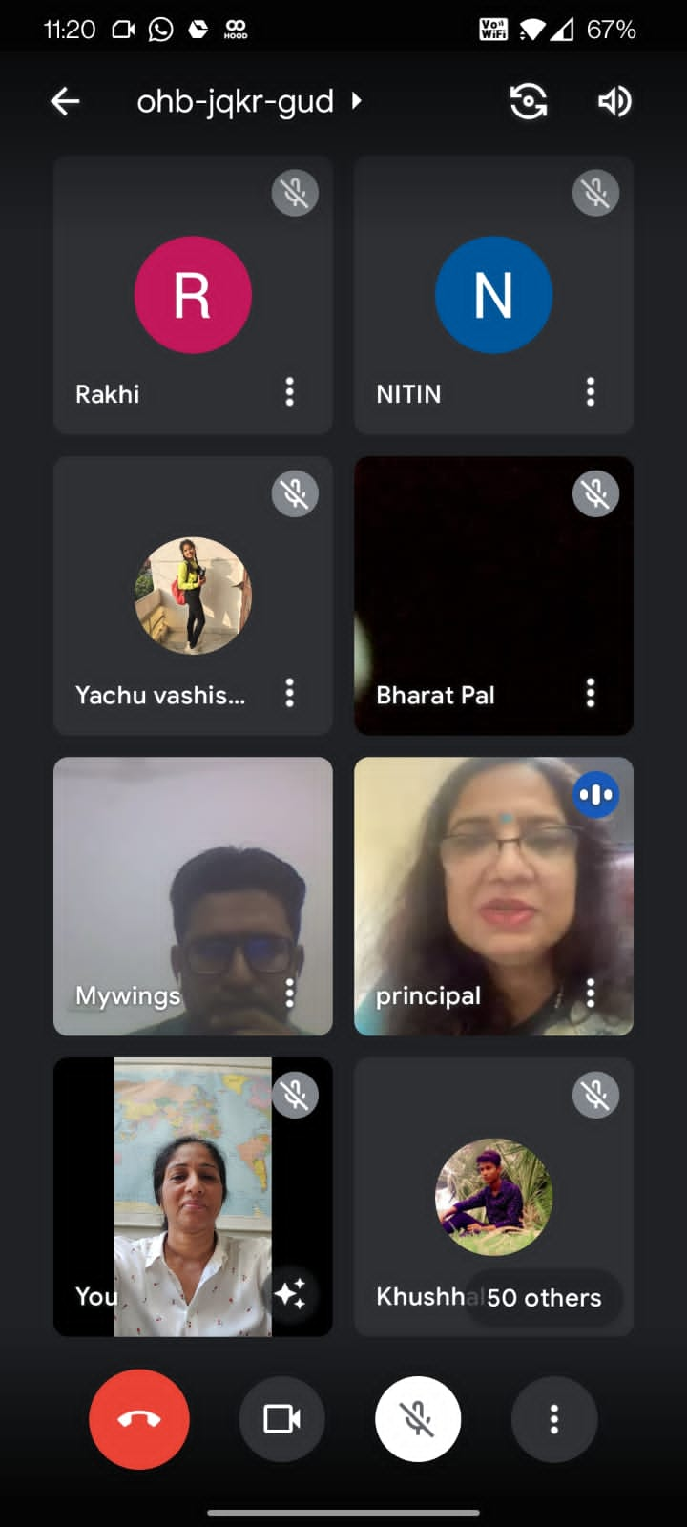
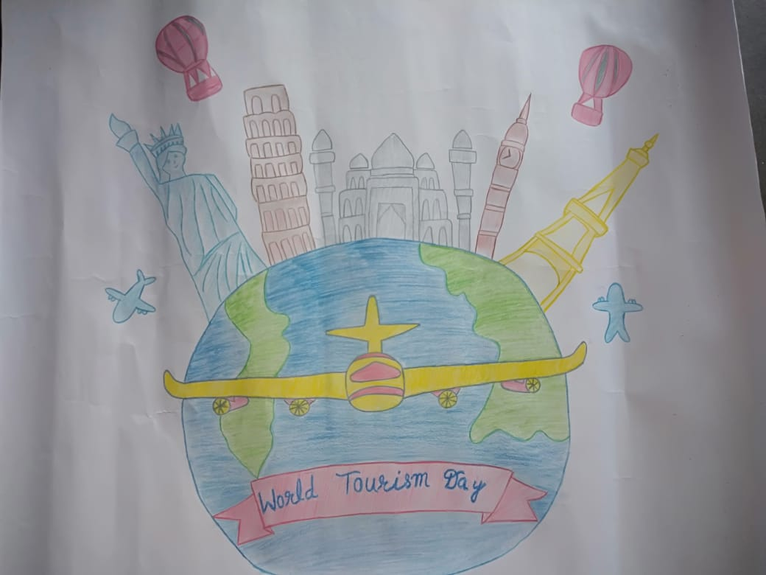

Title of the Activities & date | Organising unit/ agency/ collaborating agency | Number of teachers co-ordinated such activities | Number of students participated in such activities | Achievements/  Remarks
15) Certificate of Appreciation for "Beat covid Campaign” initiative of Mahatma Gandhi National Council of Rural Education (MGNCRE). | NSS Unit | Dr. Rachna Saini  Dr. Raman Kumar  Dr. Varsha  Ms. Poonam Rani  Ms. Priya Saini  Ms. Neha Vij  Ms. Savita Nagar |  | NSS unit of GCW,Faridabad received certificate of Appreciation for "Beat covid Campaign” initiative of Mahatma Gandhi National Council of Rural Education (MGNCRE). This certificate was awarded for the efforts in making the campaign successful by coordinating formation of 5 -student volunteer team in areas of Hospital Management, Non Hospital Management ,Support to covid affected families, medical supplies. The team worked under the able leadership of Principal Dr. Sunidhi . She also congratulated and appreciated the effort of entire NSS team including NSS PO Dr Rachna Saini, Dr. Raman Kumar, Dr. Varsha Sharma, Ms. Poonam Sharma, Ms. Savita Nagar, Ms. Priya Saini, Dr. Neha Vij and all NSS volunteers.
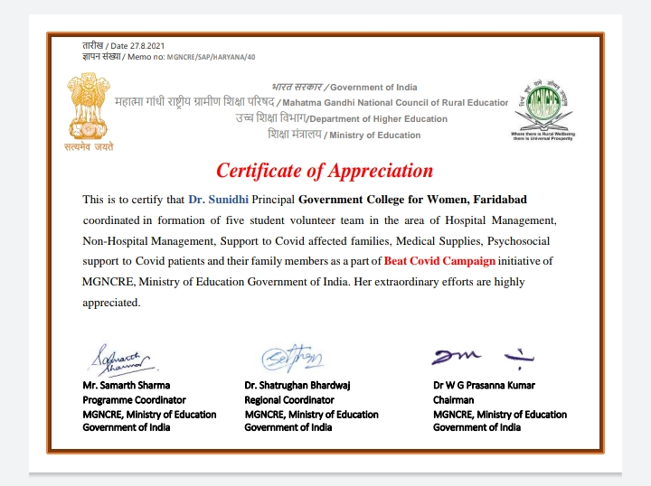

Title of the Activities & date | Organising unit/ agency/ collaborating agency | Number of teachers co-ordinated such activities | Number of students participated in such activities | Achievements/  Remarks
16) Corona vaccine drive for students, staff members of the college and other stakeholders from the community. | NSS Unit | Dr. Rachna Saini  Dr. Raman Kumar  Dr. Varsha  Ms. Poonam Rani  Ms. Priya Saini  Ms. Neha Vij  Ms. Savita Nagar | 337 students | The NSS unit of government college for women, sector 16a, faridabad organised corona vaccine drive for students, staff members of the college and other stakeholders from the community. Covishield vaccine was administered to around 500 people where 450 recipients got their first dose while around 50 recipients got 2nd dose of vaccine. The vaccination drive was led by a team of doctors from esi hospital, sector 8, faridabad. Physician dr. Shalini from the esi vaccination team tried to dispel the misconception regarding corona vaccine and declared it absolutely safe. Corona vaccine works as an immunity booster; therefore, everyone should get the vaccine as soon as possible without any fear -she retorted. Gcw: making community safe  Principal, dr. Sunidhi shared that according to who, 3rd wave of the pandemic is anticipated soon, therefore the need of the hour is to vaccinate the population in large numbers. This camp was mainly organized for staff members and students who were yet to receive 1st dose of vaccine therefore bringing into fold a large number of people into vaccination.  Nss program officer of the college dr. Rachna saini told that 337 students, 24 staff members and around 139 people from the community have been administered the 1st and 2nd doses of vaccine in this camp. The certificates will also be issued to everyone by the team of doctors. She told that the camp was successfully organised with the help and guidance of the principal of the college besides the staff and nss volunteers.
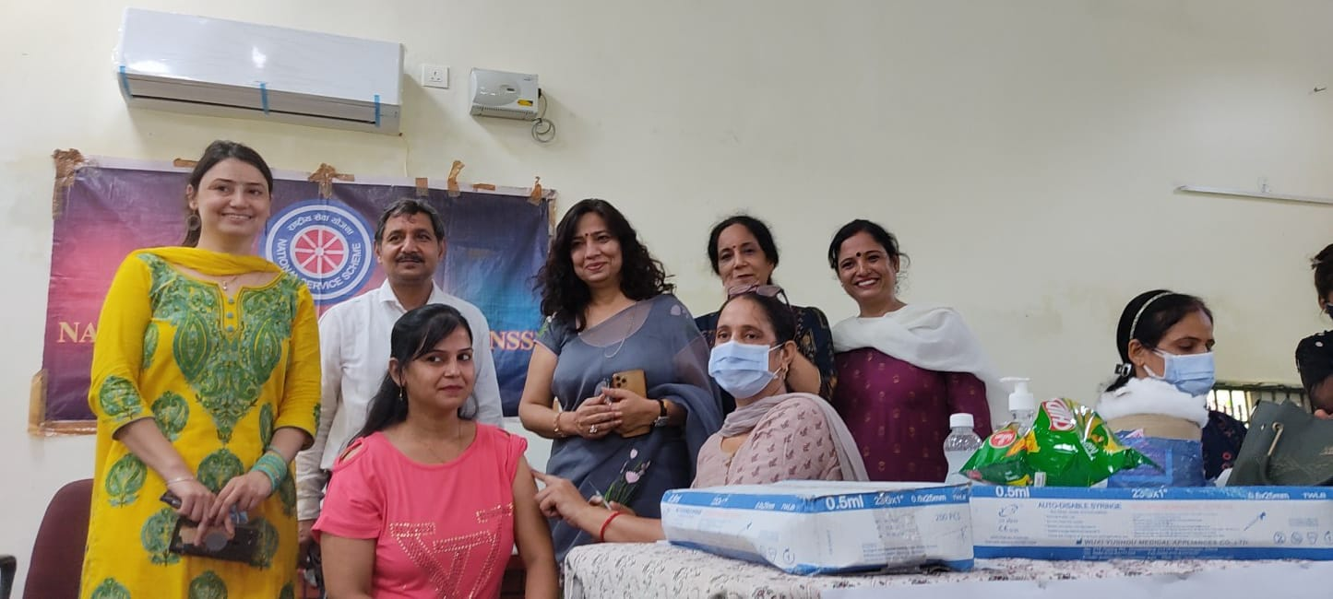

Title of the Activities & date | Organising unit/ agency/ collaborating agency | Number of teachers co-ordinated such activities | Number of students participated in such activities | Achievements/  Remarks
17) Felicitation of NSS Program Officer Dr. Rachna Saini and NSS Volunteer Kajal Singh. | MDU Rohtak | Dr. Rachna Saini | One student | NSS Program Officer Dr. Rachna Saini and NSS Volunteer Kajal Singh participated in Teacher’s Day celebration held at MDU, Rohtak were felicitated by the Hon’ble Governor Haryana along with entire MDU’s NSS team. Respected Principal Dr. Sunidhi congratulated NSS PO and NSS Volunteer on their felicitation.
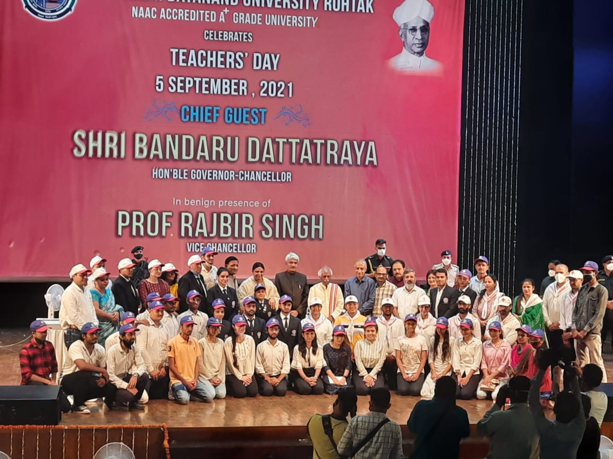

Title of the Activities & date | Organising unit/ agency/ collaborating agency | Number of teachers co-ordinated such activities | Number of students participated in such activities | Achievements/  Remarks
18) Swaachta pakwada 5th October, 2021 | Department of English | Ms. Meenal Sabharwal  Ms. Shalini Khurana  Dr. Parul Rana  Ms. Divesh | 60 students | Swaachta pakwada was held in the college on Oct 05 campus commemorating Mahatma Gandhi's Birth Anniversary .Students put their best foot forward to clean the campus in the presence of the Staff Council. Worthy Principal Dr.Sunidhi addressed the students and elaborated the role of cleanliness . Dr.Parul Rana, Ms.Shalini , Ms.Divesh also put their efforts in motivating students.Meenal Sabharwal was incharge of the Pakhwada .
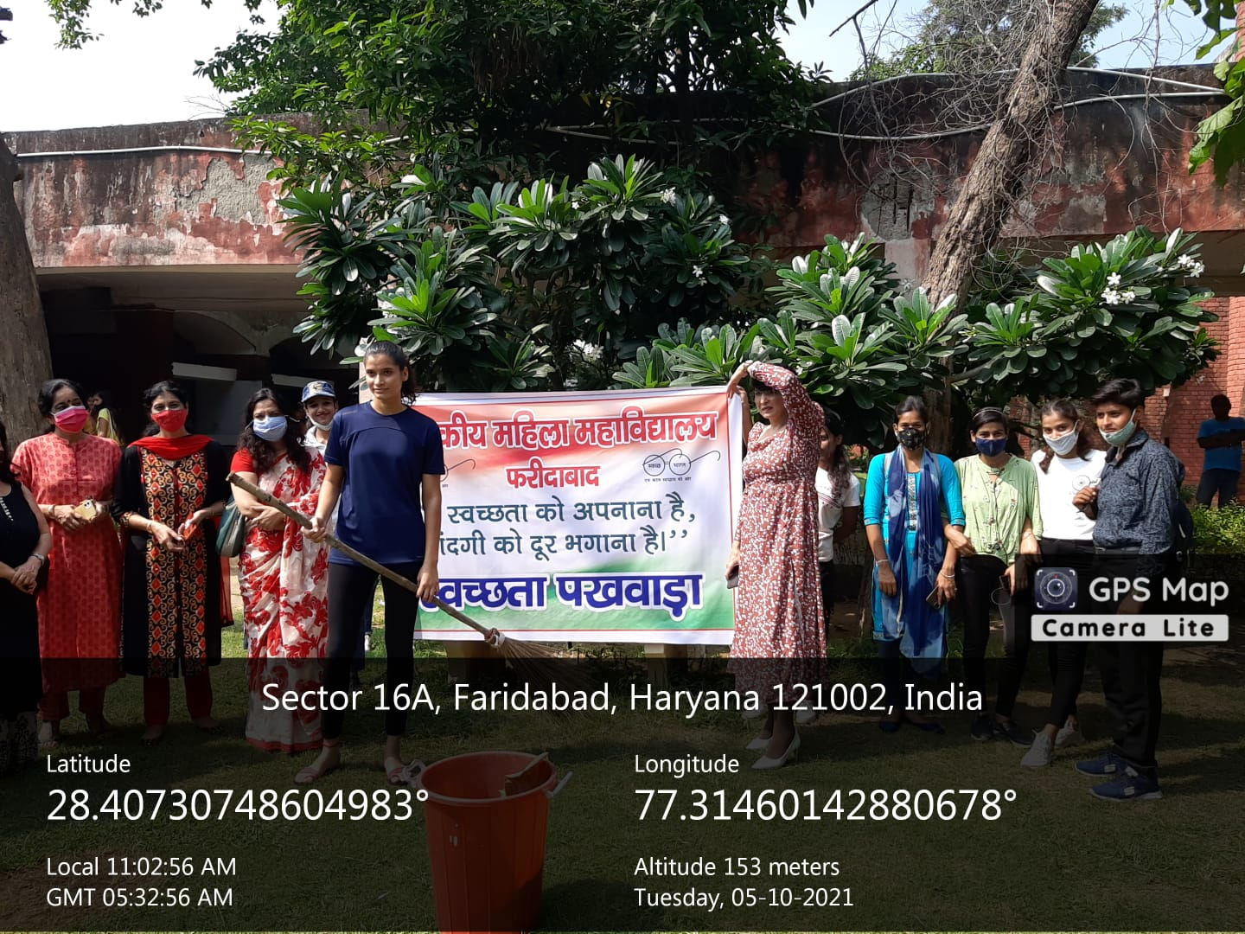
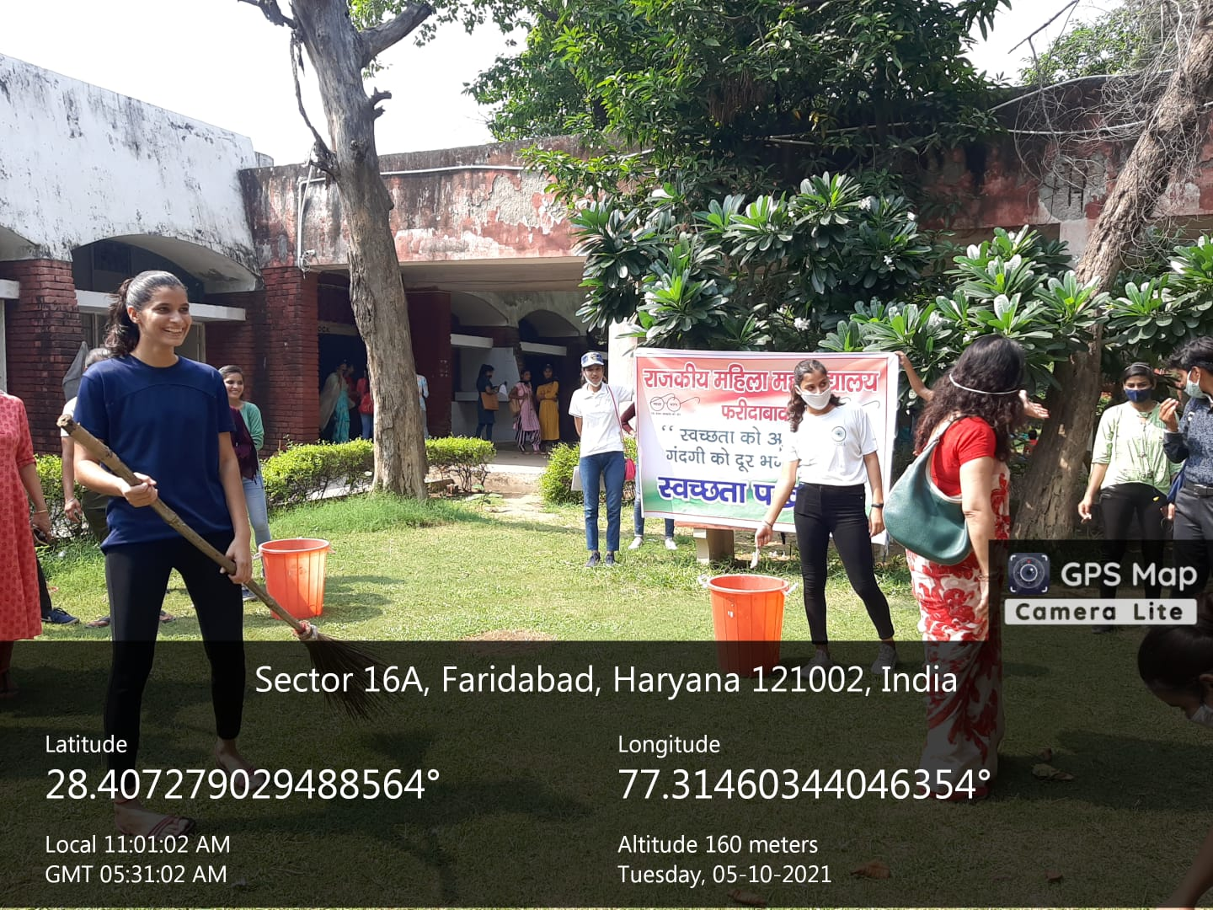
Title of the Activities & date | Organising unit/ agency/ collaborating agency | Number of teachers co-ordinated such activities | Number of students participated in such activities | Achievements/  Remarks
19) Fogging in the college on 12th October, 2021 | Red cross | Ms. Meenal Sabharwal |  | Incharge of Red Cross Committee of the college, Ms. Meenal Sabharwal coordinated with MCF for carrying out fogging in the college in view of increasing dengue cases in the city. The MCF carried out fogging in the college covering all blocks and open areas on 12th October, 2021.
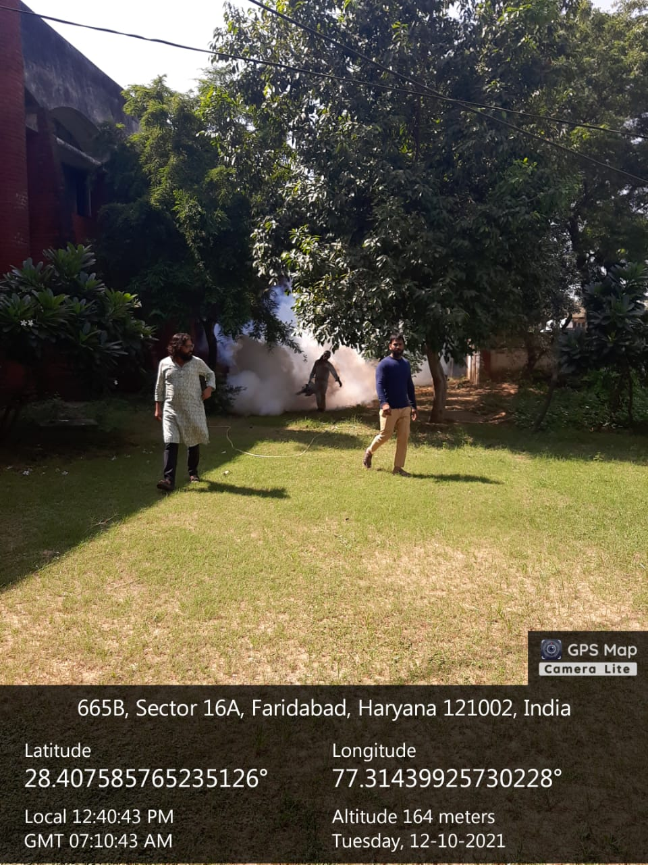

Title of the Activities & date | Organising unit/ agency/ collaborating agency | Number of teachers co-ordinated such activities | Number of students participated in such activities | Achievements/  Remarks
20) District-Level Science Quiz Competition on 22/10/2021 | Pt. J. L. N. College, Faridabad | Ms. Neha Aggarwal  Ms. Poonam Rani | 3 students | Under the sponsorship of Haryana State Council for Science, Innovation and Technology, Govt. of Haryana, A team of three students from B.Sc second year (Nisha, roll no 43; Priyanka Mandal, roll no 40; Soni Saraswat roll no 04) of our college bagged fourth position in the District-Level Science Quiz Competition organized by Pt. J. L. N. College, Faridabad on 22/10/2021 in order to bring scientific temper among college students under the tagline "Azadi ka Amrit Mahotsav". The team is now qualified for the zonal level.
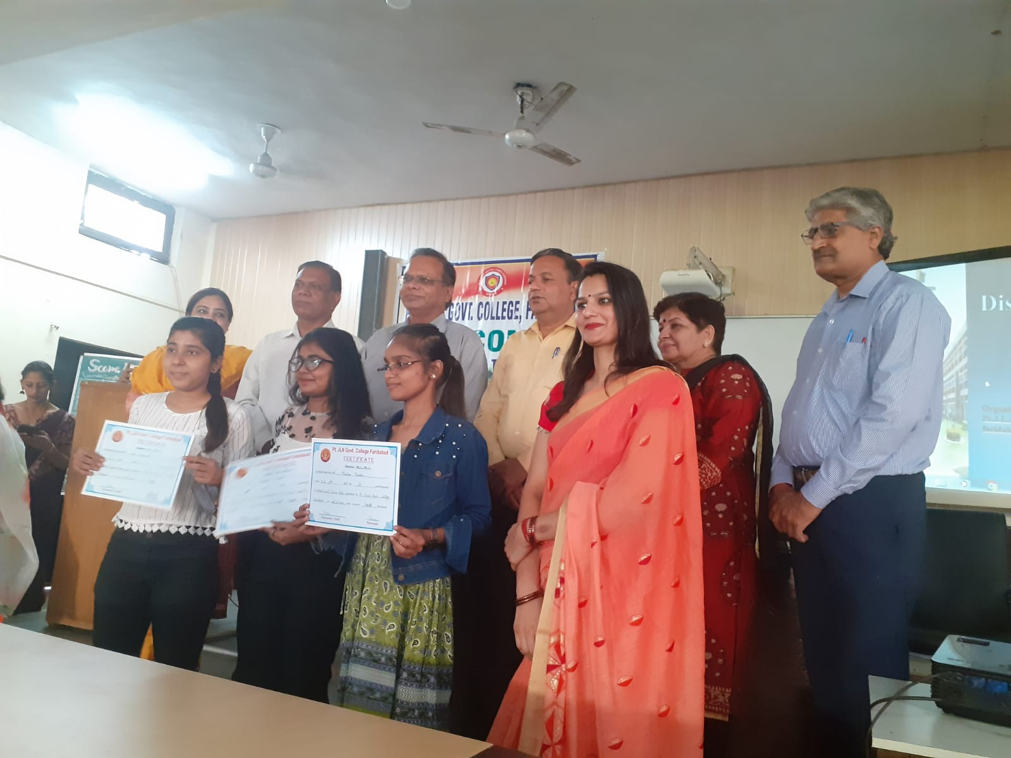

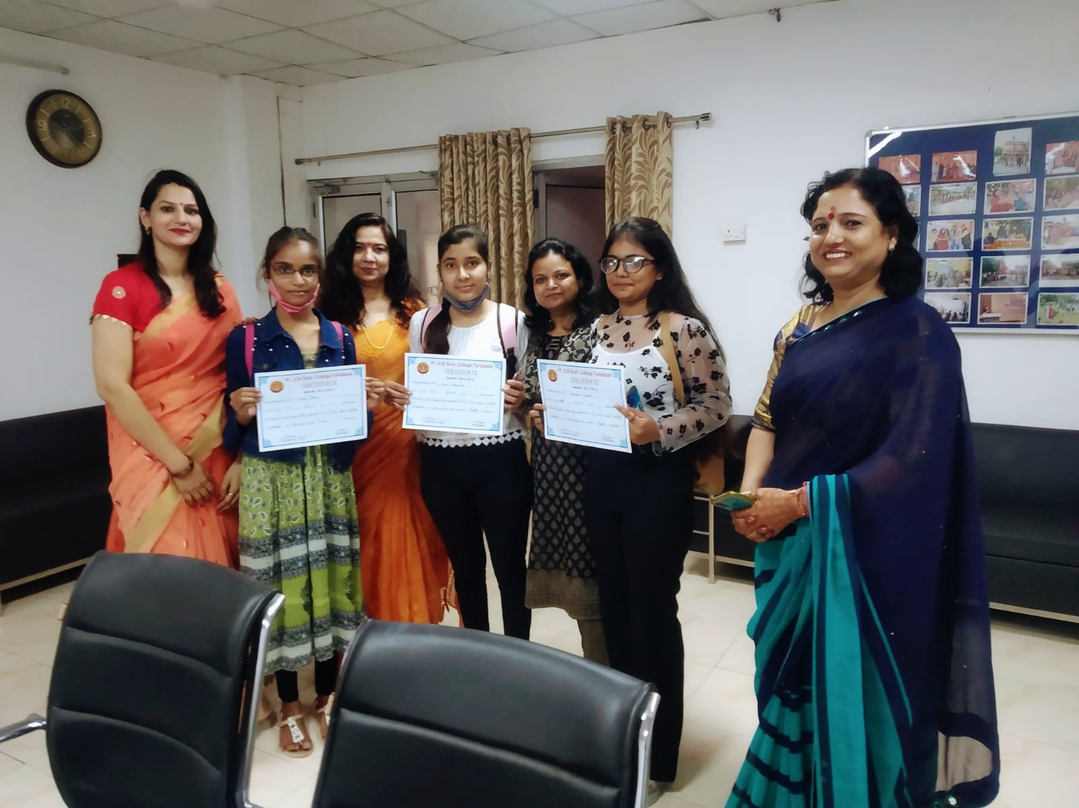

Title of the Activities & date | Organising unit/ agency/ collaborating agency | Number of teachers co-ordinated such activities | Number of students participated in such activities | Achievements/  Remarks
21) Small session on start-up programmes on 18th October, 2021 | Placement Cell and Incubation center of JLN College, Faridabad | Ms. Preeti Arora  Ms. Sonia Minocha  Ms. Neha Vij  Ms. Aashna  Ms. Jyoti Gupta  Ms. Priya Saini  Ms. Divesh  Mr. Gaurav | 70 students | Placement cell of GCW Faridabad in collaboration with incubation centre of JLN College, Faridabad organised a small session to aware the students about the startup programs on 18 October 2021. Mr Pandey and Mr. Aakash from incubation centre made the students familiar with the startup programs and also informed them about the assistance provided by the incubation centre for starting up their startups as per the direction of DGHE. Students actively participated in the awareness program and asked many questions about the startup. Madam Principal Mrs. Sunidhi encouraged the students for taking leverage of incubation centre in starting up their startups. The team members of placement cell under the guidance of Ms. Preeti Arora, convener of placement cell, coordinated with the team of incubation centre to make the event a win win for the students.
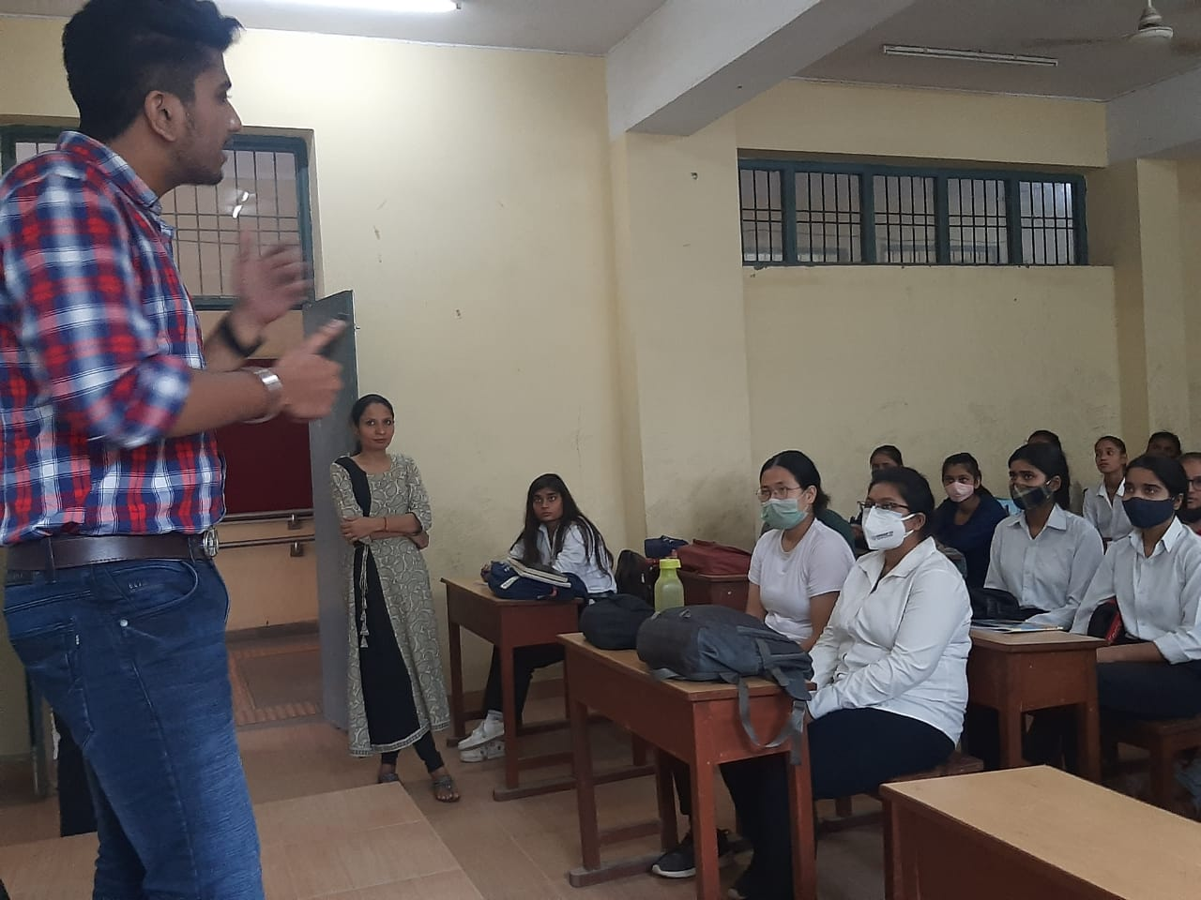
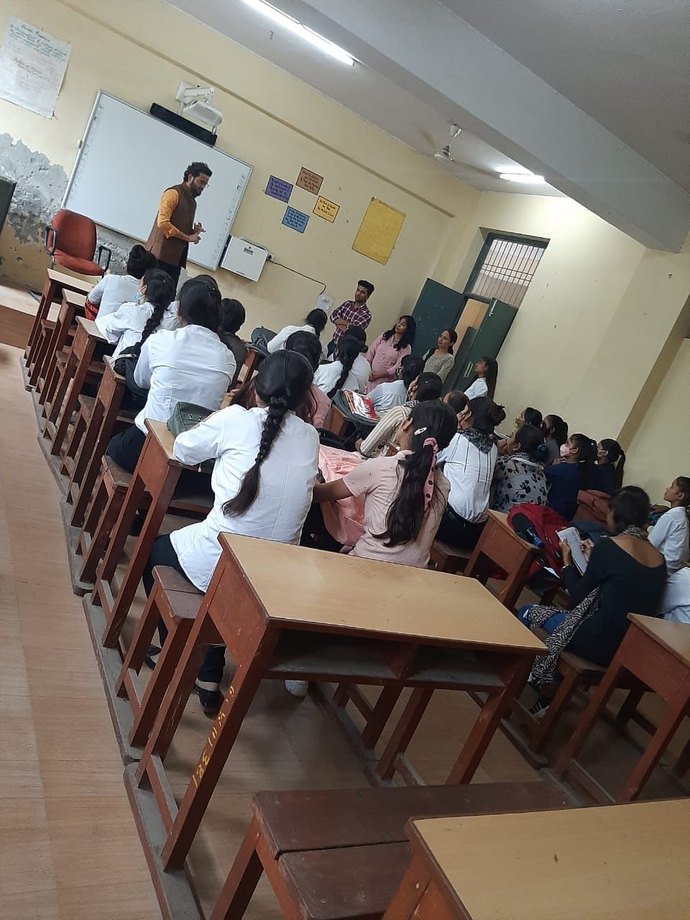

Title of the Activities & date | Organising unit/ agency/ collaborating agency | Number of teachers co-ordinated such activities | Number of students participated in such activities | Achievements/  Remarks
22) Mehandi Competition on 23rd October, 2021 | Women Cell | Dr. Neha Aggarwal, Ms. Neelam Rani, Ms. Meenal Sabharwal, Ms. Priya Saini and Ms. Divesh | 35 students | Women Cell of our college organized Mehendi Competition for the college students on 23/10/2021 to celebrate the festival of Karva Chauth. Total 35 students participated and showcased their talent irrespective of the exposure and experience. They adorned their hands with mendhi designs which helped them boost their confidence in the art. Our worthy Principal, Dr. Sunidhi, encouraged and congratulated the students for putting in efforts to keep this cultural and traditional art form alive. Our senior staff members Ms. Ritika Gupta, Ms. Archana Verma and Ms. Stavinder Kaur were the judges for the event. Aarti from BA II year got the first prize, Aparna from B.Sc II year got the second and Jagriti from B.Sc III year got the third prize. Deepshikha and Parul Shukla from B.Sc II year got the consolation prize. The event was successfully organized by Dr. Neha Aggarwal, Ms. Neelam Rani, Ms. Meenal Sabharwal, Ms. Priya Saini and Ms. Divesh. Other staff members were also present in the competition.
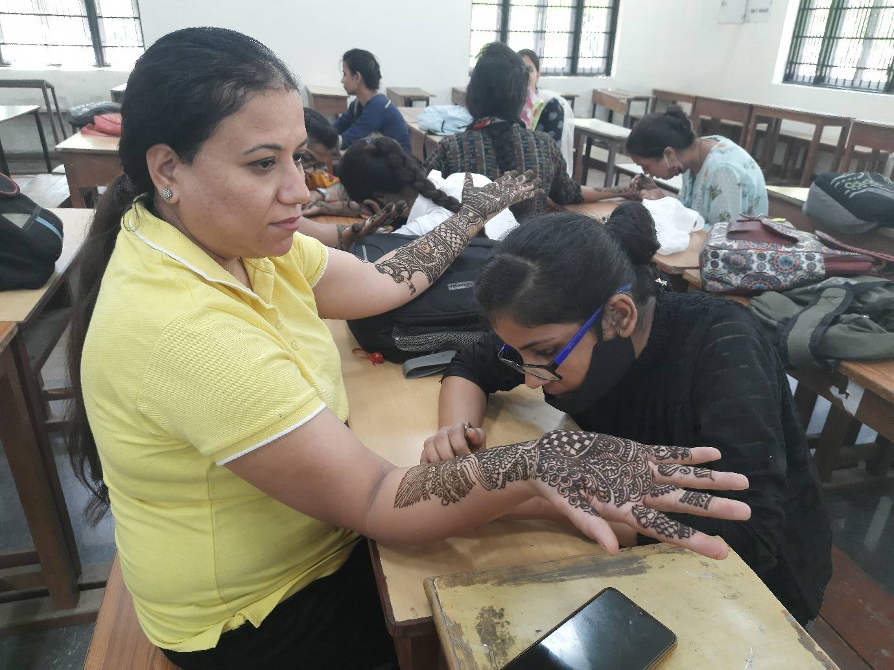
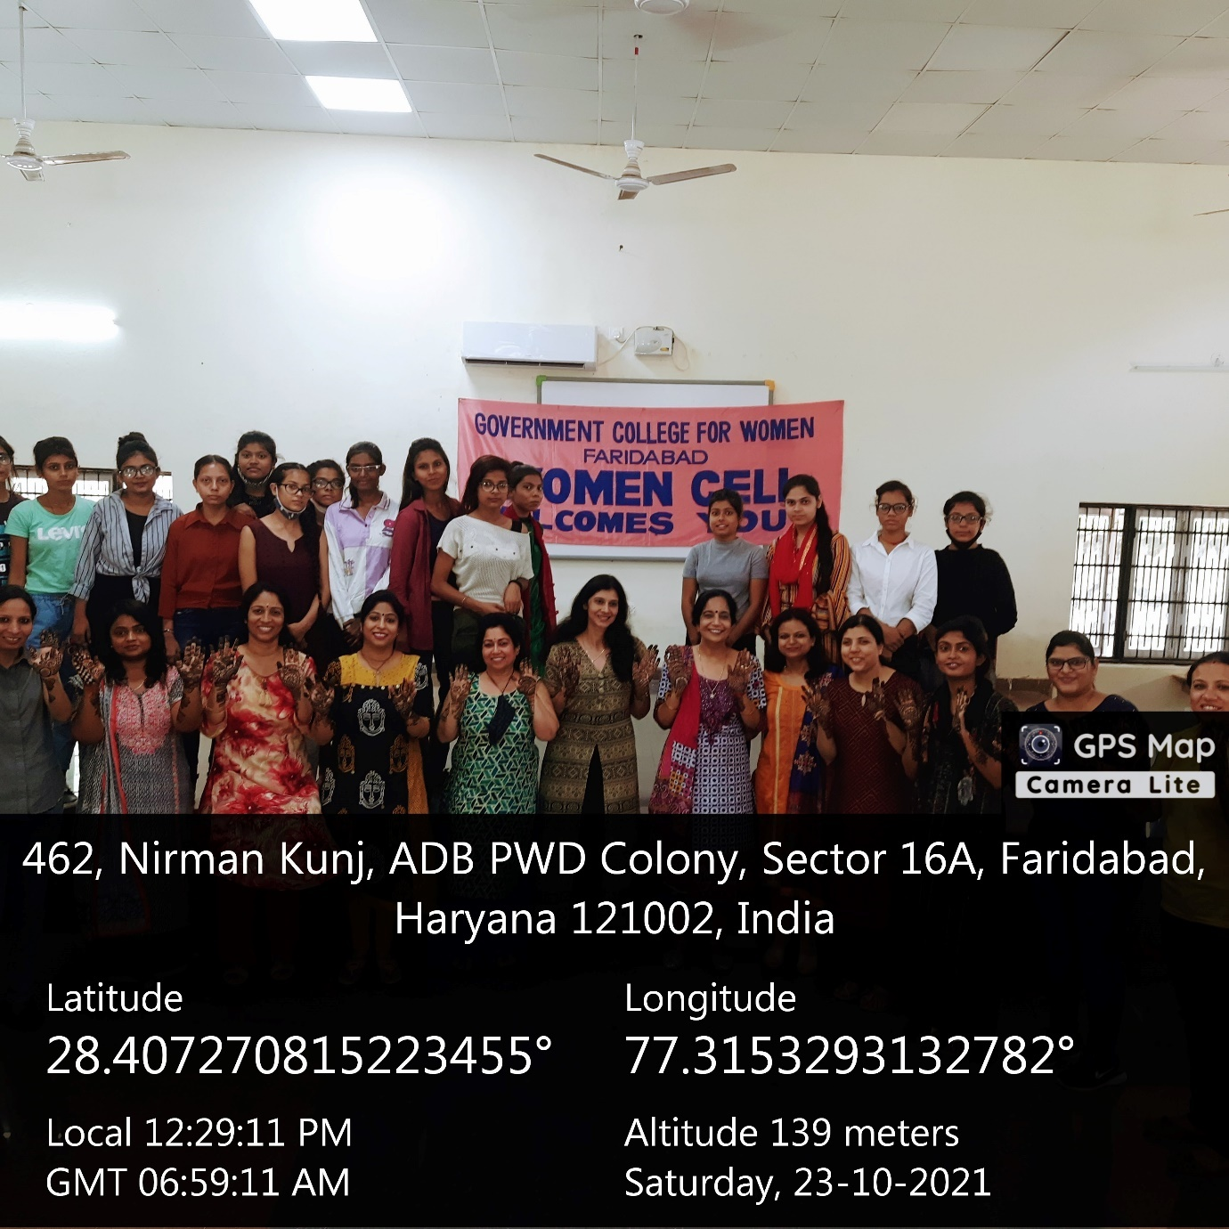

Title of the Activities & date | Organising unit/ agency/ collaborating agency | Number of teachers co-ordinated such activities | Number of students participated in such activities | Achievements/  Remarks
23) Diwali Exebition 27th October, 2021 | Placement cell and Department of Commerce & Management in collaboration with Incubation Centre  Pt. JLN College Faridabad | Ms. Preeti Arora  Ms. Sonia Minocha  Ms. Neha Vij  Ms. Aashna  Ms. Jyoti Gupta  Ms. Priya Saini  Ms. Divesh  Mr. Gaurav | 219 students | Placement cell and Department of Commerce & Management of Government College for Women, Faridabad in collaboration with Incubation Centre  Pt. JLN College Faridabad organized a Diwali Exhibition on 27th  October 2021. Many Startup organizations showcased their talent by  presenting different items such as Handmade chocolates, Diwali decor  items, Diwali diyas, Handicraft items , Preservative free mocktails  in the exhibition. Mrs. Ritika Gupta , Vice Principal Government  College for Women, Faridabad congratulated both the colleges for  their wonderful joint venture and conveyed that every student has a  potential to become an entrepreneur and there is only a need to  explore the talent and become self-dependent. All the Faculty members  and Students of various streams visited the Diwali Exhibition.  Placement Cell convener Mrs. Preeti Arora motivated the students to  become self dependent and informed students about different  opportunities available in the market to develop their career.  Incubation Centre coordinators Mr. Anurag Pandey and Mr. Aakash Tomer  also encouraged the students by telling different success stories of  new startup entrepreneurs. Event was wonderfully organized and  coordinated by Placement Cell and members of Department of Commerce &  Management.
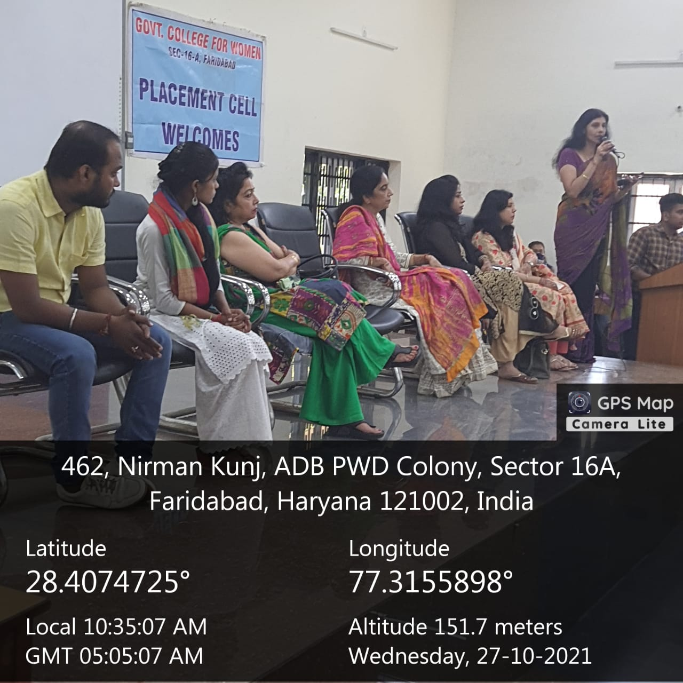

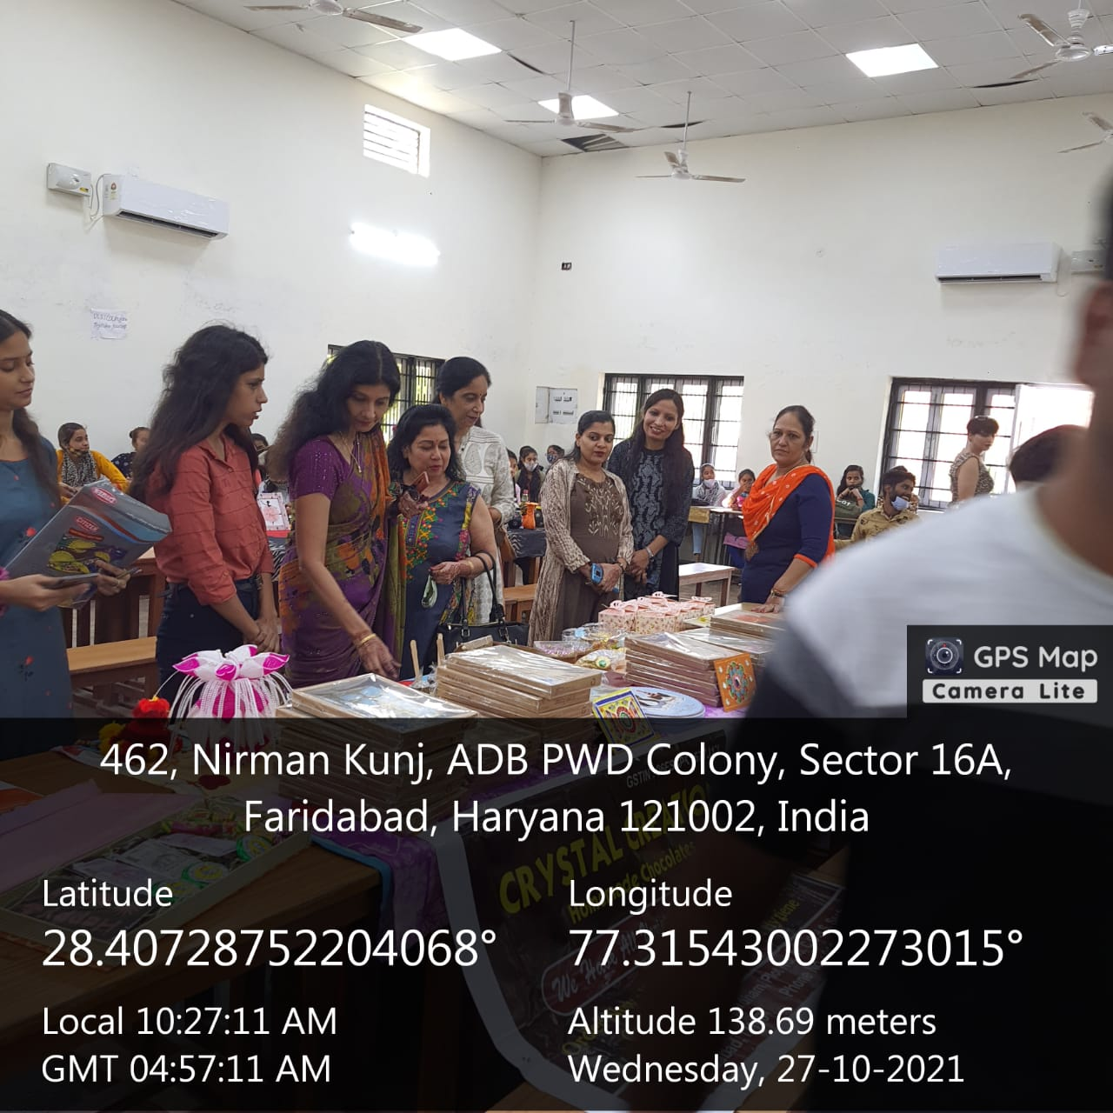
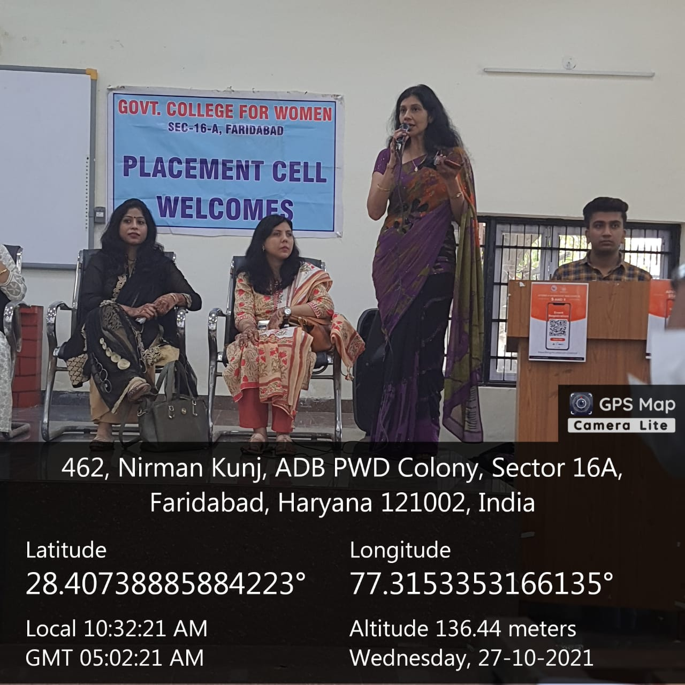

Title of the Activities & date | Organising unit/ agency/ collaborating agency | Number of teachers co-ordinated such activities | Number of students participated in such activities | Achievements/  Remarks
24) Seminar on finance on 29th October, 2021 | Placement cell and Department of Commerce & Management in  collaboration with Department of Economics | Ms. Archna Verma  Ms. Preeti Arora  Ms. Sonia Minocha  Ms. Neha Vij  Ms. Aashna  Ms. Jyoti Gupta  Ms. Priya Saini  Ms. Divesh  Mr. Gaurav  Ms. Varsha | 150 students | Placement cell and Department of Commerce & Management in  collaboration with Department of Economics of Government College for  Women, Faridabad organized a Seminar on the topic” The joy of Saving  and Investment Including Dynamics of Money.” on 29th October 2021 for  final year students of the college. Mr. Alok Kumar Manager at ITM  Group of institutions was the key note speaker. He informed students  about the importance of savings and investment in a very impressive  way. As it was an interactive session, students asked various  questions related to savings and investment. He answered all the  questions very lucidly and cleared all the doubts of the students.  Mrs. Sunidhi, Principal Government College for Women, Faridabad  motivated the students to inculcate the habit of savings and put their  best efforts to become self-dependent. Event was wonderfully organized  and coordinated by members of Placement Cell and Department of  Commerce & Management and department of Economics, Under the guidance  of Mrs. Preeti Arora, Placement Cell convener. 150 students  participated in the seminar.
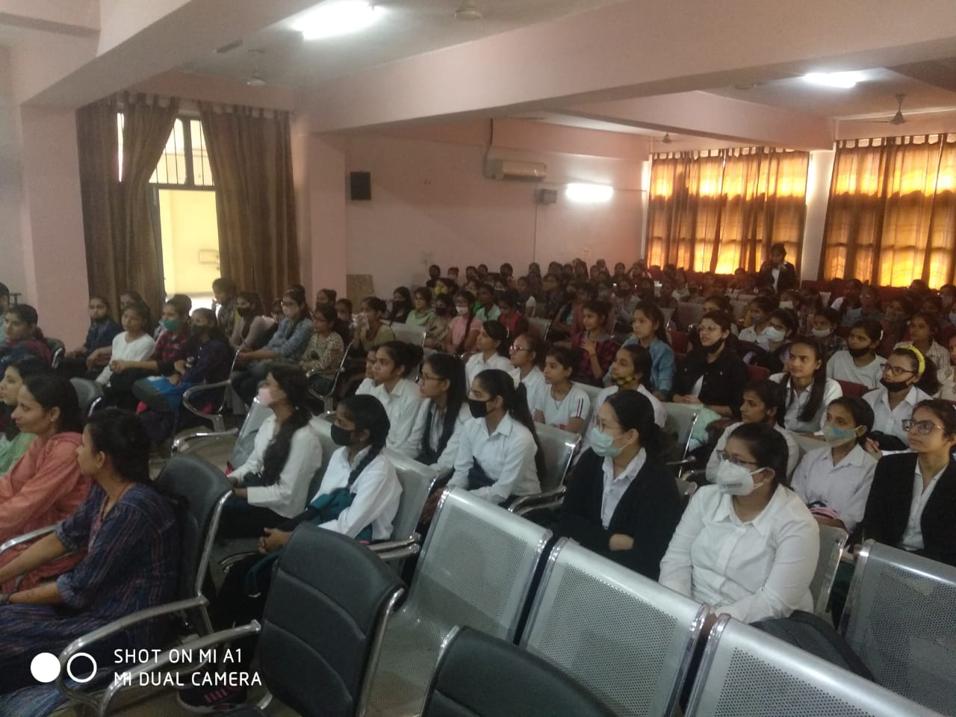
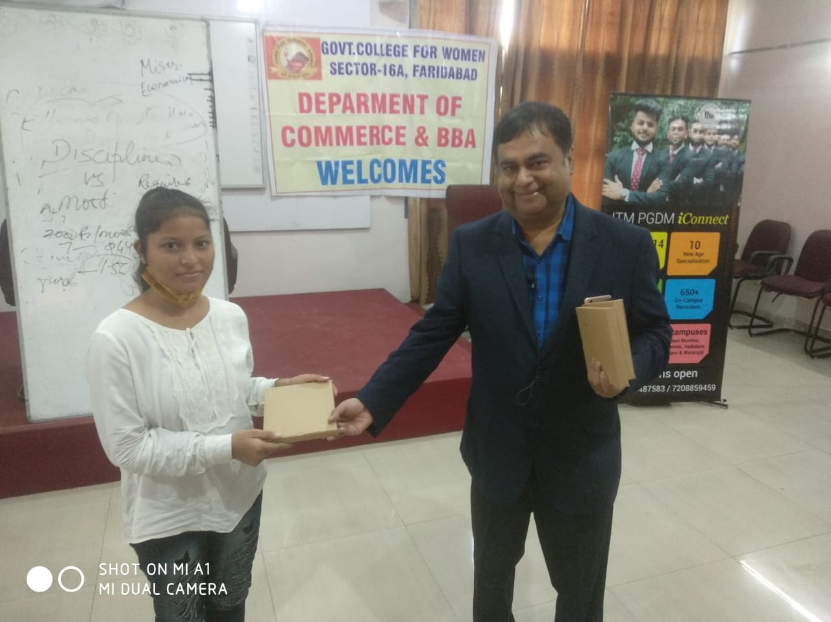

Title of the Activities & date | Organising unit/ agency/ collaborating agency | Number of teachers co-ordinated such activities | Number of students participated in such activities | Achievements/  Remarks
25) one day cleaning camp | NSS Unit | Dr. Rachna Saini  Dr. Raman Kumar, Dr. Varsha Sharma, Ms. Priya Saini, Ms. Chanchal Sharma, Ms. Poonam Sharma, Dr. Neha Vij and Ms. Savita Nagar | 50 students | Under the joint aegis of National Service Scheme Unit of Government Women's College, Faridabad and NSS Regional Directorate of Ministry of Youth Affairs and Sports, Delhi, a one-day cleanliness campaign programme was organized under Azadi Ka Amrit Mahotsav.  The volunteers of National Service Scheme of GCW, Faridabad, Pandit Jawaharlal Nehru Post Graduate College, Faridabad and J.C Bose University Faridabad participated in special cleaning drive outside Old Railway Station, Faridabad with successful disposal of 500 kg polythene and other waste.  Inaugurating the campaign, Mr. Harish, representative of NSS unit of MDU and also a recipient of Indira Gandhi Award, and Shri Manoj Kumar, representative of Regional Directorate of Ministry of Youth Affairs and Sports, Delhi called upon the students to make people aware about cleanliness. It was shared that the cleanliness campaign was launched by Hon'ble Prime Minister Narendra Modi in the year 2014 on the occasion of Gandhi Jayanti. The representatives shared that that the country is celebrating the 75th year of independence as the nectar festival of independence. Its main objective is to make the country clean and healthy.  On this occasion, Officiating Principal, Ms. Ritika Gupta encouraged the volunteers towards cleanliness and appreciated the work done by them. On this occasion, the NSS Program Officer of the college Dr. Rachna Saini talked about the benefits of keeping our houses and environs clean. Dr. Raman Kumar, Dr. Varsha Sharma, Ms. Priya Saini, Ms. Chanchal Sharma, Ms. Poonam Sharma, Dr. Neha Vij and Ms. Savita Nagar were also present on this occasion.
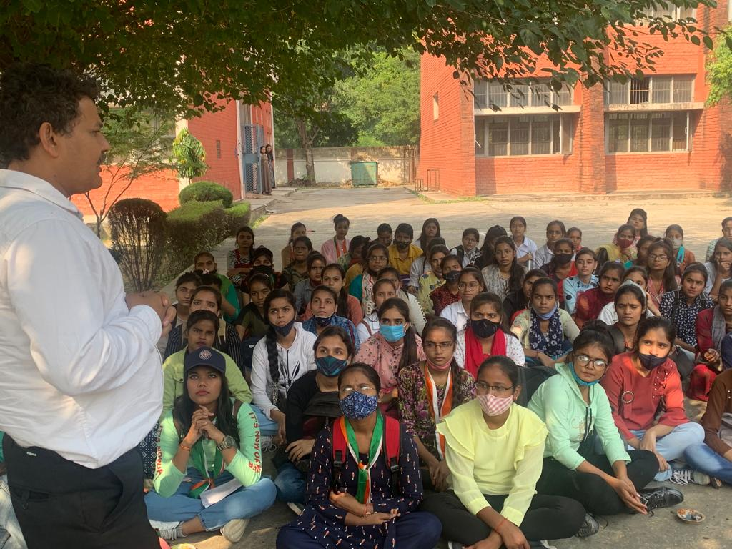

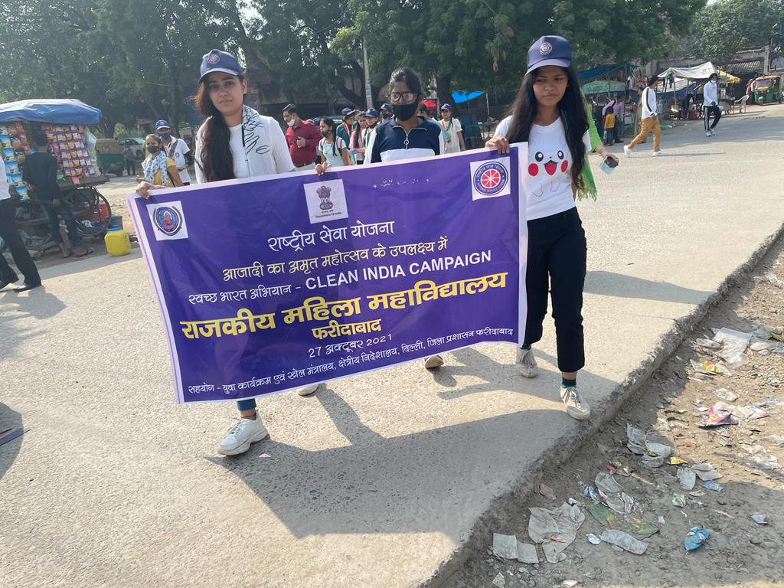

Title of the Activities & date | Organising unit/ agency/ collaborating agency | Number of teachers co-ordinated such activities | Number of students participated in such activities | Achievements/  Remarks
26) NSS State Level Camp from 19th to 25th october 2021 | chaudhary Ranbir Singh University, Jind | Dr. Rachna Saini | 2 students | NSS. State Level Camp was organized in chaudhary Ranbir Singh University, Jind from 19th to 25th october 2021. NSS volunteers of GCW  Shivangi Tiwari from BJMC 1st year and Bindu, from B. A 3rd year participated enthusiastically in the camp. They participated in various activities held during camp i.e. yoga, cleanliness drive, awareness rallies and other sports and cultural activities.  OurWorthy Principal Dr. Sunidhi Congratulated students for their active participation in state level camp.NSS incharge Dr. Rachna Saini said that these activities provides platform for the students which helps them to tackle their fears, facilitates in self growth and discipline in life.
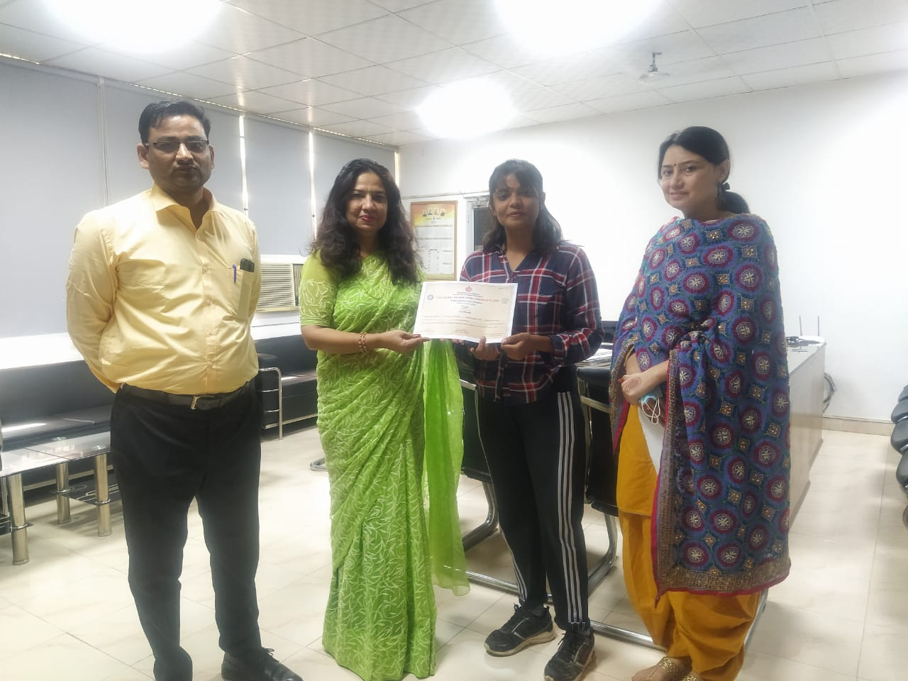

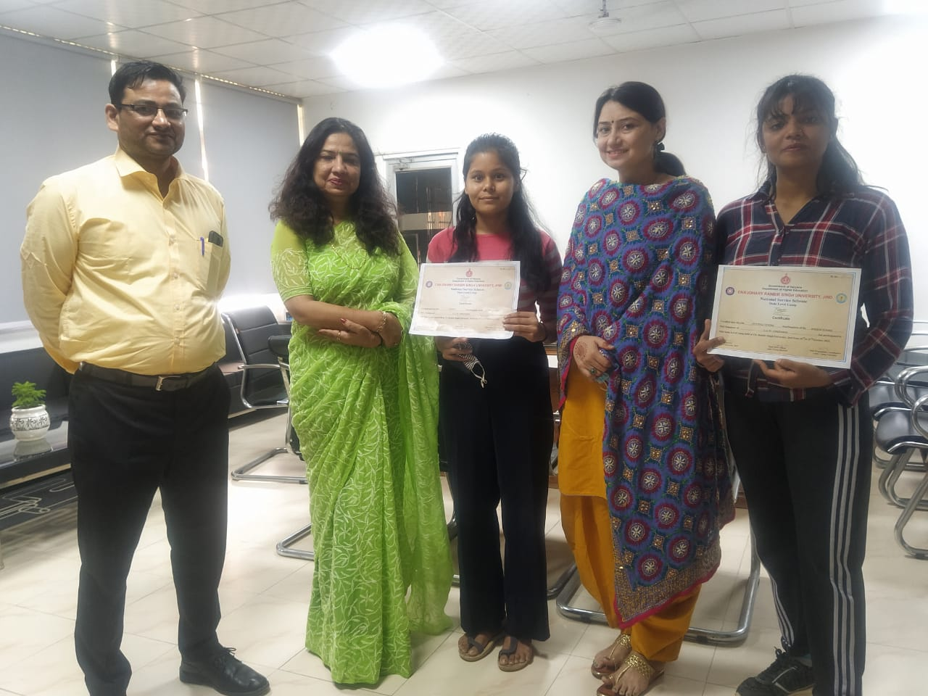

Title of the Activities & date | Organising unit/ agency/ collaborating agency | Number of teachers co-ordinated such activities | Number of students participated in such activities | Achievements/  Remarks
27) Article writing and poster making competition 29th October, 2021 | K. L. Mehta Dayanand College for Women, Faridabad | Dr. Neha Aggarwal | 2 students | Kajal Sharma, Roll no 01, of B.Sc final year got first position in Article writing competition and Deepshikha, Roll no 50, of B.Sc second yr got second position in Poster Making competition, organized by the Women Cell of K. L. Mehta Dayanand College for Women, Faridabad on 29th Oct, 2021.

Title of the Activities & date | Organising unit/ agency/ collaborating agency | Number of teachers co-ordinated such activities | Number of students participated in such activities | Achievements/  Remarks
28) Red cross activity |  |  |  | राजकीयE महिला महाविद्यालय सेक्टर 16-ए फरीदाबाद  प्रैस नोट  नेत्र एवं दंत जांच शिविर में 200 छात्राओं का हुआ चेकअप  दिनांक- 10 नवंबर 2021  राजकीय महिला महाविद्यालय सेक्टर 16 ए फरीदाबाद की रेडक्रास सोसायटी एवं लायंस क्लब डेफोडिल एनआईटी फरीदाबाद के संयुक्त तत्वाधान में बुधवार को नेत्र एवं दंत जांच शिविर का आयोजन किया गया । जिसमें 200 से अधिक छात्राओं की आंखो एवं दांतो की जांच की गई । दंत विशेषज्ञ डा. गरिमा एवं नेत्र विशेषज्ञ डा. शिवानी द्वारा छात्राओं को आंखो एवं दातांे की सुरक्षा को लेकर कई टिप्स दिए गए। उन्होने कहा कि सही देखभाल सही न होने की वजह से दांत एवं आंख संबंधित रोग उत्पन्न होते है, यदि समय रहते इन बिमारियों का पता चल जाए तो इनका इलाज संभव हो जाता है । इसलिए समय समय पर आंखो एवं दांतो की जांच करवाना जरूरी है ।  जांच शिविर का शुभारंभ करते हुए प्राचार्या डॉ. सुनिधि ने कहा कि आज हमारे खान पान में बदलाव आया है , जिसकी वजह से हमें कई प्रकार की स्वास्थ्य समस्याओं का सामना करना पड़ता है । इसलिए बेहतर दिनचर्या को अपनाएं तथा समय समय पर स्वास्थ्य जांच भी करवाते रहें ।  कार्यक्रम के मुख्य अतिथि लायंस श्री अनिल अरोड़ा ने बताया कि क्लब द्वारा फरीदाबाद के विभिन्न शिक्षण संस्थानो एवं सोसायटियों में इस प्रकार के शिविरों का आयोजन किया जा रहा है, ताकि ज्यादा से ज्यादा लोगांे को इसका लाभ मिल सके। रेडक्रास सोसायटी इंचार्ज सुश्री मीनल सब्रवाल ने बताया कि छात्राओं के सुविधा के लिए इस नैत्र एवं दंत जांच शिविर का आयोजन किया गया है । जिन छात्राओं को आंखो व दांतो में कोई कमी मिली है, डाक्टरों द्वारा उन्हें दवाइयांे के साथ कुछ जरूरी टिप्स भी दिए गए हैं। इस अवसर पर लायंस कुलभूषण शर्मा , लायसं तरूण खरबंदा, लायंस रवि मनचंदा एव रैडक्रास सोसायटी से सुश्री दिवेश, श्रीमती मीनू श्योराण, श्रीमती संगीता कंजानी एवं अन्य स्टॉफ सदस्य मौजूद रहे ।  प्राचार्या  राजकीय महिला महाविद्यालय

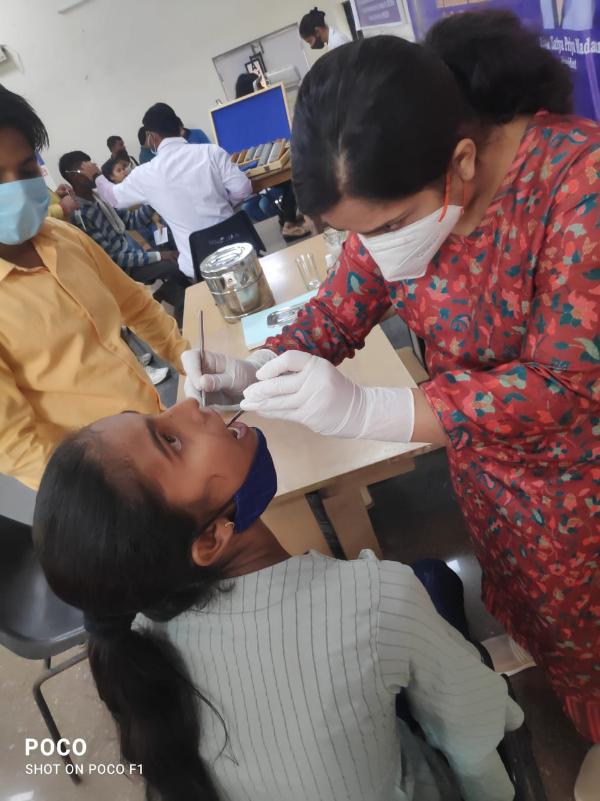

Title of the Activities & date | Organising unit/ agency/ collaborating agency | Number of teachers co-ordinated such activities | Number of students participated in such activities | Achievements/  Remarks
29) A Career Assessment Test on 13th November 2021 | Placement Cell and Department of Commerce and Management in  Collaboration with GGS India (The Academic Partner For Pearl Academy) | Ms. Preeti Arora  Ms. Sonia Minocha  Mr. Sandeep  Ms. Neha Vij  Ms. Aashna  Ms. Jyoti Gupta  Ms. Priya Saini  Ms. Divesh  Mr. Gaurav  Ms. Varsha | 238 students | Placement Cell and Department of Commerce and Management in  Collaboration with GGS India (The Academic Partner For Pearl Academy)  conducted a Career Assessment Test on 13th November 2021 for Final  Year Students of all streams of the College. GGS India is a subsidiary  of Global University Systems, an international network of higher  education institutions. This holistic test has been developed by  Industry experts who have been in the field of education for decades.  This advanced career assessment test evaluates students on 5  dimensions- style, interest, personality, aptitude and emotional  quotient. It helps students identify their strengths & weaknesses  through personalized reports and improves their career development  plans. Around 235 students participated in this test. Principal Madam  Mrs. Sunidhi visited all the test centers and conveyed the students  that this type of aptitude tests are very helpful in their overall  development. The test was successfully organized & coordinated by  Placement Cell Convenor and HOD Commerce & Management Ms. Preeti Arora  and entire team.
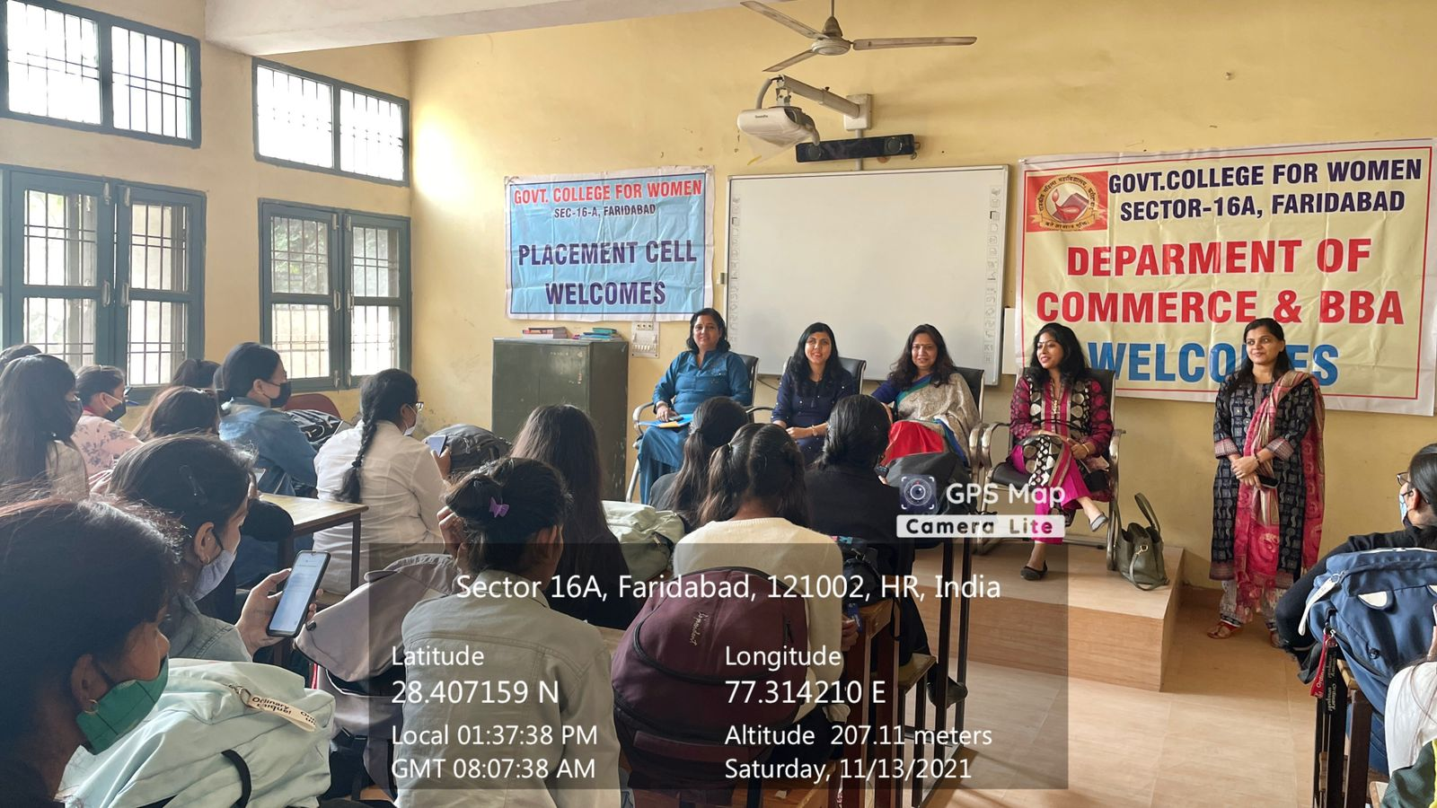
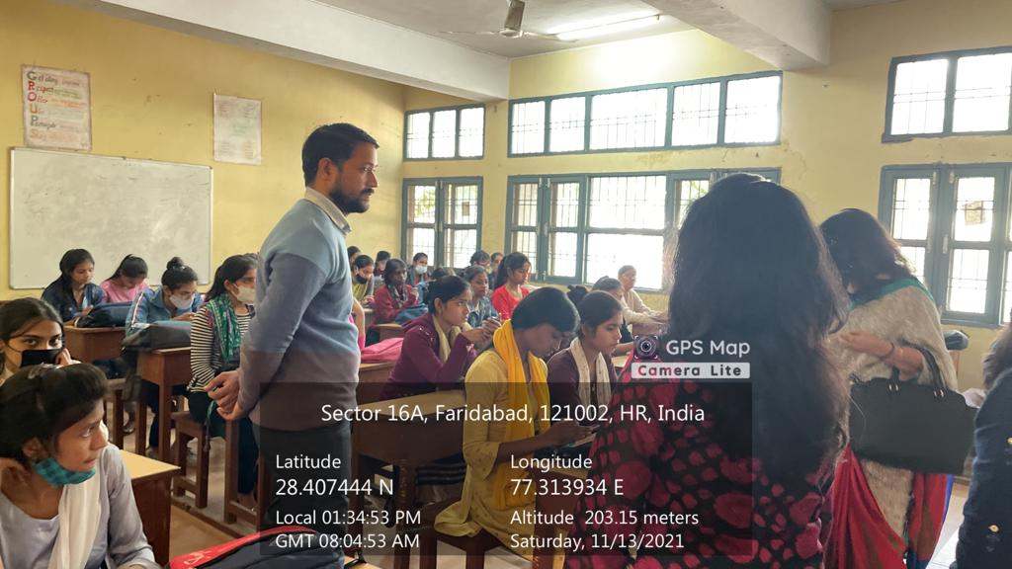

Title of the Activities & date | Organising unit/ agency/ collaborating agency | Number of teachers co-ordinated such activities | Number of students participated in such activities | Achievements/  Remarks
30) NSS Youth leadership training Camp from 2nd to 10th nov 2021.) | Maharishi Dayanand University, Rohtak at Manali | Dr. Rachna Saini | 2 students | NSS Youth leadership training Camp was organized by Maharishi Dayanand University, Rohtak at Manali from 2nd to 10th nov 2021. NSS volunteer Deepika from BA2nd year and Maina from BAJMC 2nd year participated enthusiastically in the camp. They participated in various activities held during camp.  Our Worthy Principal Dr. Sunidhi Congratulated student for their active participation in University level YLTC camp. NSS incharge Dr. Rachna Saini said that this Camp provides a platform to the volunteers to groom their personality helps them in becoming good leader.
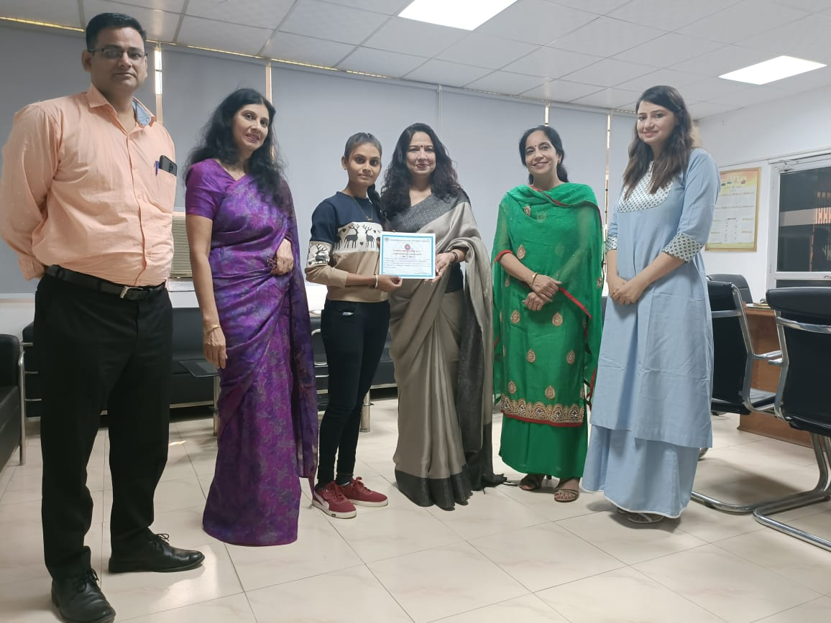

Title of the Activities & date | Organising unit/ agency/ collaborating agency | Number of teachers co-ordinated such activities | Number of students participated in such activities | Achievements/  Remarks
31) Departmental activity on 13th November, 2021 | Department of Geography | Dr. Parul Rana  Mr. Sandeep | Students of geography | The Department of Geography organised a departmental activity today i.e. 13th November, 2021 wherein students from BA first and second year made impressive powerpoint presentations on the topics like Save Aravallis through afforestation and water conservation with special reference to commendable work done by Dr. Rajender Singh, popularly know as 'Waterman of India' and his organisation Tarun Bharat Sangh and Save Yamuna by installation of waste water treatment plants and community involvement. The Dept is thankful to Principal Dr. Sunidhi ma'am for giving permission for organizing the activity which not only enhanced the understanding of students about current environmental problems but also gave them an opportunity to put forth their views and opinions with confidence.

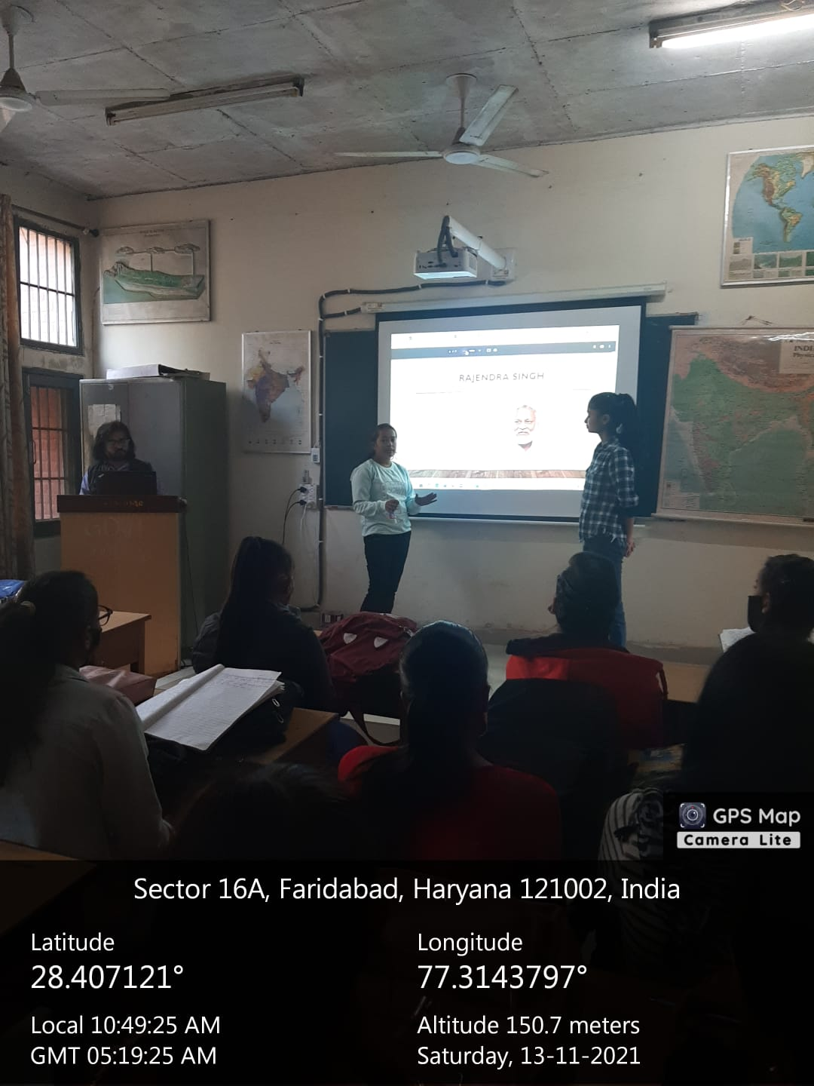
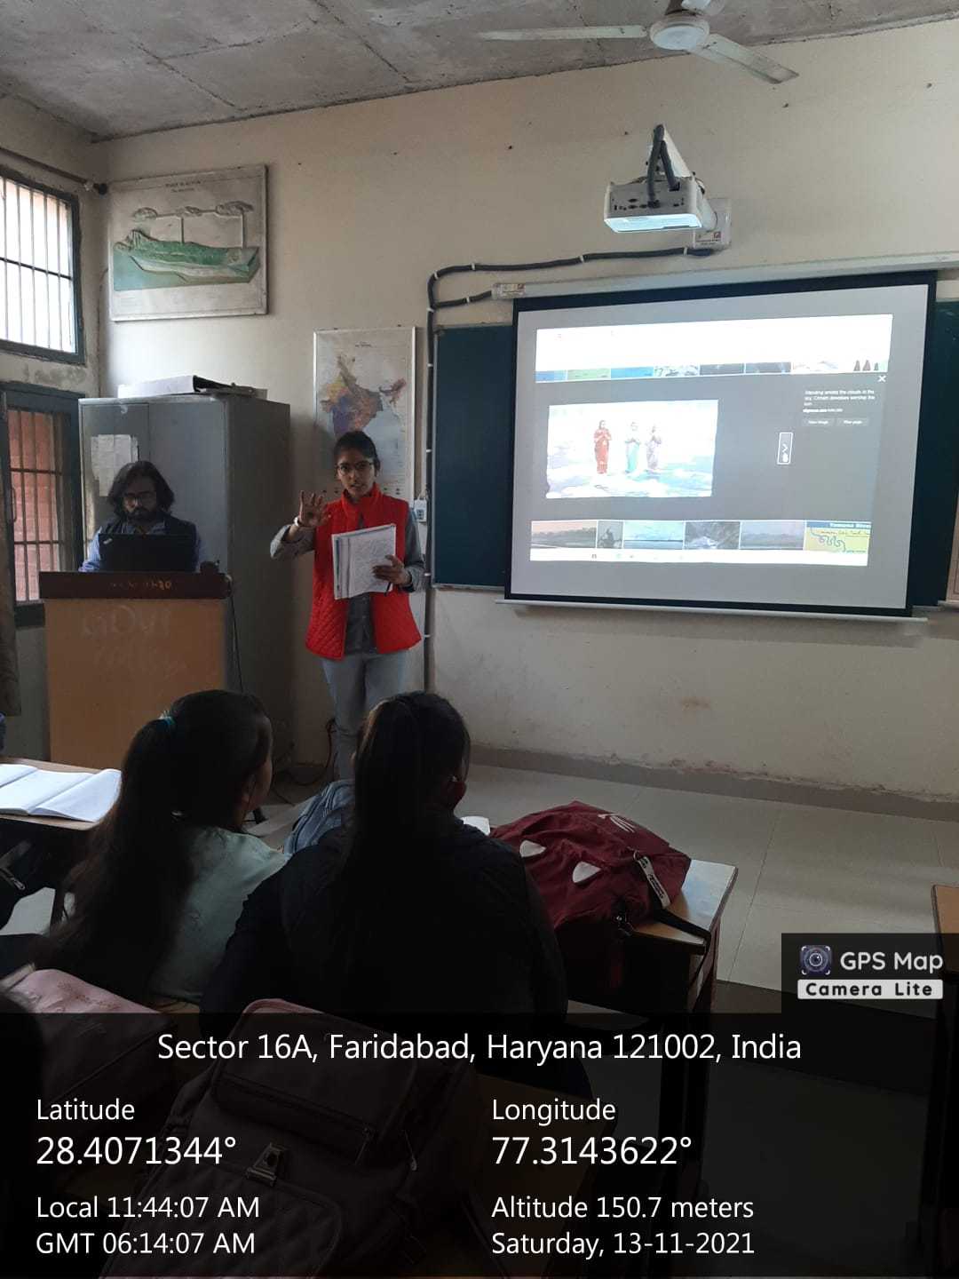

Title of the Activities & date | Organising unit/ agency/ collaborating agency | Number of teachers co-ordinated such activities | Number of students participated in such activities | Achievements/  Remarks
32) 3D Animated Video Making workshop on 16th November 2021) | Placement cell and Department of Commerce & Management | Ms. Preeti Arora  Ms. Sonia Minocha  Mr. Sandeep  Ms. Neha Vij  Ms. Aashna  Ms. Jyoti Gupta  Ms. Priya Saini  Ms. Divesh  Mr. Gaurav  Ms. Varsha | 187 students | Placement cell and Department of Commerce & Management of Government College for Women, Faridabad organized a 3D Animated Video Making  workshop on 16th November 2021 for final year students of the college.  Mr. Ramit Kumar, Programme Manager at MAAC (Maya Academy of Advanced  Cinematics) was the key note speaker. He informed students about the tools and techniques of 3D Animated Videos in a very impressive  way. As it was an interactive session, students asked various questions related to 3D animated videos. He answered all the questions logically and cleared all the doubts of the students. Mrs. Sunidhi, Principal Government College for Women, Faridabad conveyed  the students that Mass media is a new and emerging field to build their career. Event was organized and coordinated by members of Placement Cell and Department of Commerce & Management Under the guidance of Mrs. Preeti Arora, Placement Cell convener. 187 students participated in the workshop.
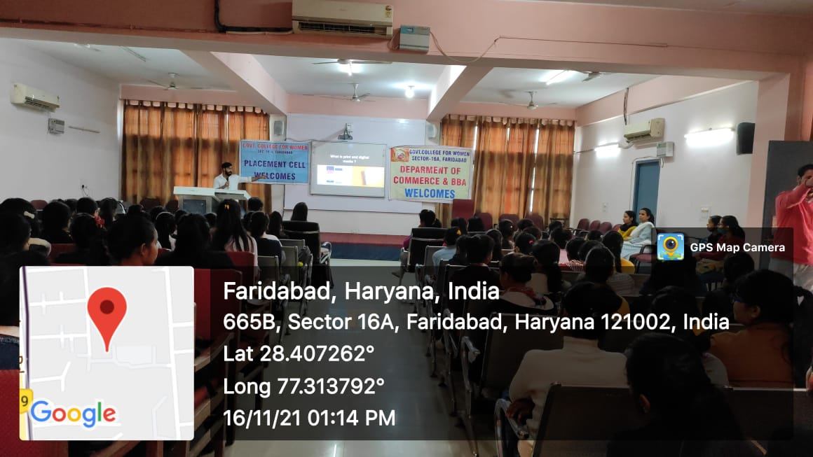
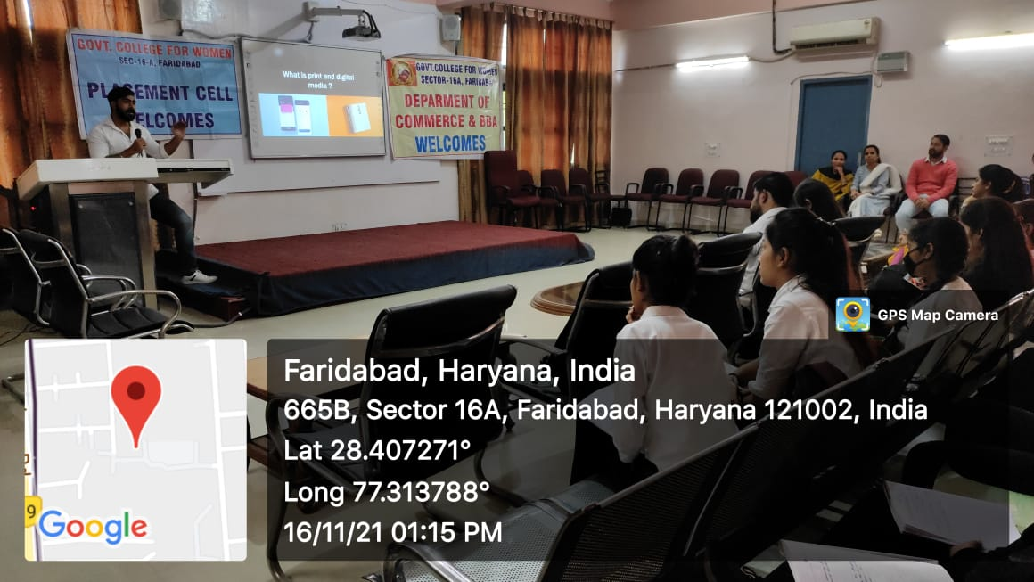

Title of the Activities & date | Organising unit/ agency/ collaborating agency | Number of teachers co-ordinated such activities | Number of students participated in such activities | Achievements/  Remarks
33) On the occasion of National Press Day on November 16th, an interactive session | Department of Journalism and mass communication c | Ms. Shalini Khurana  Dr. Rachna Saini  Ms. Savita Nagar  Mr. Suresh |  | On the occasion of National Press Day on November 16th, an interactive session was organised by the Department of Journalism and Mass Communication at Govt. College for Women, Sector 16A, Faridabad. Professor Pawan Malik (Head of Department of JMC at J.C. Bose University, Faridabad) and Mr. Mukesh Vashisht (Media Co-ordinator at CM Cell) interacted with journalism students. The session was presided over by worthy Principal of the college, Dr. Sunidhi.  Prof. Malik and Mr. Vashisht spoke about the nuances required for being a good journalist. They shared their rich experience with the students and answered all the queries raised by students.  In her address, Dr. Sunidhi motivated the journalism students for serving the nation. Ms. Ritika Gupta (senior most faculty member of the college) also addressed students on this occassion .Ms. Shalini Khurana, Asst Prof concluded the session with vote of thanks, Dr. Rachna Saini, Asst Prof anchored the session, and Mr. Suresh, Asst Prof shared information regarding National Press Day.

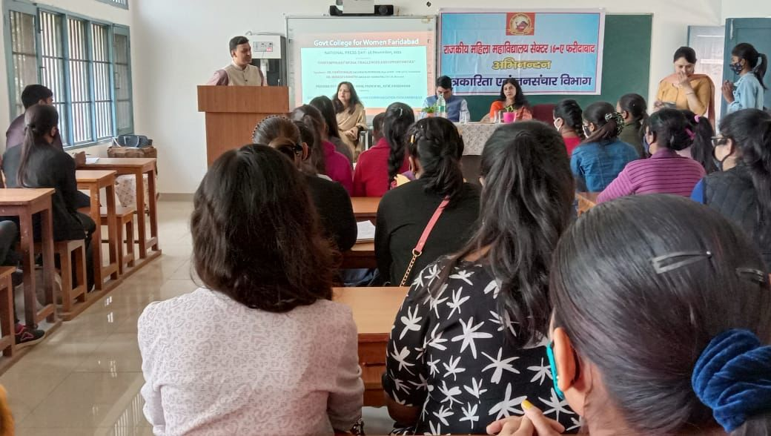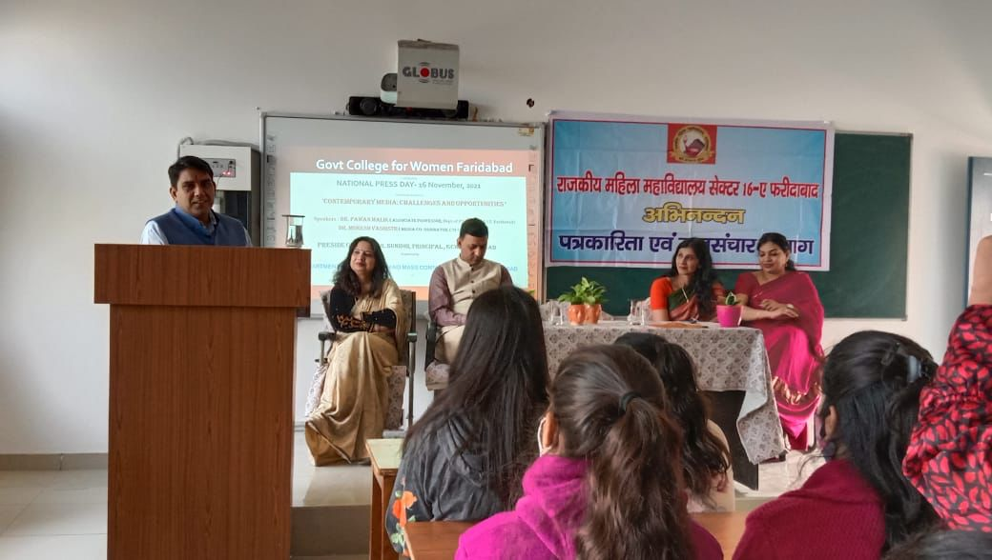
Title of the Activities & date | Organising unit/ agency/ collaborating agency | Number of teachers co-ordinated such activities | Number of students participated in such activities | Achievements/  Remarks
34) College- level Science Exhibition on 18th Nov, 2021) | Department of physics and chemistry | Ms. Neha Aggarwal  Ms. Monika  Ms. Poonam Sharma  Ms. Varsha  Ms. Chanchal  Mr. Anuj | 25 students | College- level Science Exhibition was conducted by Physics and Chemistry Department in the college on 18th Nov, 2021. It is a wonderful tool that engages students in learning new facts. It develops in them the curiosity to learn more in an interesting and experiential way. Total 25 students from Science Department participated in this event. Five exhibits from Physics and 5 exhibits from Chemistry were displayed by the students in the exhibition. Inspired, encouraged and motivated budding scientists presented different working models with great enthusiasm and excitement. All the winners were awarded with the certificates.  In Physics Department  1. Kajal Sharma (01) and Jagriti (41) from B.Sc 3rd year won first position for making Hydraulic Rocket Launcher.  2. Aarti (39), Nidhi (26) and Diksha (44) of B.Sc 2nd year won second position for making Accident prevention road safety working model.  In Chemistry Department  1. Muskan (38) and Aarti (06) of B.Sc. 3rd year won first position for making the model on Air Pollution.  2. Shikha (30), Komal (33) and Mehak (12) of B.Sc first year won 2nd position for making the working model on Bio-Plastic and Green Plastic.  First prize winners got qualified for Inter-district Science exhibition to be held on 22nd and 23rd Nov, 2021 in GC, Palwal
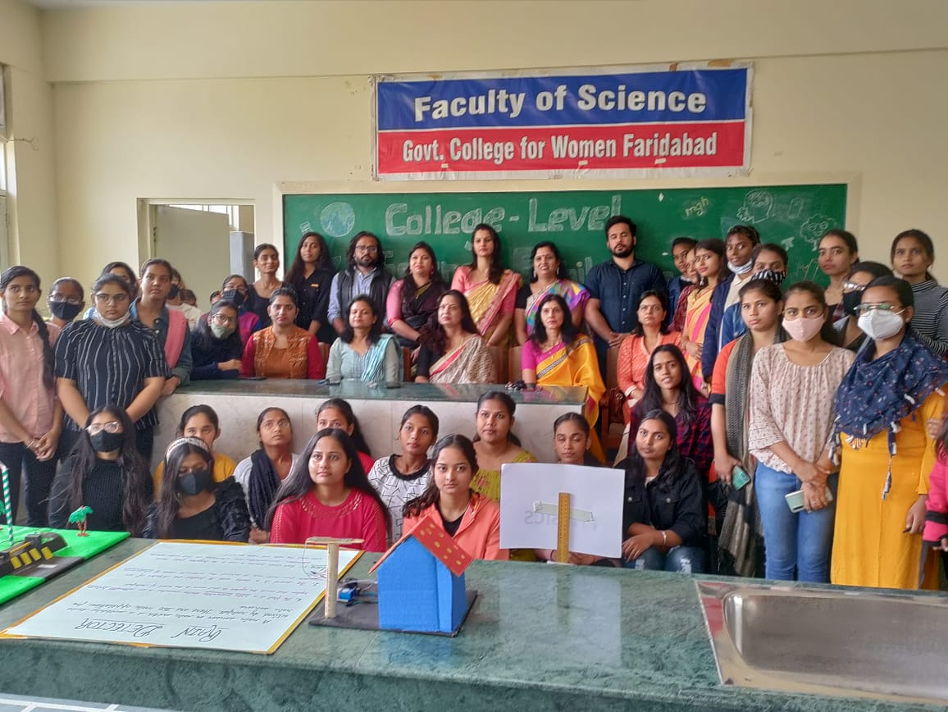
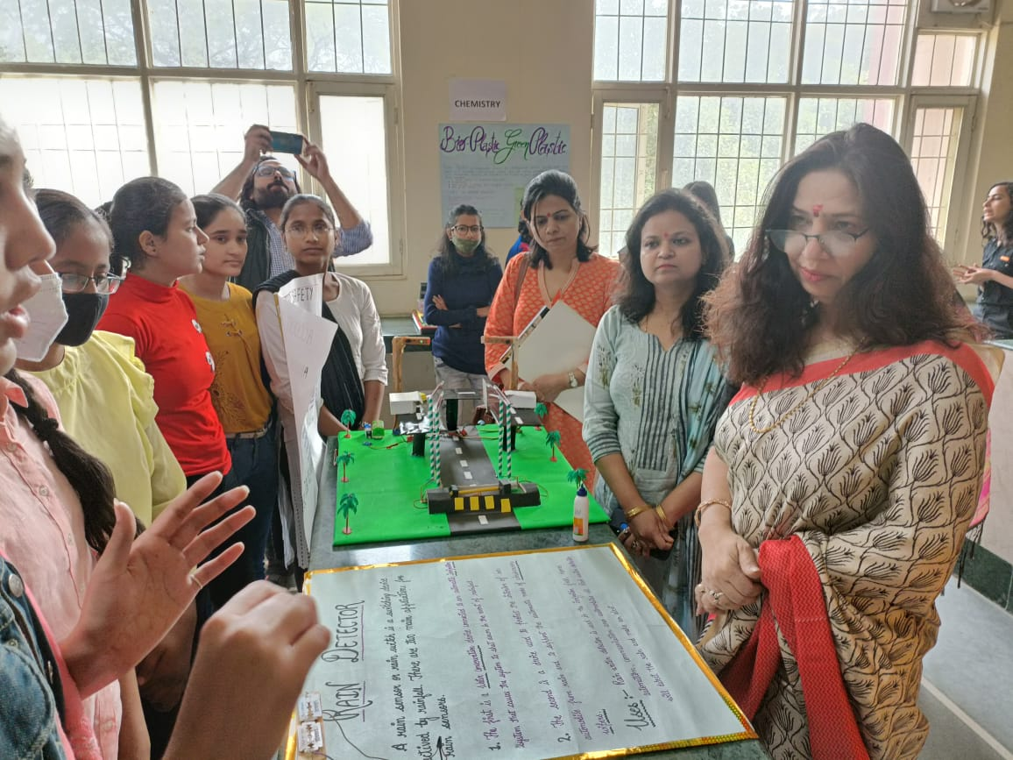
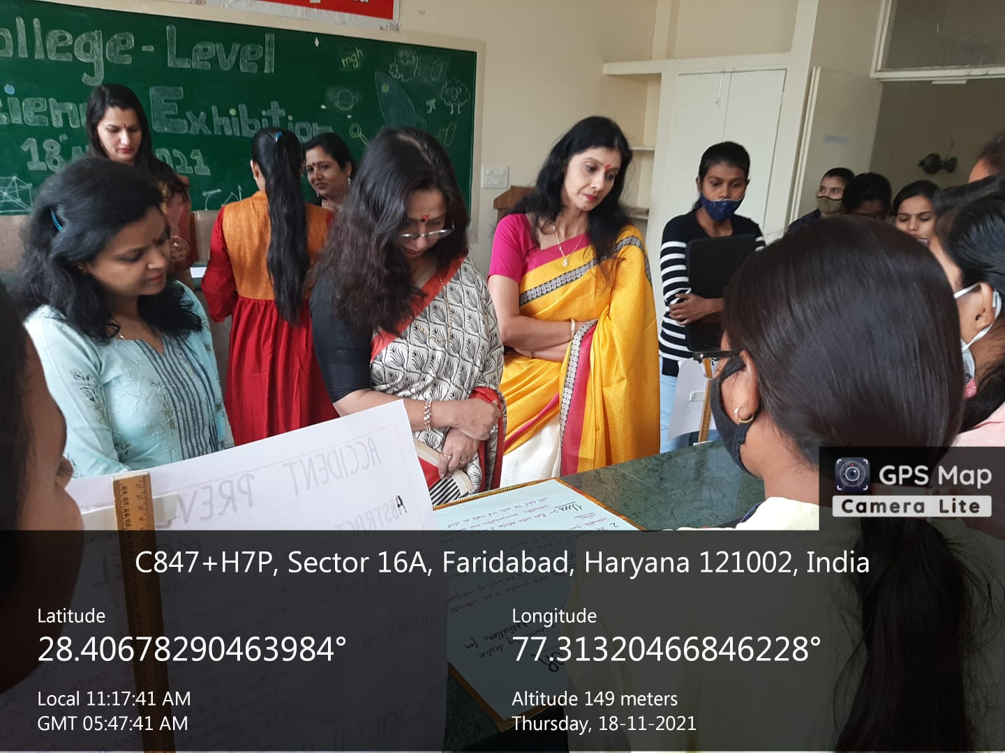

Title of the Activities & date | Organising unit/ agency/ collaborating agency | Number of teachers co-ordinated such activities | Number of students participated in such activities | Achievements/  Remarks
35) Inter-district Science Exhibition held on 22nd and 23rd Nov, 2021) | Dr. B. R. Ambedkar Government College, Palwal | Mr. Sandeep  Mr. Anuj  Ms. Kusum( lab attendant) | 8 students | Four teams comprising of 2 students each from the Departments of Physics, Chemistry, Psychology and Geography participated in 2 Day Inter District Level Science Exhibition organized by Govt. College, Palwal on 22nd and 23rd November, 2021. The team was accompanied by Assistant Professors - Mr. Sandeep and Mr. Anuj and Lab Attendant Ms.Kusum.  Two Models of Psychology and Physics bagged 2nd and 3rd positions respectively of which the details are as below:  Physics science exhibition model - Hydrolic rocket launcher with smoke absorber.  Name of participants:  Ankita Gahtori and Priya Baghel  Psychology science exhibition model - Psychology and social issue social media its time to detox  Name of participants:  Anjali and Priyanka  Principal, Dr. Sunidhi and senior faculty Ms. Ritika Gupta congratulated the winners and appreciated their hard work.
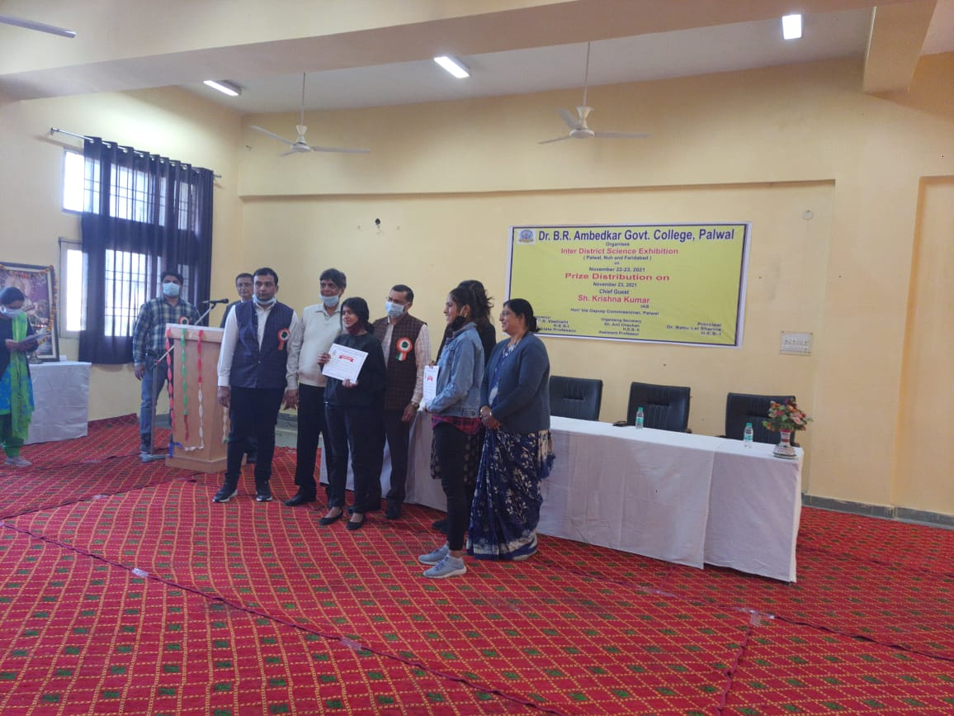
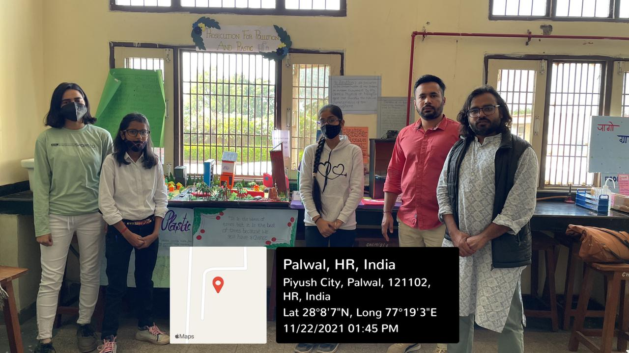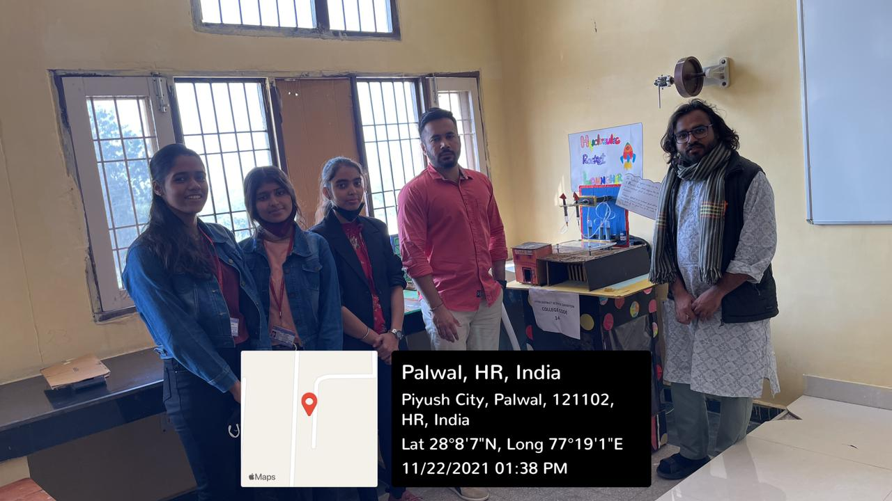
Title of the Activities & date | Organising unit/ agency/ collaborating agency | Number of teachers co-ordinated such activities | Number of students participated in such activities | Achievements/  Remarks
36) Corona Vaccine Drive on 11th December, 2021 | NSS Unit | Rachna Saini  Dr. Raman Kumar, Ms. Priya Saini, Ms Savita Nagar, Mr. Suresh, Mr. Keshav Kumar, Mr. Anuj, | 307 students | Corona Vaccine Drive was organized for the students and staff members of the college by the NSS unit of Government Women's College, Sector 16A, Faridabad.In which 61 people were given the first dose and 360 people were given the second dose. The vaccine was administered by Ms. Manjeet and Ms Kamlesh under the guidance of Dr. Shalini, who came from ESI Sector-8 Faridabad. Inaugurating the vaccine drive, Principal Dr. Sunidhi said that the state government has set a target to vaccinate all people above 18 years of age by December 31, so that people can be saved from the third possible wave of corona. That's why the second corona vaccine camp has been organized in the college.Earlier, a camp was organized in the college on August 25, 2021, in which 488 people were given first and second doses.  NSS in-charge Dr. Rachna Saini said that in this camp, 307 girl students, 18 staff members and 96 others were given the first and second doses of the vaccine. E-certificates were also issued to all by the team of doctors. On this occasion Prof. Archana Verma, Dr. Raman Kumar, Ms. Priya Saini, Ms Savita Nagar, Mr. Suresh, Mr. Keshav Kumar, Mr. Anuj, and NSS volunteers were present.
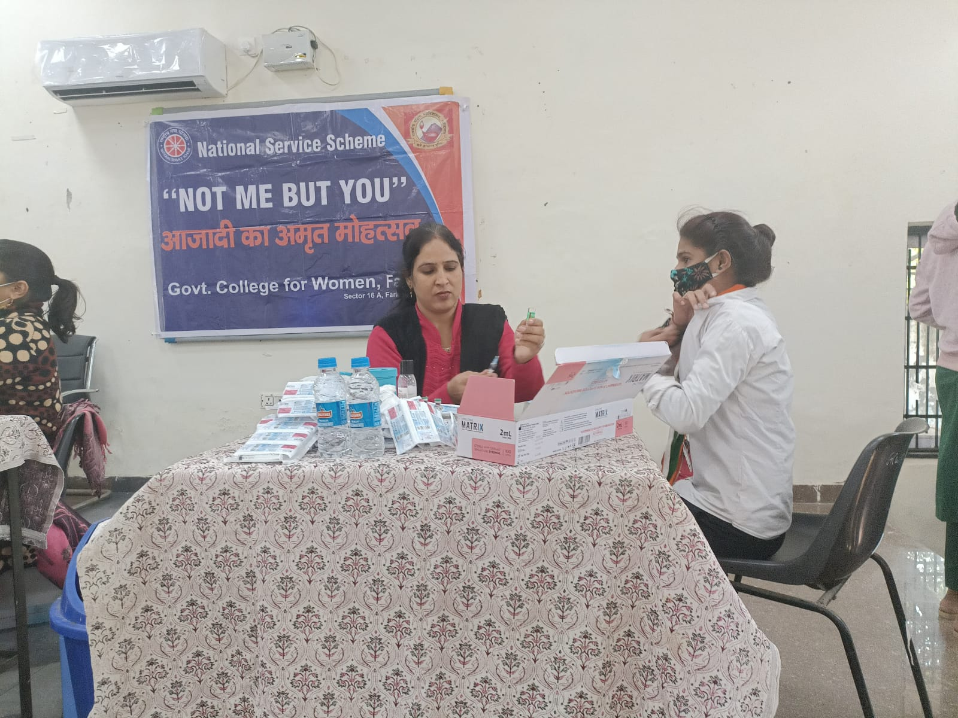
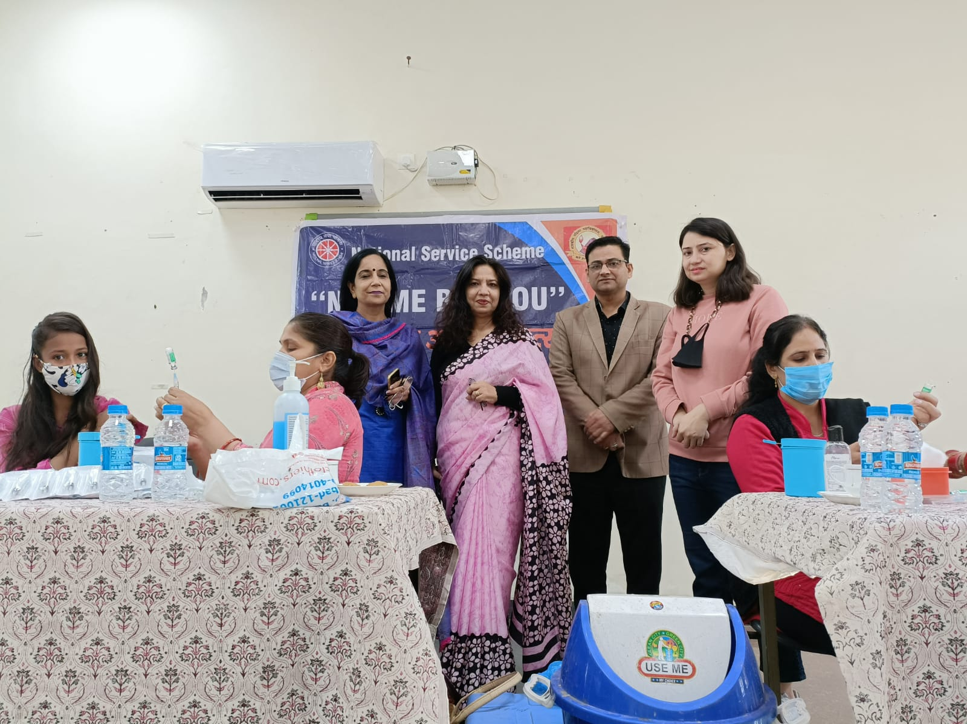

Title of the Activities & date | Organising unit/ agency/ collaborating agency | Number of teachers co-ordinated such activities | Number of students participated in such activities | Achievements/  Remarks
37) District-Level Science Essay Writing Competition 22nd December, 2021 | Haryana State Council for Science, Innovation & Technology at GC, Faridabad | Dr. Neha Aggarwal | One student | Neetu Verma, Roll no 46, of B.Sc Second year got seventh position in District-Level Science Essay Writing Competition Organized by Haryana State Council for Science, Innovation & Technology at GC, Faridabad on 22/12/2021. She is now qualified for the State-Level Science Essay Writing Competition.
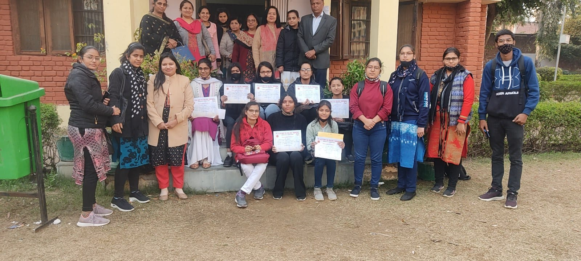

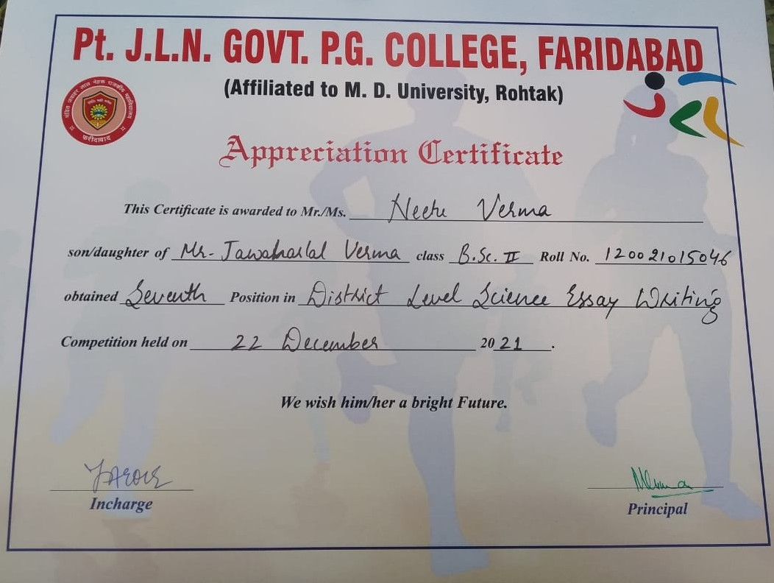

Title of the Activities & date | Organising unit/ agency/ collaborating agency | Number of teachers co-ordinated such activities | Number of students participated in such activities | Achievements/  Remarks
38) 16 days “Fine Arts Workshop” from 18/11/2021 to 07/12/2021 | Women cell | Ms. Neelam Rani  Ms. Meenal Sabharwal  Ms. Neha Aggarwal (convener)  Ms. Priya  Ms. Divesh  Ms. Chanchal | 50 students | Women Cell of our college organized 16 days “Fine Arts Workshop” for the college students from 18/11/2021 to 07/12/2021, which included several activities such as drawing, painting, sketching, clay modeling, Rangoli etc. Total 50 students participated and got benefitted from this workshop. All the participants took active part in the workshop as was evident in their enthusiasm, their involvement in all the activities, their active response, discipline and punctuality.
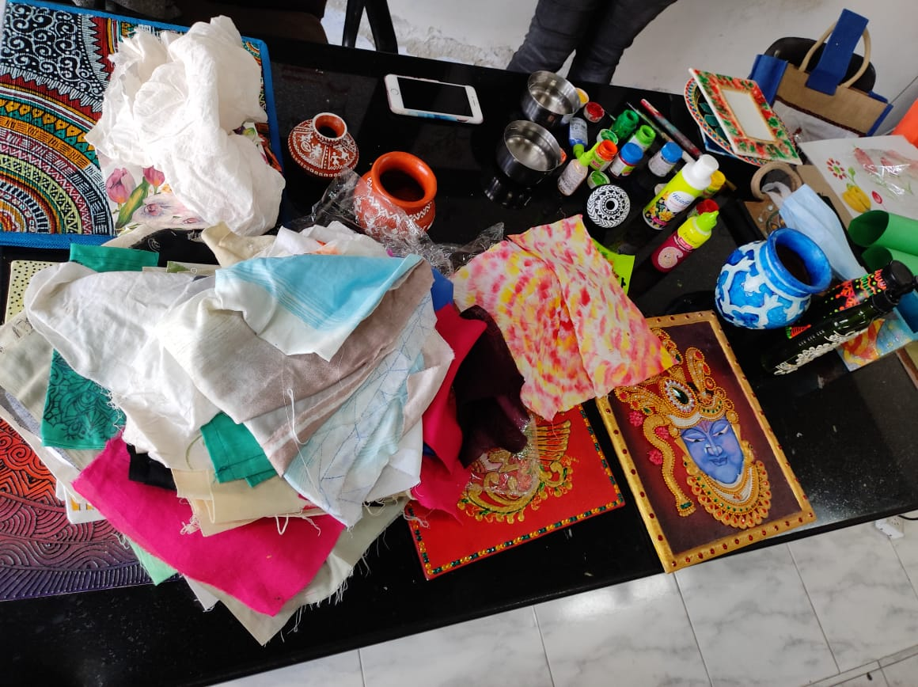
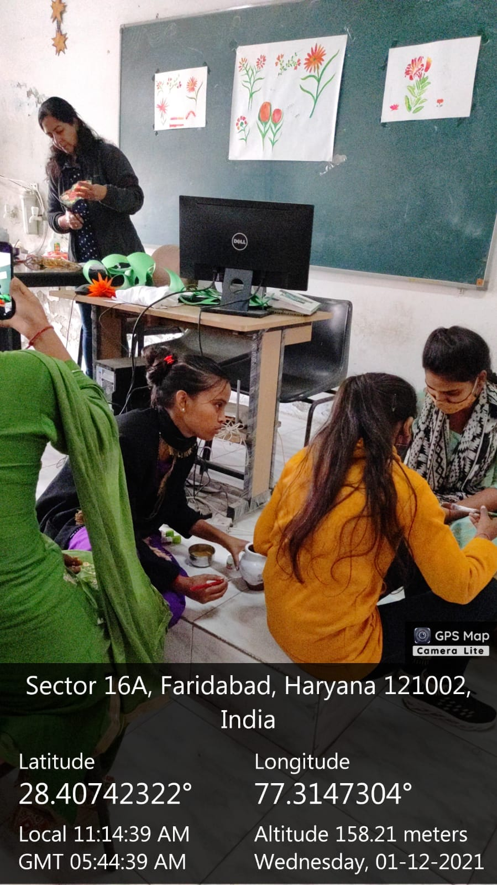

Title of the Activities & date | Organising unit/ agency/ collaborating agency | Number of teachers co-ordinated such activities | Number of students participated in such activities | Achievements/  Remarks
39) 7 days “Stitching and tailoring Workshop” from 02/12/2021 to 09/12/2021) | Women cell | Ms. Neelam Rani  Ms. Meenal Sabharwal  Ms. Neha Aggarwal (convener)  Ms. Priya  Ms. Divesh  Ms. Chanchal | 40 students | Women Cell of our college organized 7 days “Stitching and tailoring Workshop” for the college students from 02/12/2021 to 09/12/2021. Total 40 students participated in this workshop and got benefitted. Keeping in view the market demand and change fashion technology, such workshop on cutting, stitching and tailoring helps students to meet the basic stitching requirement at home. Stitching of garments at home is a money saving device for lower middle-income group. Besides tailoring can be a vocation for self-employment.
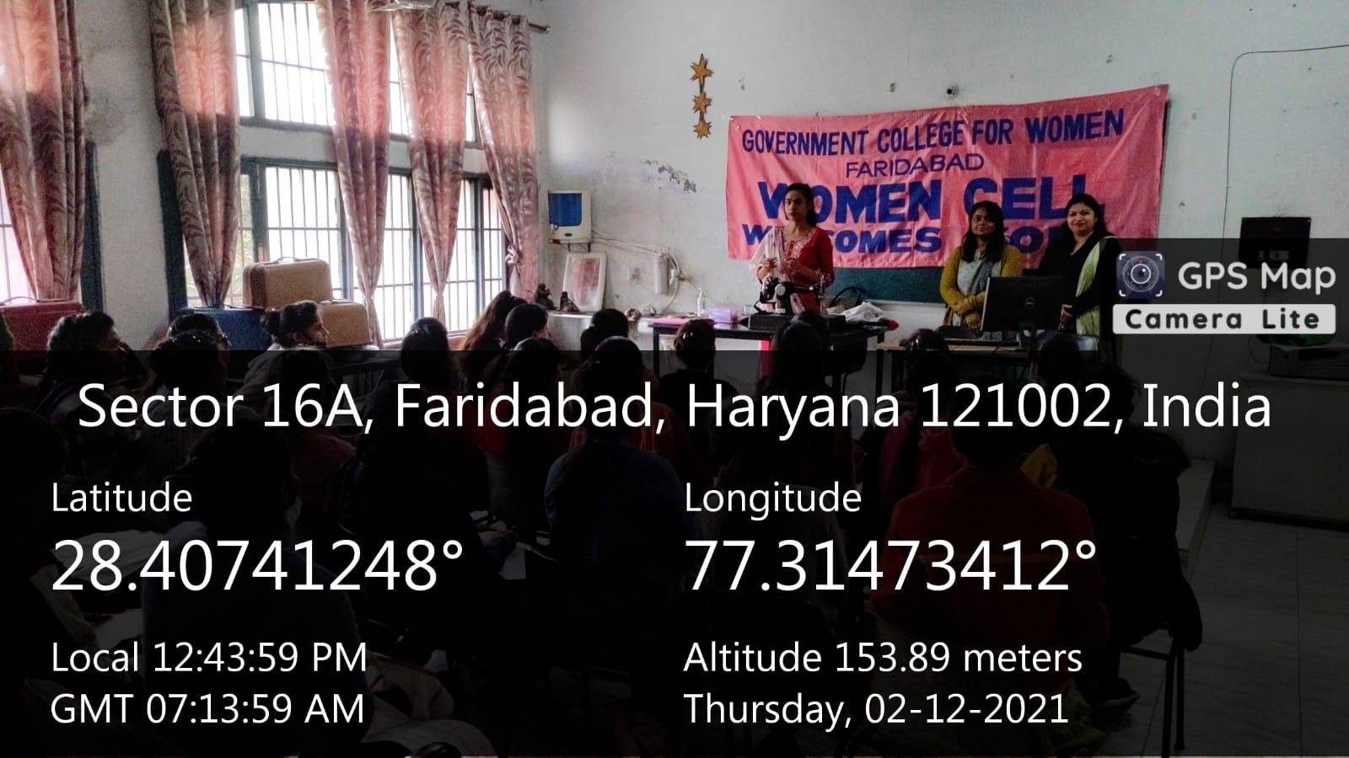
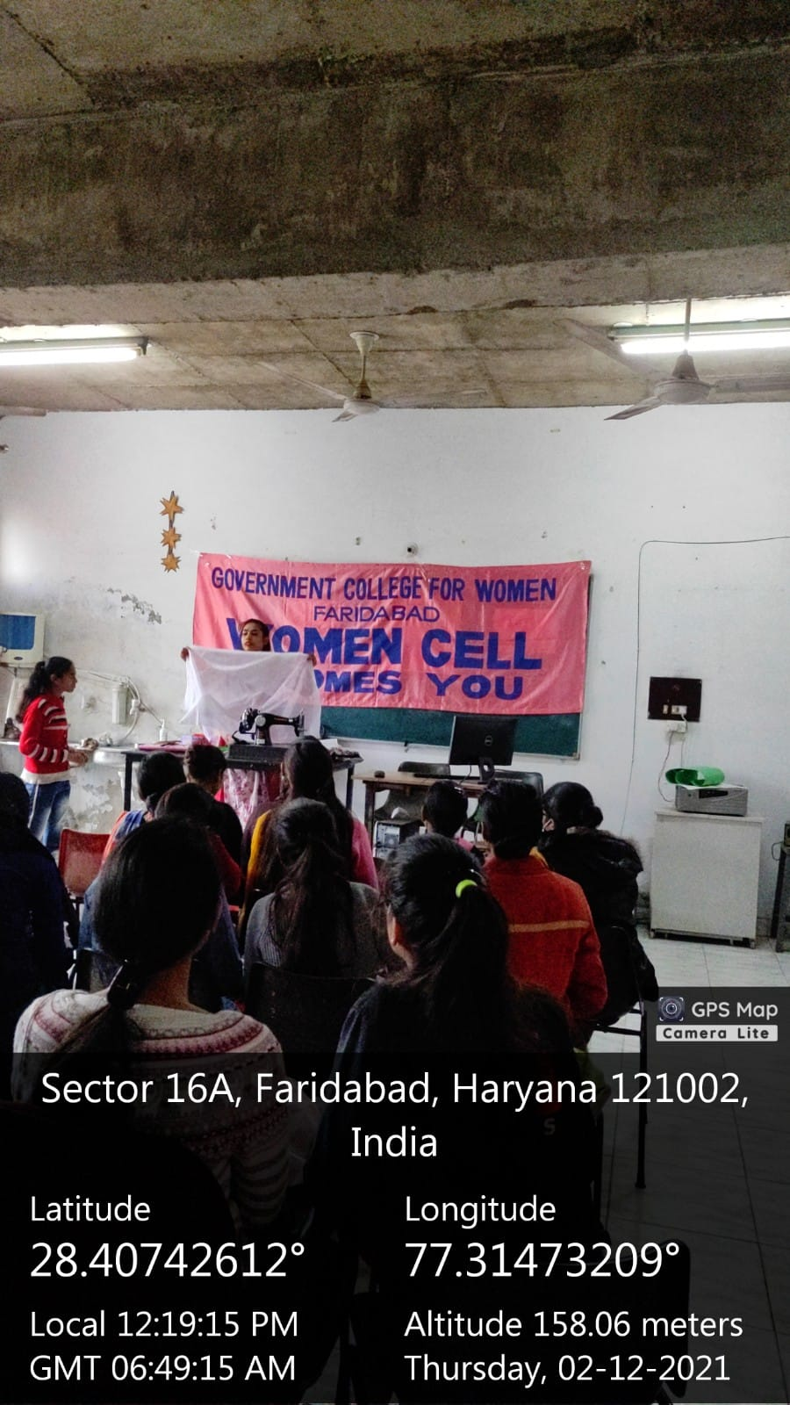

Title of the Activities & date | Organising unit/ agency/ collaborating agency | Number of teachers co-ordinated such activities | Number of students participated in such activities | Achievements/  Remarks
40) College-Level Science Essay Writing Competition on 4th December, 2021 | Faculty of Science | Dr. Neha Aggarwal  Ms. Chanchal  Ms. Varsha  Ms. Poonam  Mr. Anuj | 10 students | College-Level Science Essay Writing Competition was organized by the Faculty of Science for B.Sc students in the college on 04/12/2021. Total 10 students of B.Sc participated and the best three students (Neetu Verma, Swati Pandey and Aakshi) were selected to participate further in District-Level Science Essay Writing Competition to be held on 22/12/2021 at GC, Faridabad.
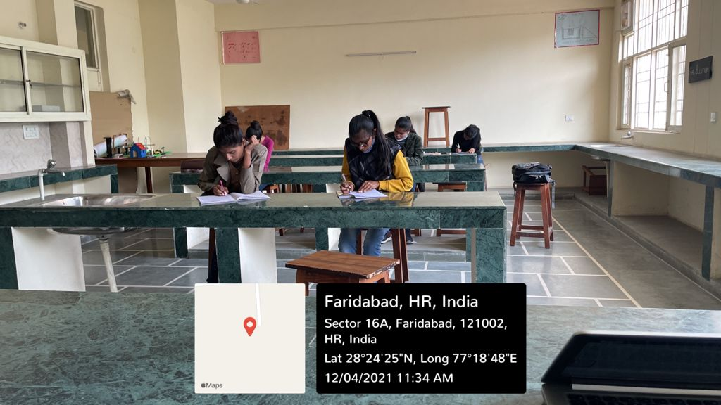

Title of the Activities & date | Organising unit/ agency/ collaborating agency | Number of teachers co-ordinated such activities | Number of students participated in such activities | Achievements/  Remarks
41) 14 days “Self-Defense Training Workshop” from 08/12/2021 to 24/12/2021 | Women cell | Ms. Neelam Rani  Ms. Meenal Sabharwal  Ms. Neha Aggarwal (convener)  Ms. Priya  Ms. Divesh  Ms. Chanchal | 59 students | Women Cell of our college organized 14 days “Self-Defense Training Workshop” for the college students from 08/12/2021 to 24/12/2021. Total 59 students participated in this workshop and got benefitted. The training was conducted to boost the self-confidence of the girls and to make them able to act in unfavorable situations. The girls were taught simple ways of self-defense and they were also spoken to about tackling situations in which they found themselves to be under any kind of harassment. The safety of the girl child should be given maximum priority and hence the workshop was seen as a boon to the girls who often have to travel away from their homes for studies and work.
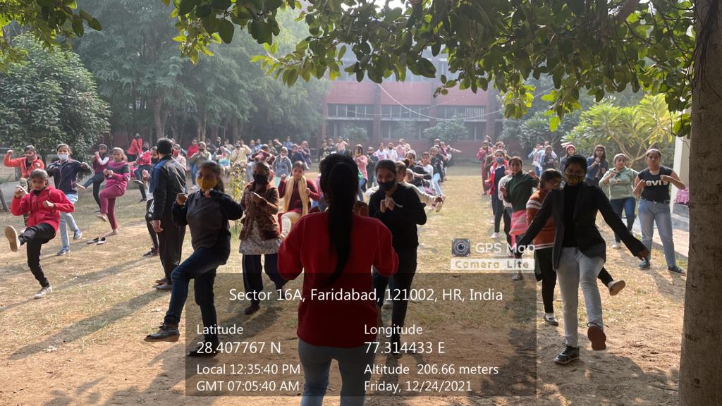

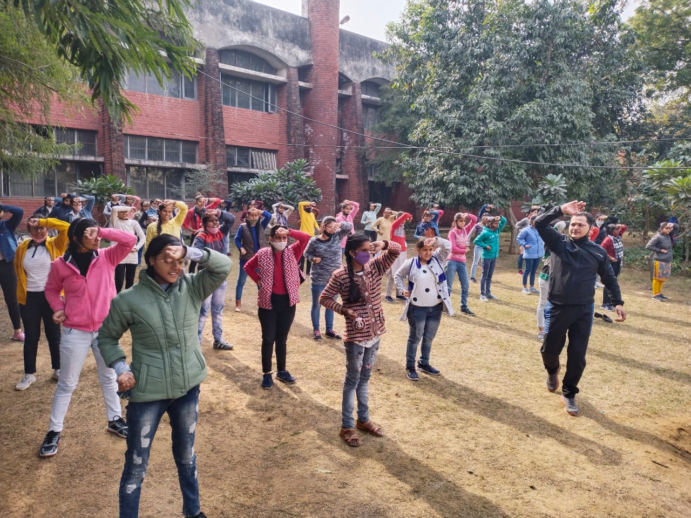

Title of the Activities & date | Organising unit/ agency/ collaborating agency | Number of teachers co-ordinated such activities | Number of students participated in such activities | Achievements/  Remarks
42) Participation in youth festival 14- 16th Dec, 2021 | Department of Music, Hindi, English | All staff members | 46 students | College participated in the Youth Festival in various categories and won 6 prizes. Poetic Recitation(English) – 1st Prize, Poetic Recitation(Punjabi) – 1st Prize, Poetic Recitation(Hindi) – 2nd Prize, Group Dance(General) – 2nd Prize, Group Dance (Haryanvi)-2nd Prize and Rangoli (Fine Arts) – 3rd Prize.

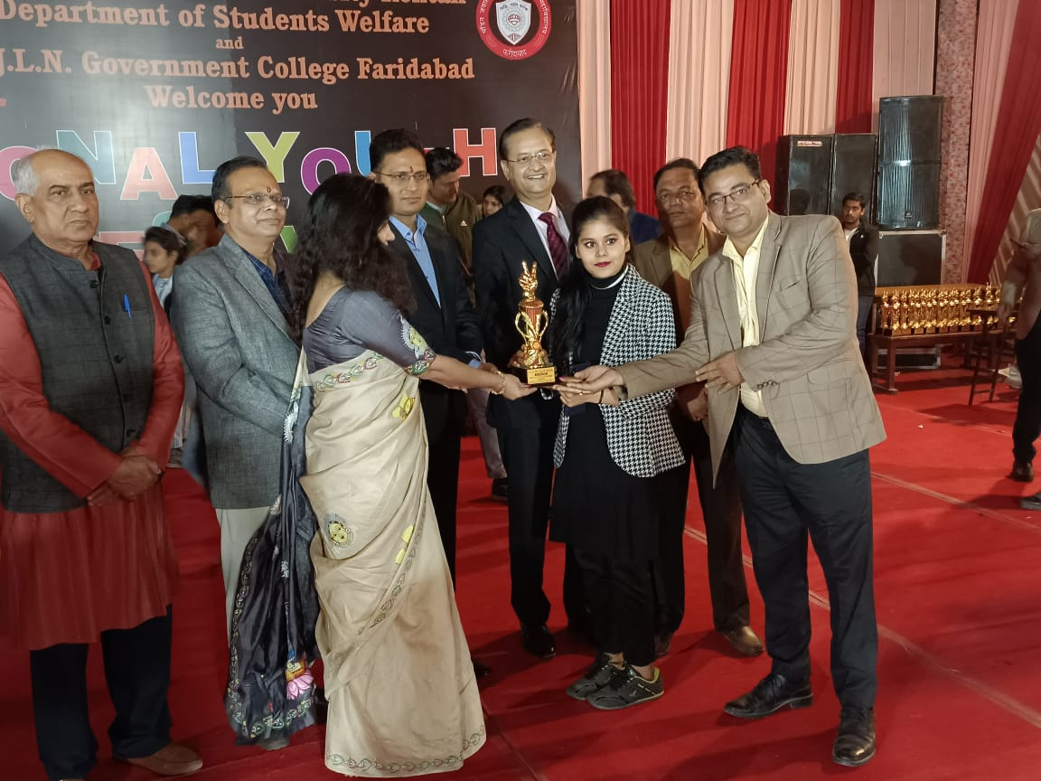

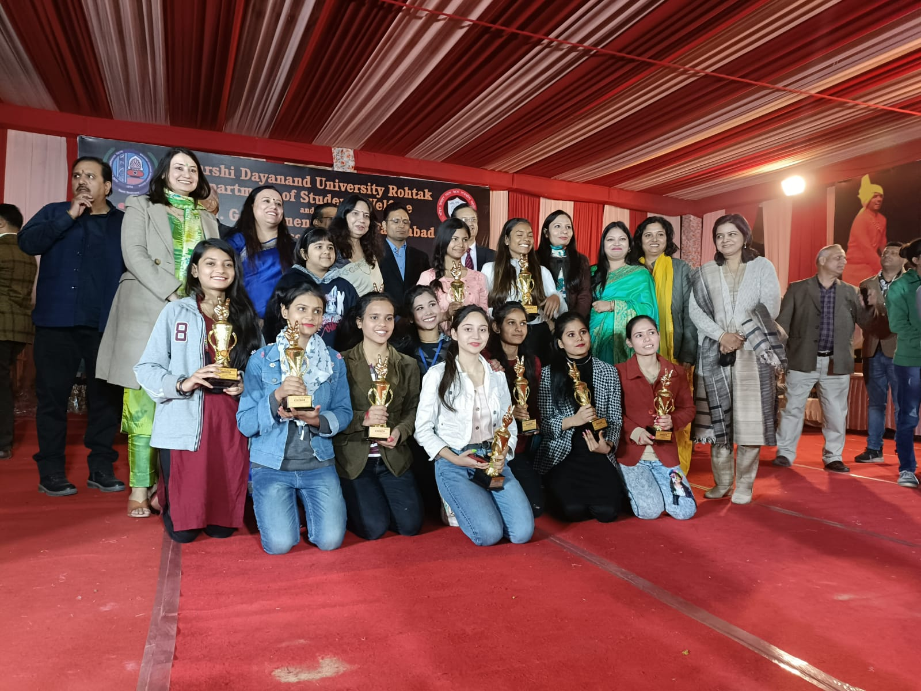

Title of the Activities & date | Organising unit/ agency/ collaborating agency | Number of teachers co-ordinated such activities | Number of students participated in such activities | Achievements/  Remarks
43) State-Level online Inter-college Mathematical Poster Making competition 29th December, 2022 | Department of Mathematics, Smt. Aruna Asaf Ali Govt. P. G. College, Kalka, Affiliated to Kurukshetra University, Kurukshetra | Dr. Neha Aggarwal | One student | Parul Shukla, Roll no 06, of B.Sc 2nd year bagged first position in State-Level online Inter-college Mathematical Poster Making competition organized by the Department of Mathematics, Smt. Aruna Asaf Ali Govt. P. G. College, Kalka, Affiliated to Kurukshetra University, Kurukshetra to celebrate National Mathematics Day- 2021 on 29/12/2021.
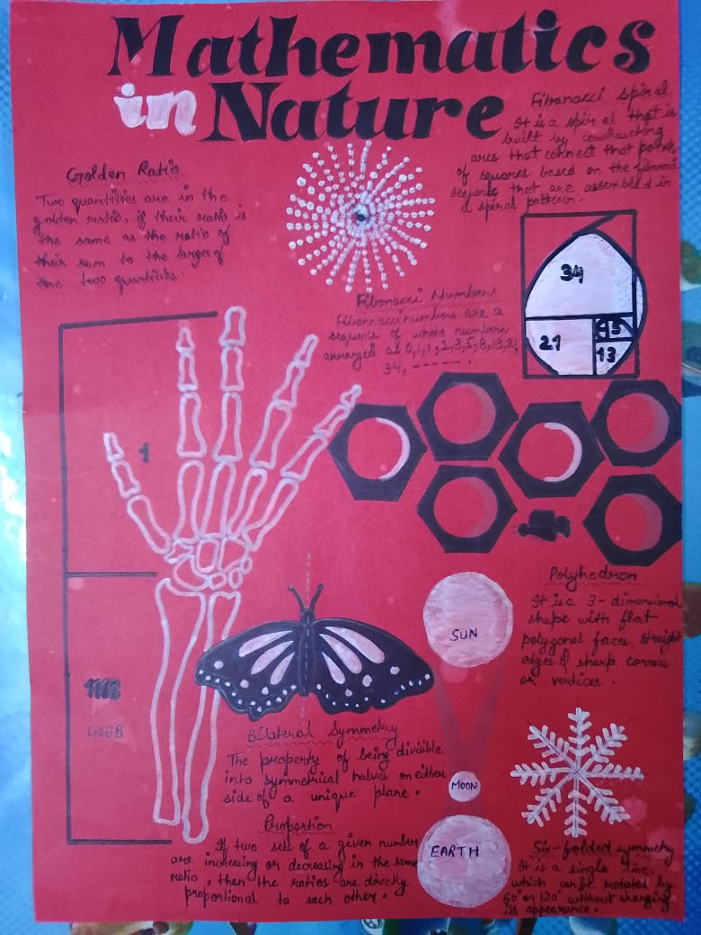

Title of the Activities & date | Organising unit/ agency/ collaborating agency | Number of teachers co-ordinated such activities | Number of students participated in such activities | Achievements/  Remarks
44) Webinar on “Financial Awareness and Consumer Training (FACT)” by NCFE on 7th January, 2022 | Placement cell and Department of Commerce & Management in  collaboration with Department of Economics | 13 teachers  Ms. Preeti Arora  Ms. Sonia Minocha  Ms. Archna Verma  Ms. Neha Vij  Ms. Jyoti Gupta  Ms. Priya Saini  Ms. Aashna  Ms. Varsha  Ms. Divesh  Ms. Manisha  Mr. Sandeep  Mr. Suresh  Mr. Gaurav | 112 students | Placement cell and Department of Commerce & Management in  collaboration with Department of Economics of Government College for  Women, Faridabad organized a webinar on “Financial Awareness and  Consumer Training (FACT)” by NCFE to provide financial education to  final year students of the college. The program is conducted through  Cisco Webex platform on 7 January 2022 at 11 AM. Ms. Jyoti Kapoor,  NCFE Trainer was the key note speaker. She informed students about  the Identity theft protection, Responsible use of credit cards,  Education loan borrowing principles, How to avoid impulse buying, How  to manage your income in a very impressive way. As it was an  interactive session, students asked various questions related to the  topic. She answered all the questions very logically and cleared all  the doubts of the students. Mrs. Sunidhi, Principal Government College  for Women, Faridabad conveyed the students that financial awareness  and consumer training is a need of the hour and this will positively  impact your financial well-being. Event was organized and coordinated  by members of Placement Cell and Department of Commerce & Management  Under the guidance of Mrs. Preeti Arora, Placement Cell convener. 112  students participated in the workshop.

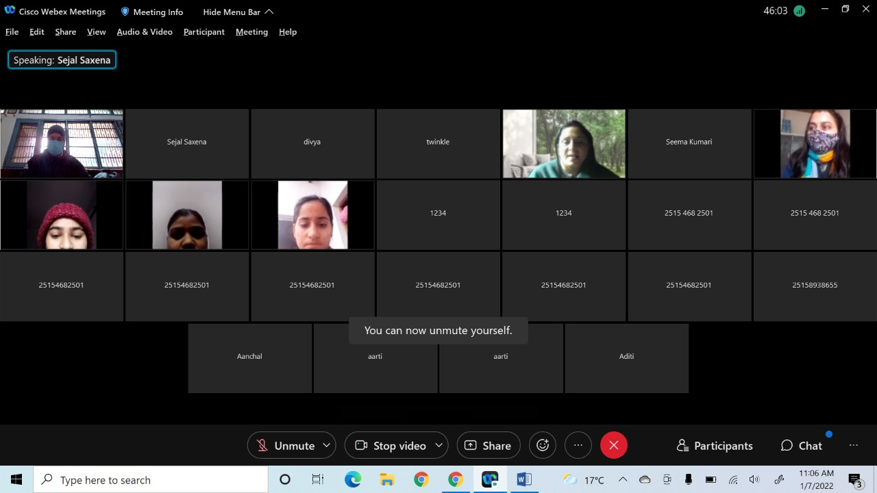
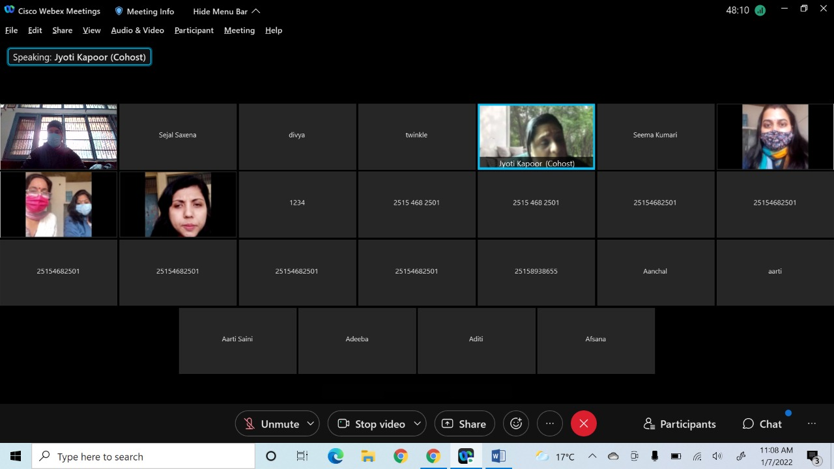

Title of the Activities & date | Organising unit/ agency/ collaborating agency | Number of teachers co-ordinated such activities | Number of students participated in such activities | Achievements/  Remarks
45) webinar on “New age careers with  Financial Security and good job prospects” by GUS Global on 15th January, 2022 | Placement cell and Department of Commerce & Management in  collaboration with Department of Economics | 13 teachers  Ms. Preeti Arora  Ms. Sonia Minocha  Ms. Archna Verma  Ms. Neha Vij  Ms. Jyoti Gupta  Ms. Priya Saini  Ms. Aashna  Ms. Varsha  Ms. Divesh  Ms. Manisha  Mr. Sandeep  Mr. Suresh  Mr. Gaurav | 226 students | Placement cell and Department of Commerce & Management in  collaboration with Department of Economics of Government College for  Women, Faridabad organized a webinar on “New age careers with  Financial Security and good job prospects” by GUS Global (academic  partners UPES, Dehradun and Pearl Academy) for final year students of  the college. The program is conducted through Cisco Webex platform on  15 January 2022 at 3.00 PM. Mr. Viveck Vaswani, Industry expert was  the key note speaker. He informed students about the financial  securities and market, emerging trends in the field of finance, how a  individual can build a career in the area in a very impressive way.  It was an interactive session, students asked various questions  related to the topic. He answered all the questions and cleared all  the doubts of the students. Event was organized and coordinated by  members of Placement Cell and Department of Commerce & Management  Under the guidance of Mrs. Preeti Arora, Placement Cell convener. 226  students participated in the workshop.
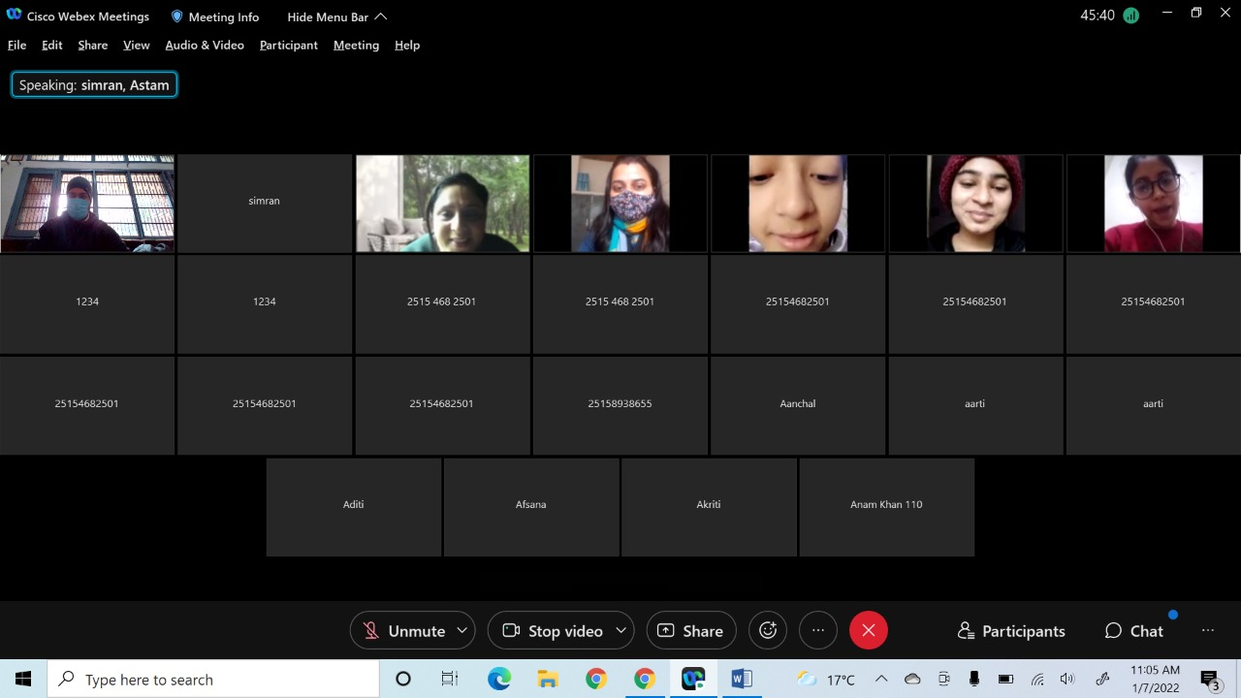
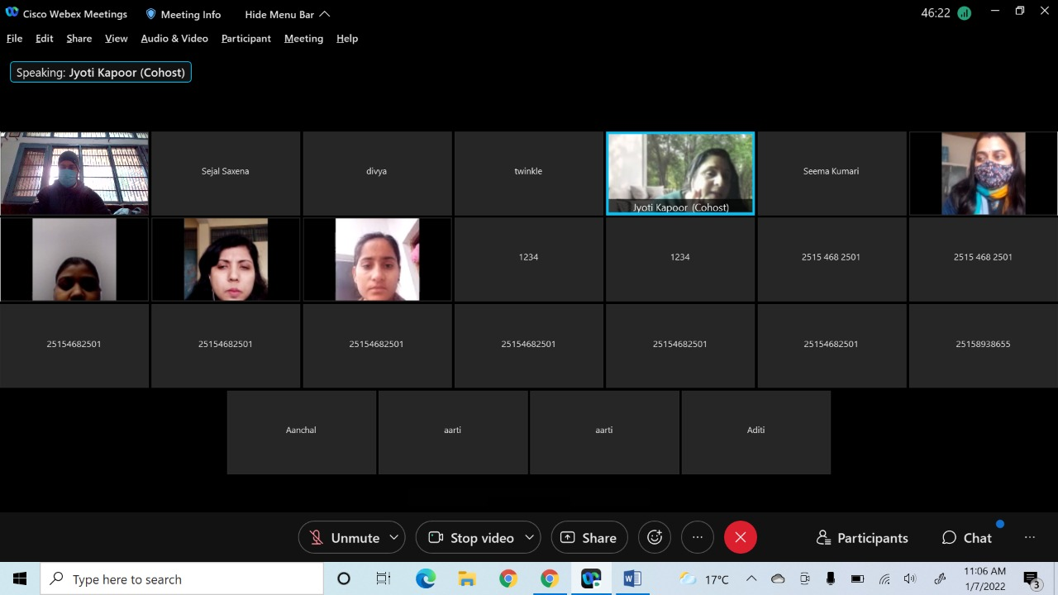

Title of the Activities & date | Organising unit/ agency/ collaborating agency | Number of teachers co-ordinated such activities | Number of students participated in such activities | Achievements/  Remarks
46) National Tourism Day by organising Departmental activity On 25 Jan 2022 | Department of Tourism Management | Ms. Preeti Raina  Ms. Keshav  Ms. Sandeep | 45 students | The Department of Tourism Management celebrated National Tourism Day by organising Departmental activity today i.e. On 25 Jan 2022 wherein students from BTTM Department submitted their Ppt and presented their impressive powerpoint presentations on various Tourist Destinations like Rajasthan , Mumbai, lucknow, Rishikesh etc.discussing it's accessibility,and attractions through online Mode. The Dept is very thankful to Principal ma'am for giving permission for organizing this activity on National Tourism Day which not only enhanced the understanding of students about Tourist Destinations but also helped them to understand the importance of Tourism industry in India as it is a big source of earning foreign exchange and Employment. This day is especially important to raise awareness about Traveling among people.
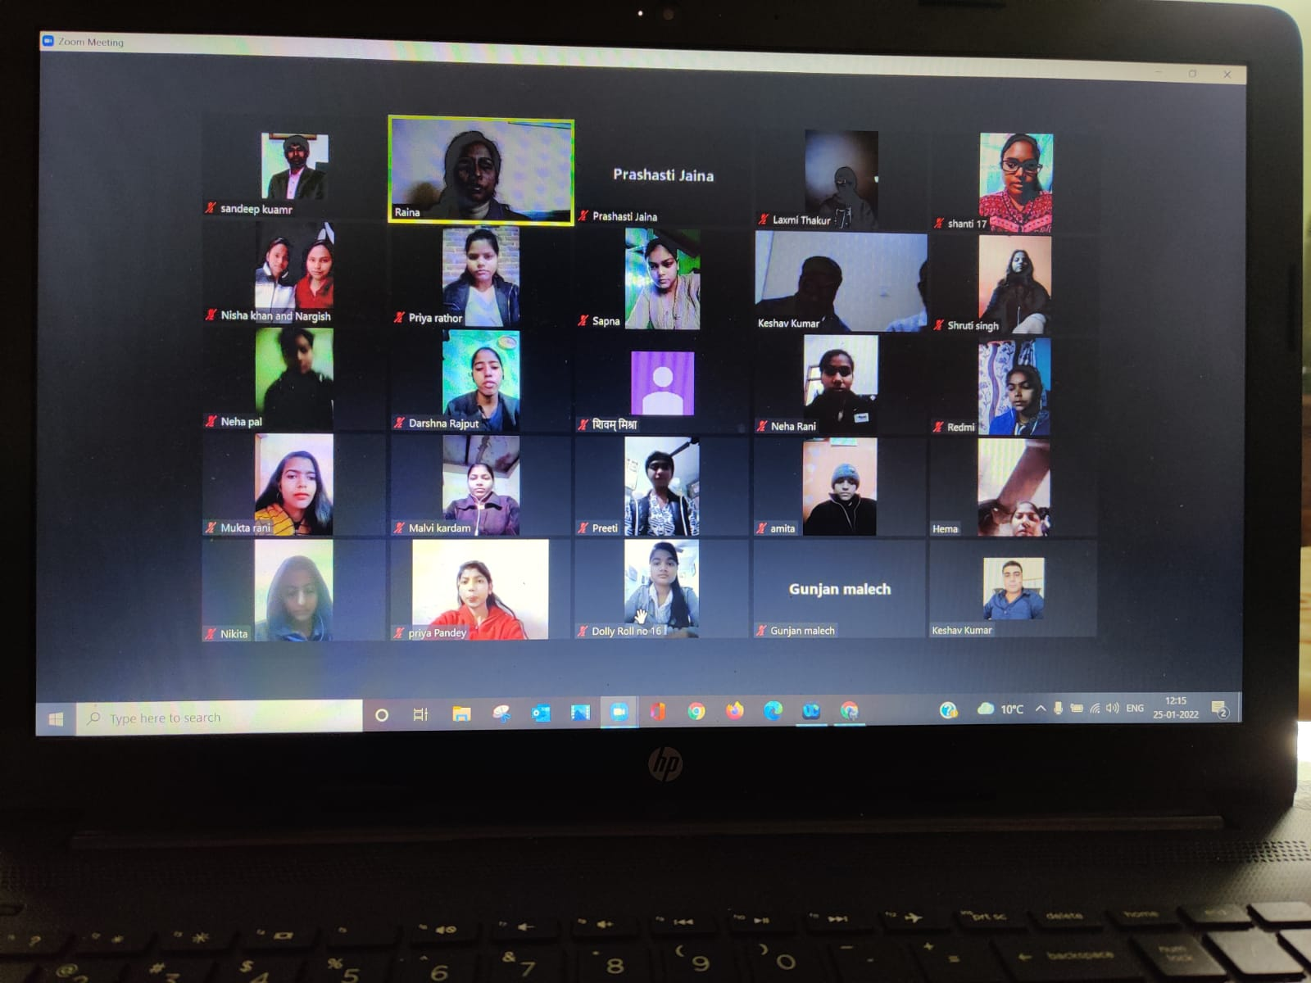
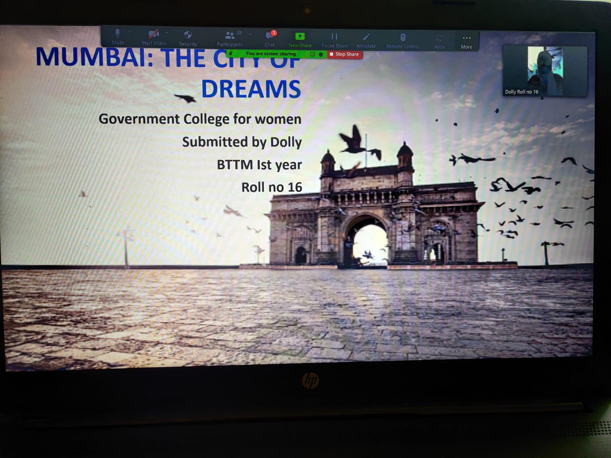

Title of the Activities & date | Organising unit/ agency/ collaborating agency | Number of teachers co-ordinated such activities | Number of students participated in such activities | Achievements/  Remarks
47) three days online workshop on “Financial Literacy” in collaboration  with Y4D Foundation and Policy Bazaar from 24th – 26th January, 2022 | Placement cel | 6 teachers  Ms. Preeti Arora  Ms. Sonia Minocha  Ms. Aashna  Ms. Aashna  Mr. Sandeep  Mr. Suresh | 182 students | Placement cell of Government College for Women, Faridabad organised a  three days online workshop on “Financial Literacy” in collaboration  with Y4D Foundation and Policy Bazaar for final year students of the  college. The program is conducted through Cisco Webex platform from  24th to 26th January, 2022at 2.00 PM. Mr. Viveck Vaswani, Industry  expert was the key note speaker. He informed students about the  financial securities and market, emerging trends in the field of  finance, how a individual can build a career in the area in a very  impressive way. It was an interactive session, students asked various  questions related to the topic. He answered all the questions and  cleared all the doubts of the students. Event was organized and  coordinated by members of Placement Cell Under the guidance of Mrs.  Preeti Arora, Placement Cell convener. 182 students participated in  the workshop.

Title of the Activities & date | Organising unit/ agency/ collaborating agency | Number of teachers co-ordinated such activities | Number of students participated in such activities | Achievements/  Remarks
48) Extension lecture on "Career and Role of Women in Science and Technology" on 3rd Feb, 2022 | Women Cell in collaboration with Faculty of Science | Dr. Neha Aggarwal  Ms. Neelam Rani  Ms. Meenal Sabharwal  Ms. Priya  Ms. Chanchal  Ms. Divesh | 2 students | Extension Lecture was conducted by Women Cell in collaboration with Faculty of Science on "Career and Role of Women in Science and Technology" by Dr. Beena Sethi, Associate professor Chemistry, K. L. Mehta Dayanand College for Women, Faridabad on 3rd Feb, 2022. The speaker highlighted the various contributions made by women in different fields of Science and Technology. She also encouraged students to pursue their career in the science and technology by citing various examples set by lady scientists. Our Principal Dr. Sunidhi also motivated the students and brought forth how women need to move out of their comfort zone and follow their ambition in practical Scienes. Total 51 B.Sc students got benefitted with it.
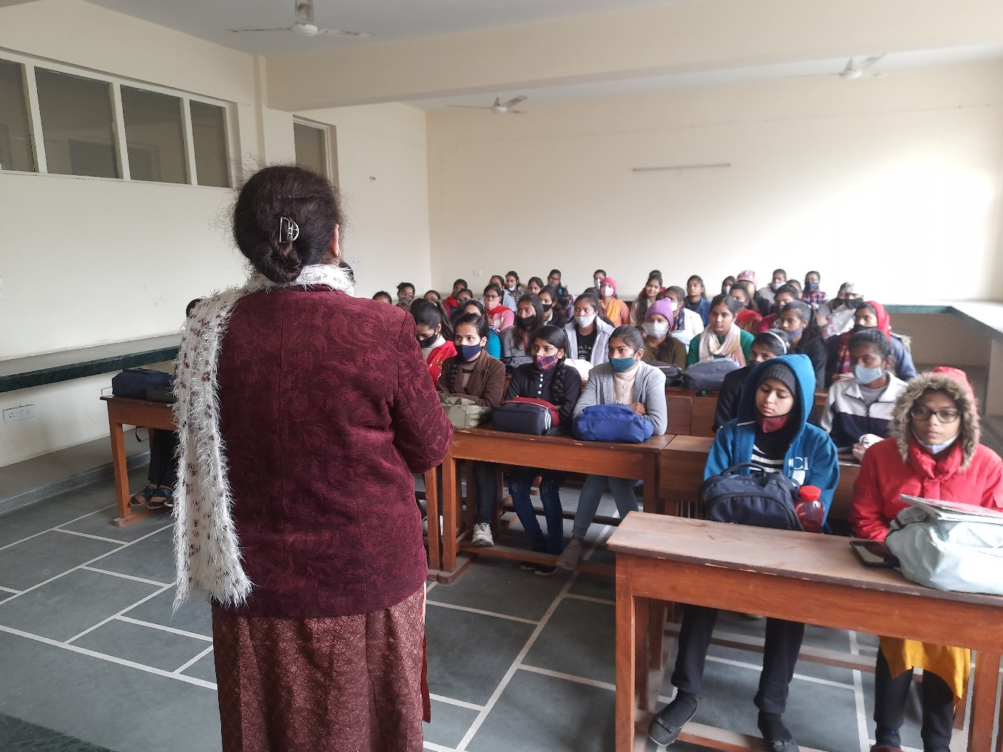
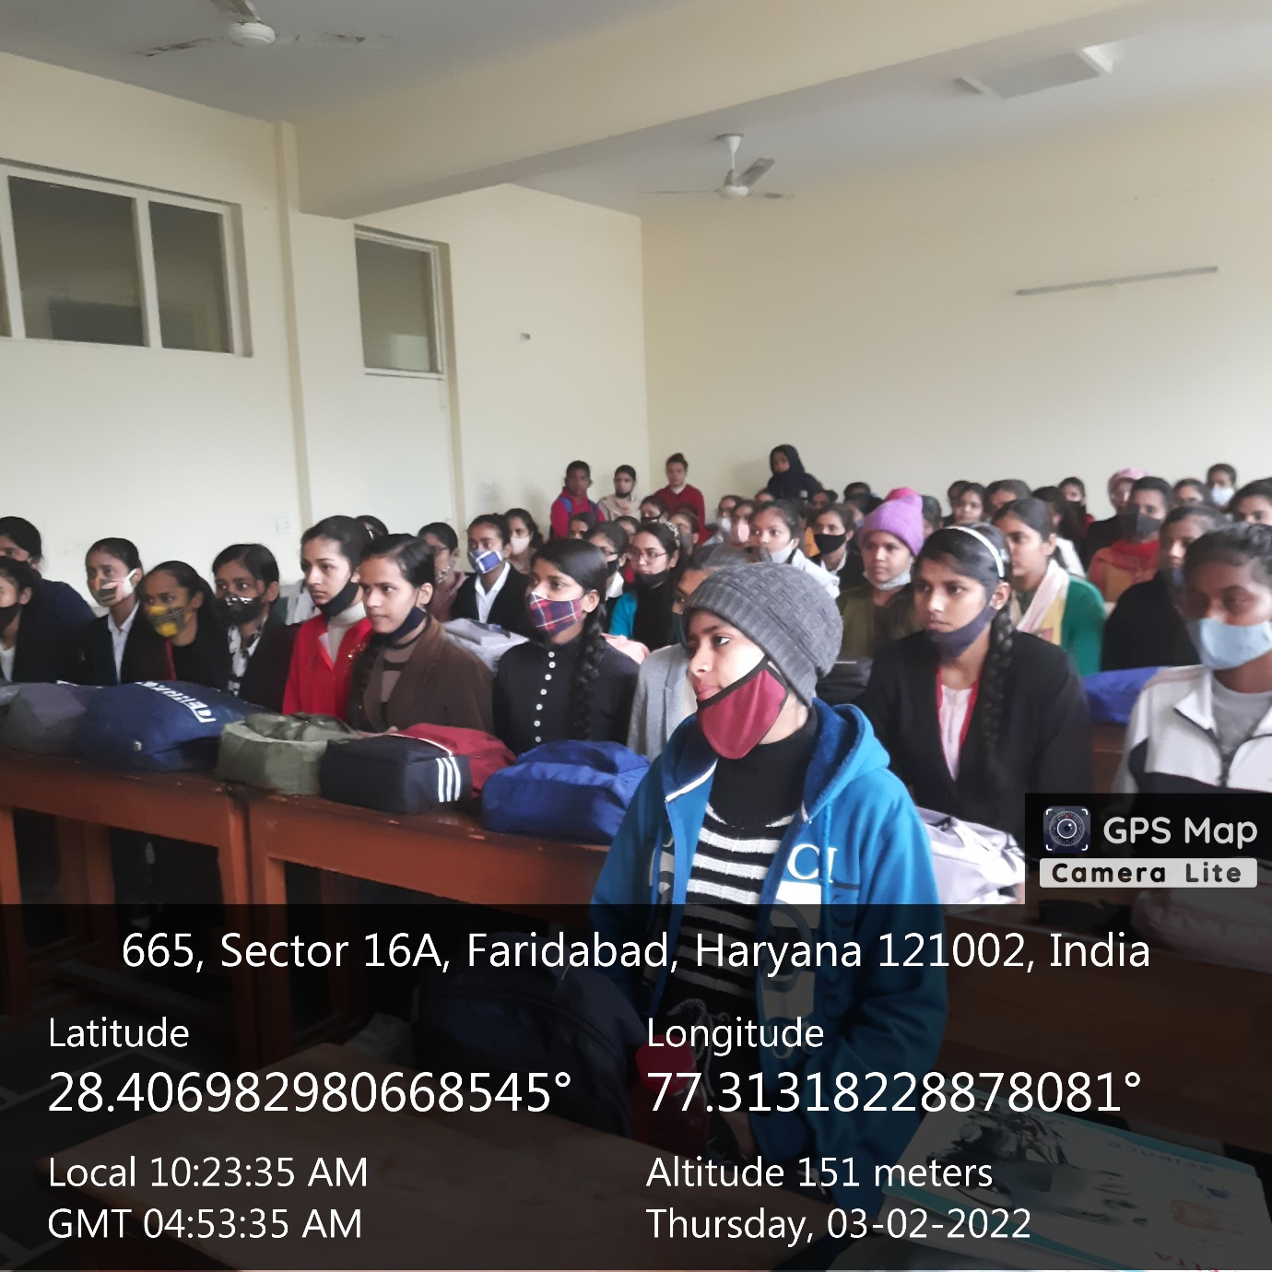

Title of the Activities & date | Organising unit/ agency/ collaborating agency | Number of teachers co-ordinated such activities | Number of students participated in such activities | Achievements/  Remarks
49) An Extension lecture on career opportunities in PR sector on 3rd Feb, 2022 | Department of Journalism and Mass Communication and Placement Cell | Ms. Rachna Saini  Ms. Preeti Arora  Ms. Sonia Minocha  Ms. Aashna  Ms. Varsha  Ms. Divesh  Ms. Savita  Ms. Sandeep  Ms. Suresh | 80 students | An Extension lecture on career opportunities in PR sector was organized under the joint aegis of Department of Journalism and Mass Communication and Placement Cell of Government College for Women, Sector 16-A, Faridabad. Mr. Rakesh Gautam, District Information and Public Relations Officer of Faridabad apprised the girl students about the possibilities of employment in the field of journalism and public relations. He shared that now a days journalism has no limits. It has a vast horizon in terms of job opportunities. There are various options available in different sectors like public relations, advertising, content writing, web writing, radio, TV,etc. He spoke that it is not possible to learn journalism in the boundaries of any education institutions it is necessary to have a free environment for the students along with the Industry exposure. Worthy Principal Dr. Sunidhi expressed gratitude to the keynote speaker and pointed out that if you have to take risk if you want to be a winner. She shared that to achieve anything in life, one has to understand its strength. There was also an interactive session for the students in which many questions were asked by the students which comprise of values in media, skills required in the media etc. All the questions of the students were answered by the keynote speaker of today's program. Faculty members of the college council, faculty of department of Journalism and Mass Communication and members of Placement Cell of the College were present on this occasion. Around 80 students attended the sessions and were benefitted from the session.

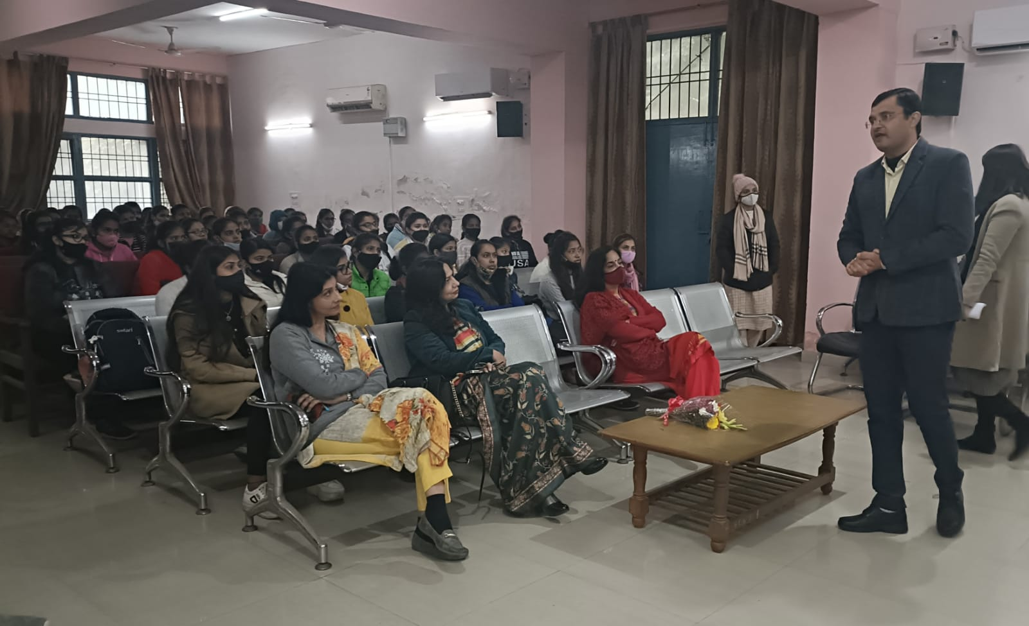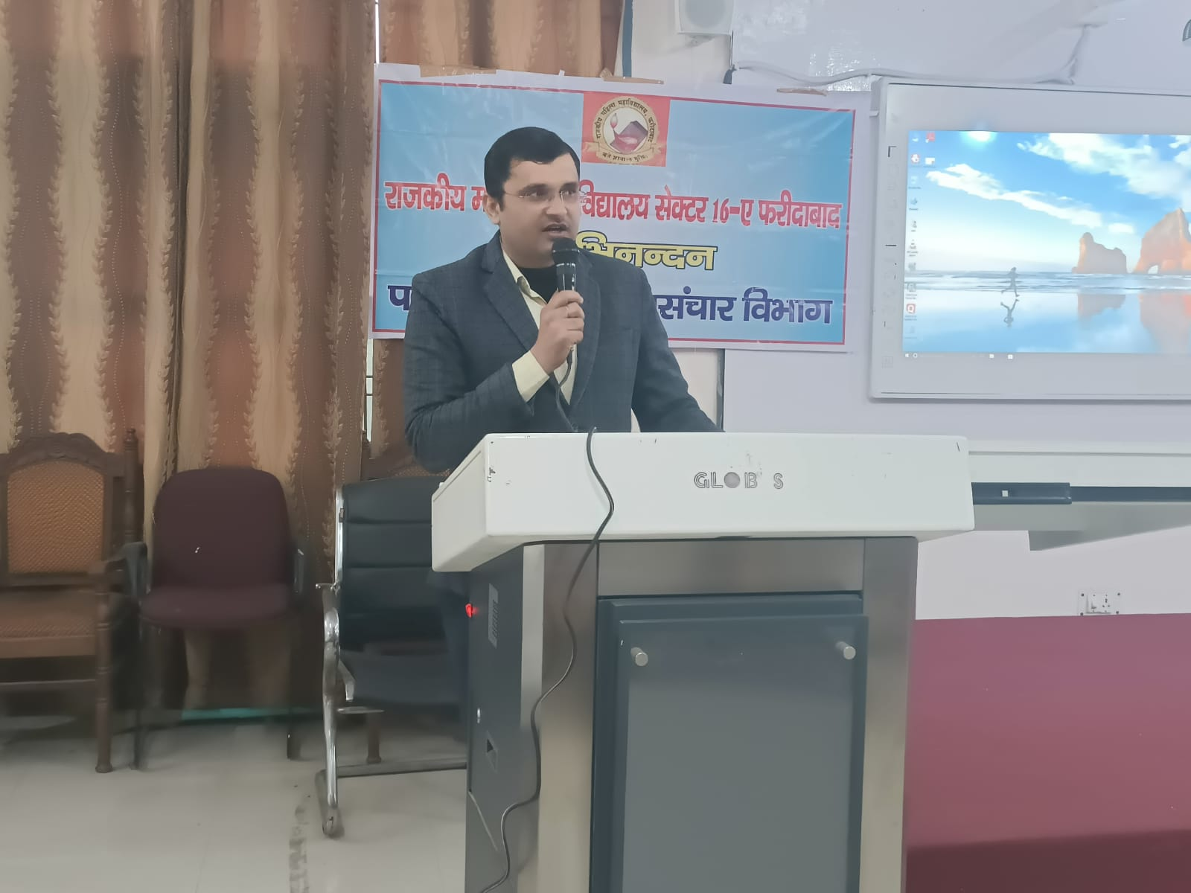

Title of the Activities & date | Organising unit/ agency/ collaborating agency | Number of teachers co-ordinated such activities | Number of students participated in such activities | Achievements/  Remarks
50) A one-day lecture on career counseling on 2nd February, 2022 | placement cell and the Department of Journalism and Mass Communication | Dr. Rachna  Ms. Savita  Mr. Suresh | 60 students | A one-day lecture on career counseling was organized under the aegis of placement cell by the Department of Journalism and Mass Communication at Government College for Women, Sector 16-A, Faridabad. Keynote speaker Dr. Mukesh Kumar, Media Expert, said that students should try to improve their communication skills along with education. If the communication skills of journalism students are better, then there is no dearth of employment opportunities in the field for them.  Principal Dr. Sunidhi expressed gratitude to the keynote speaker and encourage students for choosing professional courses.  Assistant Professor Dr Rachna Saini, Mr Suresh Kumar and Ms. Savita Nagar were present and around 60 students get benefited in the session.
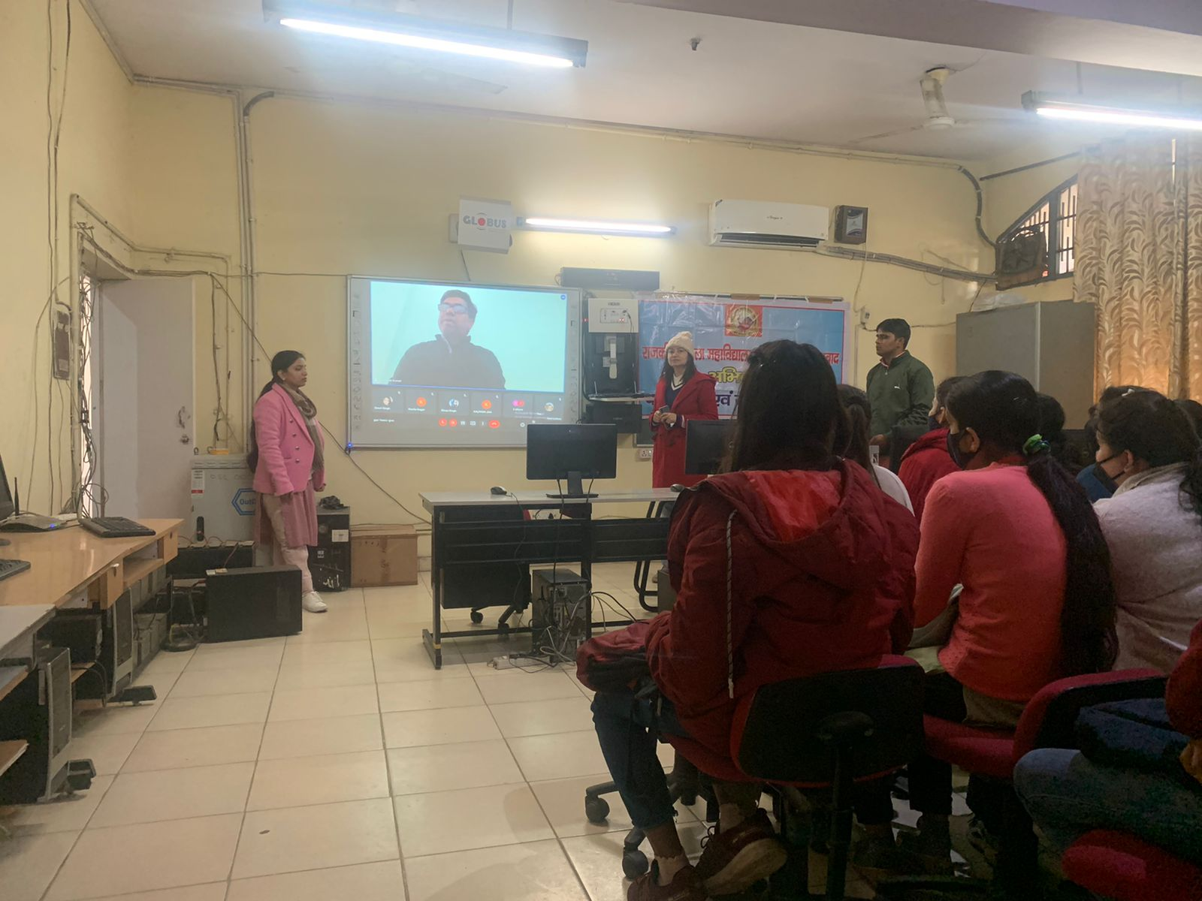
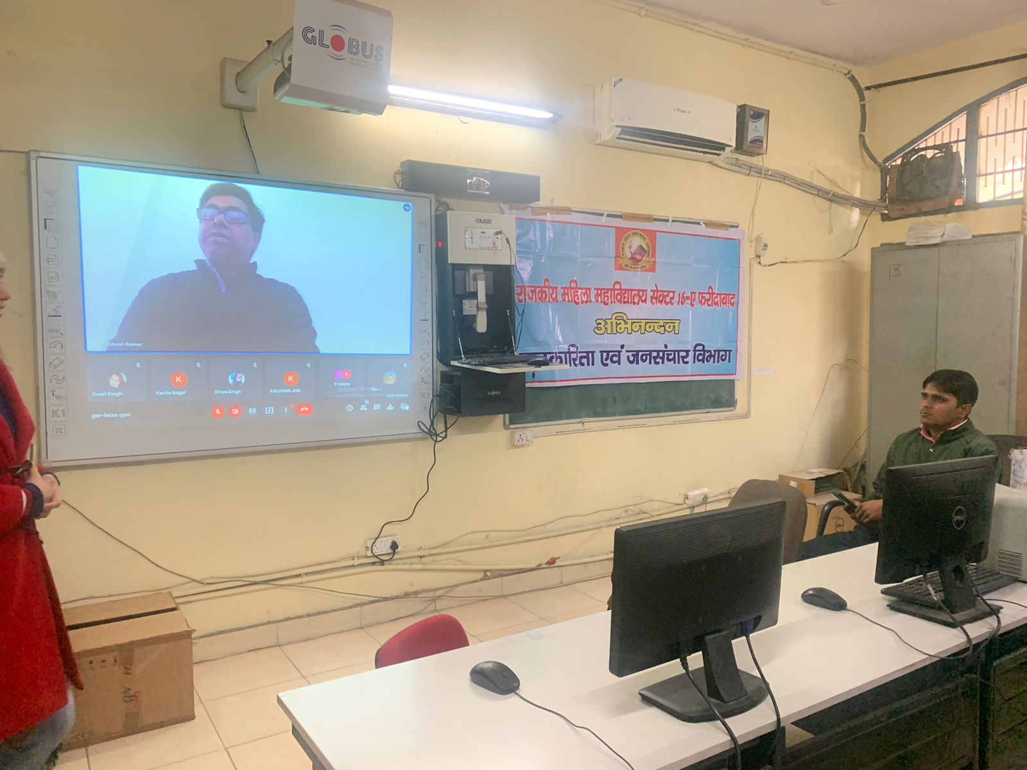

Title of the Activities & date | Organising unit/ agency/ collaborating agency | Number of teachers co-ordinated such activities | Number of students participated in such activities | Achievements/  Remarks
51) An extension lecture on tax on 4th Feb, 2022 | Placement cell in collaboration with Department of Commerce & Management | Ms. Preeti Arora  Ms. Sonia Minocha  Ms. Aashna  Ms. Varsha  Ms. Divesh  Ms. Neha Vij  Ms. Priya  Ms. Manisha  Mr. Sandeep  Ms. Suresh  Mr. Gaurav | 72 students | Placement cell in collaboration with Department of Commerce & Management of Government College for Women, Faridabad organized an Extension Lecture on "Comparison between Old and New Tax Regime and How to calculate Income Tax" for final year students of the college on 4th February 2022 at 10.00 am onwards. Ms. Aarti, Assistant Professor, DAV Centenary College was the key note speaker. She informed students about the various heads of income tax, methods of calculating tax from the old and new tax regimes and benefits of filing income tax, in a very impressive way. It was an interactive session, students asked various questions related to the topic. She answered all the questions and cleared all the doubts of the students. Event was organized and coordinated by members of Placement Cell and Department of Commerce & Management Under the guidance of Mrs. Preeti Arora, Placement Cell convener. 72 students participated in the workshop.
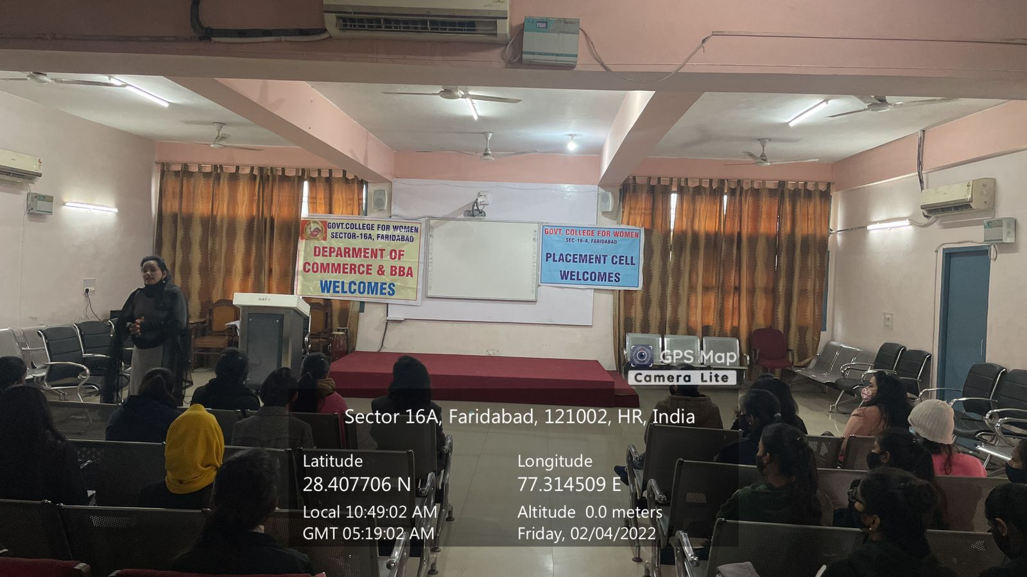
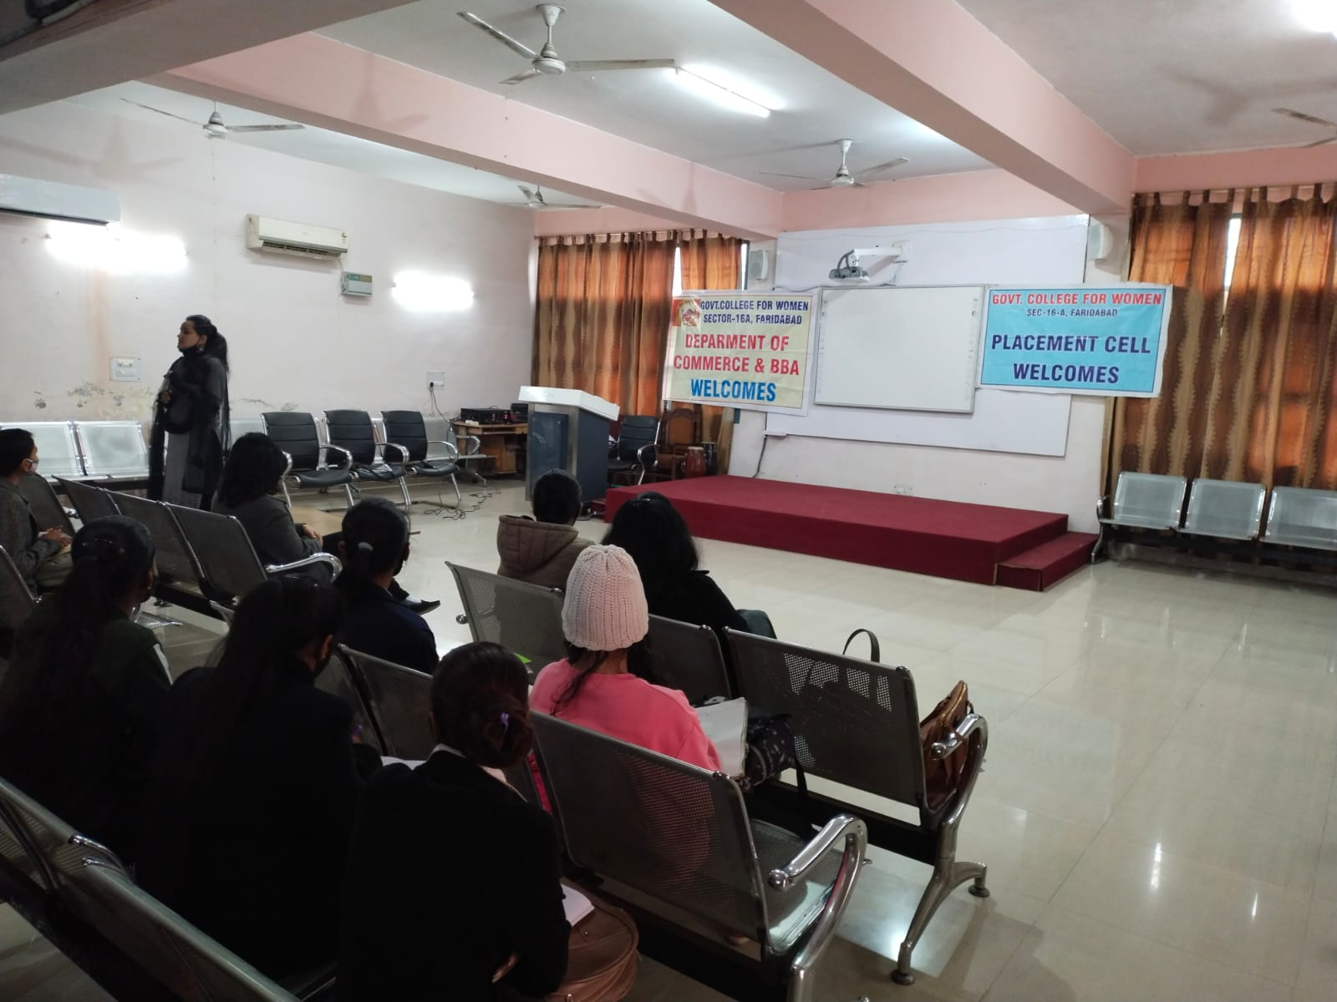

Title of the Activities & date | Organising unit/ agency/ collaborating agency | Number of teachers co-ordinated such activities | Number of students participated in such activities | Achievements/  Remarks
52) 6-days Photography Workshop from 2nd to 9th Feb, 2022 | Women Cell, in collaboration with BAJMC Department | Dr. Neha Aggarwal  Dr. Rachna Saini | 42 students | Women Cell, in collaboration with BAJMC Department, organized a “6-days Photography Workshop” for the college students from 2nd Feb, 2022 to 9th Feb, 2022. Our Photography Experts Dr. Ankush Sharma and Mr. Deepak Pushpdeep directed essential requirements for a better photography to the students via lectures and practical mode as well. They discussed about the basics of photography and camera settings, different types of photography, importance of light in taking photography shots and many more. Total 42 students participated and got benefitted from this workshop. Our Principal, Dr. Sunidhi, encouraged the students and said that this workshop enhances both the theoretical knowledge and technical skills of students that they won't find in a textbook. The workshop was successfully organized by Dr. Neha Aggarwal (Convener- Women Cell), Dr. Rachna Saini (Dept. of BAJMC) along with other members of WC and BAJMC Department.

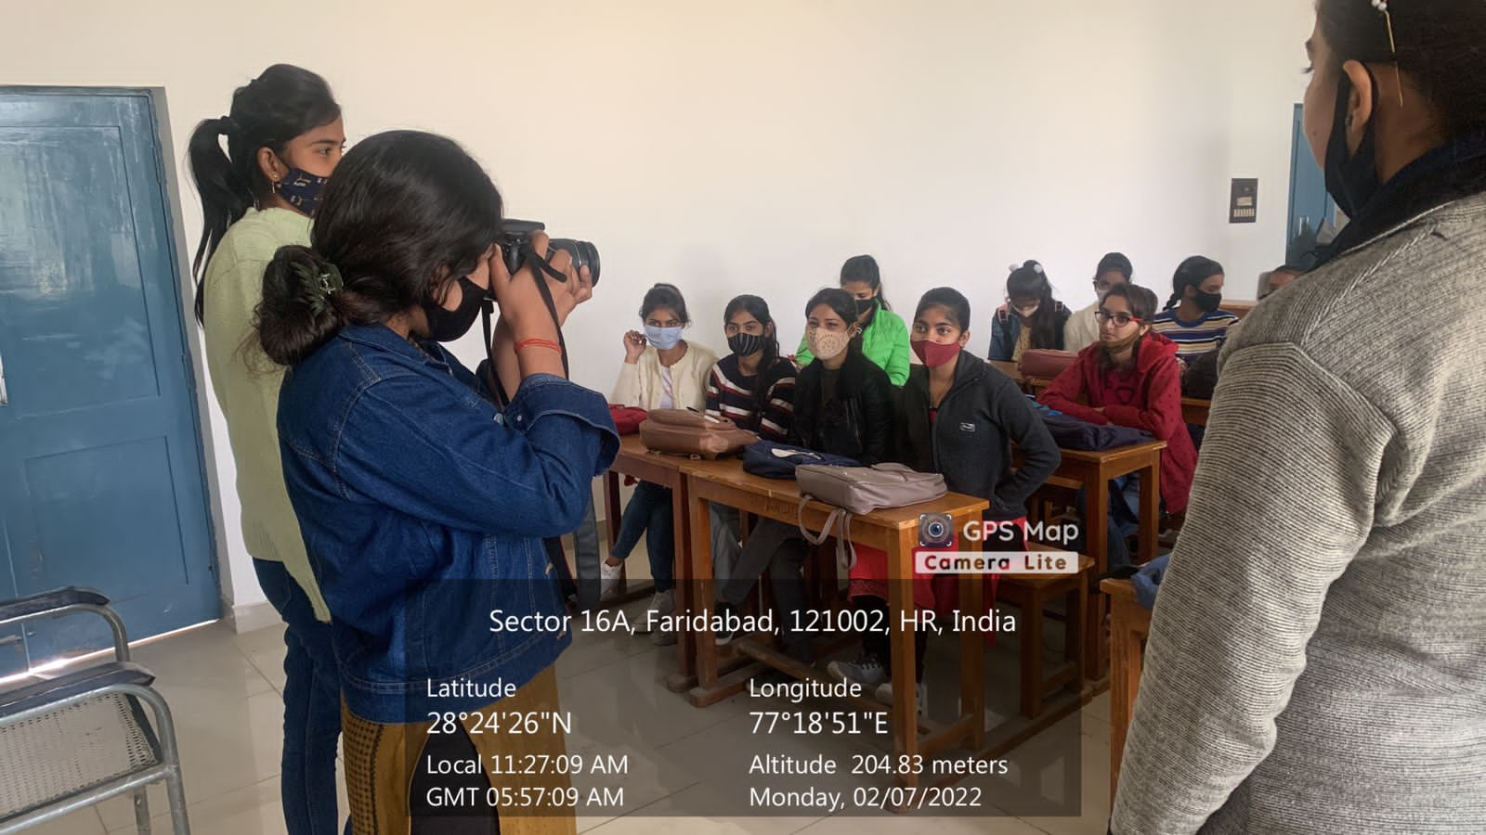
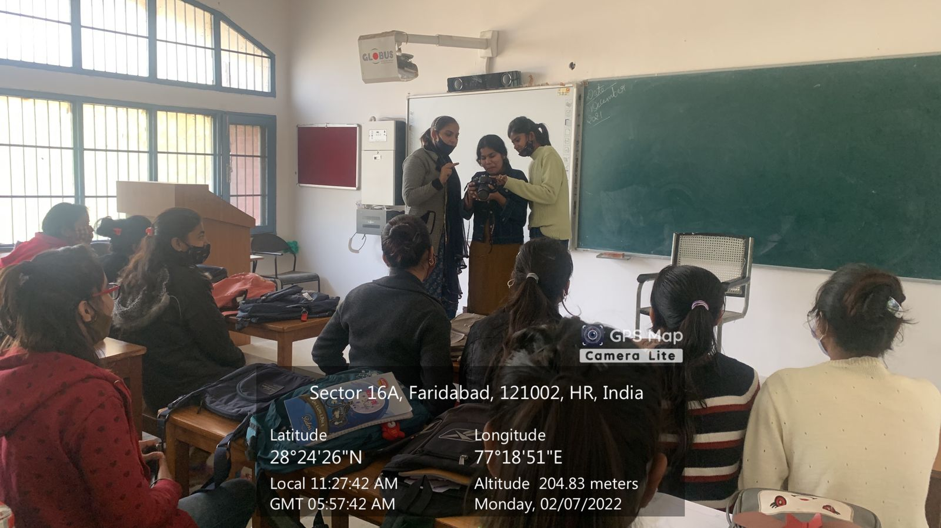

Title of the Activities & date | Organising unit/ agency/ collaborating agency | Number of teachers co-ordinated such activities | Number of students participated in such activities | Achievements/  Remarks
53) 11 days “Classical Dance Workshop” from 01/02/2022 to 14/02/2022 | Women Cell | Dr. Neha Aggarwal  Ms. Neelam Rani  Ms. Meenal  Ms. Priya  Ms. Divesh | 43 students | Women Cell of our college organized 11 days “Classical Dance Workshop” for the college students from 01/02/2022 to 14/02/2022. A very well-known and internationally acclaimed Kathak dancer, Ms. Elisha Deep Garg, was the resource person for the same. Each day the participants learned the basics of the dance form and a small choreography which adds to the beauty of this workshop. Our Principal, Dr. Sunidhi, motivated the students with her inspiring words that learning a classical dance form not only has an impact on the body but it also reflects on the personality of the learner. It impacts you to be more balanced, connected to yourself, calm, organized and a happy individual. Total 43 students participated in this workshop and got benefitted. The workshop was successfully organized by Dr. Neha Aggarwal (Convener-WC) along with the other members of Women Cell.

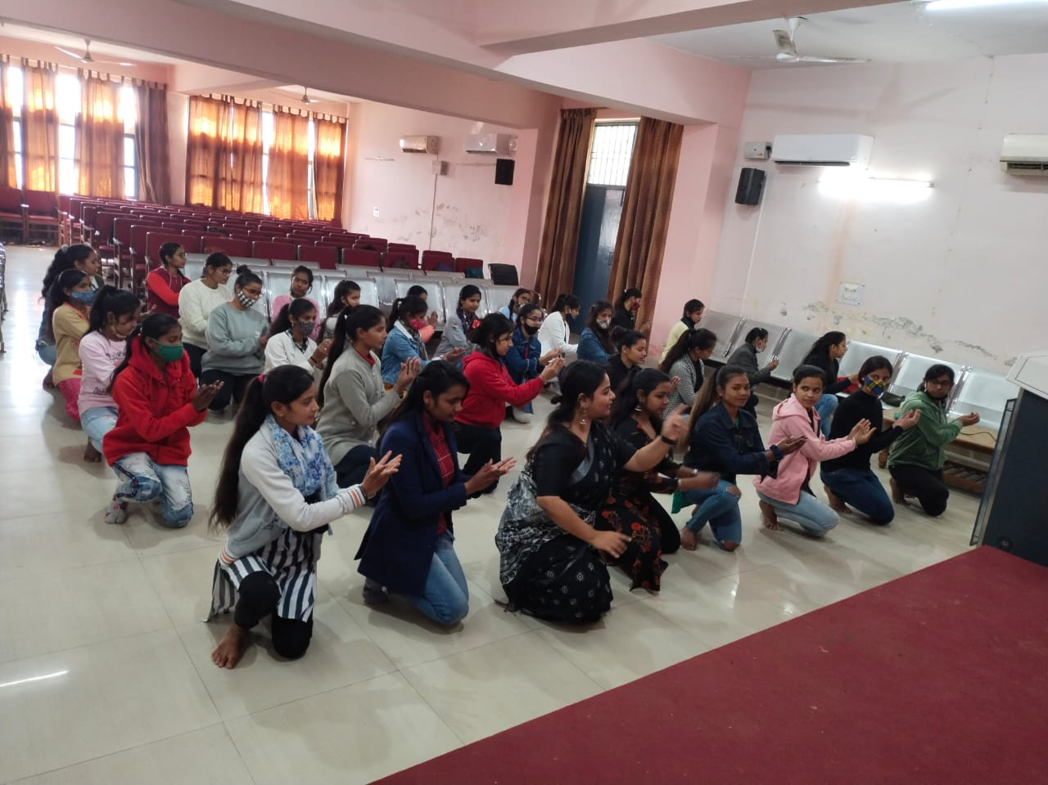
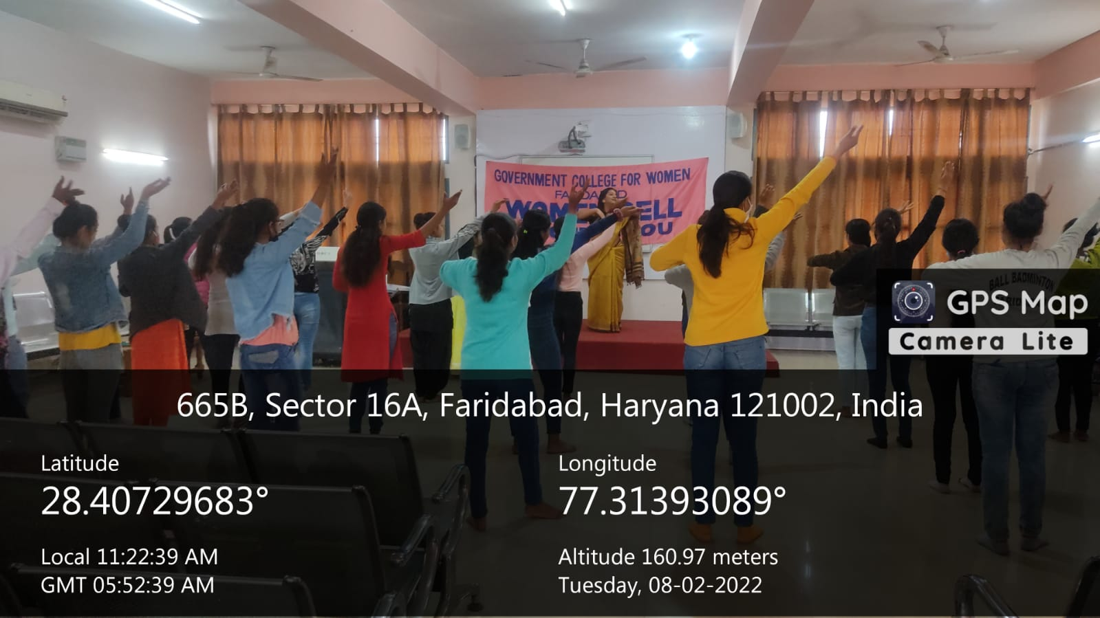
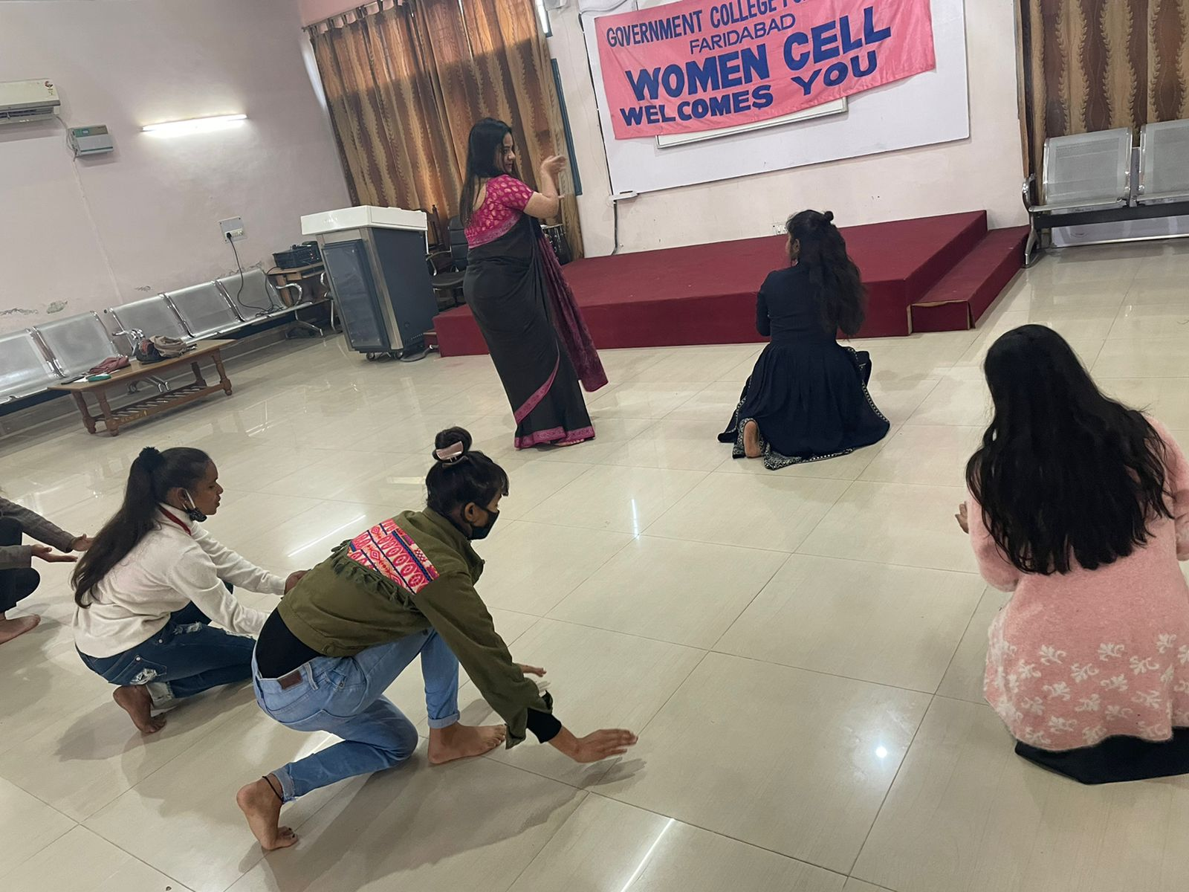

Title of the Activities & date | Organising unit/ agency/ collaborating agency | Number of teachers co-ordinated such activities | Number of students participated in such activities | Achievements/  Remarks
54) 7 days “Cooking Workshop” from 07/02/2022 to 14/02/2022 | Women Cell in collaboration with the Department of Home-Science | Ms. Neelam Rani  Dr. Neha Aggarwal | 45 students | Women Cell of our college, in collaboration with the Department of Home-Science, organized a 7 days “Cooking Workshop” for the college students from 07/02/2022 to 14/02/2022 under the guidance and support of our Principal, Dr. Sunidhi. Total 45 students participated in this workshop and learned a range of recipes from cakes and desserts, to khandvi, garlic breads, and many more. This workshop gave them confidence to do more than just follow the recipes. The workshop was successfully organized by Ms. Neelam Rani (HOD, Dept. of Home-Science), Dr. Neha Aggarwal (Convener-WC) and the other members of Women Cell.

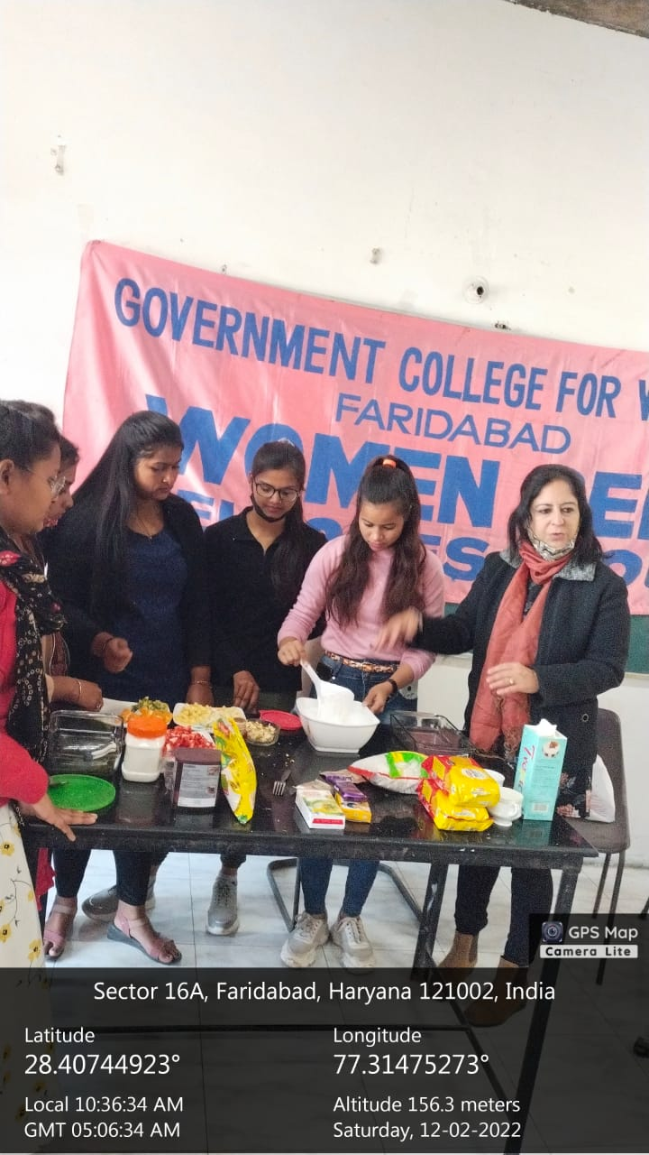
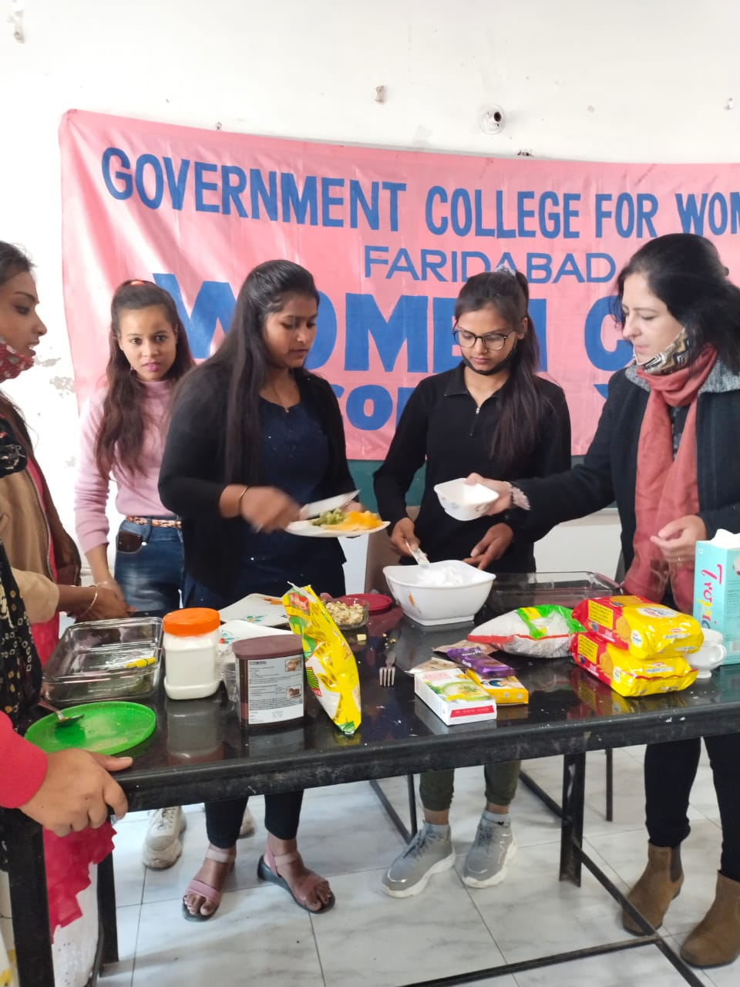
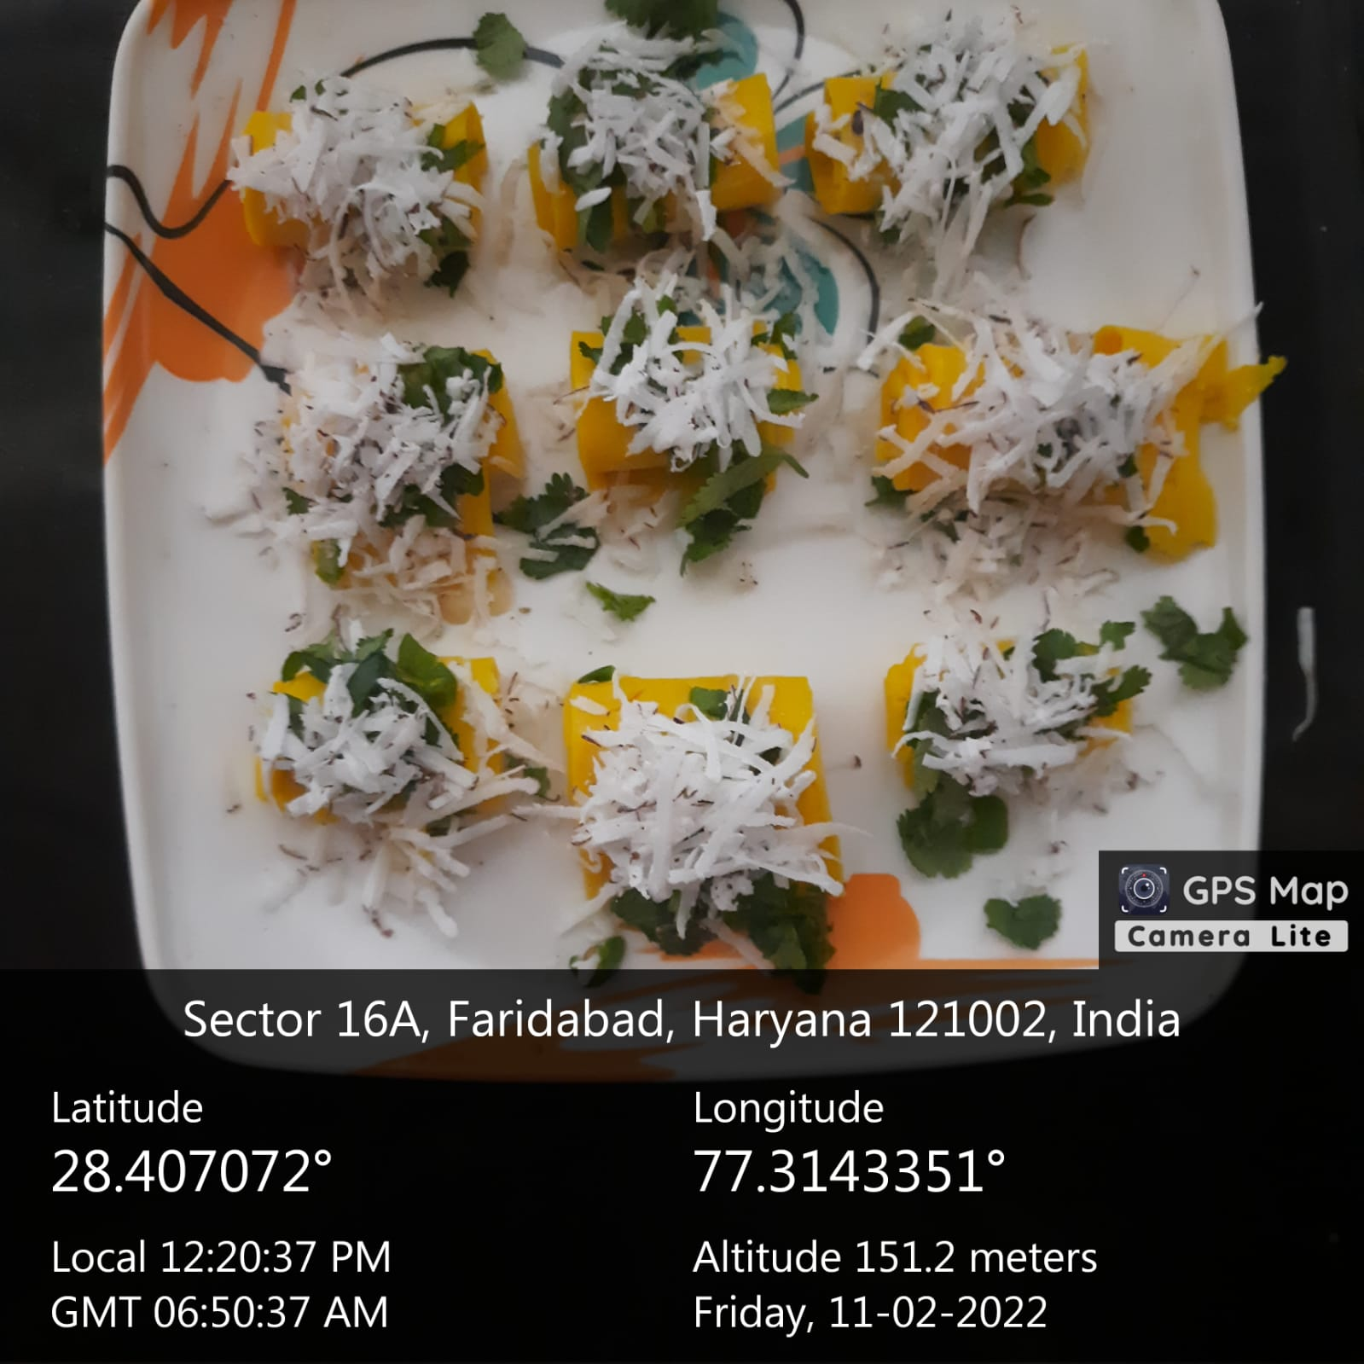

Title of the Activities & date | Organising unit/ agency/ collaborating agency | Number of teachers co-ordinated such activities | Number of students participated in such activities | Achievements/  Remarks
55) Lecture on the topic “Career Opportunities After Law and empowering Women towards Rights” on 7th February, 2022 | Placement cell in collaboration with Department of Commerce & Management | Ms. Preeti Arora  Ms. Sonia Minocha  Ms. Aashna  Ms. Varsha  Ms. Manisha  Ms. Devesh  Ms. Neha Vij  Ms. Priya  Mr. Sandeep  Mr. Suresh  Mr. Gaurav | 200 students | Placement cell in collaboration with Department of Commerce & Management of Government College for Women, Faridabad organized a Lecture on the topic “Career Opportunities After Law and empowering Women towards Rights” on 7th February, 2022 for final year students of the college. Ms. Asmita Singh, Assistant Lecturer , Assistant Dean, Jindal Global University, Sonipat was the key note speaker. She enlightened students about the various career options which the students can choose after law such as administrator, social service, judiciary and teaching profession etc with qualities requirements for entering in all the fields in a very impressive way. She said that knowledge of rights and duties is very essential for any individual to become successful. As it was an interactive session, students asked various questions related to their rights and job opportunities in the sector of law. She answered all the questions very lucidly and cleared all the doubts of the students. Mrs. Sunidhi, worthy Principal Government College for Women, Faridabad motivated the students to become self-dependent. All the members of Placement Cell and Department of Commerce & Management were present. 200 students participated in the lecture.

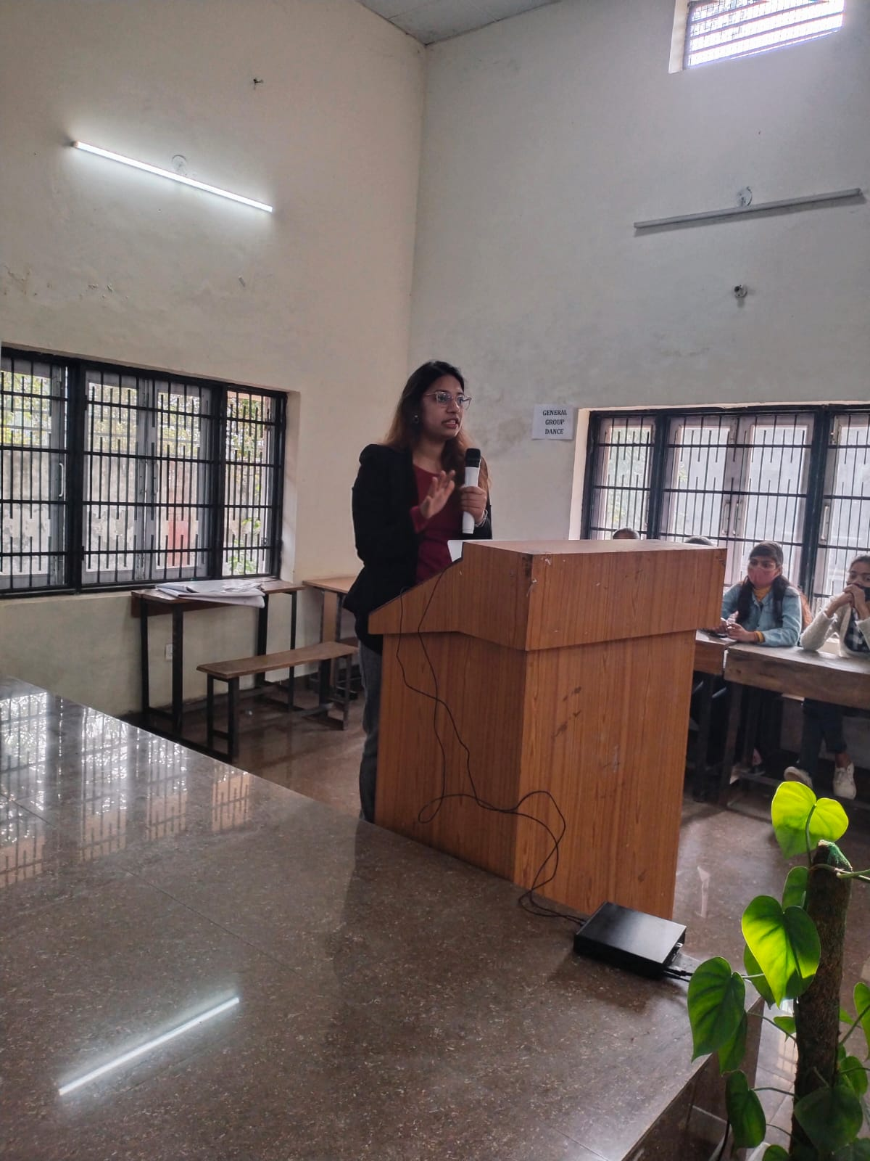
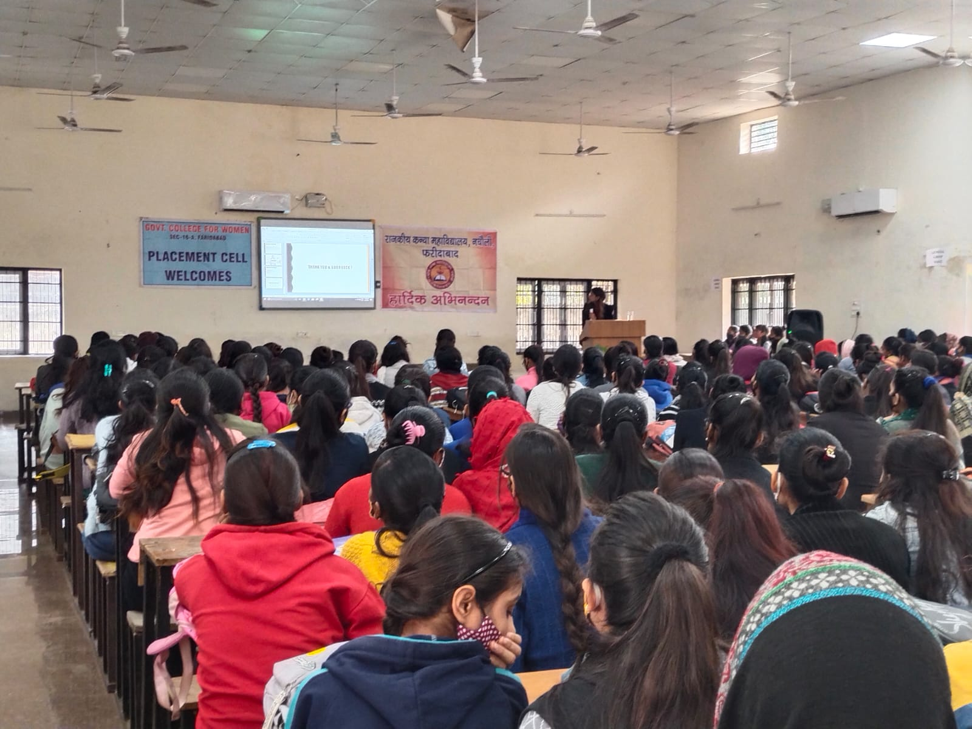

Title of the Activities & date | Organising unit/ agency/ collaborating agency | Number of teachers co-ordinated such activities | Number of students participated in such activities | Achievements/  Remarks
56) an Extension Lecture on the topic “Career Opportunities in the field of  Management and Recent trends in Management” on 15th February, 2022 | Placement cell in collaboration with Department of Commerce &  Management | Ms. Preeti Arora  Ms. Sonia Minocha  Ms. Aashna  Ms. Varsha  Ms. Manisha  Ms. Devesh  Ms. Neha Vij  Ms. Priya  Mr. Sandeep  Mr. Suresh  Mr. Gaurav | 97 students | Placement cell in collaboration with Department of Commerce &  Management of Government College for Women, Faridabad organized an Extension Lecture on the topic “Career Opportunities in the field of  Management and Recent trends in Management” on 15th February, 2022  for final year students of the college. Ms. Sonia Bhatia, Assistant  Professor, DAV Centenary College was the key note speaker. She  enlightened students about the various career options which the  students can choose after Management such as administrator,  entrepreneurship and teaching profession etc with qualities  requirements for entering in all the fields in a very impressive way.  As it was an interactive session, students asked various questions  related to job opportunities in the sector of Management. She answered  all the questions very lucidly and cleared all the doubts of the  students. Mrs. Sunidhi, worthy Principal Government College for  Women, Faridabad motivated the students and said that study of  Management is not only required to pass the exam but it is also very  important to balance your personal as well as professional life. All  the members of Placement Cell and Department of ji Commerce & Management  were present. 97 students participated in the lecture.

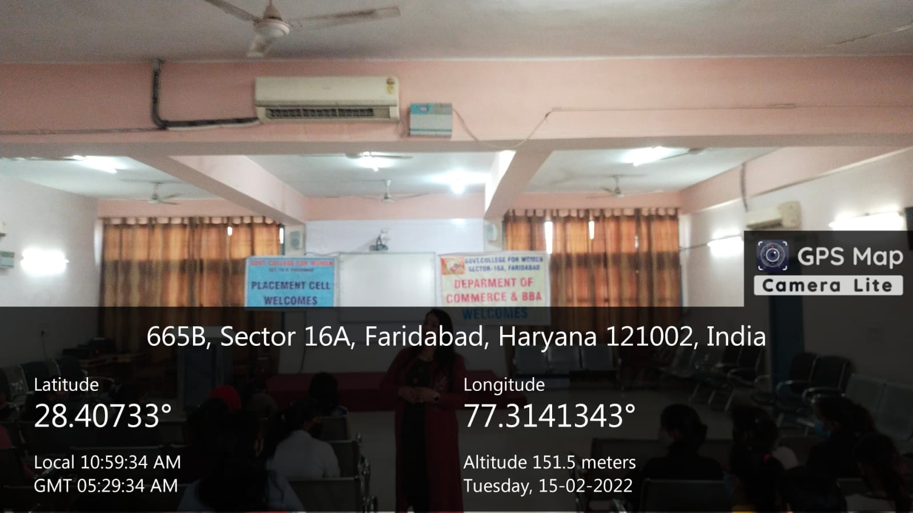
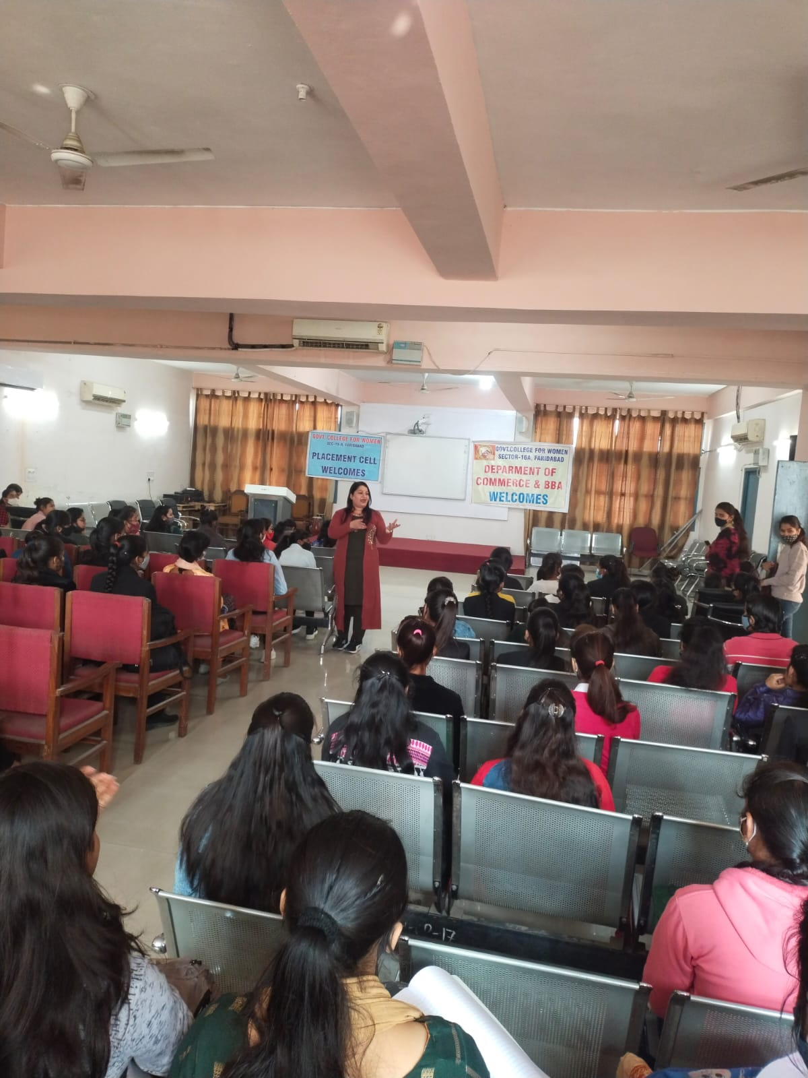

Title of the Activities & date | Organising unit/ agency/ collaborating agency | Number of teachers co-ordinated such activities | Number of students participated in such activities | Achievements/  Remarks
57) 5-days workshop on “Beauty and Make-Up Tips” from 10/02/2022 to 15/02/2022 | Women Cell | Dr. Neha Aggarwal | 56 students | Women Cell of our college organized a 5-days workshop on “Beauty and Make-Up Tips” for the college students from 10/02/2022 to 15/02/2022 under the guidance and support of our Principal, Dr. Sunidhi. The workshop was conducted to provide the students with important techniques and knowledge on topics such as makeup, hair styling etc. to let them enhance their own beautiful features, disguise minor faults in appearance and express themselves creatively. Total 56 girls availed of the benefits of the workshop. The workshop was successfully organized by Dr. Neha Aggarwal (Convener-WC) along with the other members of Women Cell.

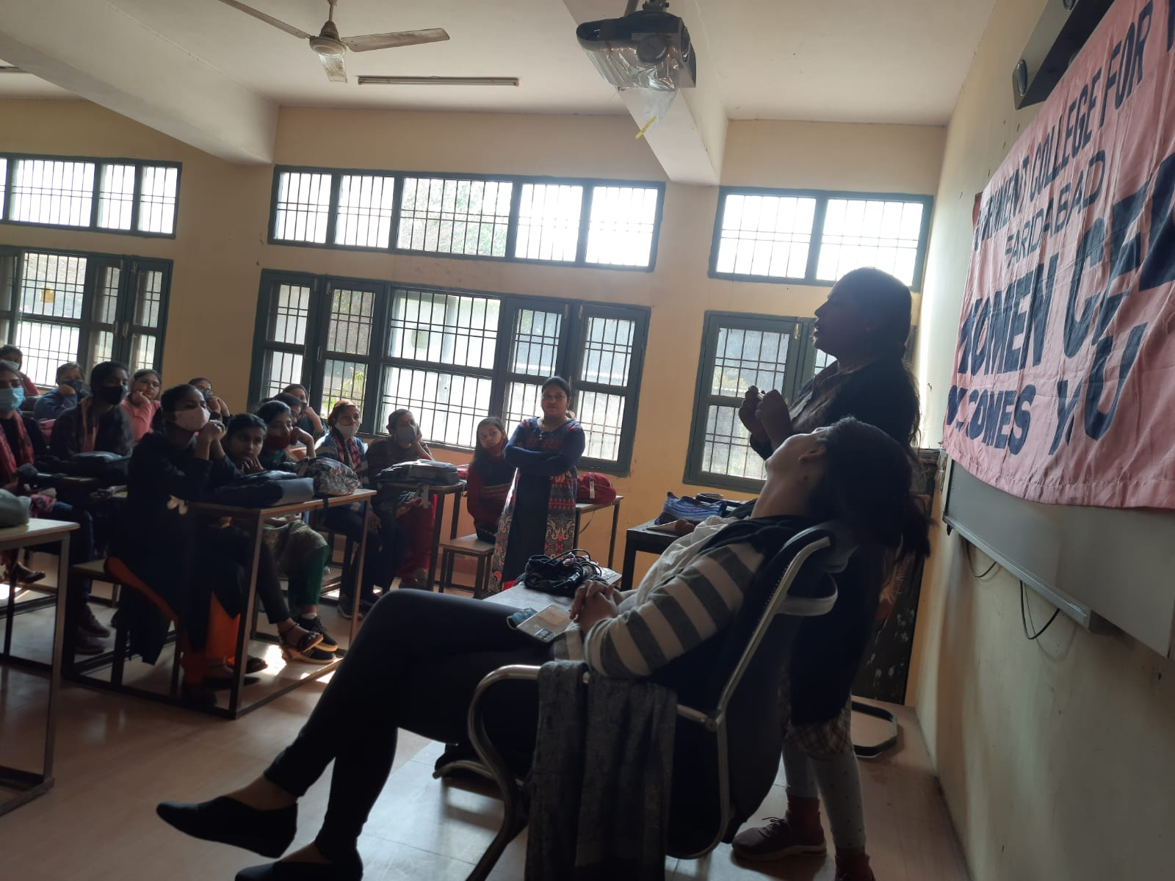
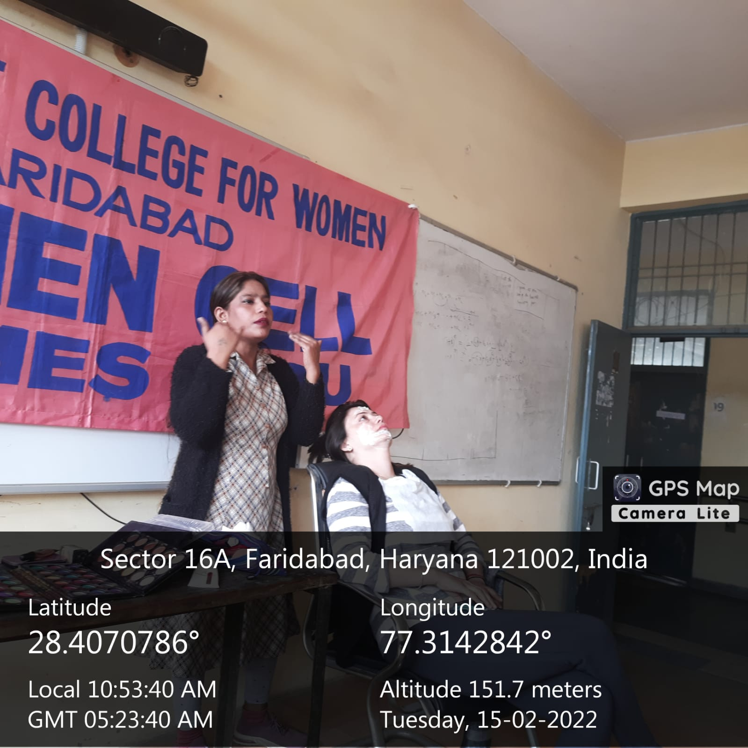
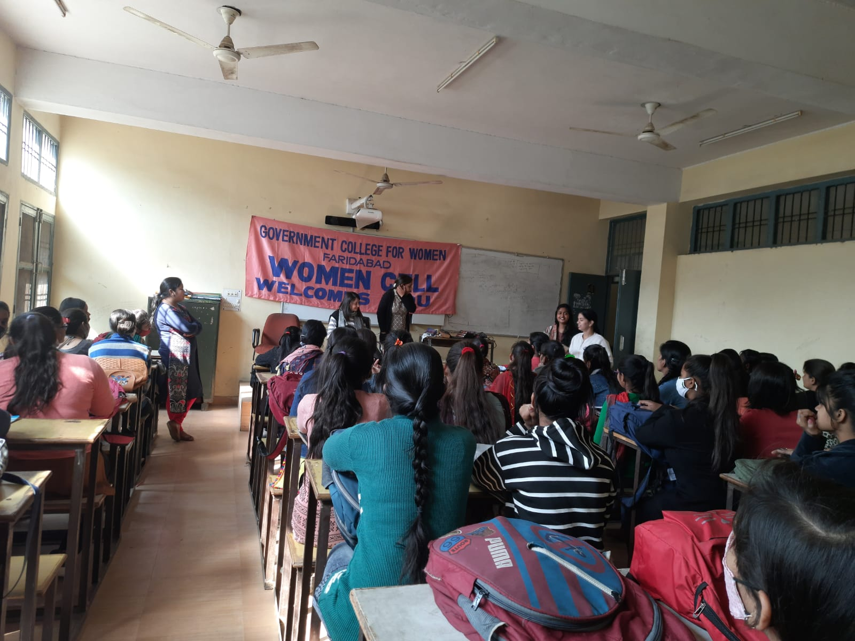

Title of the Activities & date | Organising unit/ agency/ collaborating agency | Number of teachers co-ordinated such activities | Number of students participated in such activities | Achievements/  Remarks
58) slogan writing / poster making competition | Road Safety Club | Ms. Meenal Sabharwal | 150 students | Under Road Safety Club, a slogan writing / poster making competition was held in the college today at 12.30. Students participated in large numbers in this awareness drive towards Road Safety. Prizes would be declared after segregation of the posters into top 3

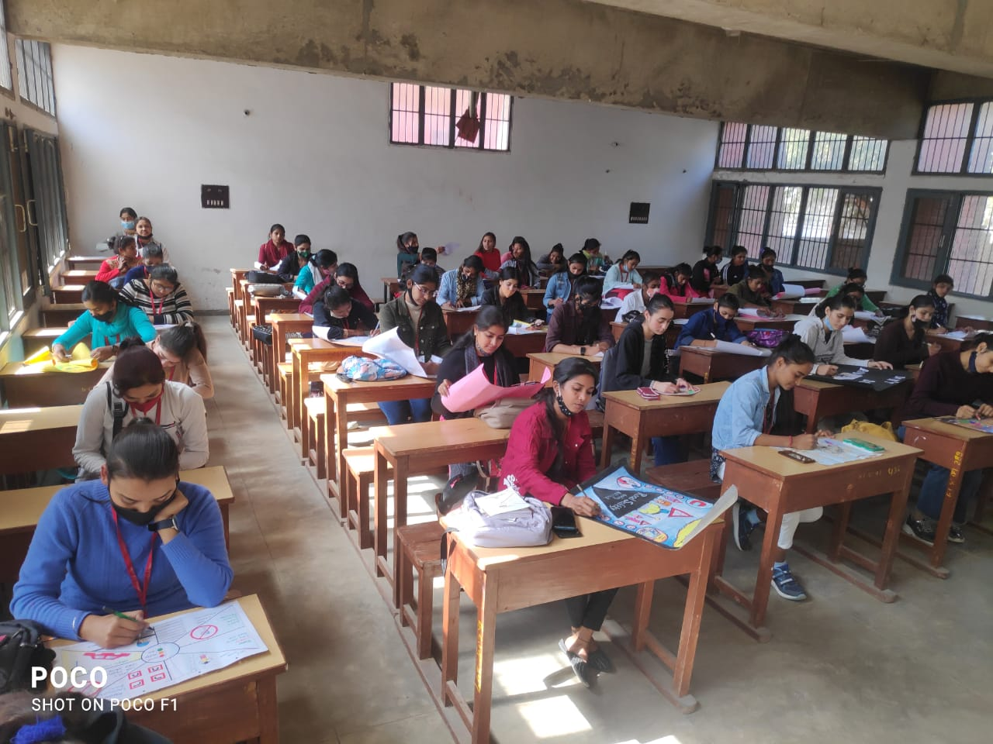

Title of the Activities & date | Organising unit/ agency/ collaborating agency | Number of teachers co-ordinated such activities | Number of students participated in such activities | Achievements/  Remarks
59) Article writing and poster making competition on 29 oct, 2021 | Women Cell of K. L. Mehta Dayanand College for Women, Faridabad | Dr. Neha Aggarwal | 2 students | Kajal Sharma, Roll no 01, of B.Sc final year got first position in Article writing competition and Deepshikha, Roll no 50, of B.Sc second yr got second position in Poster Making competition, organized by the Women Cell of K. L. Mehta Dayanand College for Women, Faridabad on 29th Oct, 2021.

Title of the Activities & date | Organising unit/ agency/ collaborating agency | Number of teachers co-ordinated such activities | Number of students participated in such activities | Achievements/  Remarks
60) State-level online Science Quiz Competition on 28th February, 2022 | Department of science | Dr. Neha Aggarwal  Ms. Poonam Sharma  Ms. Chanchal  Ms. Varsha  Mr. Anuj | 107 students | National Science Day is celebrated on February 28 every year to mark the discovery of the Raman effect by Nobel prize winning Indian physicist CV Raman. Marking the occasion, State-level online Science Quiz Competition was conducted for the college students by the Faculty of Science, Government College for Women, Faridabad on 28th February, 2022 under the leadership and guidance of our Principal, Dr. Sunidhi. Total 107 students from different colleges of Haryana participated in the quiz. Deepti Sarout and Varsha from JCBUST, Faridabad, Ritesh from GCW Lakhan Majra, Rohtak and Kamlesh from GCW, Faridabad got the highest scores. Moreover, 24 students from different colleges of Haryana scored 90%. The event was successfully organized by Dr. Neha Aggarwal, Dean, Faculty of Science along with the other fellow members of the Department.

Title of the Activities & date | Organising unit/ agency/ collaborating agency | Number of teachers co-ordinated such activities | Number of students participated in such activities | Achievements/  Remarks
61) Celebration of international women’s day on 8th March, 2022 | Women Cell | Dr. Neha Aggarwal  Ms. Neelam Rani  Ms. Meenal  Ms. Priya  Ms. Chanchal  Ms. Divesh | 23 students | The Women Cell of our college celebrated International Women’s Day on 8th March, 2022 with great enthusiasm under the guidance and leadership of our Principal, Dr. Sundihi. On this occasion, several activities were organized, which are listed as follows:  1. Our college students shared different posters to celebrate Women’s achievements. They also shared letters communicating messages to their favorite inspirational girls or women. Total 23 students participated in it.  2. Our college students including staff members wore purple on 08/03/2022 to show their support for International Women’s Day since the color signifies justice and dignity.  3. Moreover, students in large numbers along with Principal ma'am and the other female staff members formed a human chain to represent the oneness of women all over the world. It depicts the statement of gender equality. Our Principal, Dr. Sunidhi, also addressed the students with her inspiring words about how a woman works hard everyday to achieve both the personal and professional goals. She further acknowledged the massive contribution of women in every sphere of life. We all should be proud to be a woman.  The event was successfully conducted by Dr. Neha Aggarwal (Convener- Women Cell) along with the other staff members of Women Cell.

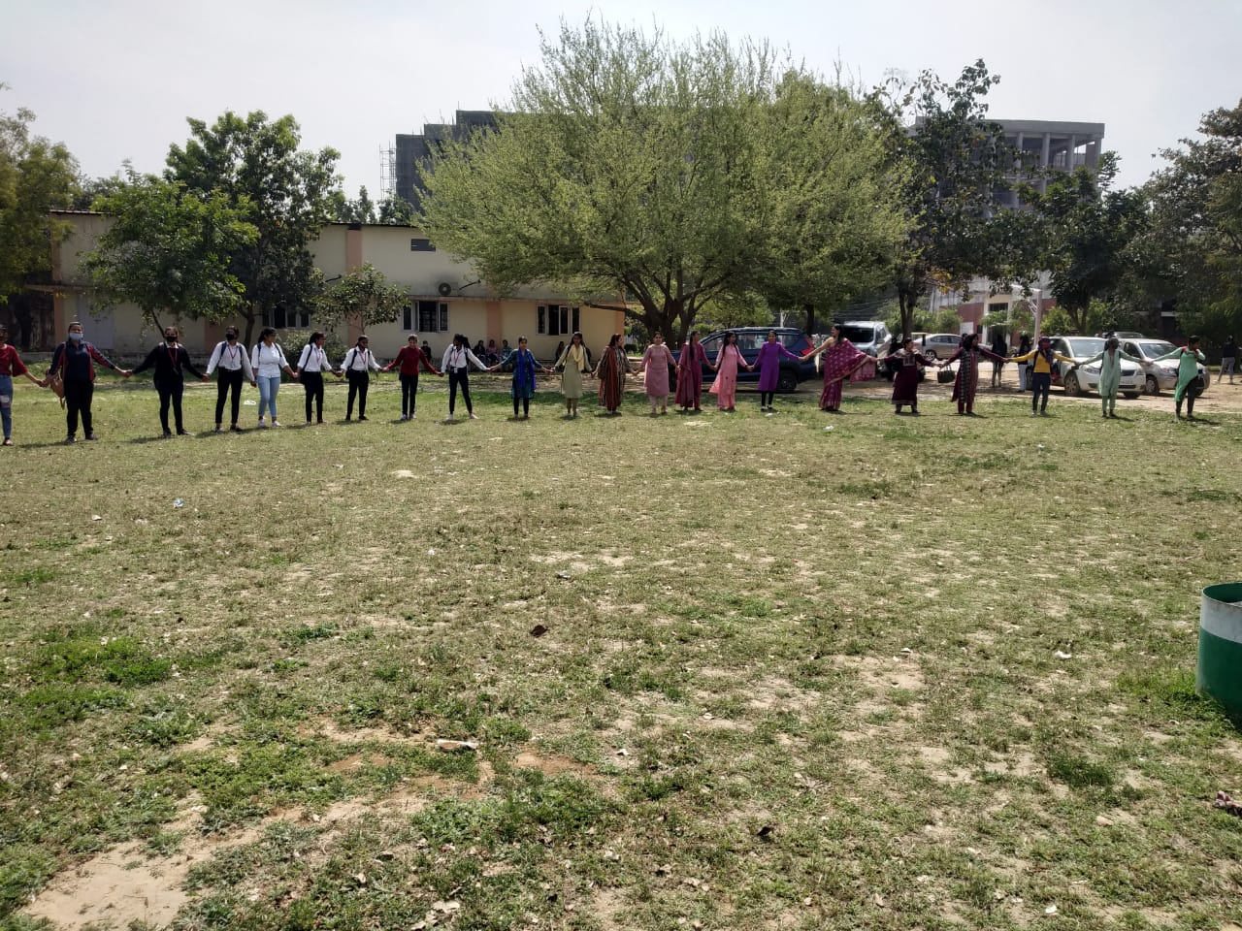
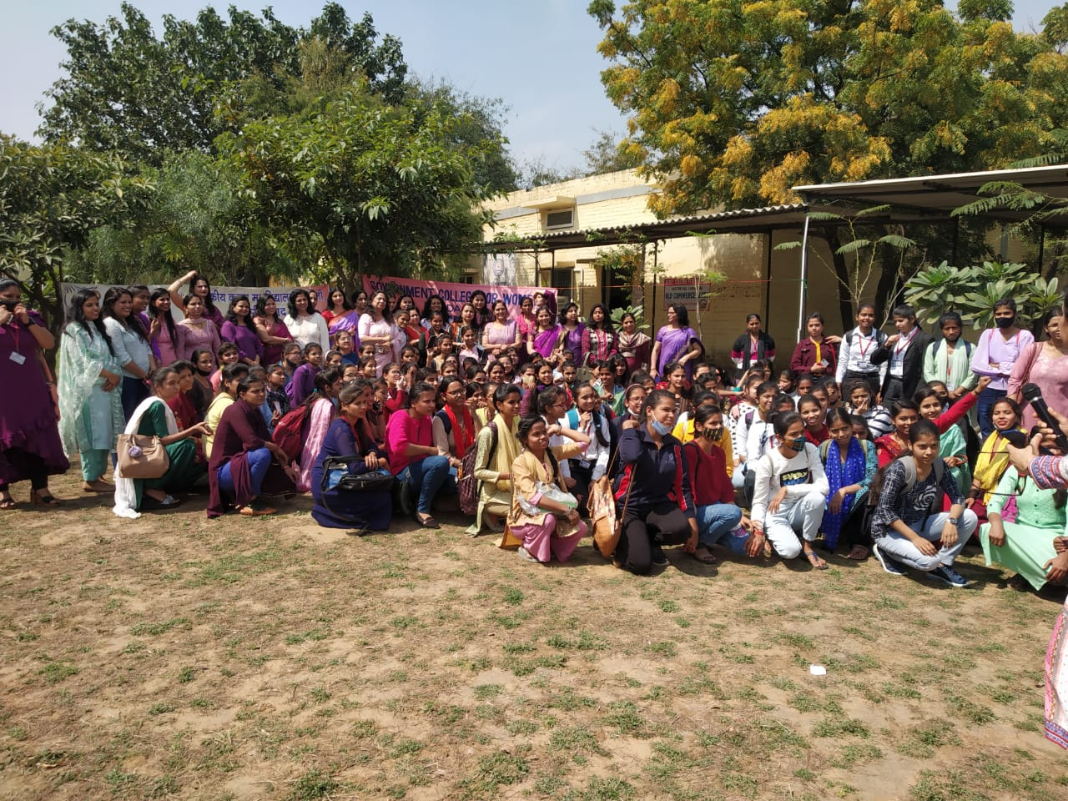

Title of the Activities & date | Organising unit/ agency/ collaborating agency | Number of teachers co-ordinated such activities | Number of students participated in such activities | Achievements/  Remarks
62) Musical Concert on international women’s day on 8th March, 2022 | Women cell, in collaboration with the Music Department | Dr. Neha Aggarwal  Ms. Neelam Rani  Ms. Meenal  Ms. Priya  Ms. Chanchal  Ms. Divesh | - | Women cell, in collaboration with the Music Department, organized a Musical Concert under the leadership of Dr. Sunidhi, on the occasion of International Women's Day on 8th March, 2022. The artists for the evening were Dr. Devender Verma, Dr. Vijay Shankar Choubey, Ms. Tanishka Saini, Sh. Swami Krishankant, Sh. Prabhakar Pandey and Mr. Pradyuman Arya. The symphony was matchless with a blend of different musical instruments. Mr. Amit Gulia, Estate officer Faridabad, Mr. Paramjeet Singh Chahal, SDM Faridabad, Mr. Pankaj Setia, SDM Badkal, Dr. Tarun Kumar, Ex-CMO Faridabad, Mr. Dinesh Yadav, Add. Director Food & Supply, Dr. Balram Yadav, Assistant Professor- Music (V), GC Tigaon and Dr. Vishal Singh, Chemistry Department, GC Faridabad were the esteemed guests of Honors.

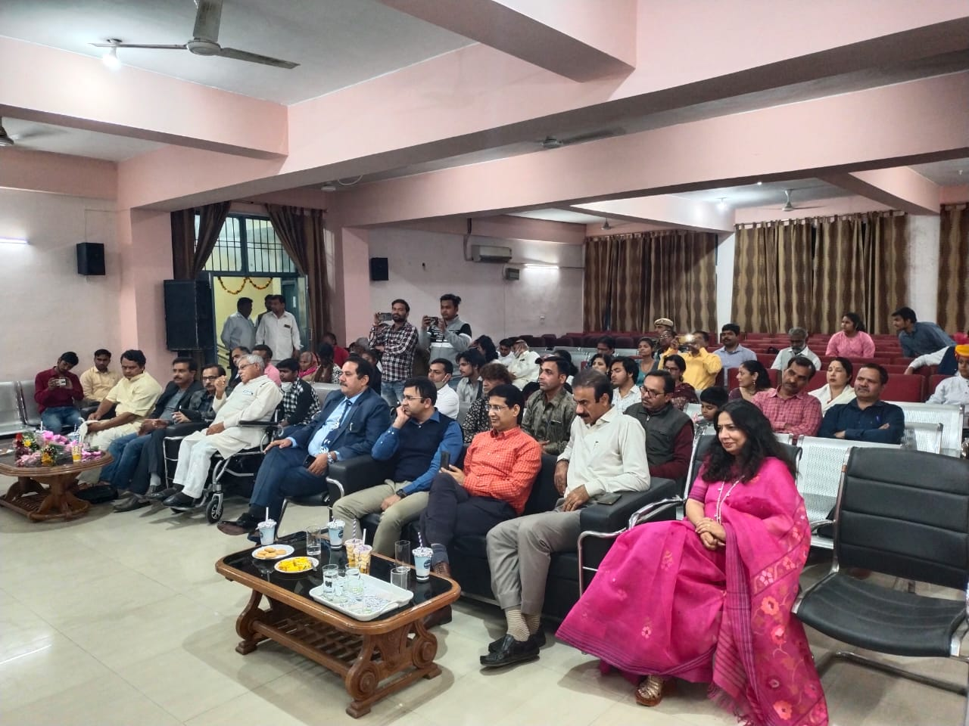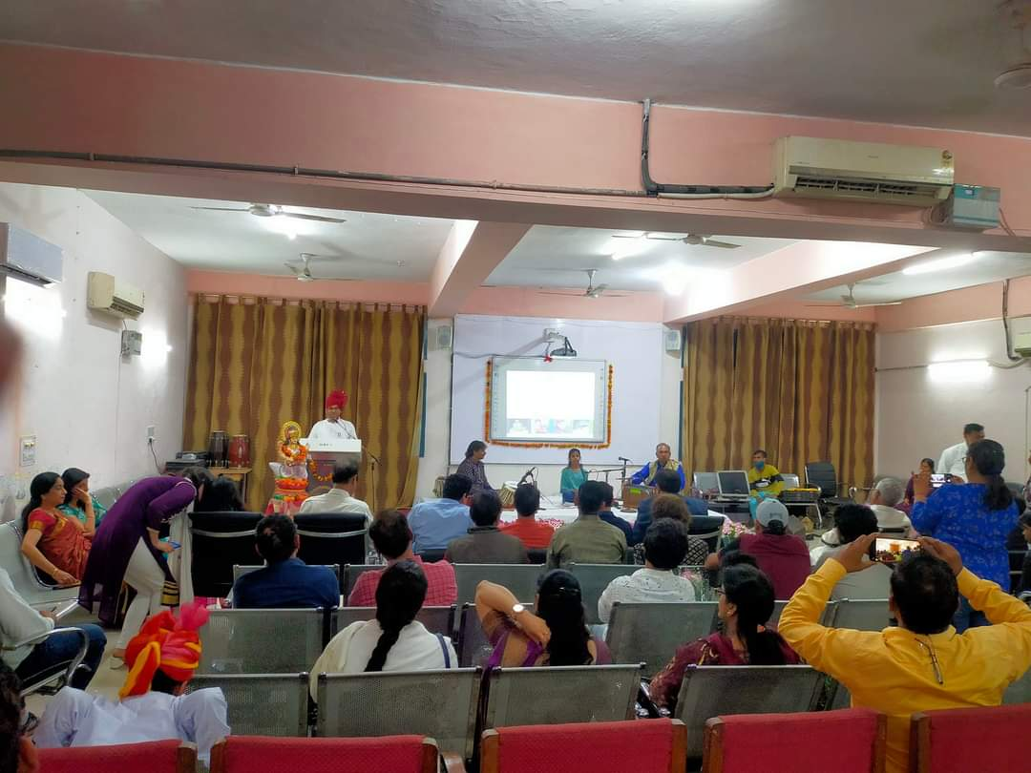

Title of the Activities & date | Organising unit/ agency/ collaborating agency | Number of teachers co-ordinated such activities | Number of students participated in such activities | Achievements/  Remarks
63) Prices in inter zonal youth festival 25th to 27th March, 2022 | MDU Rohtak | Ms. Meenal Sabharwal  Ms. Neelam Rani | 2 students | Inter Zonal Youth Festival held at MDU, Rohtak from 25th to 27th March, 2022. Anika Goswami BA III won 3rd prize in English poetic recitation and Anjali BA III won 2nd prize in Rangoli making.[
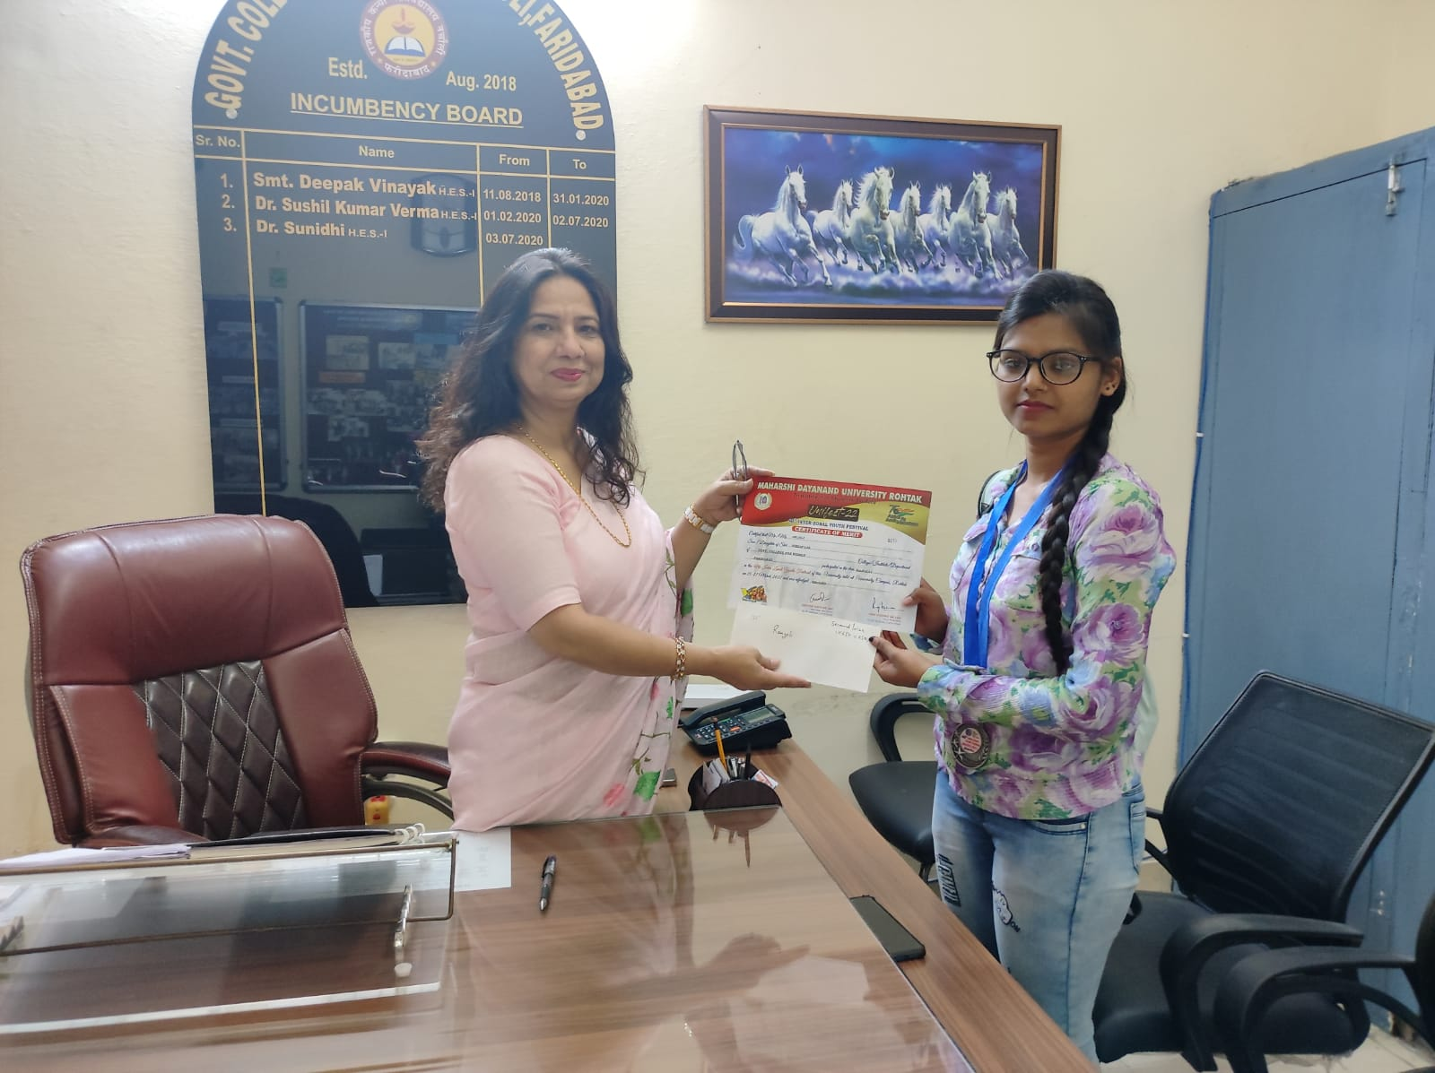
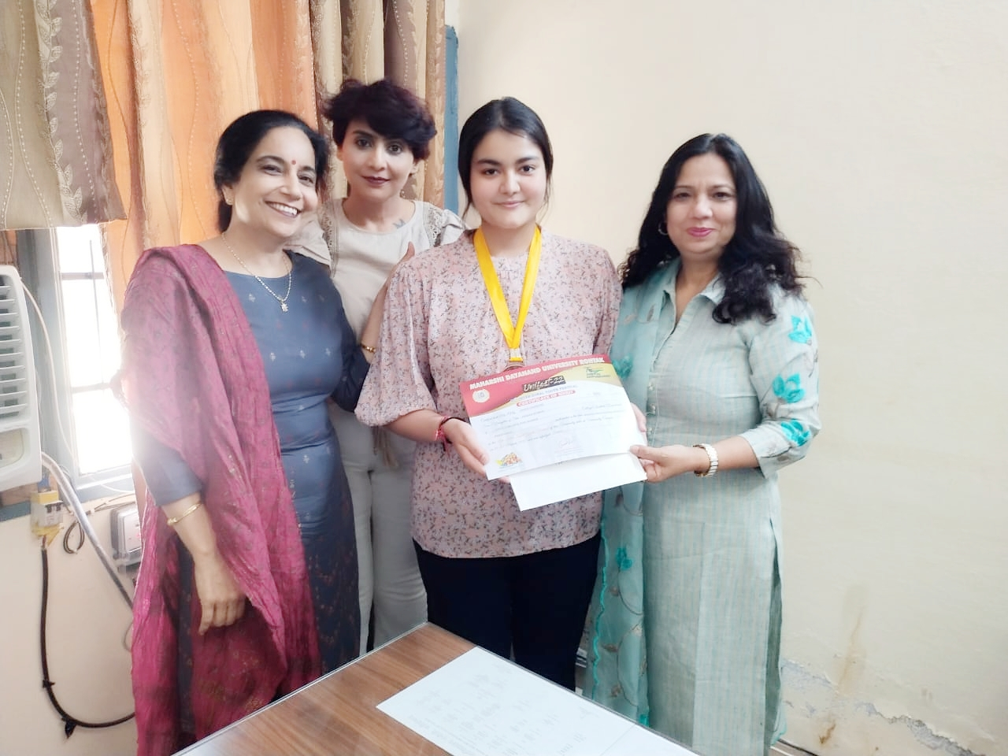

Title of the Activities & date | Organising unit/ agency/ collaborating agency | Number of teachers co-ordinated such activities | Number of students participated in such activities | Achievements/  Remarks
64) Presented the model in the Science Exhibition, Science Conclave- 2022 held on 28th and 29th April, 2022 | J. C. Bose Univ. of Science & Technology, YMCA, Faridabad, Haryana. | Dr. Neha Aggarwal | 2 students | Two students of B.Sc II year, Prachi Pal Roll no 08 and Nisha Roll no 43, participated and successfully presented the model in the Science Exhibition, Science Conclave- 2022 held on 28th and 29th April, 2022 to celebrate “Azadi ka Amrit Mahotsav” sponsored by the Haryana State Council for Science, Innovation & Technology (HSCSIT), Haryana & YMCA MOB Alumini Association at J. C. Bose Univ. of Science & Technology, YMCA, Faridabad, Haryana.

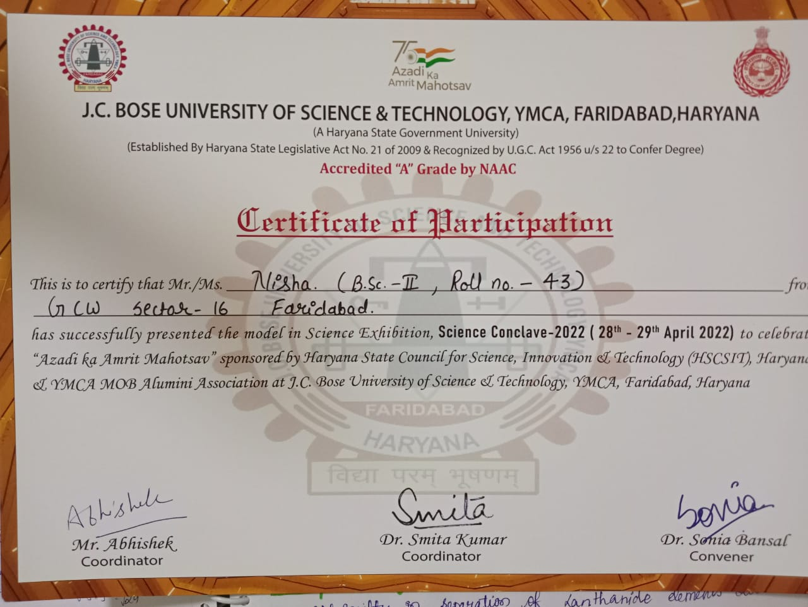
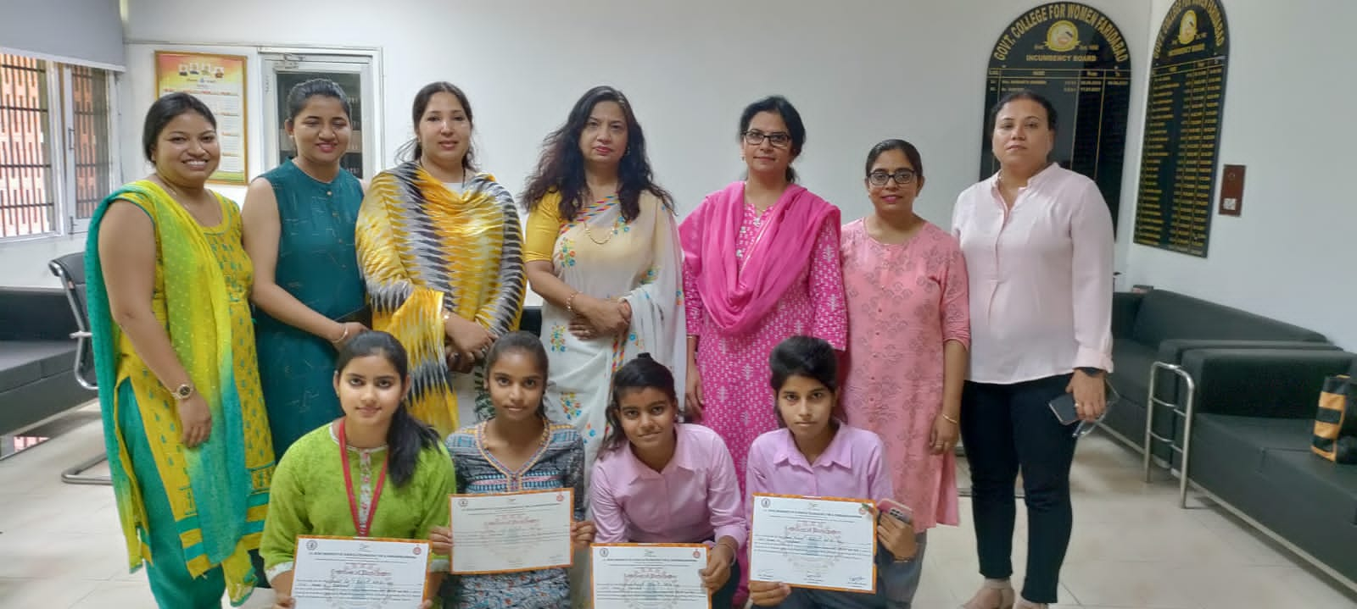

Title of the Activities & date | Organising unit/ agency/ collaborating agency | Number of teachers co-ordinated such activities | Number of students participated in such activities | Achievements/  Remarks
65) Essay writing competition on 29th April, 2022) | Legal Literacy cell | Dr. Preeti Raina  Ms. Sonia Minocha  Ms. Priya  Ms. Savita | 98 students | Legal Literacy Cell of Government College for Women organized Essay Writing Competition on the themes “Protection of Women from domestic violence Act, 2005, Dowry Prohibition and Fundamental Duties” on 29th April, 2022. Total 98 students participated in the competition. Event was organized under the guidance of Dr. Preeti Raina , Convener Legal Literacy Cell. Ms. Sonia Minocha, Ms. Priya Saini and Ms. Savita Nagar were also present.

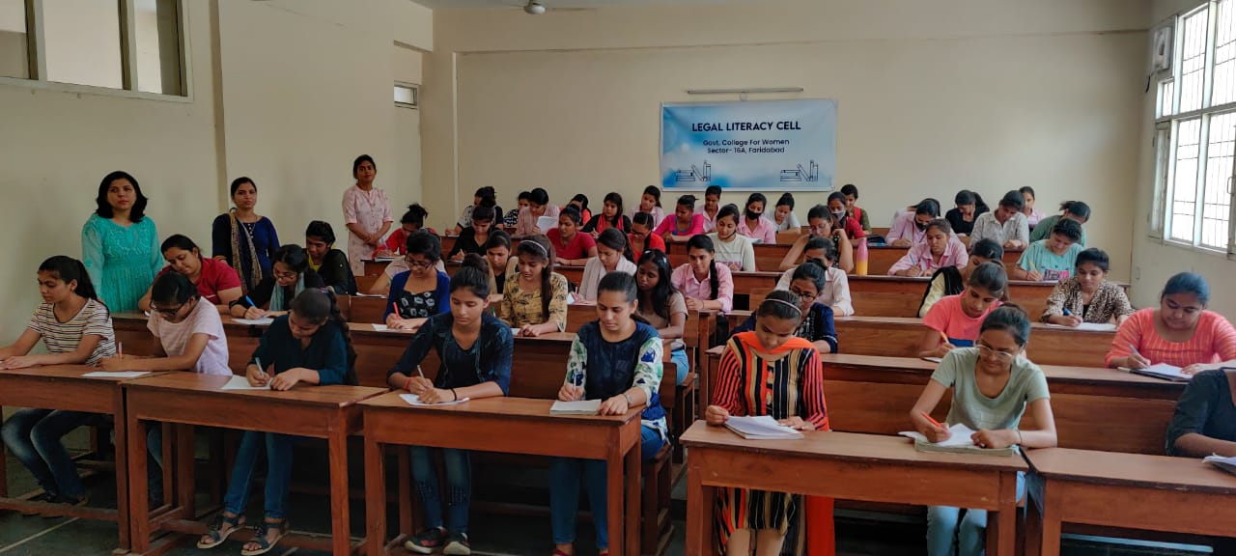
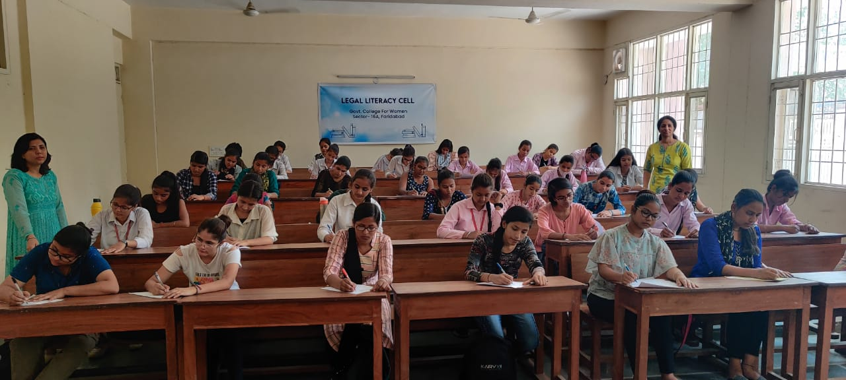

Title of the Activities & date | Organising unit/ agency/ collaborating agency | Number of teachers co-ordinated such activities | Number of students participated in such activities | Achievements/  Remarks
66) A webinar on 'भक्तिकालीन साहित्य का भारत को विश्व गुरु बनाने में सहयोग . | Department of Hindi on 29.04.2022 | Dr. Raman Kumar | 96 students | A webinar was organised by by Department of Hindi on 29.04.2022 on 'भक्तिकालीन साहित्य का भारत को विश्व गुरु बनाने में सहयोग .The key speaker were Dr Parveen Verma GGDSD College Palwal and Dr Usha Rani Department of Hindi H.P University,Shimla.Our worthy Principal Dr.Sunidhi Singh precided over the the webinar and pondered upon the relevance of spiritual awakening in India and its effects on Hindi Literature. Dr.Raman, Department of Hindi managed the whole show efficiently and diligently and also discussed the related topic of upsurge of spiritual literature on India.Dr Vijaya Shridhar,Dr Pooja Singh,Dr Poonam Almadi and Kuldeep gave their technical assistance for the success of webinar.The webinar was a great success and proved to be a stepping stone towards highlighting the postulates of Spiritual Literature in Hindi.

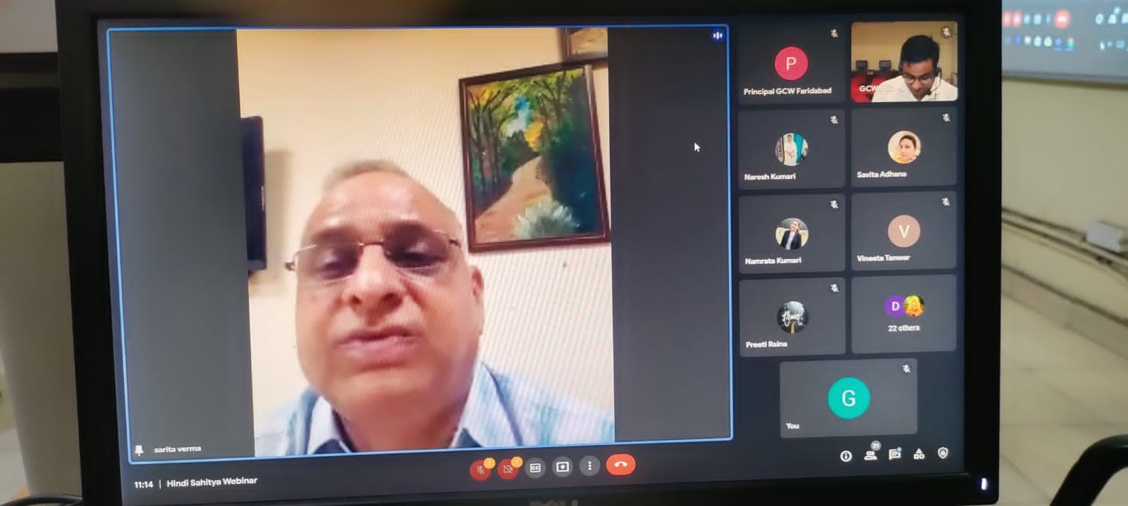

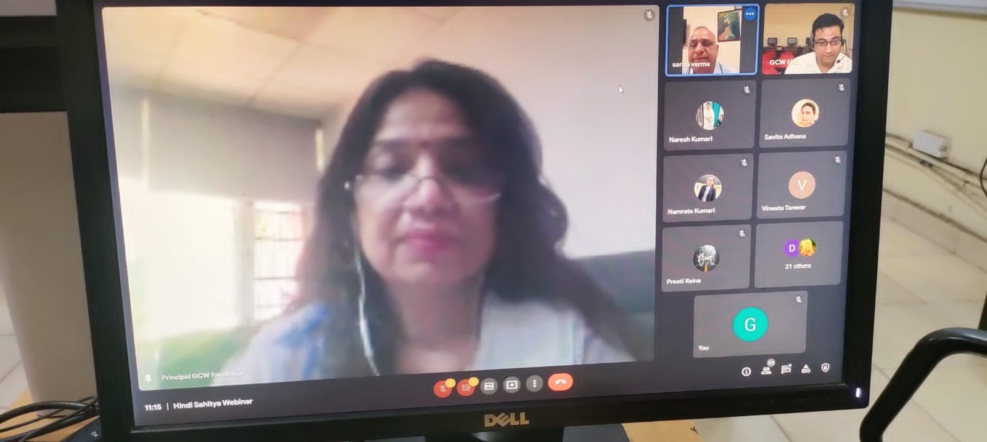

Title of the Activities & date | Organising unit/ agency/ collaborating agency | Number of teachers co-ordinated such activities | Number of students participated in such activities | Achievements/  Remarks
67) 7 days "stitching and tailoring workshop" for the home science students from 28 April to 6 May, 2022. | Department of Home Science | Ms. Neelam Rani | 50 students | Department of Home Science organized a 7 days "stitching and tailoring workshop" for the home science students from 28 April to 6 May. under the guidance and support of our Principal , Dr. Sunidhi .Total50 students participated in this workshop and got benefitted from this workshop. stitching and tailoring helps students to meet the basic stitching requirement at home and money saving device for lower income group.

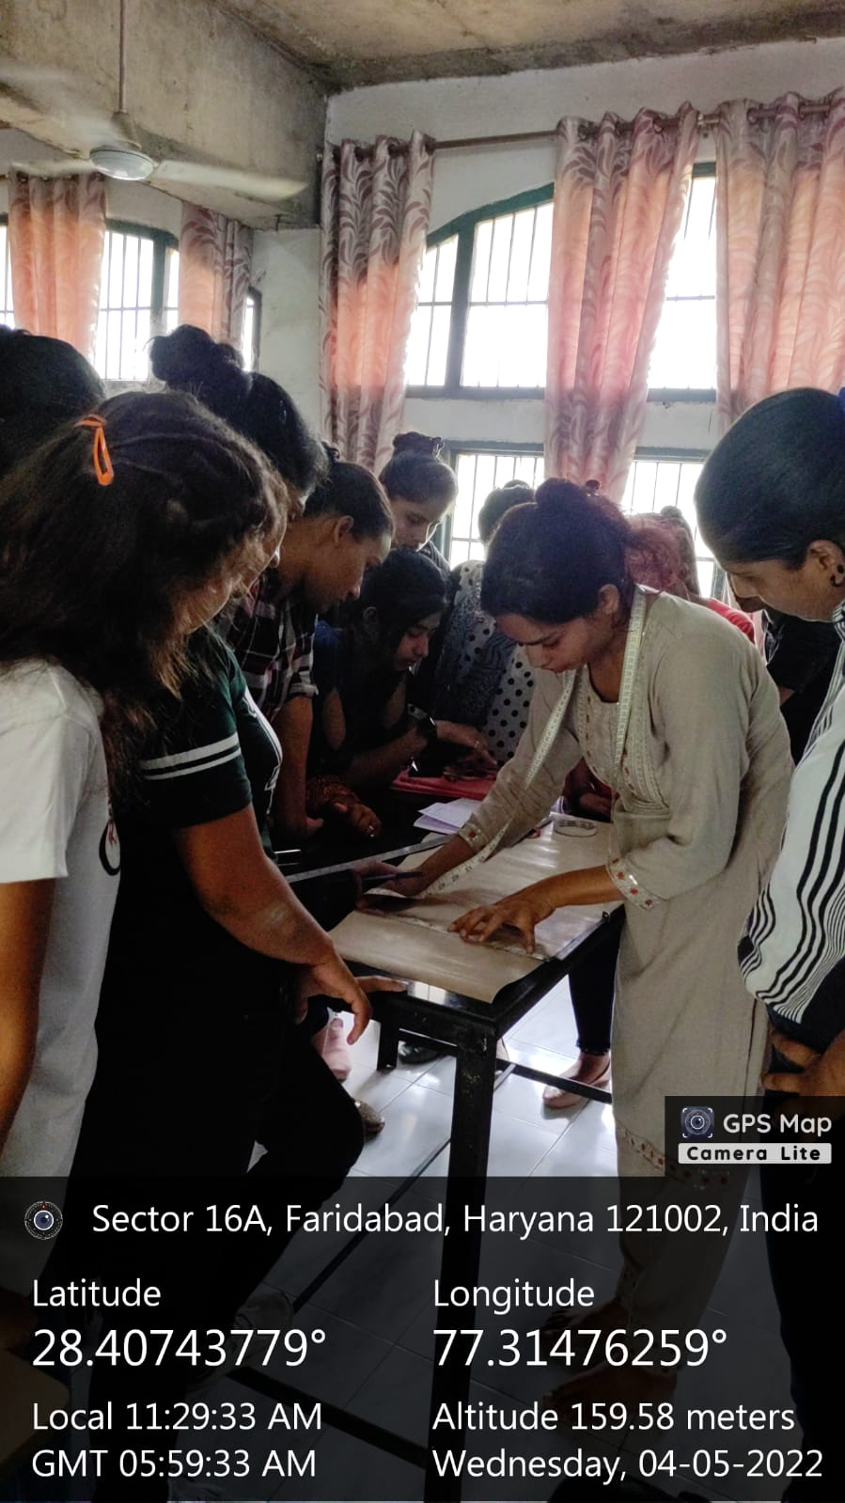

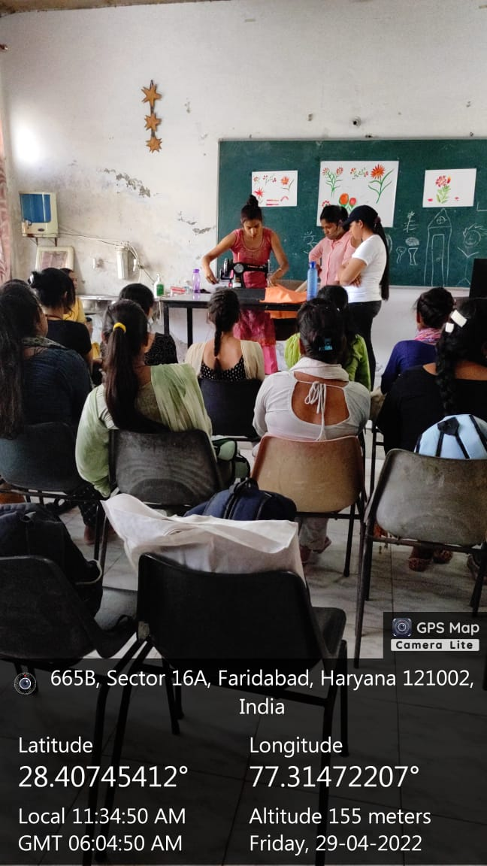

Title of the Activities & date | Organising unit/ agency/ collaborating agency | Number of teachers co-ordinated such activities | Number of students participated in such activities | Achievements/  Remarks
68) Marathon on 1st May, 2022 | Eco Club and NSS | Dr.Parul Rana, Neelam, Poonam,Raman, Neha vij, Priya,Varsha & other Staff members | 180 students | A Marathon was organised by Eco Club and NSS on May 1 at Town Park Sector 12 Faridabad. Lions Club sponsored the marathon of 2 km students collectively propagated the idea of save oil save soil . Dr Sunidhi principal deliberated on the need of saving oil and thence cutting on environmental pollution. ECO Club incharge Meenal Sabharwal alongwith Dr.Parul Rana, Neelam, Poonam,Raman, Neha vij, Priya,Varsha & other Staff members participated in the run.There were around 180 enthusiastic students who made the run a success.

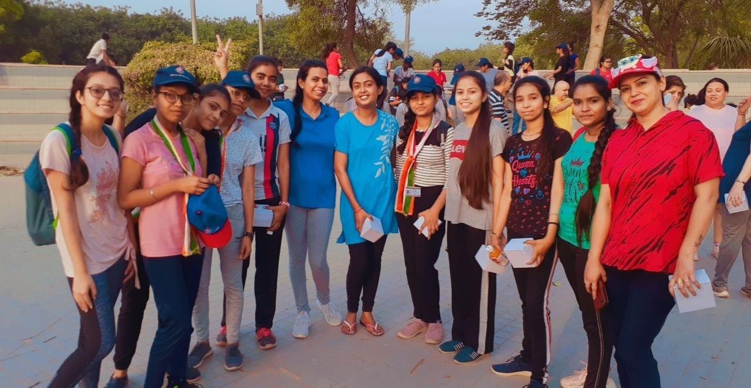

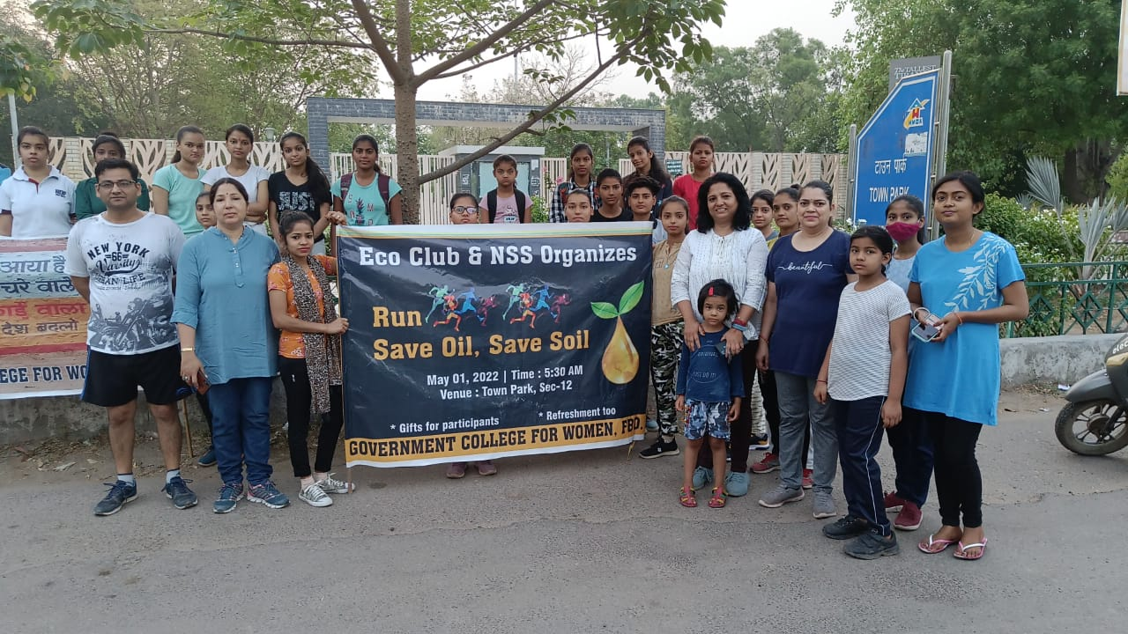

Title of the Activities & date | Organising unit/ agency/ collaborating agency | Number of teachers co-ordinated such activities | Number of students participated in such activities | Achievements/  Remarks
69) Slogan writing and On the spot Painting Competition on 4th May, 2022 | Legal Literacy Cell | Dr. Preeti Raina  Ms. Sonia Minocha  Ms. Priya Saini  Ms. Savita | 60 students | Legal Literacy Cell of Government College for Women organized Slogan writing and On the spot Painting Competition on the themes “Acid attack Human Rights, Female foeticide, and Constitutional values on 04 May, 2022. Total 60 students participated in the competition. Event was organized under the guidance of our worthy Principal Dr. Sunidhi Singh. All legal literacy committe members were also present.

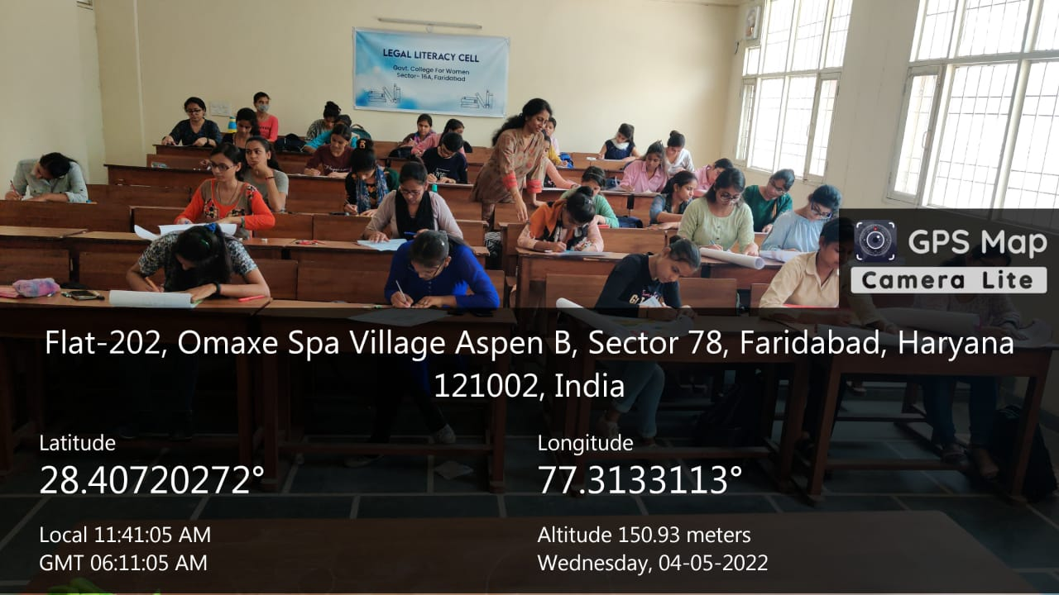
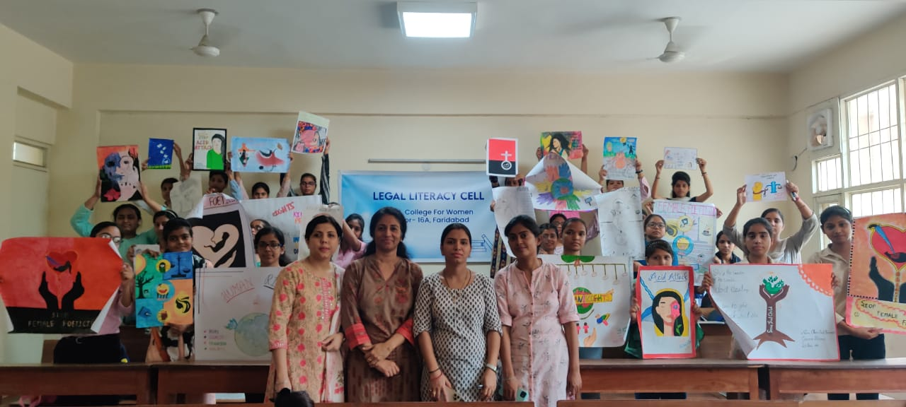

Title of the Activities & date | Organising unit/ agency/ collaborating agency | Number of teachers co-ordinated such activities | Number of students participated in such activities | Achievements/  Remarks
Debate, 70) Declamation, and poetic Recitation Competition on 06 may 2022 | Legal Literacy Cell | Dr. Preeti Raina  Ms. Sonia Minocha  Ms. Priya  Ms. Savita | 30 students | Legal Literacy Cell of Government College for Women organized Debate, Declamation, and poetic Recitation Competition on 06 may 2022.  students spoke on Topics 'In the opinion of the house, RTI is better tool for society, In the opinion of house Ragging is a evil, Child marriage for and against.  Topic of Declamation were  ' Right of disabled person',  Rights of destitute women and children, Drug de addiction.  Poetic recitation Competition was on the themes “Acid attack Human Rights, Female foeticide, and Dowry prohibition  About 30 students participated and expressed their views in these competitions. Event was organized under the guidance of our worthy Principal Dr. Sunidhi Singh. Mr. Raman, Mr. Suresh Kumar and Ms Meenu were also present along with legal literacy committe members.

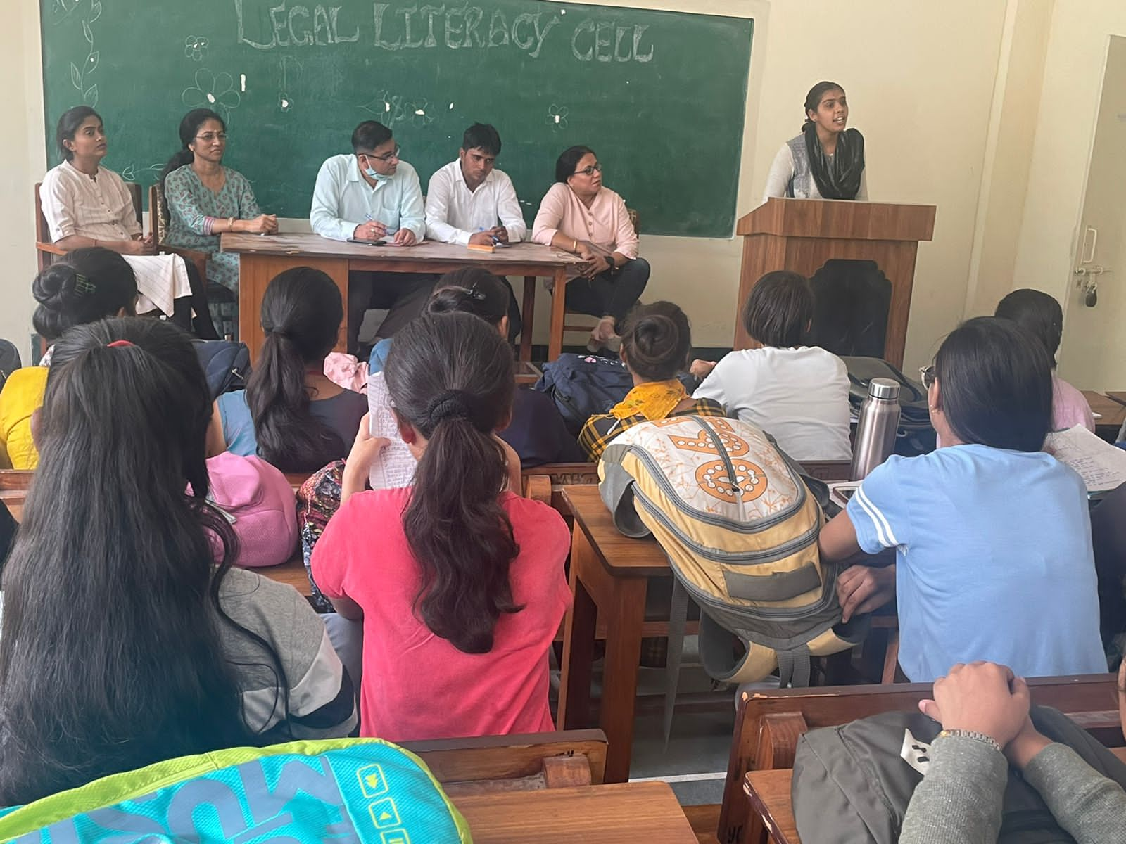

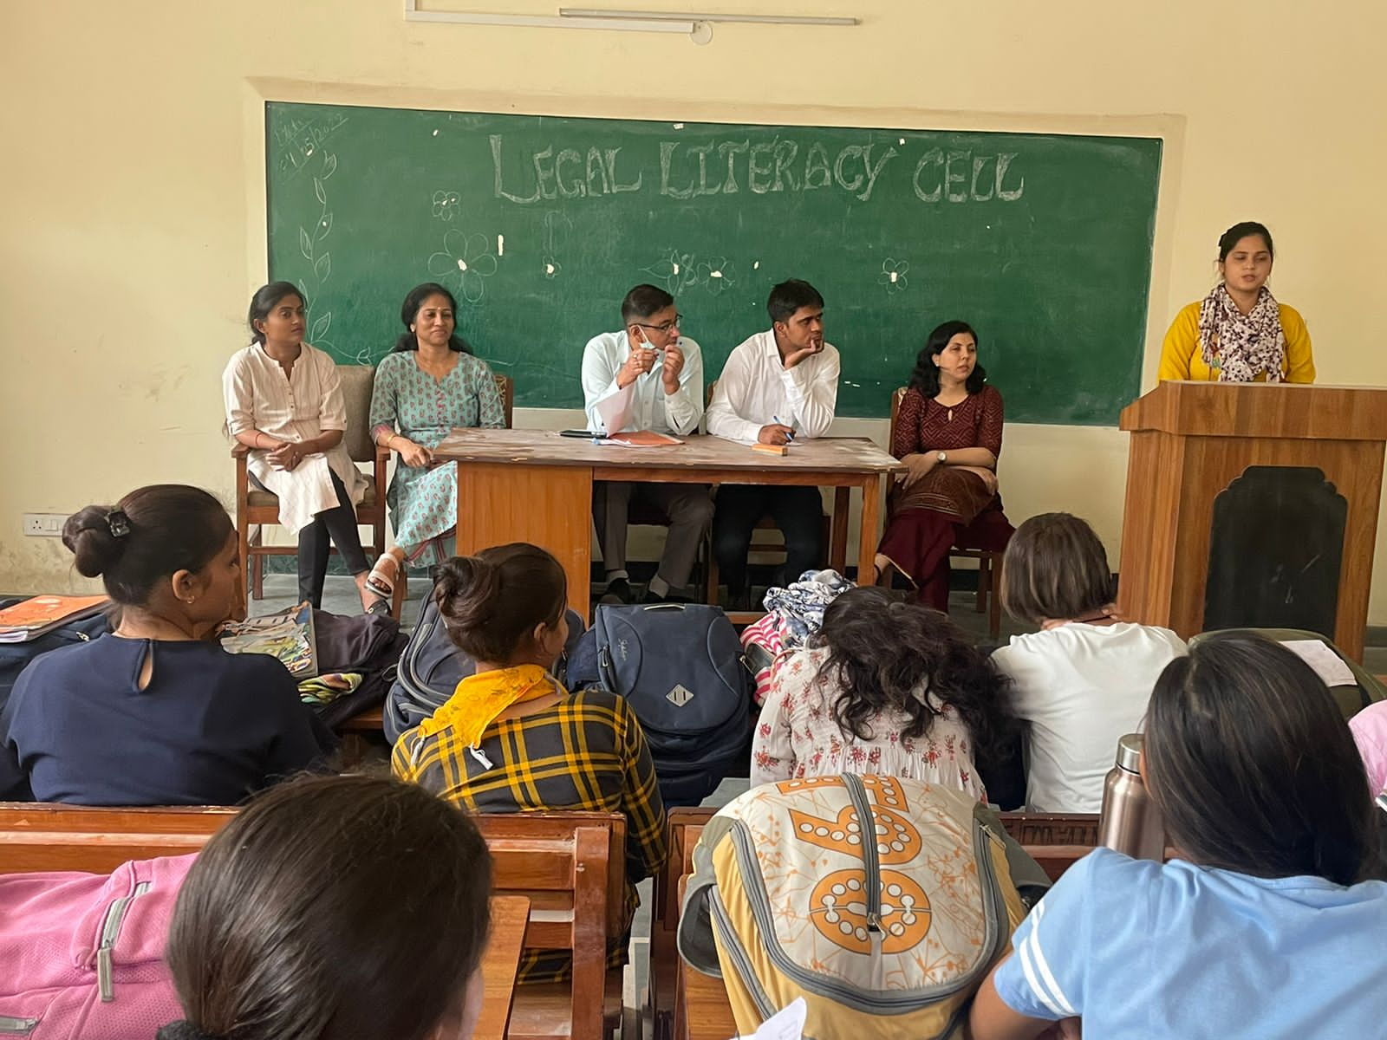

Title of the Activities & date | Organising unit/ agency/ collaborating agency | Number of teachers co-ordinated such activities | Number of students participated in such activities | Achievements/  Remarks
71) Singing competition on 7th May 2022 | KL Mehta government college Faridabad | Dr. Ram Nivas | 2 students | In a competition organised by KL Mehta government college Faridabad on 7th May 2022. Our students Bindu from BA final year and Saba from BA second year got third position in singing competition hosted in the memory of Nightingale of India late Shri Lata Mangeshkar ji. Our worthy Principal mam Dr Sunidhi congratulated the students and music incharge Dr Ramnivas for encouraging the students she also praised the students for their hard work.

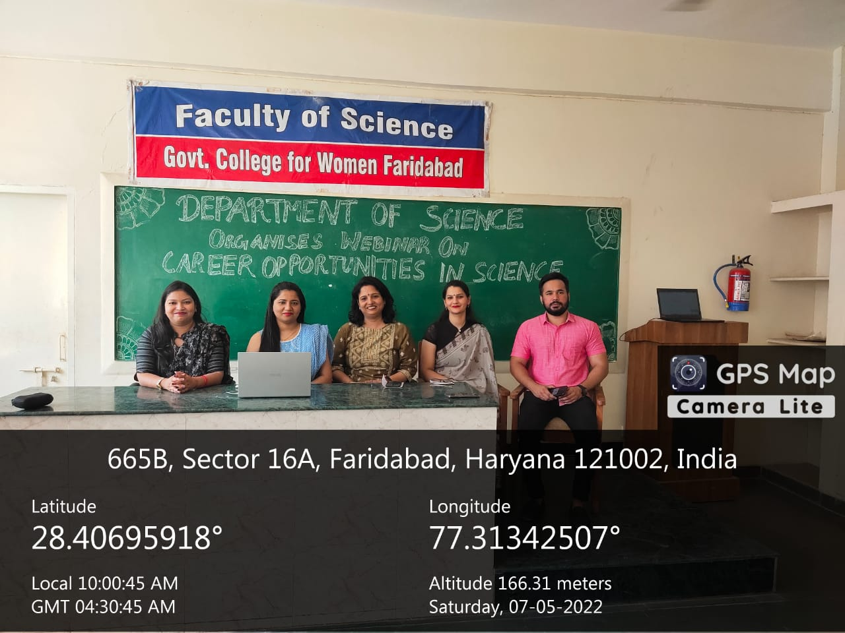

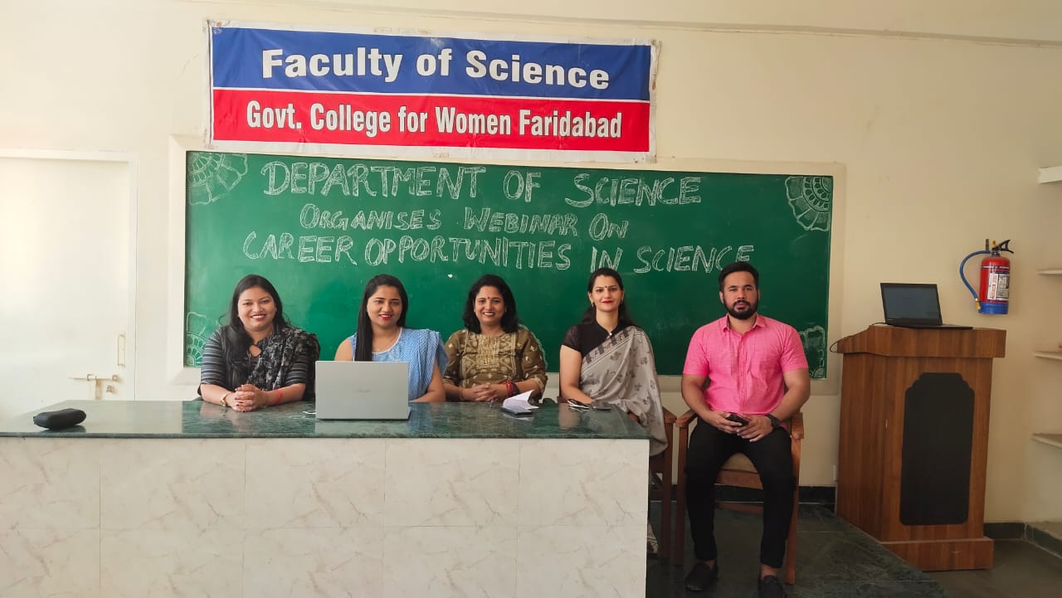

Title of the Activities & date | Organising unit/ agency/ collaborating agency | Number of teachers co-ordinated such activities | Number of students participated in such activities | Achievements/  Remarks
72) National level Collage making competition | Department of Tourism Management | Dr. Preeti Raina  Mr. Sandeep  Mr. Keshav | 39 students | Department of Tourism Management GCW, Faridabad under the guidance of our Principal ma'am Dr. Sunidhi Singh organised National level Collage making competition. Students were allowed to send their entries on mail upto 20 April. Guidelines were given to them. We got 39 entries in this competition. students were from GCW Faridabad, DAV College Faridabad, pg govt college sec, 9 Gurgaon,Government college Ballabgarh, Amity university Noida Ambedkar university delhi, Gulzar group khanna, ludhiana, IITM Gwalior, Govt polytechnic Thane, Sikkim university, BMS Banglore, university of Eng and management, Kolkata, IHTM Rohtak and BMN college of Homescience Matunga, Maharashtra.  Students had given their best efforts in selecting the Tourist Destinations. Attractions like Taj Mahal and kutubminar were beautifully compiled by colourful cut outs of pages  Sonia from Govt college Ballabgarh stood 1st,krishna Chaurasia of DAV centenary college faridabad stood 2nd and Sapna from GCW Faridabad and Simran Priyadarshini f rt om Amity university, Noida(UP) shared the 3rd position. Judges of this event were Ms. Satvinder kaur, Ms Neelam Rani and Dr. Parul Rana. This competition was organised by Dr Preeti Raina, Dr. Sandeep kumar and Mr. Keshav Kumar Vaishnav of Department of Tourism.

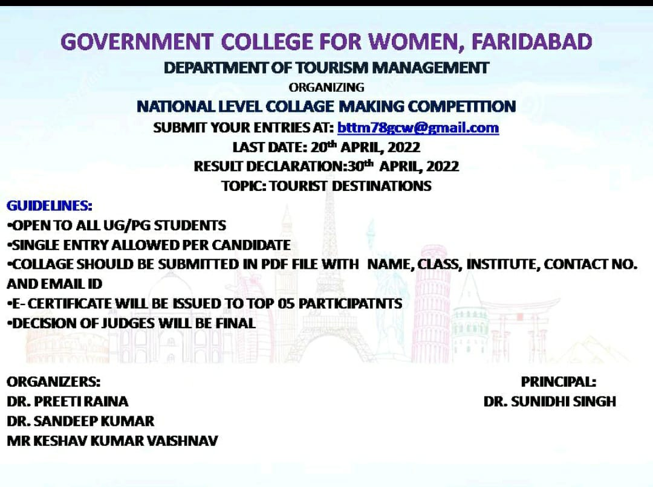
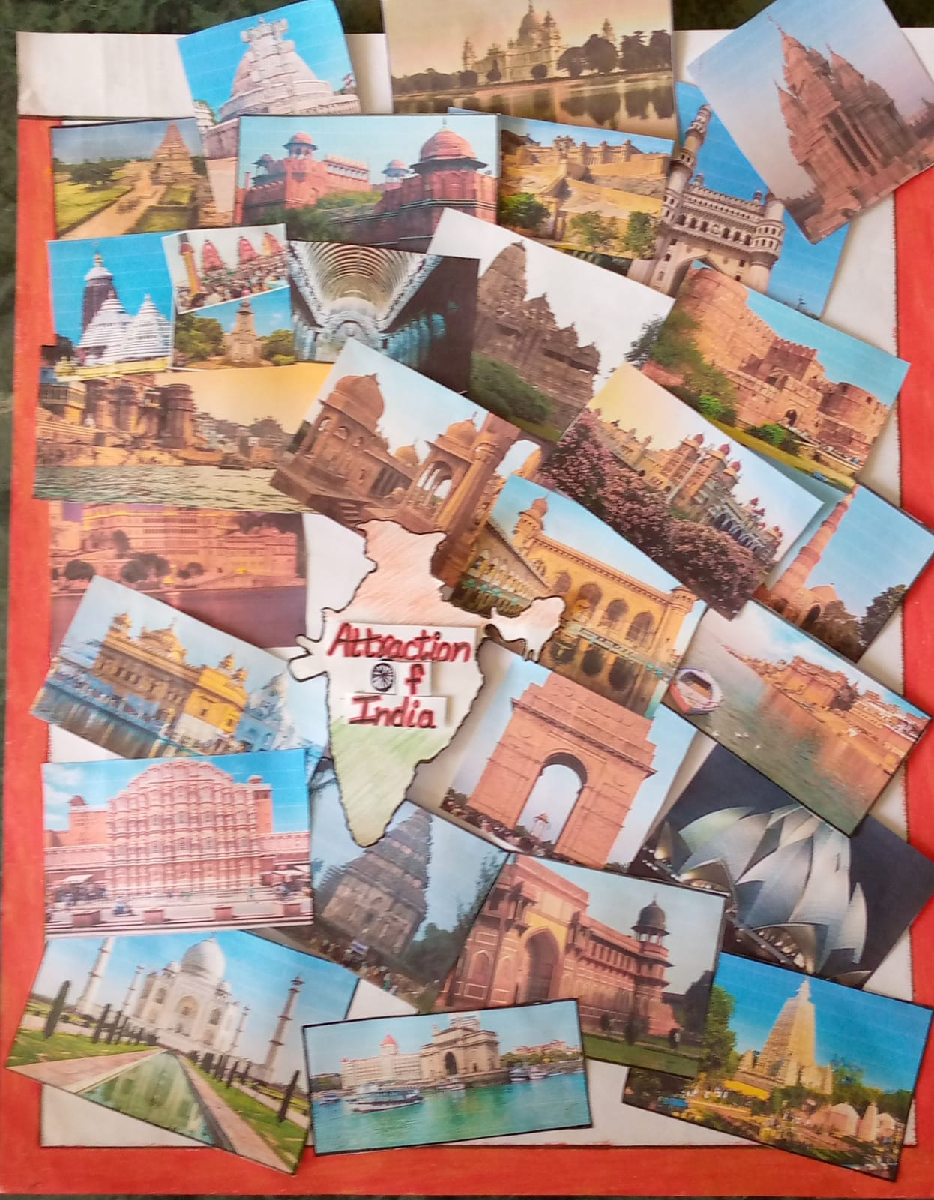

Title of the Activities & date | Organising unit/ agency/ collaborating agency | Number of teachers co-ordinated such activities | Number of students participated in such activities | Achievements/  Remarks
73) ) seminar cum hiring programme on 30th April, 2022 | Placement cell in collaboration with Department of Commerce & Management | Ms. Preeti Arora  Ms. Sonia Minocha  Ms. Neha Vij  Ms. Aashna  Ms. Priya  Ms. Divesh  Ms. Manisha  Ms. Varsha  Mr. Sandeep  Mr. Gaurav  Mr. Suresh | 162 students | Placement cell in collaboration with Department of Commerce & Management of Government College for Women, Faridabad organized a seminar cum hiring programme on 30th April, 2022 for final year students of the college. Event was conducted by Mr. Anil Khurana, Director Khurana Investment & TATA AIA Life Insurance with their team members. Mr. Sandeep Singh, Trainer, Mr. Ajay Awasty, Branch Manager, TATA AIA and Ms. Aaisha, member of Nive Bupa were the key note speakers. they enlightened students about the various career options in the field of Insurance with quality requirements for entering in all the fields in a very impressive way. Mock interview for the students was also conducted after the session. Mrs. Sunidhi, worthy Principal Government College for Women, Faridabad motivated the students to become self-dependent. Event was successfully coordinated by all the members of Placement Cell and Department of Commerce & Management under the leadership of Ms. Preeti Arora, convener Placement Cell. 162 students participated in the event.

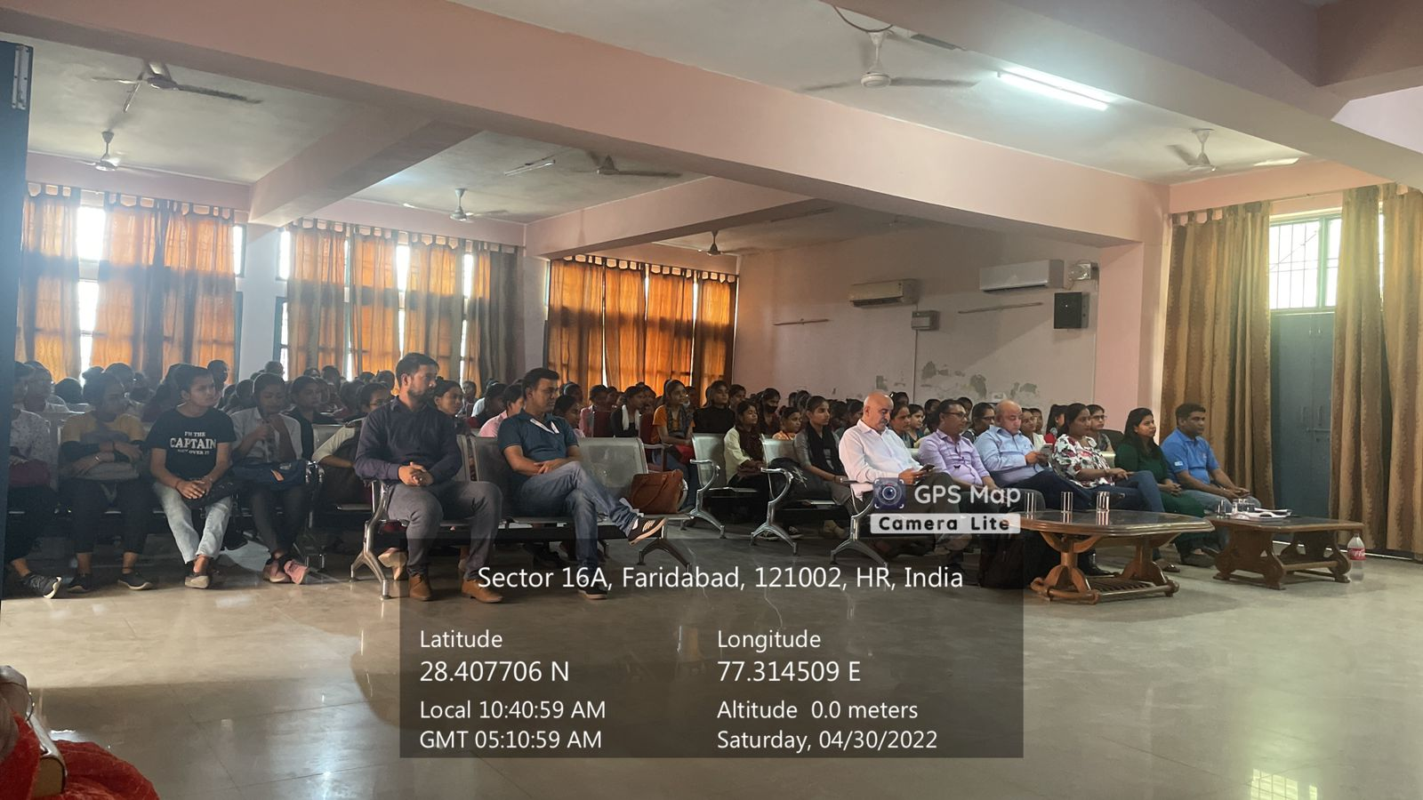

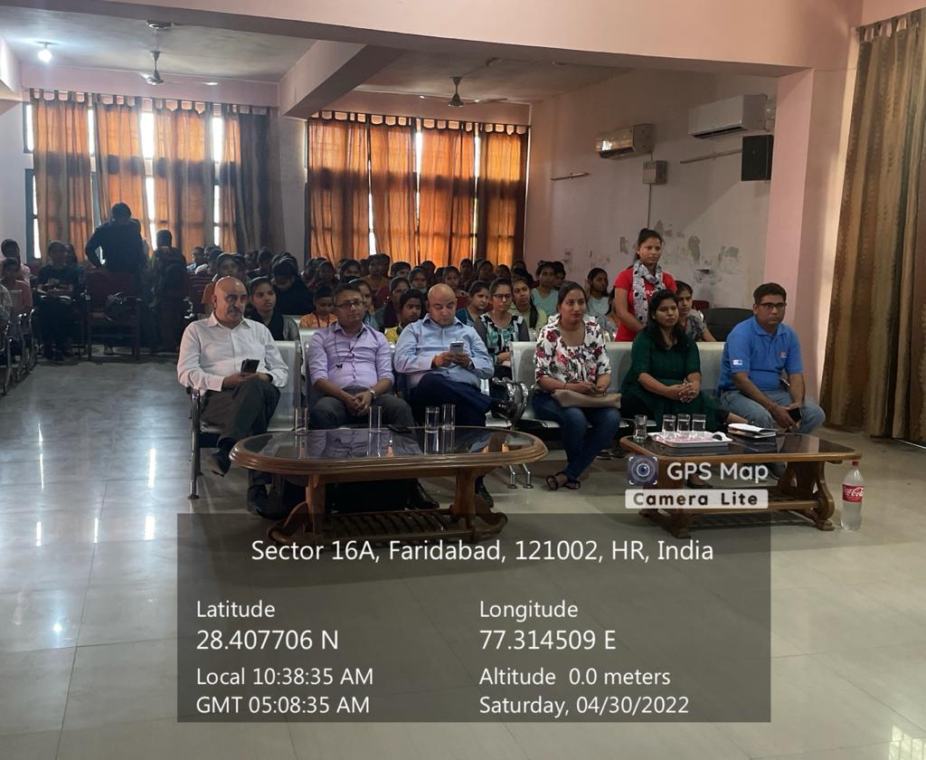

Title of the Activities & date | Organising unit/ agency/ collaborating agency | Number of teachers co-ordinated such activities | Number of students participated in such activities | Achievements/  Remarks
74) Webinar on "Career Opportunities in Science" in our college for 10th, 11th and 12th class students of Government Girls senior secondary school, Faridabad on 07/05/2022 | Department of science | Ms. Monika  Ms. Chanchal  Ms. Poonam  Ms. Varsha  Mr. Anuj | 210 students | Faculty of Science organized a Webinar on "Career Opportunities in Science" in our college for 10th, 11th and 12th class students of Government Girls senior secondary school, Faridabad on 07/05/2022, as per the letter no. DHE-020003/4/2020-college-1-DHE dated 05/04/2022. The speaker Smt. Monika, Assistant Professor (Chemistry), GCW, Faridabad enlightened the students with various career opportunities in science. She compiled a list of career options that students can pursue after studying science (non medical or medical) in class 12.  She told that Science and technology is the key element for growth of modern India. Our Worthy Principal Dr. Sunidhi Singh told the students to focus on the aim to fullfill their dreams. Total 210 students of the school participated and showed great enthusiasm in this webinar. Event was successfully organised under the guidance of our worthy Principal. Dr. Neha Aggarwal, Dr. Varsha Sharma, Ms. Poonam Rani, Ms. Chanchal and Mr. Anuj also attended the webinar.

Title of the Activities & date | Organising unit/ agency/ collaborating agency | Number of teachers co-ordinated such activities | Number of students participated in such activities | Achievements/  Remarks
75) An inter-departmental activity on 10th May, 2022 | Faculty of computer science | Dr. Vijaya Shridhar, Dr. Pooja Singh, Dr. Poonam Almadi and Dr. Meenu Sheoran | 100 students | Faculty of computer science department organized an inter-departmental activity in our college on 10/05/2022 at 10:30 am. It was a two phased activity in which students of BBA 1st , BBA 2nd, BBA 3rd, BA 1st and B.COM 1st participated.  Near about 100 students participated in the event. Our worthy principal Dr. Sunidhi Singh told the students about the importance of science and technology for the growth of modern India and needs to implement it for fulfilling their dreams. The students showed great enthusiasm in this activity. The topics presented in the activity were Cyber Security, Ethical Hacking, Virtual Reality. Criteria for evaluation of event were technology implementation, PPT presentation skill and content relevance.  Computer department faculty members Dr. Vijaya Shridhar, Dr. Pooja Singh, Dr. Poonam Almadi and Dr. Meenu Sheoran contributed in the event.

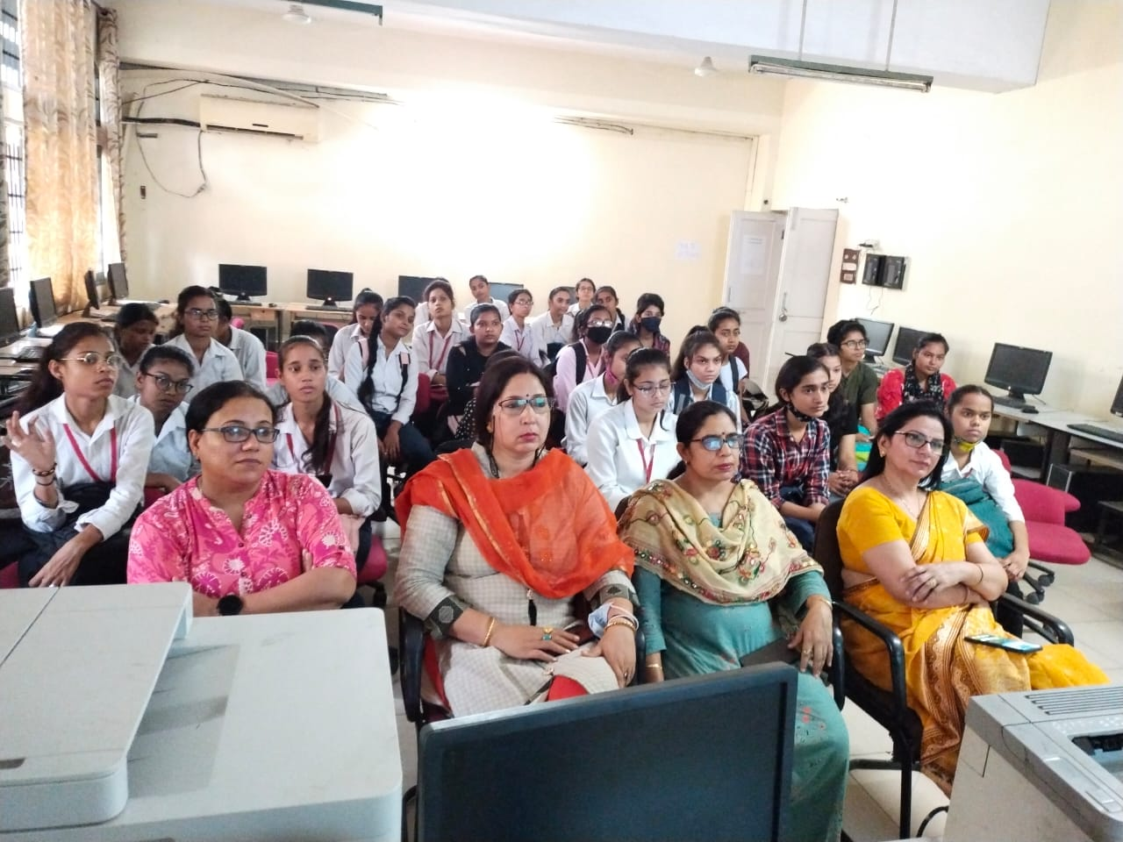
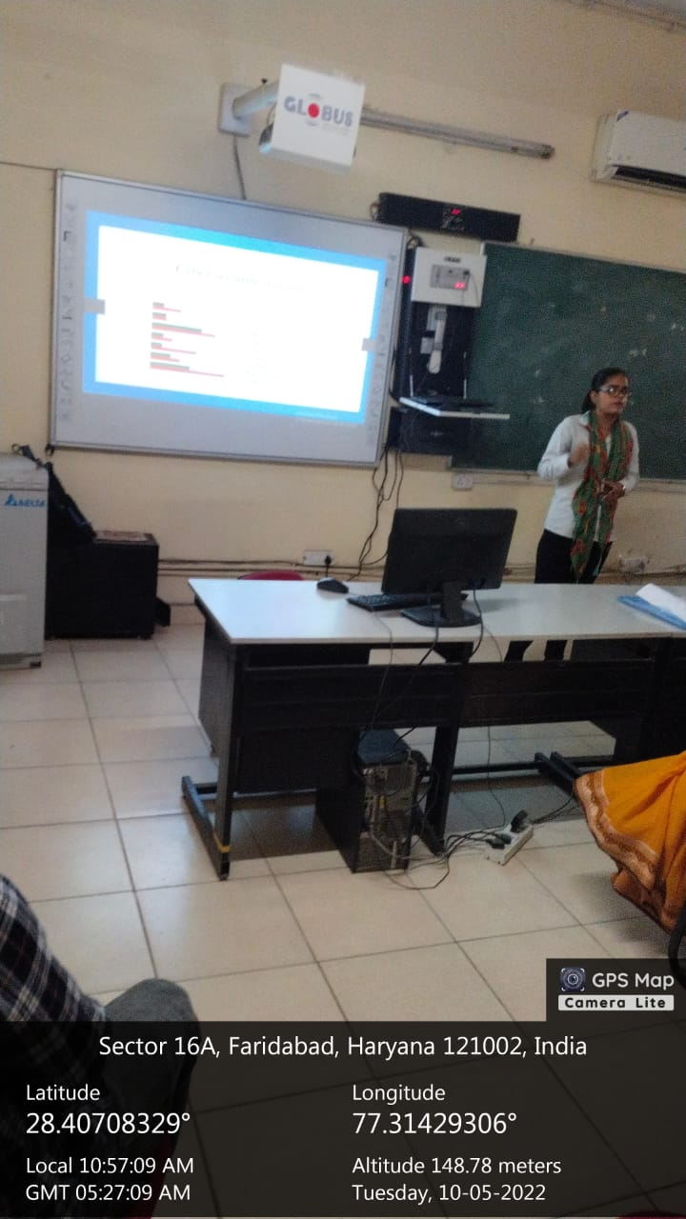

Title of the Activities & date | Organising unit/ agency/ collaborating agency | Number of teachers co-ordinated such activities | Number of students participated in such activities | Achievements/  Remarks
76) selection to represent MDU, Rohtak in KHELO INDIA | Physical education department | Mr. Balbir Dhaiya | 3 students | A very proud moment for our college as our 3 students have been selected to represent MDU, Rohtak in KHELO INDIA UNIVERSITY GAMES which will take place in Karnataka (Banglore) from 22nd April to 3rd May by showing outstanding performance at nationals and All India Inter University.1. Urvashi Bhardwaj , BA-2nd year (Boxing).2. Sunita , B.Sc-2nd year (Fencing). 3. Ankita , B.Sc-3rd year (Fencing).

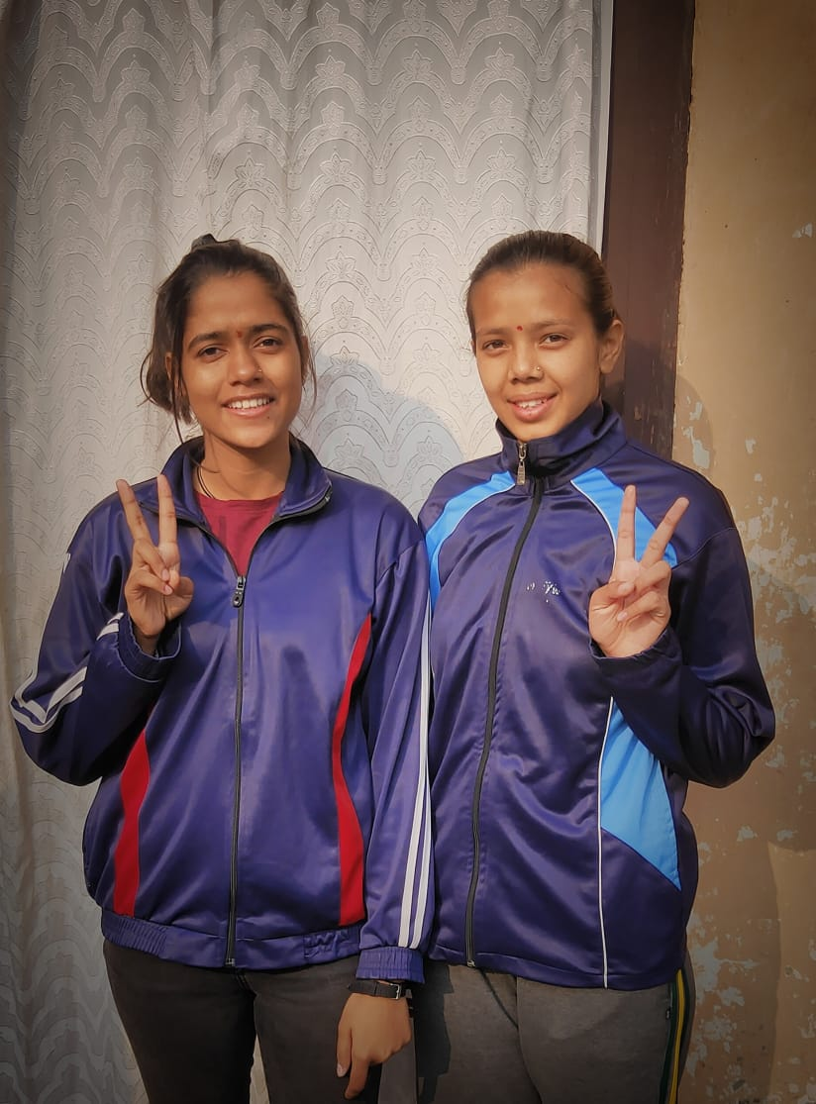

Title of the Activities & date | Organising unit/ agency/ collaborating agency | Number of teachers co-ordinated such activities | Number of students participated in such activities | Achievements/  Remarks
77) next level “7-days Photography Workshop” for the college students from 25th April, 2022 to 2nd May, 2022, | Women Cell, in collaboration with BAJMC Department, | Ms. Shalini Khurana  Dr. Rachna Saini | 56 students | Women Cell, in collaboration with BAJMC Department, organized a next level “7-days Photography Workshop” for the college students from 25th April, 2022 to 2nd May, 2022, after the successful completion of first photography workshop in the last semester. This workshop mainly focussed on enhancing the technical skills of students which included some practical sessions on photography as well. Our photography experts Mr. Deepak Pushpdeep and Mr. Ashok Kumar directed practical indications on what to do in certain scenarios for the best effect (e.g. in lighting or composition), which allows the students to go beyond their comfort zone in photography and focus on improving their art beyond the basics. Total 56 students participated and got benefitted from this workshop. Our Principal, Dr. Sunidhi, motivated the students with her inspiring words that how this workshop would help them in enhancing both the theoretical and practical knowledge that won't be available in any book or user manual. The workshop was successfully organized by Ms. Shalini Khurana, Dr. Rachna Saini, along with the other members of Women Cell and BAJMC Department.

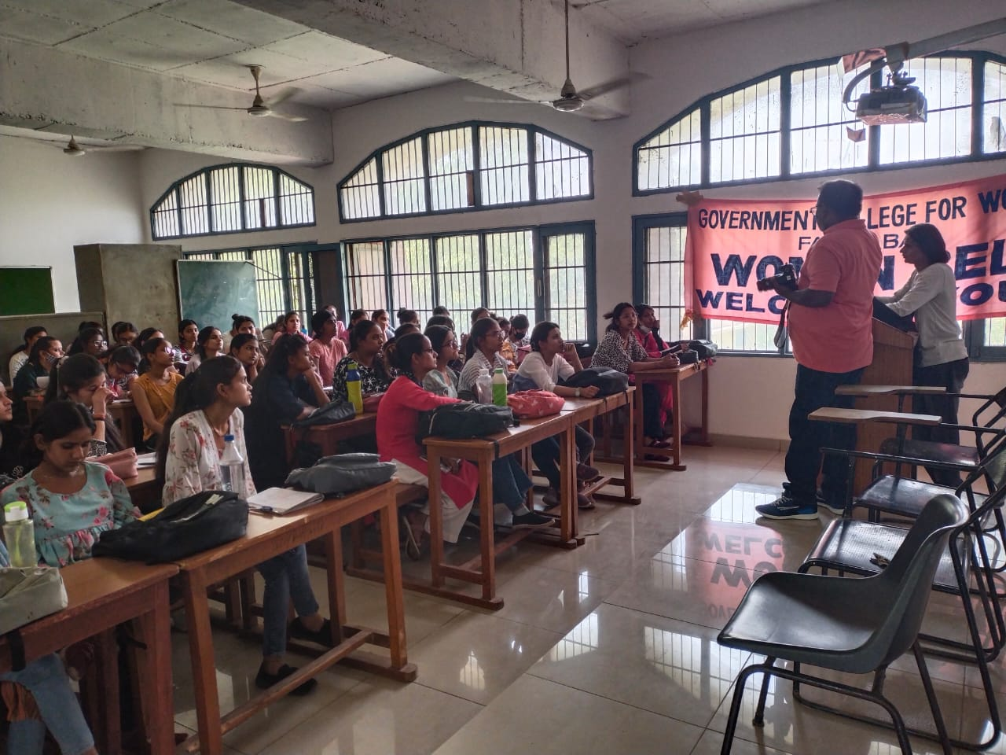
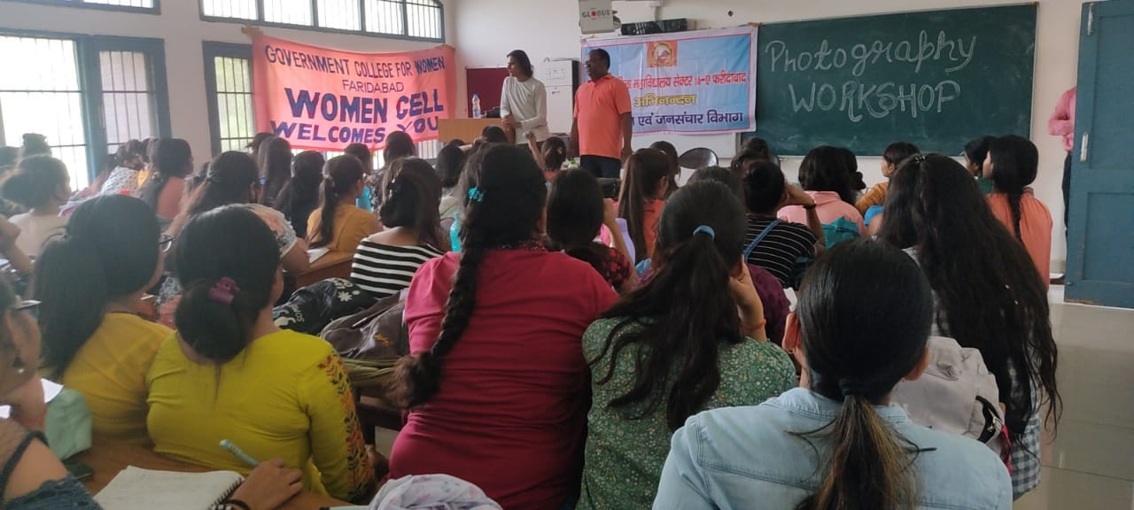

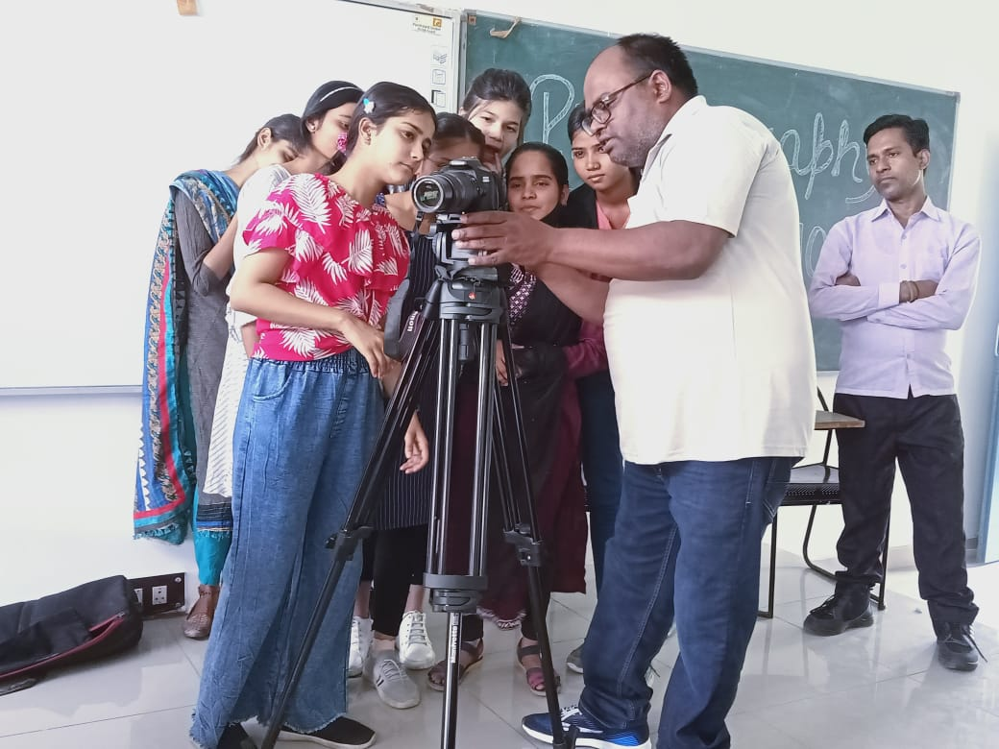

Title of the Activities & date | Organising unit/ agency/ collaborating agency | Number of teachers co-ordinated such activities | Number of students participated in such activities | Achievements/  Remarks
78) Essay Writing Competition for the science students on 20th May, 2022 | Faculty of science | Mrs. Monika , Mr. Anuj, Mrs Chanchal, Dr. Varsha sharma and Ms Poonam | 30 students | Science Department of our college organized Essay Writing Competition for the science students on 20th May, 2022. Total 30 students participated in the competition. The event was organized under the guidance of Dr. Sunidhi, Principal, GCW Faridabad. Mrs Monika , Mr. Anuj, Mrs Chanchal, Dr. Varsha sharma and Ms Poonam were also present there.

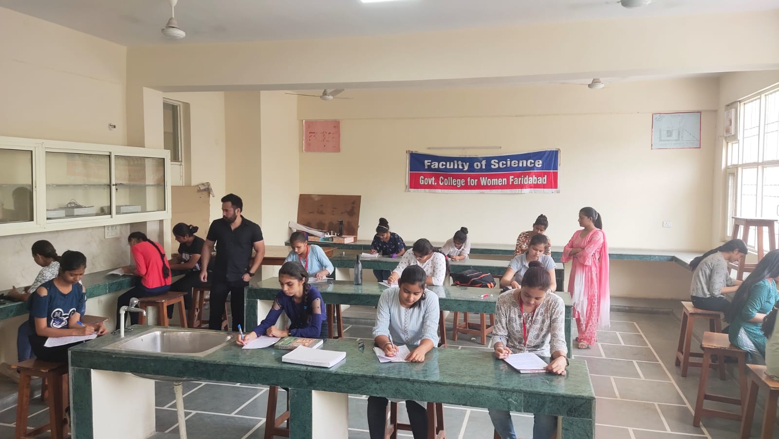

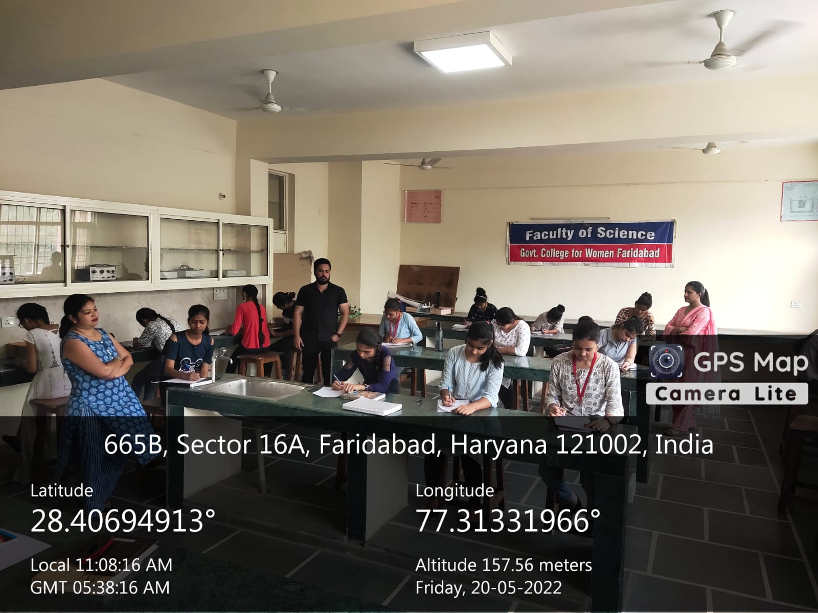

Title of the Activities & date | Organising unit/ agency/ collaborating agency | Number of teachers co-ordinated such activities | Number of students participated in such activities | Achievements/  Remarks
79)National level Poster making competition 10th May, 2022 | Department of Psychology and Home science | Ms. Ritika Gupta  Ms. Neelam Rani | 39 students | Department of Psychology and Home science GCW,Faridabad under the guidance and support of our Principal ma'am Dr. sunidhi singh organised National level Poster making competition.students were allowed to send their entries on mail,we got 39 entries in this competition.students were from GCW Faridabad,DN college faridabad,GCG ballabgarh,Govt.PG college Tigaon,Govt.Brijindra college Faridkot,Hansraj college Delhi,Multani Mal Modi college Patiala,Govt.college Panchkula,Devki Devi jain memorial college for ludhiana, Dayanand Mahila Mahaviddyala Kurukshetra,Integrated school of law,(UP),JC boss University faridabad.Tanisha from Govt.PG collegeTigaon stood1st,Sonia from Govt. college for Girls Ballabgarh stood 2nd and Mukal soni from Devki Devi Memorial college for women Ludhiana and Arti from GCW Faridabad shared the 3rd Position. judges of this event were Dr.Parul Rana,Dr.Preeti Raina, Ms.Shalini Khurana.This competition was organised by Ms.Ritika Gupta and Ms. Neelam rani.

Title of the Activities & date | Organising unit/ agency/ collaborating agency | Number of teachers co-ordinated such activities | Number of students participated in such activities | Achievements/  Remarks
8) An open house discussion on Role of PR in Crisis Management . | Deptt of Journalism and Mass Communication | Ms Shalini Khurana, Dr Rachna Saini ,Mr Suresh and Ms Savita | 30 students | Deptt of Journalism and Mass Communication on the occasion of National PR Day organised an open house discussion on Role of PR in Crisis Management .Students of all three batches participated in this discussion.  Faculty members Ms Shalini Khurana, Dr Rachna Saini ,Mr Suresh and Ms Savita also shared valuable information regarding Ro  le of PR in Crisis Management.
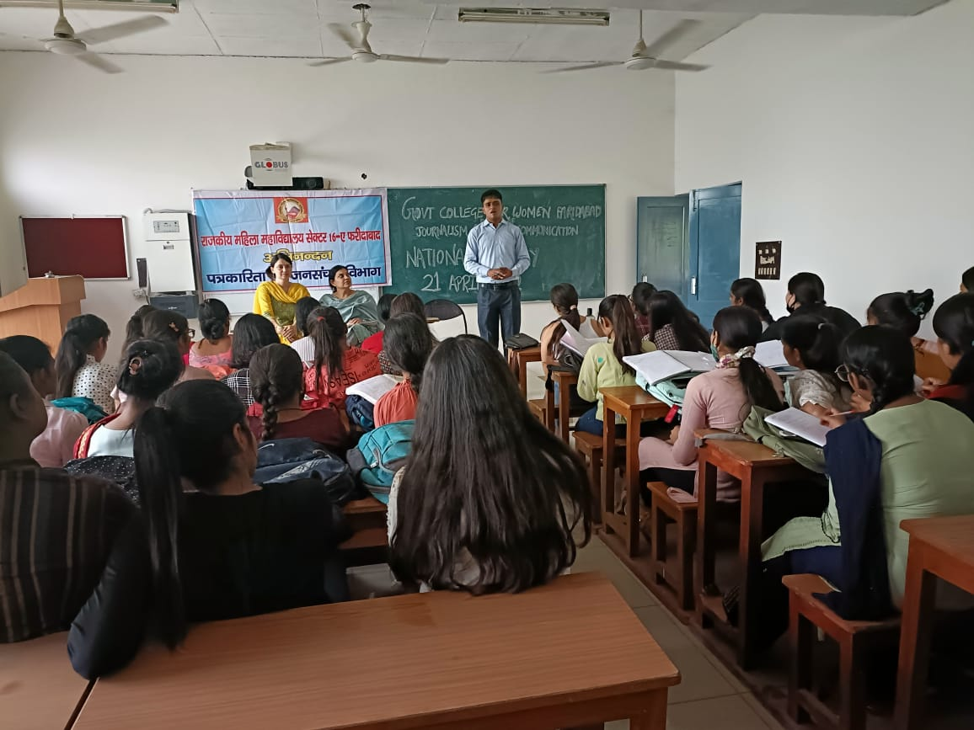

Title of the Activities & date | Organising unit/ agency/ collaborating agency | Number of teachers co-ordinated such activities | Number of students participated in such activities | Achievements/  Remarks
81) A Webinar on 21/05/2022 | Faculty of Science | Mrs Monika, Dr. Varsha Sharma, Mrs Poonam Rani and Mr Anuj | 115 students | Faculty of Science organized a Webinar in our college on 21/05/2022 at 10.00 am. The speaker Smt. Chanchal, Assistant Professor (Physics) enlightened the students with various career opportunities in science.  She told that Science and technology is the key element for growth of modern India. Total 115 students of GGSSS Old Faridabad participated and showed great enthusiasm in this webinar. Event was organised under the guidance of our worthy Principal Dr. Sunidhi Singh. Mrs Monika, Dr. Varsha Sharma, Mrs Poonam Rani and Mr Anuj also attended the webinar.

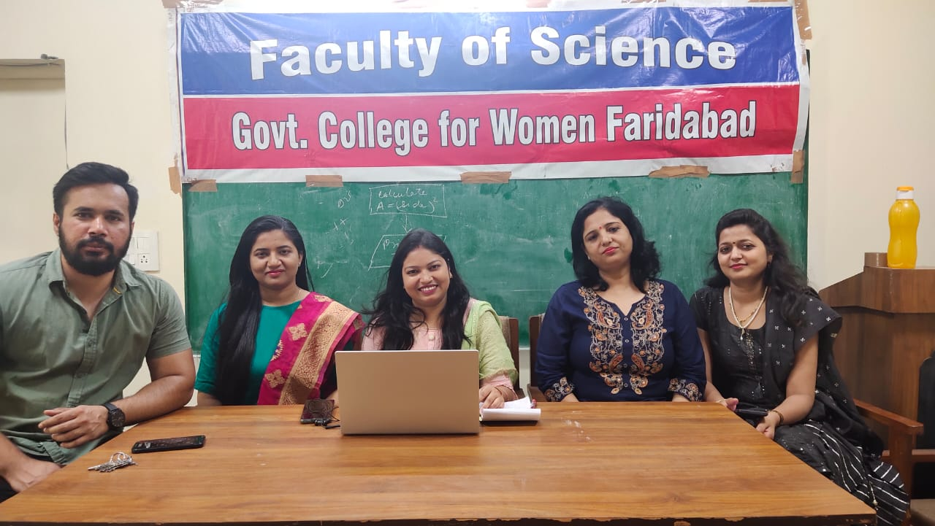
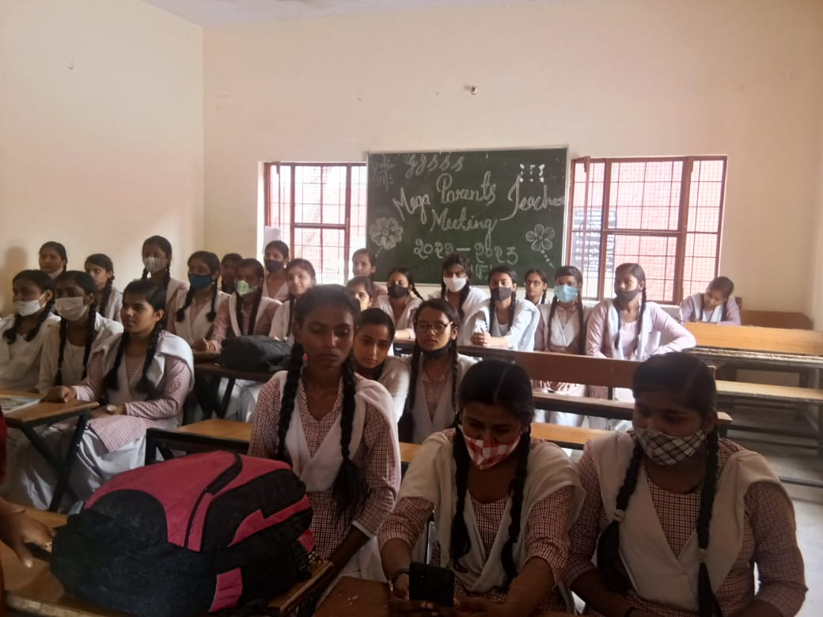

Title of the Activities & date | Organising unit/ agency/ collaborating agency | Number of teachers co-ordinated such activities | Number of students participated in such activities | Achievements/  Remarks
82) A Webinar on "Career Opportunities in Science" on 07/05/2022 | Faculty of Science | Ms. Chanchal  Ms. Poonam Rani  Mr. Anuj | 116 students | Faculty of Science organized a Webinar on "Career Opportunities in Science" in our college for 10th, 11th and 12th class students of Government Girls senior secondary school, NIT 5, Faridabad on 07/05/2022, as per the letter no. DHE-020003/4/2020-college-1-DHE dated 05/04/2022. The speaker Smt. Monika, Assistant Professor (Chemistry), GCW, Faridabad enlightened the students with various career opportunities in science. She compiled a list of career options that students can pursue after studying science (non medical or medical) in class 12.

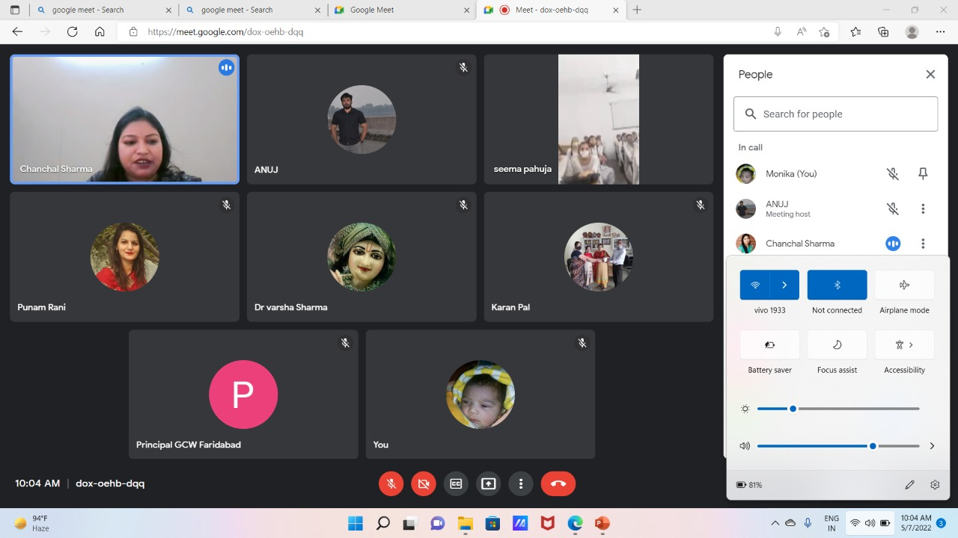

Title of the Activities & date | Organising unit/ agency/ collaborating agency | Number of teachers co-ordinated such activities | Number of students participated in such activities | Achievements/  Remarks
83) An interactive session | Department of Journalism and Mass Communication | Ms. Shalini Khurana  Dr. Rachna Saini  Ms. Savita Nagar  Mr. Suresh | 70 students | An interactive session was organised by Department of Journalism and Mass Communication at Govt. College for Women, Sector 16A, Faridabad.  Dhirender Rajput(Bureau Chief, Dainik Bhaskar), Bhola Pandey( Senior Reporter), Murti Dalal(Senior Reporter Amar Ujala) interacted with the journalism students. The session was presided over by our worthy Principal Dr. Sunidhi.  Dhirender Rajput, Bhola Pandey and Murti Dalal spoke about the nuances required for being a good journalist and importance of research for writing a good news story.  They shared their rich experiences with the students and answered all the questions raised by the students.  Ms. Shalini Khurana Asst Prof anchored the session, Mr. Suresh Kumar concluded the session with vote of thanks, and Dr. Rachna Saini and Ms. Savita Nagar also shared their views on being a good journalist.  About 70 students participated in session.

